Name: Md. Abdullah Al Mahmud Naiem

ID: 21-45255-2

Section: G

LAB 3

Write C++ code to identify relational operators and label them from a given expression.

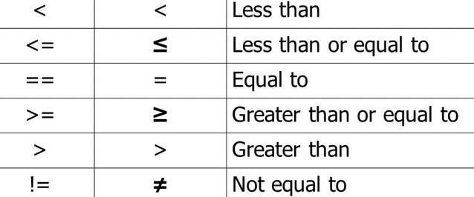

Input: x == 5 Output: == Equal to

Input: y >= n

Output: >= Greater than or equal to

Input: x > 5

Output: > Greater than

Your code should scan each string one character at a time.

Submit a PDF report with code and screen shot of your console output. Mention your Name & Section

CODE:

#include <iostream> #include <string> using namespace std; int main() {

string expression;

cout << "Enter an expression: "; getline(std::cin, expression);

int i = 0;

int length = expression.length(); while (i < length) {

if (expression[i] == '=') {

if (i + 1 < length && expression[i + 1] == '=') { cout << "== Equal to" << endl;

i += 2;

} else {

cout << "= Assignment" << endl; i++;

} else if (expression[i] == '<') {

if (i + 1 < length && expression[i + 1] == '=') { cout << "<= Less than or equal to" << endl; i += 2;

} else {

cout << "< Less than" << endl; i++;

}

} else if (expression[i] == '>') {

if (i + 1 < length && expression[i + 1] == '=') { cout << ">= Greater than or equal to" << endl; i += 2;

} else {

cout << "> Greater than" << endl; i++;

}

} else {

i++;}}

return 0;

}

**Output:**

