**Task4**

Q1 What is heap in DS?

A **Heap** is a complete binary tree data structure that satisfies the heap property: for every node, the value of its children is less than or equal to its own value. Heaps are usually used to implement priority queues, where the smallest (or largest) element is always at the root of the tree.

Types :

* **Max Heap:** The root node contains the maximum value, and the values decrease as you move down the tree.
* **Min Heap:** The root node contains the minimum value, and the values increase as you move down the tree.

## **Heap Data Structure Applications**

Heaps have various applications, like:

* Heaps are commonly used to implement priority queues, where elements are retrieved based on their priority (maximum or minimum value).
* Heapsort is a sorting algorithm that uses a heap to sort an array in ascending or descending order.
* Heaps are used in graph algorithms like **Dijkstra’s algorithm** and **Prim’s algorithm** for finding the shortest paths and minimum spanning trees.

## **Other Types of Heap Data Structure**

* [Binomial Heap](https://www.geeksforgeeks.org/binomial-heap-2/)
* [Fibonacci Heap](https://www.geeksforgeeks.org/fibonacci-heap-set-1-introduction/)
* [Leftist Heap](https://www.geeksforgeeks.org/leftist-tree-leftist-heap/)
* [K-ary Heap](https://www.geeksforgeeks.org/k-ary-heap/)

Q2 b-tree Usage?

B-tree is used for indexing and is a data structure that provides sorted data and allows searches, sequential access, attachments and removals in sorted order

Q3 RB tree Usage?

In computer science, a red–black tree is a self-balancing binary search tree data structure noted for fast storage and retrieval of ordered information. The nodes in a red-black tree hold an extra "color" bit, often drawn as red and black, which help ensure that the tree is always approximately balanced.

Q4 What is inline Functions?

C++ provides inline functions to reduce the function call overhead. An inline function is a function that is expanded in line when it is called. When the inline function is called whole code of the inline function gets inserted or substituted at the point of the inline function call.

inline return-type function-name(parameters)  
{  
 // function code

}

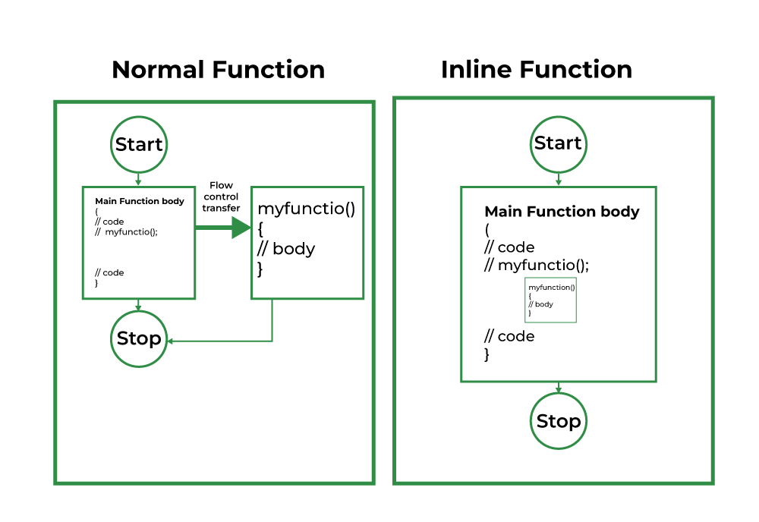  
For functions that are large and/or perform complex tasks, the overhead of the function call is usually insignificant compared to the amount of time the function takes to run. However, for small, commonly-used functions, the time needed to make the function call is often a lot more than the time needed to actually execute the function’s code. This overhead occurs for small functions because the execution time of a small function is less than the switching time.

Q5 what deos 32-bit and 64-bit means?

32-bit => can work with 3 giga of rams .

64-bit => can work with 128 giga.

This provide faster processing.

Q6 What is friend function ?

Defined outside the class scope but can access all privates and protected members in that class.

In that class it contain the prototype of this friend function with keyword friend.

Q7 Difference between struct and class ?

Class default is private .

Struct default is public .

Q8 What is diamond inheritance?

The diamond inheritance problem occurs when two superclasses of a class have a common base class.