# High-Level:

* Collected and annotated 275 images
* Performed quality control on Roboflow datasets for all 4 military branches
* Managed project datasets on Roboflow
  + Created marines dataset
  + Merged all military datasets into one large dataset
  + Reclassified the merged dataset into several types ML dataset types (object classification, semantic segmentation, and instance segmentation)
  + Consolidated 8 classes into 2 classes to improve classification results
  + Performed manual assignments for training/validation/testing
* Performed several iterations of machine learning training on our custom datasets using YOLOv8.
* Uploaded the US/RU marines source images and URLs on Google Drive.

# Low-Level:

## Dataset Quality Analysis

* + Reviewed individual datasets and provided feedback to each team member regarding annotation accuracy and image clarity.

## Roboflow Management

* + Train/Valid/Test split performed manually to ensure equal distribution for each class. A PowerPoint slide deck was created to document how each class was represented with regard to the split.
  + Combined all individual datasets to form 1 large dataset with 8 classes. I duplicated the object detection class into 2 more types: Semantic Segmentation and Instance Segmentation. Lastly, I duplicated the merged object detection dataset to consolidate the 8 classes into 2 classes (US military and Russian military).
  + Large object detection dataset with 8 classes (not deployed)

* + Large object detection dataset with 2 classes (deployed)

* + Marines-only object detection dataset with 2 classes (deployed)

## Transfer learning iterations performed

### YOLOv8s, 25 epochs, 8 classes, not deployed

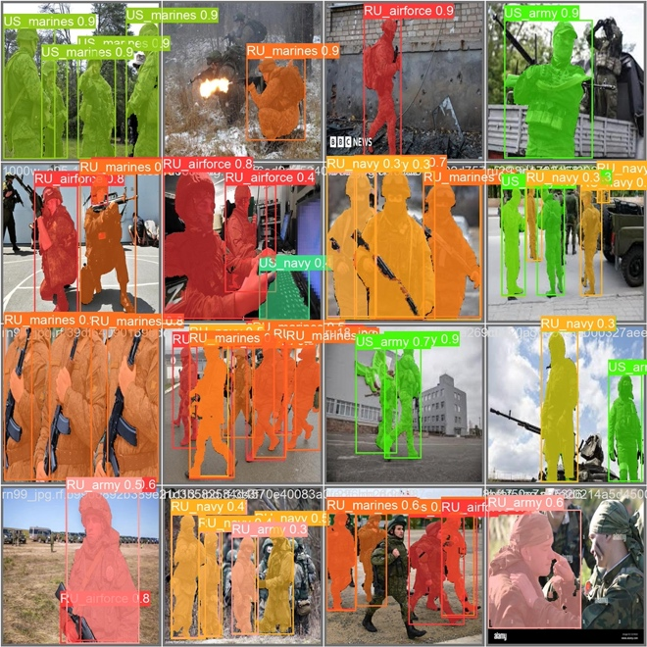

### YOLOv8n, 5 epochs, 2 classes, deployed (<https://app.roboflow.com/eep567-x0zpr/friend_or_foe_class_consolidation_objdet/1>)



### YOLOv8s, 5 epochs, 2 classes, not deployed



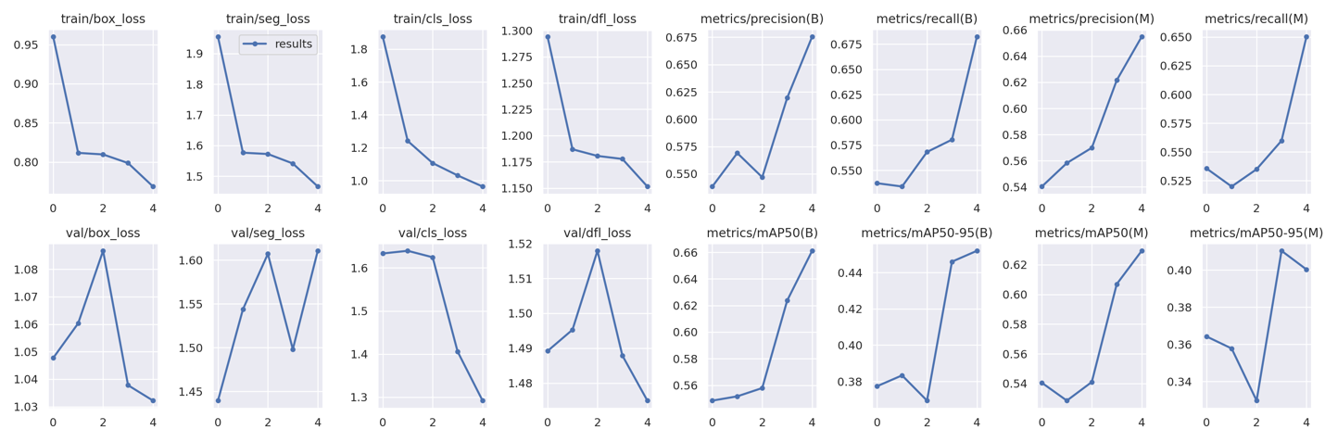

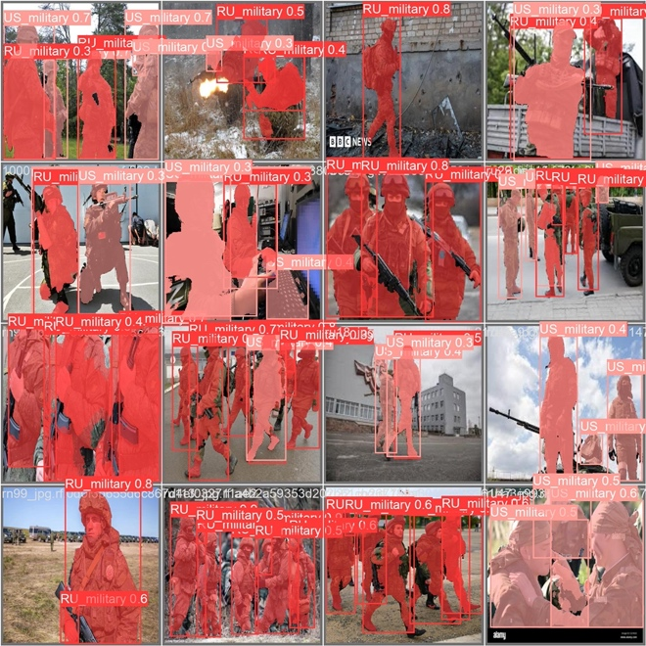



### YOLOv8s, 50 epochs, 2 classes, deployed (<https://app.roboflow.com/eep567-x0zpr/friend_or_foe_class_consolidation_objdet/2>)



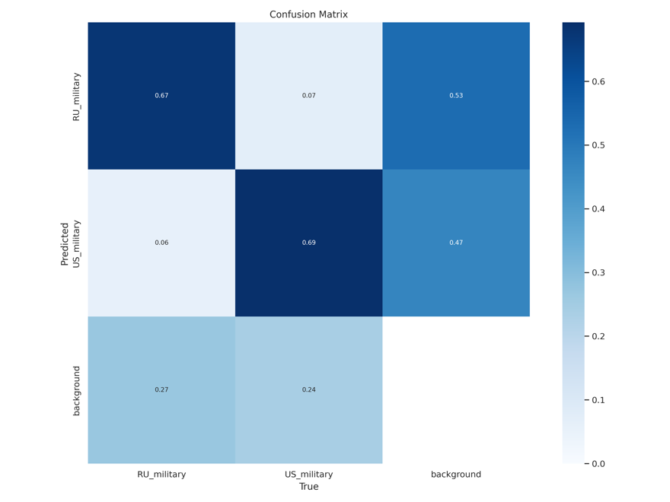

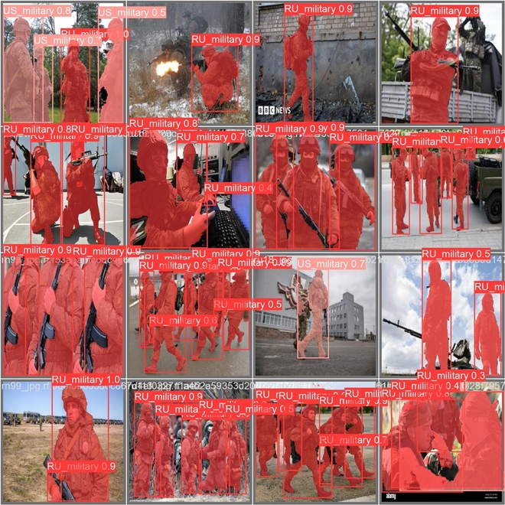



### YOLOv8s, 50 epochs, 2 classes, initial learning rate reduced to 0.001, cosine learning rate scheduler enabled, deployed



### YOLOv8s, 300 epochs, 2 classes, initial learning rate reduced to 0.001, cosine learning rate scheduler enabled, not deployed, failed to complete.

NOTE: Training terminated early due to lack of improvements for 50 epochs. Training only went until epoch 237 but best results were saved at epoch 187.



### YOLOv8s, 50 epochs, 2 classes (marines only), initial learning rate reduced to 0.001, cosine learning rate scheduler enabled, deployed



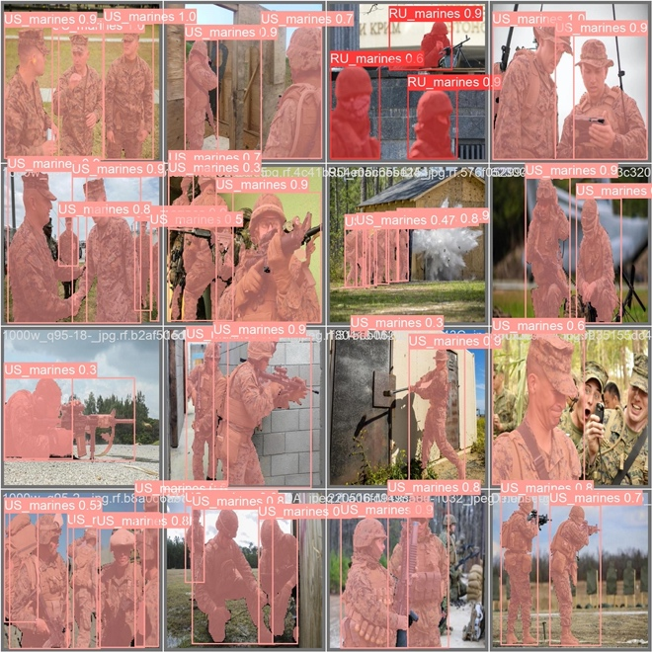

# Preliminary Conclusions

<Insert team feedback including test results>

Our initial results for the machine learning model suffered from a few setbacks primarily due to issues with the dataset quality. The team was able to sufficiently acquire images for the US military branches due to the abundance of those images, however, collecting Russian military images proved to be far more difficult. This difficulty arose from a combination of duplicate and obscure Russian military pictures available online, compounded by misalignment between Russian military branches and their US counterparts. Furthermore, the presence of blurry images in the dataset is bound to have negative effects on the training process of the ML model. Further exacerbating the dataset quality issue is the fact that the hazy images were later processed using data augmentation techniques that added noise and blurriness. The inclusion of said images resulted in the poor performance of our computer vision model as it struggled to accurately distinguish friendly forces from foes. It was also noted that using 8 classes to represent the custom dataset may have been overly ambitious given the fidelity of the available Russian military images.

All things considered; the first few versions of the model appeared to have unreliable classification results. Fortunately, in using Roboflow to deploy our custom datasets and trained computer vision model, we were able to access various prognostics which include precision/recall/mAP results, confusion matrix, and training graphs. Said prognostics allowed the team to investigate the issues described above and address them accordingly. For instance, the custom dataset classes were consolidated into 2 classes to simplify classification and focus on optimizing the machine learning model. Additionally, subsequent iterations of the model leveraged the confusion matrix and dataset distribution graphs to address the dataset quality issues by refining the Russian military images and changing the data augmentation techniques which improved the overall efficacy and reliability of the model.

In parallel with building the machine learning model, the team started crafting and developing the challenge and response system (CRS) which is aimed at confirming the military faction of the identified soldier. The physical architecture of this system involves an Enhanced Weapon System (EWS) and a modified soldier uniform with an embedded receiver/transponder system. In practice, the ultimate setup will utilize a Software-Defined Radio (SDR) mounted on the EWS, however, our current demonstration employs a socket-based server-client connection for proof of concept. It’s worth noting that while the current CRS demonstration is standalone, the intended use of this system will be integrated with the machine learning model.