## Query / Find Documents

query the `movies` collection to

1. get all documents

1. get all documents with `writer` set to "Quentin Tarantino"

1. get all documents where `actors` include "Brad Pitt"

1. get all documents with `franchise` set to "The Hobbit"

1. get all movies released in the 90s

1. get all movies released before the year 2000 or after 2010

## Update Documents

1. add a synopsis to "The Hobbit: An Unexpected Journey" : "A reluctant hobbit, Bilbo Baggins, sets out to the Lonely Mountain with a spirited group of dwarves to reclaim their mountain home - and the gold within it - from the dragon Smaug."

1. add a synopsis to "The Hobbit: The Desolation of Smaug" : "The dwarves, along with Bilbo Baggins and Gandalf the Grey, continue their quest to reclaim Erebor, their homeland, from Smaug. Bilbo Baggins is in possession of a mysterious and magical ring."

1. add an actor named "Samuel L. Jackson" to the movie "Pulp Fiction"

## Text Search

1. find all movies that have a synopsis that contains the word "Bilbo"

1. find all movies that have a synopsis that contains the word "Gandalf"

1. find all movies that have a synopsis that contains the word "Bilbo" and not the word "Gandalf"

1. find all movies that have a synopsis that contains the word "dwarves" or "hobbit"

1. find all movies that have a synopsis that contains the word "gold" and "dragon"

## Delete Documents

1. delete the movie "Pee Wee Herman's Big Adventure"

1. delete the movie "Avatar"

## Querying related collections

1. find all users

1. find all posts

1. find all posts that was authored by "GoodGuyGreg"

1. find all posts that was authored by "ScumbagSteve"

1. find all comments

1. find all comments that was authored by "GoodGuyGreg"

1. find all comments that was authored by "ScumbagSteve"

1. find all comments belonging to the post "Reports a bug in your code"

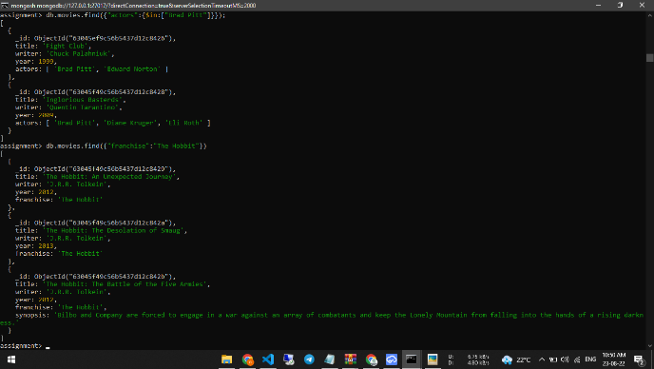 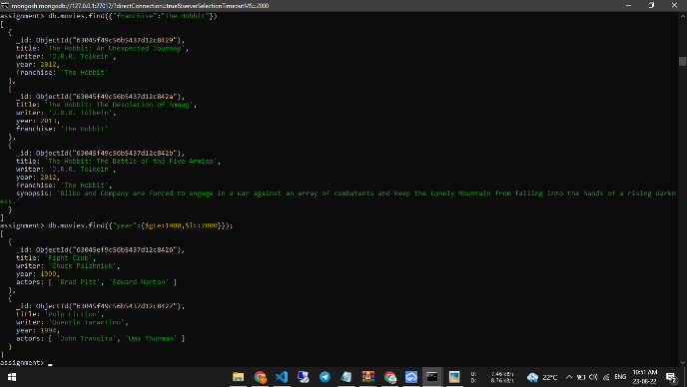 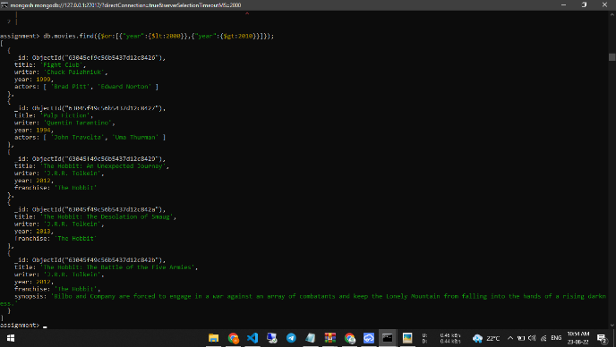 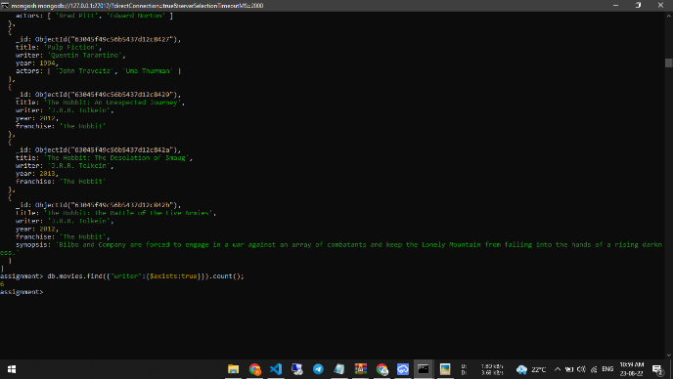 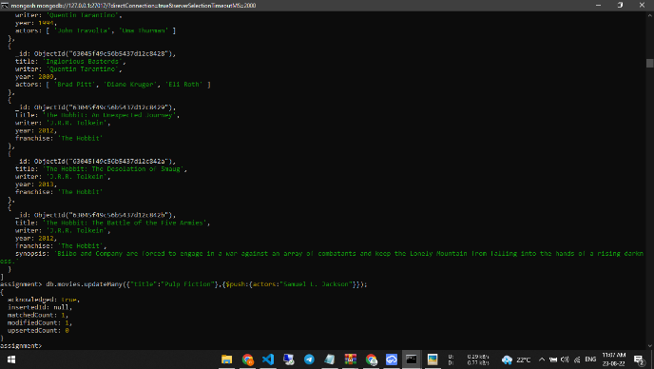 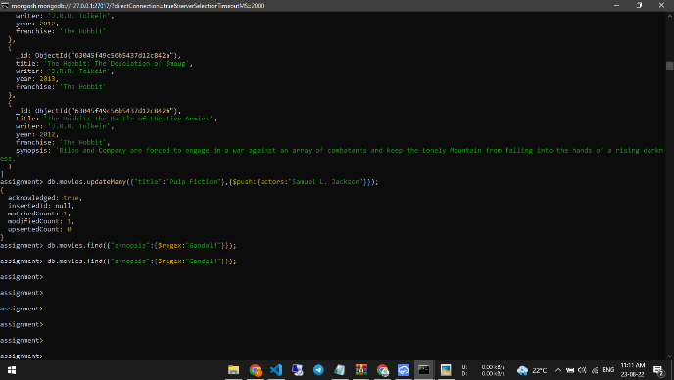 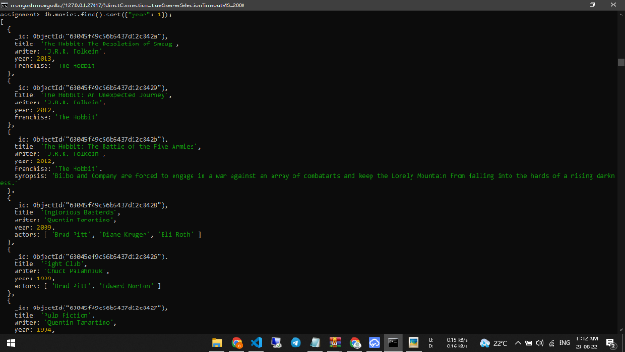 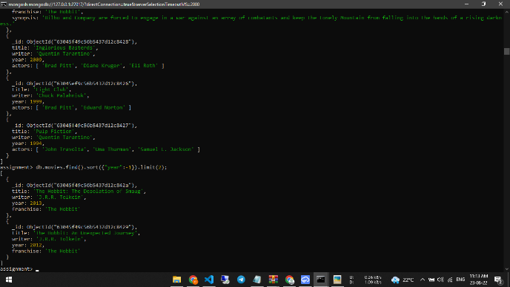 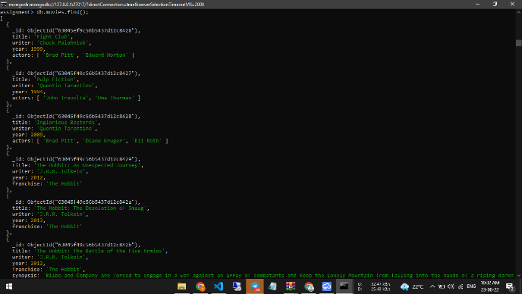 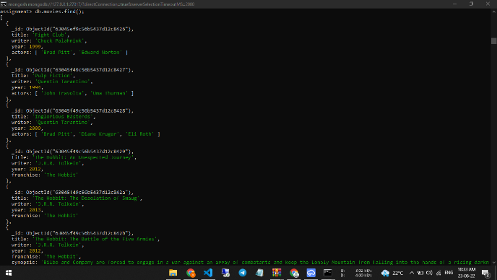 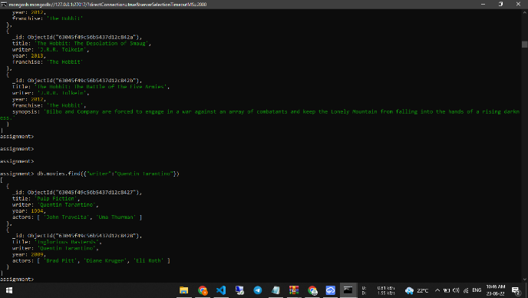 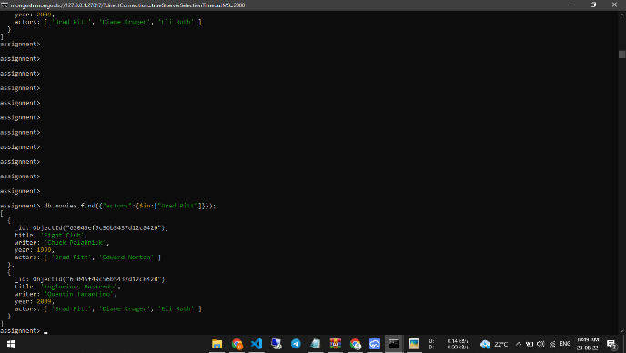

mongosh mongodb://127.0.0.1:27017/?directConnection=true&serverSelection TimeoutMS=2000

assignment> db.movies.find({"actors":{$in:["Brad Pitt"]}});

[

]

[

{

_id: ObjectId("63045ef9c56b5437d12c8426"),

title: 'Fight Club',

writer: 'Chuck Palahniuk',

}

assignment> db.movies.find({"franchise":"The Hobbit"})

{

]

year: 1999,

actors: [ 'Brad Pitt', 'Edward Norton' ]

_id: ObjectId("63045f49c56b5437d12c8428"),

title: 'Inglorious Basterds',

writer: 'Quentin Tarantino',

year: 2009,

actors: ['Brad Pitt', 'Diane Kruger', 'Eli Roth']

_id: ObjectId("63045f49c56b5437d12c8429"),

title: 'The Hobbit: An Unexpected Journey'

writer: 'J.R.R. Tolkein',

year: 2012,

franchise: 'The Hobbit'

_id: ObjectId("63045f49c56b5437d12c842a"),

title: 'The Hobbit: The Desolation of Smaug',

writer: 'J.R.R. Tolkein',

year: 2013,

franchise: 'The Hobbit'

_id: ObjectId("63045f49c56b5437d12c842b"),

title: 'The Hobbit: The Battle of the Five Armies',

writer: 'J.R.R. Tolkein',

year: 2012,

franchise: 'The Hobbit',

synopsis: 'Bilbo and Company are forced to engage in a war against an array of combatants and keep the Lonely Mountain from falling into the hands of a rising darkn

ess.

}

assignment>

U:

D:

6.75 kB/s

4.80 kB/s

22°C

4) ENG

10:50 AM

23-08-22

mongosh mongodb://127.0.0.1:27017/?directConnection=true&serverSelection TimeoutMS=2000

assignment> db.movies.find({"franchise":"The Hobbit"})

[

]

[

{

_id: ObjectId("63045f49c56b5437d12c8429"),

title: 'The Hobbit: An Unexpected Journey'

writer: 'J.R.R. Tolkein',

year: 2012,

franchise: 'The Hobbit'

]

_id: ObjectId("63045f49c56b5437d12c842a"),

title: 'The Hobbit: The Desolation of Smaug',

writer: 'J.R.R. Tolkein',

year: 2013,

franchise: 'The Hobbit'

ess.

}

assignment> db.movies.find({"year":{$gte:1900, $1t:2000}});

{

_id: ObjectId("63045f49c56b5437d12c842b"),

title: 'The Hobbit: The Battle of the Five Armies',

writer: 'J.R.R. Tolkein',

year: 2012,

franchise: 'The Hobbit',

synopsis: 'Bilbo and Company are forced to engage in a war against an array of combatants and keep the Lonely Mountain from falling into the hands of a rising darkn

_id: ObjectId("63045ef9c56b5437d12c8426"),

title: 'Fight Club',

writer: 'Chuck Palahniuk',

year: 1999,

actors: [ 'Brad Pitt', 'Edward Norton' ]

_id: ObjectId("63045f49c56b5437d12c8427"),

title: 'Pulp Fiction',

writer: 'Quentin Tarantino',

year: 1994,

actors: [ 'John Travolta', 'Uma Thurman' ]

}

assignment>

U:

D:

7.46 kB/s

8.76 kB/s

22°C

4) ENG

10:51 AM

23-08-22

[

mongosh mongodb://127.0.0.1:27017/?directConnection=true&serverSelection TimeoutMS=2000

assignment> db.movies.find({$or:[{"year":{$lt:2000}},{"year": {$gt:2010}}]});

{

2

]

_id: ObjectId("63045ef9c56b5437d12c8426"),

title: 'Fight Club',

writer: 'Chuck Palahniuk',

year: 1999,

actors: [ 'Brad Pitt', 'Edward Norton' ]

_id: ObjectId("63045f49c56b5437d12c8427"),

title: 'Pulp Fiction',

writer: 'Quentin Tarantino',

year: 1994,

actors: [ 'John Travolta', 'Uma Thurman' ]

_id: ObjectId("63045f49c56b5437d12c8429"),

title: 'The Hobbit: An Unexpected Journey'

writer: 'J.R.R. Tolkein',

year: 2012,

franchise: 'The Hobbit'

_id: ObjectId("63045f49c56b5437d12c842a"),

title: 'The Hobbit: The Desolation of Smaug',

writer: 'J.R.R. Tolkein',

year: 2013,

franchise: 'The Hobbit'

_id: ObjectId("63045f49c56b5437d12c842b"),

title: 'The Hobbit: The Battle of the Five Armies',

writer: 'J.R.R. Tolkein',

year: 2012,

franchise: 'The Hobbit',

synopsis: 'Bilbo and Company are forced to engage in a war against an array of combatants and keep the Lonely Mountain from falling into the hands of a rising darkn

ess.

}

assignment>

U:

D:

0.45 kB/s

0.44 kB/s

22°C

4) ENG

10:54 AM

23-08-22

c. mongosh mongodb://127.0.0.1:27017/?directConnection=true&serverSelection TimeoutMS=2000

actors: [ 'Brad Pitt', 'Edward Norton' ]

ess.

}

]

_id: ObjectId("63045f49c56b5437d12c8427"),

title: 'Pulp Fiction',

writer: 'Quentin Tarantino',

6

year: 1994,

actors: [ 'John Travolta', 'Uma Thurman' ]

_id: ObjectId("63045f49c56b5437d12c8429"),

title: 'The Hobbit: An Unexpected Journey'

writer: 'J.R.R. Tolkein',

year: 2012,

franchise: 'The Hobbit'

_id: ObjectId("63045f49c56b5437d12c842a"),

title: 'The Hobbit: The Desolation of Smaug',

writer: 'J.R.R. Tolkein',

year: 2013,

franchise: 'The Hobbit'

_id: ObjectId("63045f49c56b5437d12c842b"),

title: 'The Hobbit: The Battle of the Five Armies',

writer: 'J.R.R. Tolkein',

year: 2012,

assignment> db.movies.find({"writer":{$exists:true}}).count();

assignment>

franchise: 'The Hobbit',

synopsis: 'Bilbo and Company are forced to engage in a war against an array of combatants and keep the Lonely Mountain from falling into the hands of a rising darkn

!!

U:

D:

1.80 kB/s

3.68 kB/s

22°C

ENG

10:59 AM

23-08-22

ess.

}

]

{

mongosh mongodb://127.0.0.1:27017/?directConnection=true&serverSelection TimeoutMS=2000

writer: 'Quentin Tarantino',

year: 1994,

actors: ['John Travolta', 'Uma Thurman' ]

}

_id: ObjectId("63045f49c56b5437d12c8428"),

title: 'Inglorious Basterds',

writer: 'Quentin Tarantino',

year: 2009,

actors: ['Brad Pitt', 'Diane Kruger', 'Eli Roth' ]

_id: ObjectId("63045f49c56b5437d12c8429"),

title: 'The Hobbit: An Unexpected Journey'

writer: 'J.R.R. Tolkein',

year: 2012,

franchise: 'The Hobbit'

_id: ObjectId("63045f49c56b5437d12c842a"),

title: 'The Hobbit: The Desolation of Smaug',

writer: 'J.R.R. Tolkein',

year: 2013,

franchise: 'The Hobbit'

_id: ObjectId("63045f49c56b5437d12c842b"),

title: 'The Hobbit: The Battle of the Five Armies',

writer: 'J.R.R. Tolkein',

year: 2012,

franchise: 'The Hobbit',

synopsis: 'Bilbo and Company are forced to engage in a war against an array of combatants and keep the Lonely Mountain from falling into the hands of a rising darkn

assignment> db.movies.updateMany({"title":"Pulp Fiction"},{$push:{actors: "Samuel L. Jackson"}});

acknowledged: true,

insertedId: null,

matchedCount: 1,

modifiedCount: 1,

upsertedCount: 0

assignment>

U:

D:

0.29 kB/s

0.77 kB/s

22°C

4) ENG

11:07 AM

23-08-22

mongosh mongodb://127.0.0.1:27017/?directConnection=true&serverSelection TimeoutMS=2000

writer: 'J.R.R. Tolkein',

year: 2012,

franchise: 'The Hobbit'

ess.

}

]

{

_id: ObjectId("63045f49c56b5437d12c842a"),

title: 'The Hobbit: The Desolation of Smaug',

writer: 'J.R.R. Tolkein',

year: 2013,

franchise: 'The Hobbit'

_id: ObjectId("63045f49c56b5437d12c842b"),

title: 'The Hobbit: The Battle of the Five Armies',

writer: 'J.R.R. Tolkein',

year: 2012,

franchise: 'The Hobbit',

synopsis: 'Bilbo and Company are forced to engage in a war against an array of combatants and keep the Lonely Mountain from falling into the hands of a rising darkn

assignment> db.movies.updateMany({"title":"Pulp Fiction"},{$push:{actors: "Samuel L. Jackson"}});

acknowledged: true,

insertedId: null,

matchedCount: 1,

modifiedCount: 1,

upsertedCount: 0

}

assignment> db.movies.find({"synopsis": {$regex: "Gandalf"}});

assignment> db.movies.find({"synopsis": {$regex: "Gandalf"}});

assignment>

assignment>

assignment>

assignment>

assignment>

assignment>

}

U:

D:

0.00 kB/s

0.00 kB/s

22°C

4) ENG

11:11 AM

23-08-22

mongosh mongodb://127.0.0.1:27017/?directConnection=true&serverSelection TimeoutMS=2000

assignment> db.movies.find().sort({"year": -1});

[

{

ess.

},

{

_id: ObjectId("63045f49c56b5437d12c842a"),

title: 'The Hobbit: The Desolation of Smaug',

writer: 'J.R.R. Tolkein',

year: 2013,

franchise: 'The Hobbit'

_id: ObjectId("63045f49c56b5437d12c8429"),

title: The Hobbit: An Unexpected Journey',

writer: 'J.R.R. Tolkein',

year: 2012,

franchise: 'The Hobbit'

_id: ObjectId("63045f49c56b5437d12c842b"),

title: 'The Hobbit: The Battle of the Five Armies',

writer: 'J.R.R. Tolkein',

year: 2012,

franchise: 'The Hobbit',

synopsis: 'Bilbo and Company are forced to engage in a war against an array of combatants and keep the Lonely Mountain from falling into the hands of a rising darkn

_id: ObjectId("63045f49c56b5437d12c8428"),

title: 'Inglorious Basterds'

writer: 'Quentin Tarantino',

year: 2009,

actors: ['Brad Pitt', 'Diane Kruger', 'Eli Roth']

_id: ObjectId("63045ef9c56b5437d12c8426"),

title: 'Fight Club',

writer: 'Chuck Palahniuk',

year: 1999,

actors: [ 'Brad Pitt', 'Edward Norton' ]

_id: ObjectId("63045f49c56b5437d12c8427"),

title: 'Pulp Fiction',

writer: 'Quentin Tarantino',

year: 1994,

}

U:

D:

0.15 kB/s

0.16 kB/s

22°C

4) ENG

11:12 AM

23-08-22

ess.

},

{

]

[

mongosh mongodb://127.0.0.1:27017/?directConnection=true&serverSelection TimeoutMS=2000

franchise: 'The Hobbit',

synopsis: 'Bilbo and Company are forced to engage in a war against an array of combatants and keep the Lonely Mountain from falling into the hands of a rising darkn

_id: ObjectId("63045f49c56b5437d12c8428"),

title: 'Inglorious Basterds'

writer: 'Quentin Tarantino',

]

year: 2009,

actors: ['Brad Pitt', 'Diane Kruger', 'Eli Roth']

_id: ObjectId("63045ef9c56b5437d12c8426"),

title: 'Fight Club',

writer: 'Chuck Palahniuk',

year: 1999,

actors: [ 'Brad Pitt', 'Edward Norton' ]

}

assignment> db.movies.find().sort({"year": -1}).limit(2);

{

_id: ObjectId("63045f49c56b5437d12c8427"),

title: 'Pulp Fiction',

writer: 'Quentin Tarantino',

year: 1994,

actors: ['John Travolta', 'Uma Thurman', 'Samuel L. Jackson' ]

_id: ObjectId("63045f49c56b5437d12c842a"),

title: 'The Hobbit: The Desolation of Smaug',

writer: 'J.R.R. Tolkein',

year: 2013,

franchise: 'The Hobbit'

_id: ObjectId("63045f49c56b5437d12c8429"),

title: The Hobbit: An Unexpected Journey',

writer: 'J.R.R. Tolkein',

year: 2012,

franchise: 'The Hobbit'

}

assignment>

}

U:

D:

0.26 kB/s

1.09 kB/s

22°C

4) ENG

X

11:13 AM

23-08-22

mongosh mongodb://127.0.0.1:27017/?directConnection=true&serverSelection TimeoutMS=2000

assignment> db.movies.find();

[

{

_id: ObjectId("63045ef9c56b5437d12c8426"),

title: 'Fight Club',

writer: 'Chuck Palahniuk',

year: 1999,

actors: [ 'Brad Pitt', 'Edward Norton' ]

_id: ObjectId("63045f49c56b5437d12c8427"),

title: 'Pulp Fiction',

writer: 'Quentin Tarantino',

year: 1994,

actors: ['John Travolta', 'Uma Thurman' ]

_id: ObjectId("63045f49c56b5437d12c8428"),

title: 'Inglorious Basterds',

writer: 'Quentin Tarantino',

year: 2009,

actors: ['Brad Pitt', 'Diane Kruger', 'Eli Roth' ]

_id: ObjectId("63045f49c56b5437d12c8429"),

title: 'The Hobbit: An Unexpected Journey'

writer: 'J.R.R. Tolkein',

year: 2012,

franchise: 'The Hobbit'

_id: ObjectId("63045f49c56b5437d12c842a"),

title: 'The Hobbit: The Desolation of Smaug',

writer: 'J.R.R. Tolkein',

year: 2013,

franchise: 'The Hobbit'

_id: ObjectId("63045f49c56b5437d12c842b"),

title: 'The Hobbit: The Battle of the Five Armies',

writer: 'J.R.R. Tolkein',

year: 2012,

franchise: 'The Hobbit',

synopsis: 'Bilbo and Company are forced to engage in a war against an array of combatants and keep the Lonely Mountain from falling into the hands of a rising darkn

ENG

10:32 AM

U:

32.47 kB/s

22°C

D:

25.48 kB/s

23-08-22

Le

.98

C

mongosh mongodb://127.0.0.1:27017/?directConnection=true&serverSelection TimeoutMS=2000

assignment> db.movies.find();

[

{

_id: ObjectId("63045ef9c56b5437d12c8426"),

title: 'Fight Club',

writer: 'Chuck Palahniuk',

year: 1999,

actors: [ 'Brad Pitt', 'Edward Norton' ]

_id: ObjectId("63045f49c56b5437d12c8427"),

title: 'Pulp Fiction',

writer: 'Quentin Tarantino',

year: 1994,

actors: ['John Travolta', 'Uma Thurman' ]

_id: ObjectId("63045f49c56b5437d12c8428"),

title: 'Inglorious Basterds',

writer: 'Quentin Tarantino',

year: 2009,

actors: ['Brad Pitt', 'Diane Kruger', 'Eli Roth' ]

_id: ObjectId("63045f49c56b5437d12c8429"),

title: 'The Hobbit: An Unexpected Journey'

writer: 'J.R.R. Tolkein',

year: 2012,

franchise: 'The Hobbit'

_id: ObjectId("63045f49c56b5437d12c842a"),

title: 'The Hobbit: The Desolation of Smaug',

writer: 'J.R.R. Tolkein',

year: 2013,

franchise: 'The Hobbit'

_id: ObjectId("63045f49c56b5437d12c842b"),

title: 'The Hobbit: The Battle of the Five Armies',

writer: 'J.R.R. Tolkein',

year: 2012,

X

franchise: 'The Hobbit',

synopsis: 'Bilbo and Company are forced to engage in a war against an array of combatants and keep the Lonely Mountain from falling into the hands of a rising darkn

ENG

10:33 AM

U:

3.02 kB/s

22°C

D:

4.00 kB/s

23-08-22

ess.

}

]

mongosh

year: 2012,

franchise: 'The Hobbit'

[

]

mongodb://127.0.0.1:27017/?directConnection=true&serverSelection TimeoutMS=2000

{

_id: ObjectId("63045f49c56b5437d12c842a"),

title: 'The Hobbit: The Desolation of Smaug',

writer: 'J.R.R. Tolkein',

year: 2013,

franchise: 'The Hobbit'

assignment>

assignment>

assignment>

assignment> db.movies.find({"writer":"Quentin Tarantino"})

_id: ObjectId("63045f49c56b5437d12c842b"),

title: 'The Hobbit: The Battle of the Five Armies',

writer: 'J.R.R. Tolkein',

year: 2012,

franchise: 'The Hobbit',

synopsis: 'Bilbo and Company are forced to engage in a war against an array of combatants and keep the Lonely Mountain from falling into the hands of a rising darkn

_id: ObjectId("63045f49c56b5437d12c8427"),

title: 'Pulp Fiction',

writer: 'Quentin Tarantino',

year: 1994,

actors: ['John Travolta', 'Uma Thurman' ]

_id: ObjectId("63045f49c56b5437d12c8428"),

title: 'Inglorious Basterds',

writer: 'Quentin Tarantino',

year: 2009,

actors: ['Brad Pitt', 'Diane Kruger', 'Eli Roth' ]

}

assignment>

1

ㄨˊ

TO

U:

D:

0.81 kB/s

1.55 kB/s

22°C

4) ENG

10:46 AM

23-08-22

]

[

mongodb://127.0.0.1:27017/?directConnection=true&serverSelection TimeoutMS=2000

mongosh

year: 2009,

actors: ['Brad Pitt', 'Diane Kruger', 'Eli Roth' ]

assignment>

assignment>

assignment>

assignment>

assignment>

assignment>

assignment>

assignment>

assignment>

assignment>

assignment>

assignment> db.movies.find({"actors":{$in:["Brad Pitt"]}});

]

}

{

}

_id: ObjectId("63045ef9c56b5437d12c8426"),

title: 'Fight Club',

writer: 'Chuck Palahniuk',

year: 1999,

actors: [ 'Brad Pitt', 'Edward Norton' ]

_id: ObjectId("63045f49c56b5437d12c8428"),

title: 'Inglorious Basterds',

writer: 'Quentin Tarantino',

year: 2009,

actors: ['Brad Pitt', 'Diane Kruger', 'Eli Roth' ]

assignment>

U:

D:

0.14 kB/s

0.00 kB/s

22°C

4) ENG

10:49 AM

23-08-22