**Keywords, Identifier, Literals, Operators and Expression Assignment**

Mandatory:

1. Choose all valid identifiers

a. int int

ans:not valid

b. int _numvalue

ans:valid

c. float price_money

ans:valid

d. char name1234567890123456789012345678901234567890

ans:valid

e. char name value

ans:valid

f. char $name

ans:invalid

2. What is the meaning of the following keywords, show the usage

a. auto:auto is the storage class specifier used to declare automatic variables

b. extern:is the storage class specifier used to declare variables with external ;linkage

c. volatile:is a type qualifier that tells the compiler not to optimize away accesses to the variaable

d. sizeof:this return the size of the datatypes or variable in byte

e. const:fixed value that cannot be changed

3. Explain the difference between the following variables.

a. char *ptr = “ABC”;

b. char arr[]=”ABC”;

Can you manipulate the contents of ptr? Why?

Answer:pointer to string literal(read only)

Cannot modify the contents of the strings

Can you manipulate the contents of arr? Why?

Answer:character array

Can modify individual character in the array

Which one of the above is a string literal?

Answer: “ABC” is the string literal in both cases.its sequence of character enclosed in double

4. Predict the output of the following code .

void main()

{

//set a and b both equal to 5.

int a=5, b=5;

//Print them and decrementing each time.

//Use postfix mode for a and prefix mode for b.

printf("\n%d %d",a--,--b);

printf("\n%d %d",b++,--b);

}

Answer: output

5 4

4 4

5. Refer the code snippet. It fails with error. Fix it.

#include<stdio.h>

int main()

{

int i,k;

const int num;

/* for(i = 0;i < 9;i++)

{

k = k + 1;

} */

num = num + k; /* Compiler gives the error here */

printf("final value of k:%d\n",k);

printf("value of num:%d\n",num);

return 0;

}

Answer:the error in the code is constant variable num is being modified

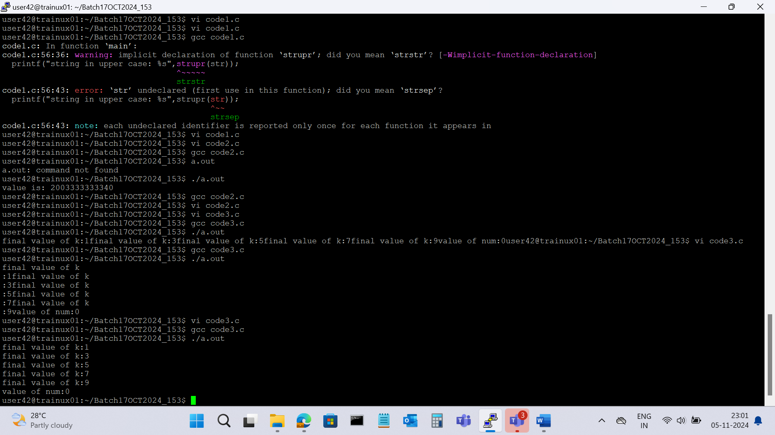

6. Consider the following code snippet. Evaluate the value of f1, f2 and f3.

int main()

{

int i = 10;

int j = 3;

float f1 = i / j;

float f2 = (float ) i / j;

float f3 = (float)(i/j);

}

Answer:

f1=1.0

f2=3.33333

f3=3.0