**Introduction to Pointers Assignments**

Mandatory

1. Refer the code snippet below. int main()

{

char arr=”hello hi “;

int *ptr = arr;

printf(“sizeof ptr:%d, arr:%d”, sizeof(ptr), sizeof(arr));

display(ptr); // display the address in hex and contents using pointer

}

Perform the following.

1. Implement the display() function (Use the “0x%x” formatting specifier to print addresses in hexadecimal.)
2. comment on the sizeof(ptr) and sizeof(arr)

2. Refer the code snippet below. int main()

#define MAX 100

#define SUCCESS 0

#define FAILURE 1

int main()

{

char arr[MAX] = “Learning C“;

char*ptr = arr;

char appendstr[3]= “in my org”;

printf(“Address of ptr:%x”, ptr);

int ret = append(ptr, appendstr);// append the string

printf(“Address of ptr:%x”, ptr);

if (ret == SUCCESS)

{

display(ptr); // display the address in hex and contents using pointer

}

}

Perform the following.

a. Implement the append() function to append the contents of the appendstr[] to arr using pointer.

[Note: append() should only use its content and not manipulate it. Contents should be retained even after the call]

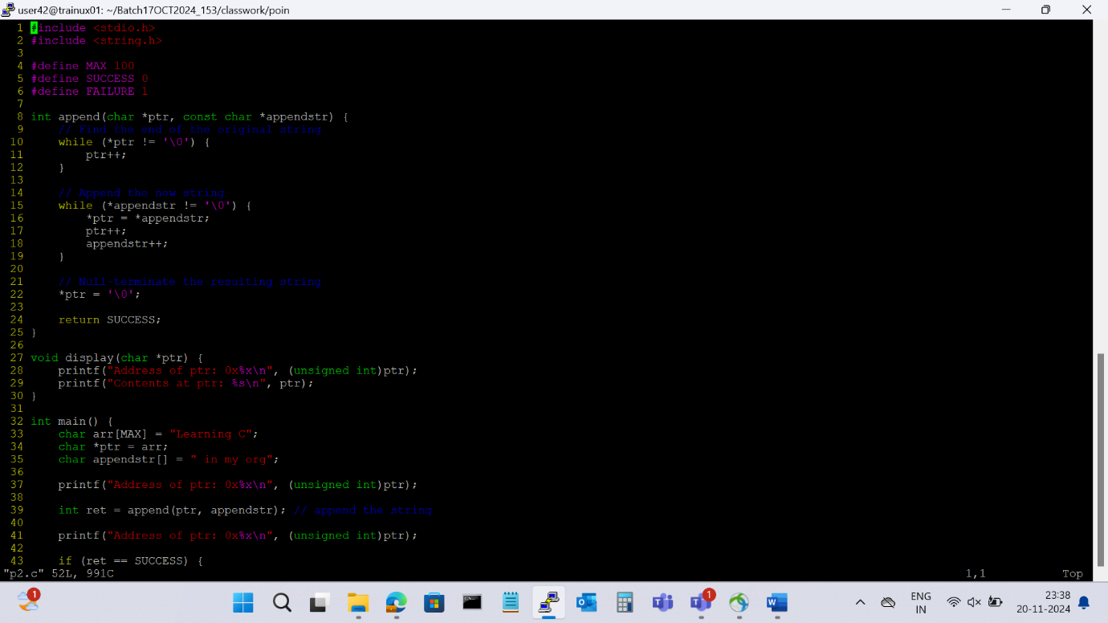

3. Refer the code in “pointer_prg.c”. The functions swap_nums() and swap_pointers() are expected to swap the numbers and pointers respectively. But swap_pointers() is currently not giving the expected results. Analyse and the fix the issue.

The issue with the `swap_pointers()` function is that it swaps the local copies of the pointers `x` and `y` within the function, but these changes are not reflected outside the function. To fix this, you need to pass the addresses of the pointers to the function so that the changes are reflected in the original pointers.

