BST assignments

Mandatory

- Refer the example code of BST using array in socodery. Add the traversal methods below.
  - int inorder_traversal(char *array[], int count)
  - int preorder_traversal(char *array[], int count)
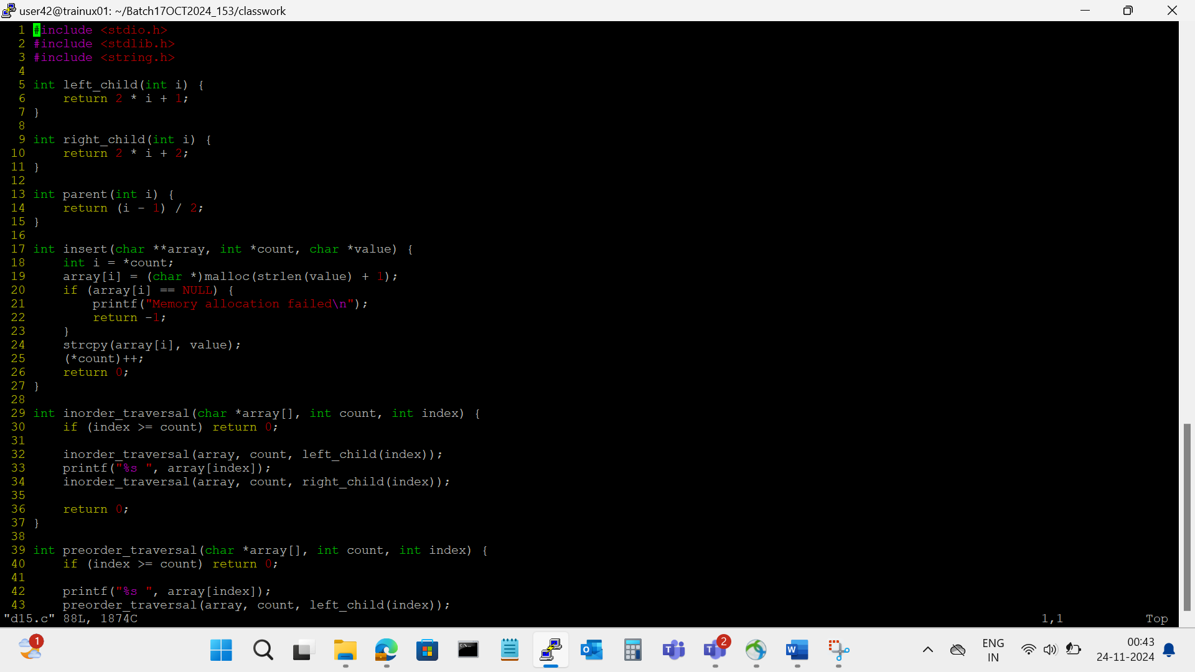
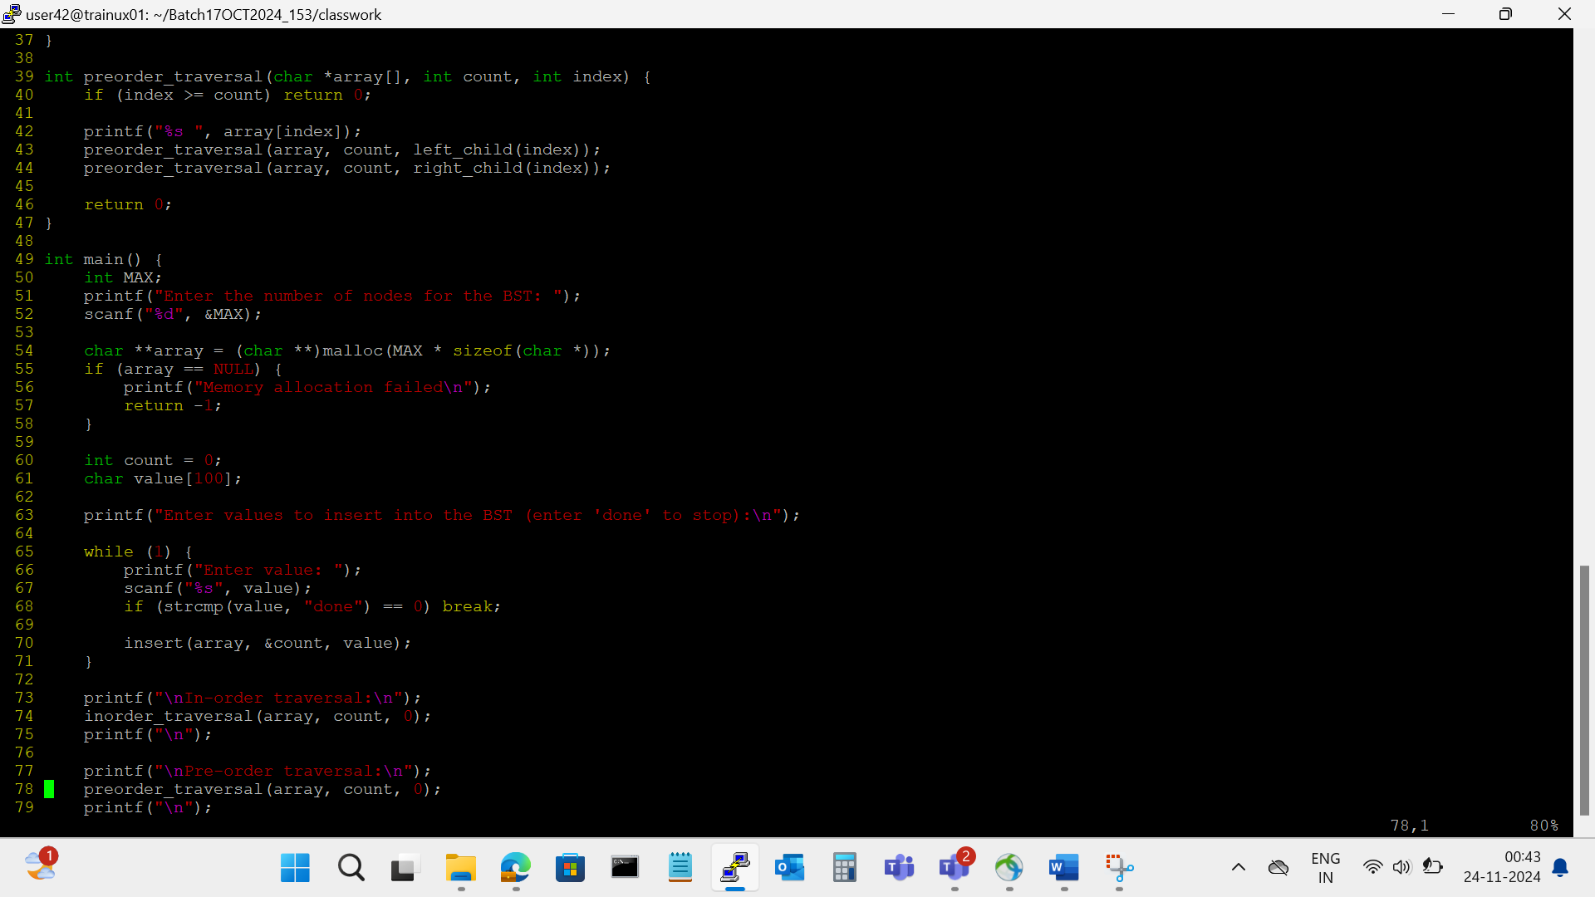
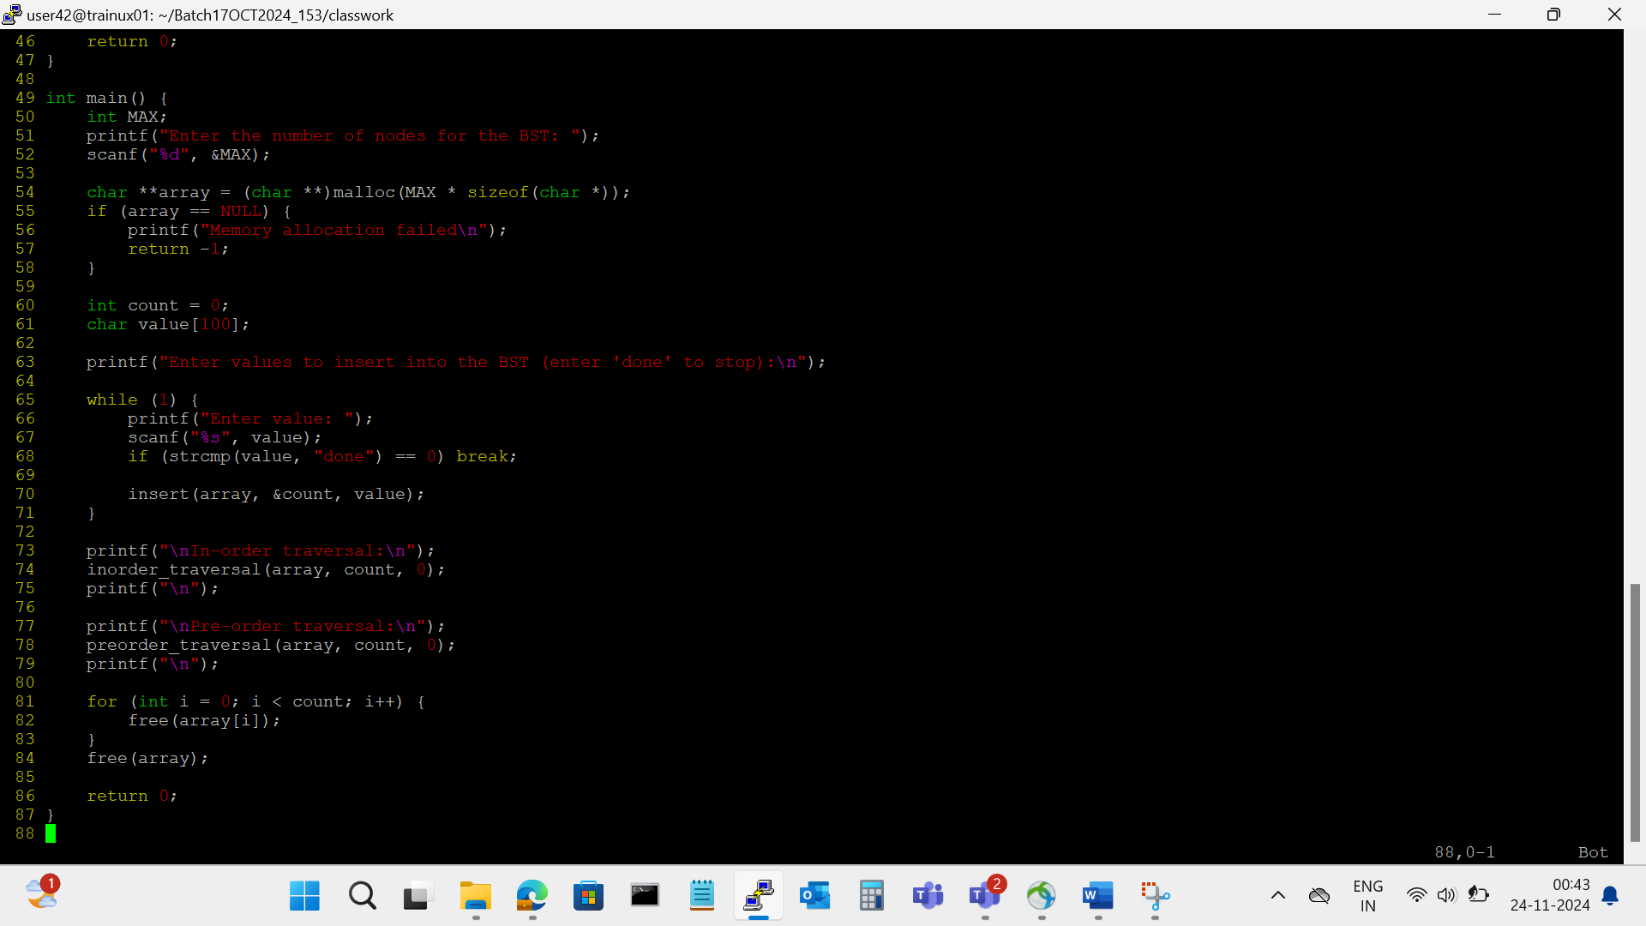

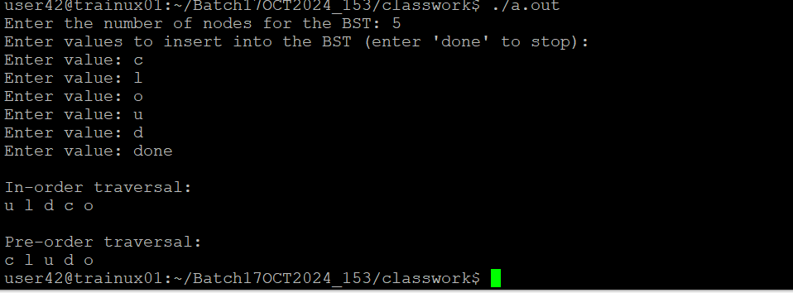
- In main(), instead of line below, update and modify to read MAX dimension at runtime.
char *array[MAX];
char **array; //read MAX dimension from the user at runtime and use it
Update the remaining functions accordingly and test it.
