## Commands Utilities

This assignment expects the participant to identify specific command(s) OR perform the given action using one or commands as per the given question. You are requested to maintain the answers (i.e command(s) as per given question) for all questions below.

**Mandatory Questions**

1. Which command is used to know the current working directory?

$pwd

1. How would you find out its contents?

$ll

1. Identify the commands with inputs to do the following
   1. create a directory d1

$mkdir d1

* 1. create a subdirectory d2 in d1

$cd d1

$d1 mkdir d2

* 1. change to directory d2

$cd d2

* 1. create an empty file “f1.txt”

$touch f1.txt

* 1. display the contents of “f1.txt”

$cat f1.txt

* 1. view the contents of d1 from current directory d2

ls ../d1

1. Use the ls command with its options. How will you identify directories from the listing?

$ls -f or $ls -l

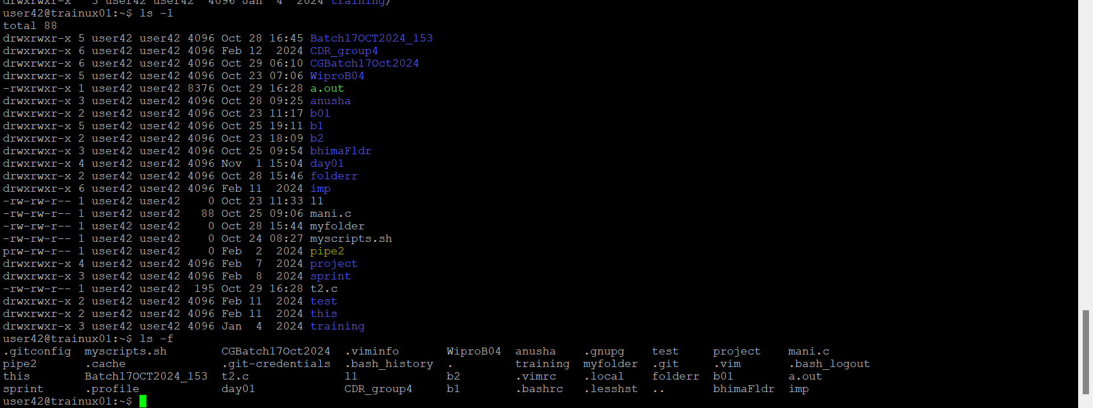

1. Use ls to do the following
   1. List files with single character names.
   2. List hidden files also. [ Note : Hidden files are files having name started with a “.” ]

$ls -a

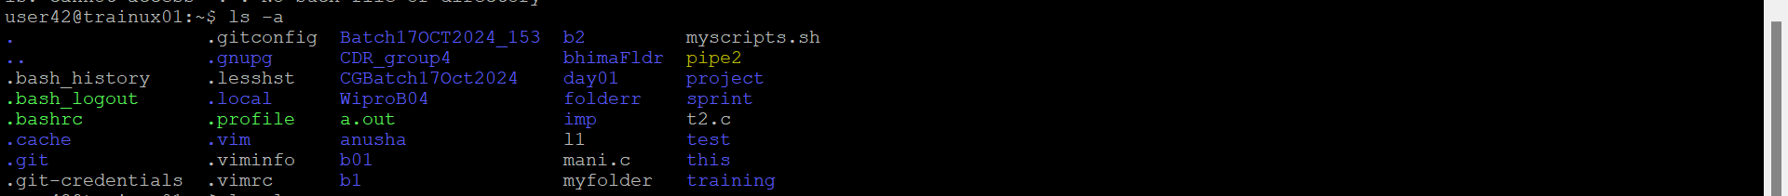

* 1. Suppose there are files tb1.1, tb2.1, tb3.1, ….tb10.1. Write command to list all the files [Hint: use wild card characters]

$ls tb[1-9] tb10.1

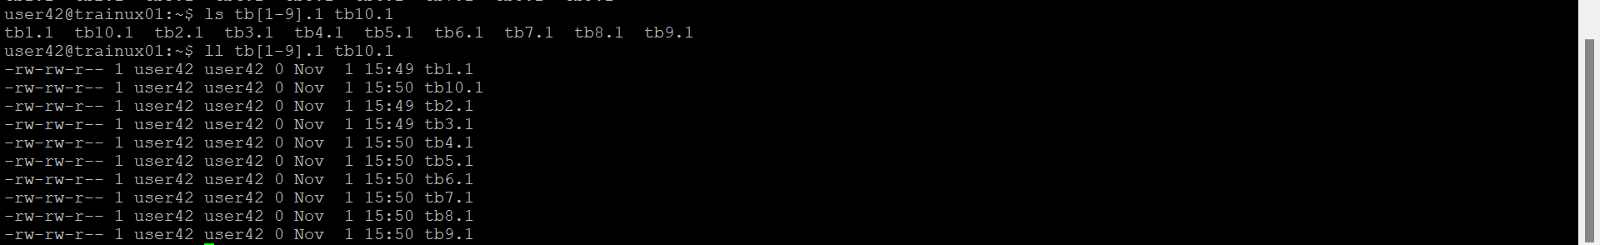

1. Write the command to list all files in descending order of their size.

Ls -lhS | sort -r

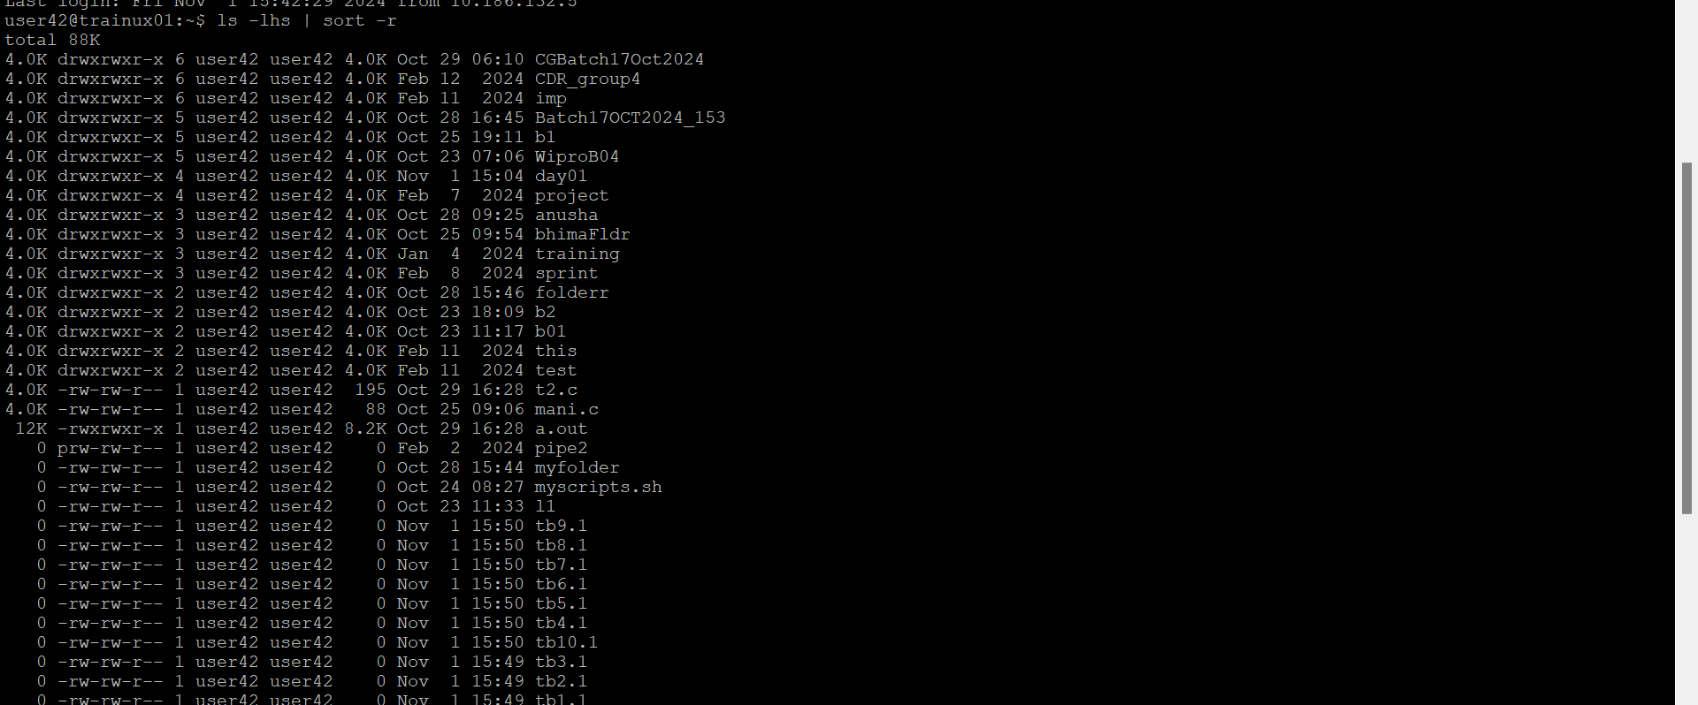

1. Suppose there are files temp1, temp2, temp3. Write command to remove the files without listing them explicitly

$rm temp{1,2,3}

1. Which command is used to list top few lines in the file?

$head filename

1. Create a directory “testdir”

$mkdir testdir

1. Use cp command to do the following
   1. Copy the file tb1.1 (created above) in the same directory.

$cp tb1.1 tb1.1_copy

* 1. Write a command to copy all the files i.e tb1.1,tb2.1,tb3.1,…..tb10.1 in a new directory –“new”

$mkdir new

$cp tb[1-9].1 tb10.1 new

* 1. Create a subdirectory in new in named“new1”.

new$mkdir new1

* 1. Write a command to copy selectively only tb2.1, tb6.1, tb7.1 and tb10.1 in the directory new1.

cp tb{2,6,7,10}.1 new1

* 1. Write a command to copy the entire directory “new” to a directory “newprogs”. [Note : use the –R option of “cp” command ]

cp -R new newprogs

1. Find out the difference between
   1. ]“mv” & “cp”

mv :renames a file and deletes the original file after moving it

cp:create a copy of file and the original file remains unchanged

* 1. “rm”, “rmdir”

rm:delete files

rmdir:delete empty dictrectories

* 1. “mkdir” and “mkdir -p”

mkdir:create new directory

mkdir-p:create a new directory and its parent directories if they don’t exist

1. Use a single command rmdir once to remove “testdir” and all its sub directories and files created above.

$rmdir testdir

1. Which command is used to get the manual information of a command?

$ man command_name

1. If you are not able to change to a directory what could be the likely cause?

Incorrect directory name

Permission denied

Directory doesn’t exist

File system errors

1. Explain the differences among the following commands:  
                 a. cd /

Changes the current working directory to the root directory

b. cd ..

changes the current working directory to the parent directory

  c. cd

without any arguments changes the current working directory to the user home directory

  d. cd ../..

changes the current working directory to the grandparent directory

**Advanced Optional Questions**

1. How could you display the inode number of a file?

$ls -i



1. What is the pipe symbol? What effect does it have?

The pipe symbol is used to connect the output of one command to the input of another command. ( | )

1. Find out the details of “ps” command ?

The ps command used to display information about running processes.This shows pid, memory usage, and the command line