**WorkWize – Project Management Tool**

**Major Project**

**CS 816: Software Production Engineering**

Guided By

|  |
| --- |
| **B. Thangaraju** |
| **Professor** |
| **International Institute of Information Technology, Bangalore** |
|  |
| Under the Assistance of |
| **Samaksh Dhingra** |
| **Teaching Assistant** |
|  |



**International Institute of Information Technology, Bangalore**

Created by:

|  |  |  |
| --- | --- | --- |
| **Vraj Jatin Naik** |  | **Arjun Gangani** |
| **MT2023050** |  | **MT2023153** |
| **Vraj.Naik@iiitb.ac.in** |  | **Arjun.Gangani@iiitb.ac.in** |

# ABSTRACT

In industrial settings, traditional project management methods often lack efficiency and responsiveness due to manual processes and disjointed workflows. Existing systems may not sufficiently address the specific needs of industrial projects, leading to challenges in coordination, task assignment, and progress tracking. There is a growing demand for platforms that can accommodate real-time user feedback and updates.

The project "WorkWize" aims to address these challenges by developing a comprehensive project management platform tailored for industrial environments. The primary objective is to enhance project workflows and facilitate effective management by all stakeholders. WorkWize incorporates roles for employees, managers, and administrators, each with specific functionalities to streamline project execution and oversight.

Employees can view assigned tasks, update progress, and visualize their task history, while managers can create, update, and delete projects, track progress, and manage time and effort distribution. Administrators oversee user management and system administration, ensuring smooth operation and handling technical issues.

Utilizing a robust tool stack including AngularJS for the front end, Spring Boot for the back end, and MySQL for the database, WorkWize leverages DevOps tools such as GitHub, Jenkins, Docker, Docker Compose, Ansible, and the ELK stack to automate the CI/CD pipeline, ensure efficient application management, and provide comprehensive log analysis. This integration of tools and methodologies results in a streamlined, efficient, and responsive project management solution.

# TABLE OF CONTENTS

**ABSTRACT I**

**TABLE OF CONTENTS II**

**LIST OF FIGURES III**

**1. INTRODUCTION 1**

**2. APPLICATION FEATURE 2**

**2.1 ROLES 2**

**2.2 ROLE-WISE FUNCTIONALITIES 2**

**3. ARCHITECTURE 5**

**4. DESIGN 6**

**4.1 USE CASE DIAGRAM 6**

**4.2 CLASS DIAGRAM 7**

# LIST OF FIGURES

# INTRODUCTION

Workflow management is the process of optimizing data paths in a given process. It involves creating and optimizing the sequence of tasks required to complete a particular project. A Workflow Management System (WMS) automates this process by creating a form to hold data and automating a sequential path of tasks for the data to follow until it is fully processed. By automating repetitive processes, a WMS such as WorkWize frees up time and resources for more important tasks. Additionally, it ensures that uncompleted tasks are automatically followed up on, reducing the risk of errors or delays.

WorkWize is an efficient WMS that provides a range of features for workflow management and automation. Its customizable forms allow for the creation of unique workflows that meet the specific needs of any project. The system provides real-time monitoring of progress, allowing for easy tracking of project status and identification of potential bottlenecks. The system also generates detailed performance metrics, providing insights into how to optimize the workflow further.

The scope of WorkWize is broad, as it is suitable for any industry, whether small-scale or large-scale, that requires workflow management and automation. By using WorkWize, organizations can increase productivity, improve efficiency, and reduce errors and delays.

# APPLICATION FEATURE



## **Roles**

1. **Employee:**

Role Description: Employees execute assigned tasks within projects under the guidance of managers.

1. **Manager:**

Role Description: Managers oversee projects and task assignments, ensuring smooth workflow and project progress.

1. **Admin:**

Role Description: Administrators have the highest level of access and are responsible for managing users, including adding and removing employees and managers, as well as overseeing the overall system administration.

## **Role-wise Functionalities**

1. **EMPLOYEE:**

* **Tasks Related:**

Description: Employees can view tasks assigned to them.

Actions:

1. **View Assigned Tasks:**

Description: Employees can see tasks assigned to them under projects.

1. **Update Task Progress:**

Description: Employees can update the progress status of tasks assigned to them.

1. **Visualize Personal Progress:**

Description: Employees can visualize their progress as per the tasks assigned to them.

* **View Profile:**

Description: Employees can view their personal details and task history.

Actions:

* View personal details
* View task history
* **Reset Password:**

Description: Employees can reset their passwords if forgotten.

Actions:

* Request password reset
* Set new password

1. **MANAGER:**

* **Create, Update, and Delete Projects:**

Description: Managers can create new projects, update existing projects, and delete projects they have created.

Actions:

* Create new projects
* Edit existing projects
* Delete projects from the system
* **Manage Employees:**

Description: Managers can add employees to projects and manage them by assigning tasks related to the project.

Actions:

* Add employees to projects
* Assign tasks to employees
* **Project Progress Monitoring:**

Description: Managers can track the progress of their projects.

Actions:

* View project progress
* **Time and Effort Distribution:**

Description: Managers can allocate and adjust time distribution and visualize effort distribution.

Actions:

* Give/edit distribution of time in the project effort table
* Visualize effort distribution
* **Reset Password:**

Description: Managers can reset their passwords if forgotten.

Actions:

* Request password reset
* Set new password

1. **ADMIN:**

* **Manage Users:**

Description: Admins can add, view, edit, and remove users (both employees and managers) from the system.

Actions:

* Add new users
* View user profiles
* Edit user profiles
* Delete user accounts
* **System Administration:**

Description: Admins oversee the overall system administration, ensuring its smooth operation and handling any technical issues.

Actions:

* Handle system configurations
* Perform maintenance tasks
* Address technical issues and escalations

# ARCHITECTURE

# DESIGN

## **USE CASE DIAGRAM**

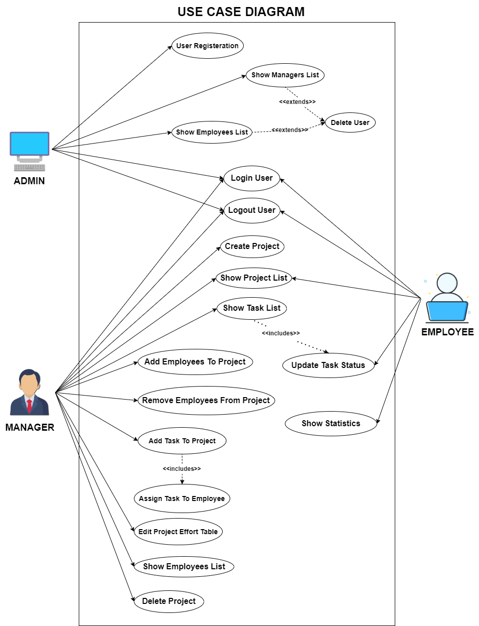

## **CLASS DIAGRAM**

