*-- Created by Vertabelo (http://vertabelo.com)*

*-- Last modification date: 2021-12-17 07:29:00.016*

*-- tables*

*-- Table: Accessories*

**CREATE** **TABLE** Accessories (

accessID **integer** **NOT** **NULL**,

accessName **varchar**(25) **NOT** **NULL**,

**fixed** **varchar**(25) **NOT** **NULL**,

detachable **varchar**(25) **NOT** **NULL**,

**CONSTRAINT** Accessories_pk **PRIMARY** **KEY** (accessID)

) ;

*-- Table: Billing*

**CREATE** **TABLE** Billing (

billID **integer** **NOT** **NULL**,

billDate **date** **NOT** **NULL**,

billUnits **integer** **NOT** **NULL**,

ratePerUnit **integer** **NOT** **NULL**,

subTotal **integer** **NOT** **NULL**,

grandTotal **integer** **NOT** **NULL**,

Customers_custID **integer** **NOT** **NULL**,

**CONSTRAINT** Billing_pk **PRIMARY** **KEY** (billID)

) ;

*-- Table: Customers*

**CREATE** **TABLE** Customers (

custID **integer** **NOT** **NULL**,

custName **varchar**(25) **NOT** **NULL**,

custContact **integer** **NOT** **NULL**,

mobileType **varchar**(25) **NOT** **NULL**,

mobileSerial **varchar**(25) **NOT** **NULL**,

MOBILES_mobileID **integer** **NOT** **NULL**,

**CONSTRAINT** Customers_pk **PRIMARY** **KEY** (custID)

) ;

*-- Table: MOBILES*

**CREATE** **TABLE** MOBILES (

mobileID **integer** **NOT** **NULL**,

mobileName **varchar**(25) **NOT** **NULL**,

mobileType **varchar**(25) **NOT** **NULL**,

mobileVersion **integer** **NOT** **NULL**,

mobileSerial **varchar**(25) **NOT** **NULL**,

Accessories_accessID **integer** **NOT** **NULL**,

Suppliers_supplierID **integer** **NOT** **NULL**,

**CONSTRAINT** MOBILES_pk **PRIMARY** **KEY** (mobileID)

) ;

*-- Table: Suppliers*

**CREATE** **TABLE** Suppliers (

supplierID **integer** **NOT** **NULL**,

supplierName **varchar**(25) **NOT** **NULL**,

supplierType **varchar**(25) **NOT** **NULL**,

supplierLocation **varchar**(25) **NOT** **NULL**,

Contract **varchar**(25) **NOT** **NULL**,

Regular **varchar**(25) **NOT** **NULL**,

**CONSTRAINT** Suppliers_pk **PRIMARY** **KEY** (supplierID)

) ;

*-- foreign keys*

*-- Reference: Billing_Customers (table: Billing)*

**ALTER** **TABLE** Billing **ADD** **CONSTRAINT** Billing_Customers

**FOREIGN** **KEY** (Customers_custID)

**REFERENCES** Customers (custID);

*-- Reference: Customers_MOBILES (table: Customers)*

**ALTER** **TABLE** Customers **ADD** **CONSTRAINT** Customers_MOBILES

**FOREIGN** **KEY** (MOBILES_mobileID)

**REFERENCES** MOBILES (mobileID);

*-- Reference: MOBILES_Accessories (table: MOBILES)*

**ALTER** **TABLE** MOBILES **ADD** **CONSTRAINT** MOBILES_Accessories

**FOREIGN** **KEY** (Accessories_accessID)

**REFERENCES** Accessories (accessID);

*-- Reference: MOBILES_Suppliers (table: MOBILES)*

**ALTER** **TABLE** MOBILES **ADD** **CONSTRAINT** MOBILES_Suppliers

**FOREIGN** **KEY** (Suppliers_supplierID)

**REFERENCES** Suppliers (supplierID);

*-- sequences*

*-- Sequence: Accessories_seq*

**CREATE** **SEQUENCE** Accessories_seq

**INCREMENT** **BY** 1

**NOMINVALUE**

**NOMAXVALUE**

**START** **WITH** 1

**NOCACHE**

**NOCYCLE**;

*-- Sequence: Billing_seq*

**CREATE** **SEQUENCE** Billing_seq

**INCREMENT** **BY** 1

**NOMINVALUE**

**NOMAXVALUE**

**START** **WITH** 1

**NOCACHE**

**NOCYCLE**;

*-- Sequence: Customers_seq*

**CREATE** **SEQUENCE** "Customers_seq

**INCREMENT** **BY** 1

**NOMINVALUE**

**NOMAXVALUE**

**START** **WITH** 1

**NOCACHE**

**NOCYCLE**;

*-- Sequence: MOBILES_seq*

**CREATE** **SEQUENCE** MOBILES_seq

**INCREMENT** **BY** 1

**NOMINVALUE**

**NOMAXVALUE**

**START** **WITH** 1

**NOCACHE**

**NOCYCLE**;

*-- Sequence: Suppliers_seq*

**CREATE** **SEQUENCE** Suppliers_seq

**INCREMENT** **BY** 1

**NOMINVALUE**

**NOMAXVALUE**

**START** **WITH** 1

**NOCACHE**

**NOCYCLE**;

*-- End of file.*

**Data Sources**

The Mobile Retail Accessories Shop is a place where customers can walk-in for their mobile accessories and servicing related. The data base with related product info gets updated manually the time when it first available at stores. All the parts are been given unique code to put it in their class.

Say for example, when a particular customer enquires about specific part for his mobile or handovers the mobile for service at stores, the device details like make, serial number, version number etc., gets captured then and there itself. In case any spare parts are to be replaced to that mobile then type of spare part with ID will be tracked from databased and given to technician for replacement. The service gets billed with details like mobile id, accessories id, number of units consumed, rate per unit and unit cost and total bill amount will gets displayed.

**Database already with list of suppliers for related accessories**

suppliers

**SELECT** * **FROM** `gklearning`.`suppliers` **LIMIT** 1000;

**INSERT** **INTO** `gklearning`.`suppliers` **VALUES** ('101', 'GreenTechSolutions', 'Regular', 'NY', '153', 'Yes');

**INSERT** **INTO** `gklearning`.`suppliers` **VALUES** ('102', 'ReadyPhones', 'Seasonal', 'Texas', '367', 'No');

**INSERT** **INTO** `gklearning`.`suppliers` **VALUES** ('104', 'ITechSolus', 'Regular', 'Washinton', '492', 'Yes');

**INSERT** **INTO** `gklearning`.`suppliers` **VALUES** ('103', 'magnaSol', 'regular', 'LosAngles', '875', 'yes');

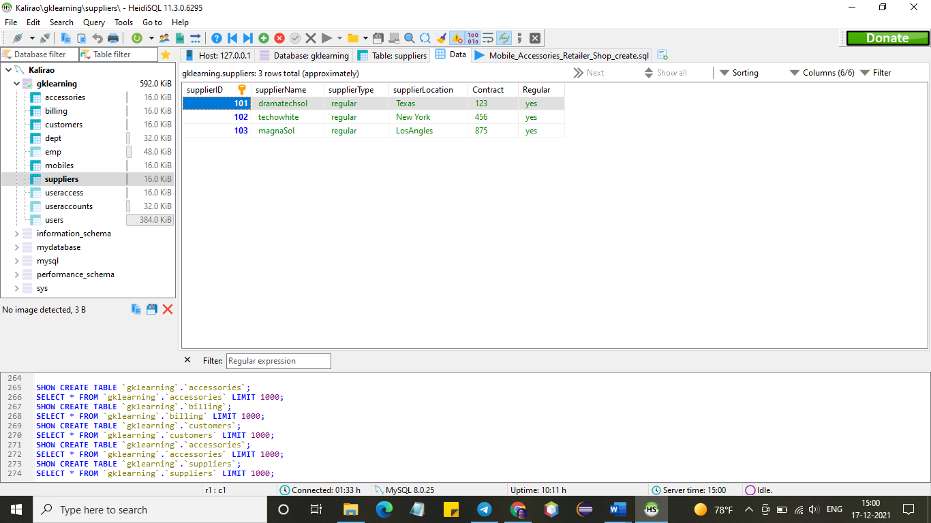

**Customers data captured and made entries to see data flow into tables**

customers

**SELECT** * **FROM** `gklearning`.`customers` **LIMIT** 1000;

**INSERT** **INTO** `gklearning`.`customers` **VALUES** ('401', 'JessicaDoe', '678', 'Samsung', '459', '301');

**INSERT** **INTO** `gklearning`.`customers` **VALUES** ('402', 'Mathews', '321', 'apple', '879', '302');

**INSERT** **INTO** `gklearning`.`customers` **VALUES** ('403', 'Robertz', '465', 'htc', '298', '301');

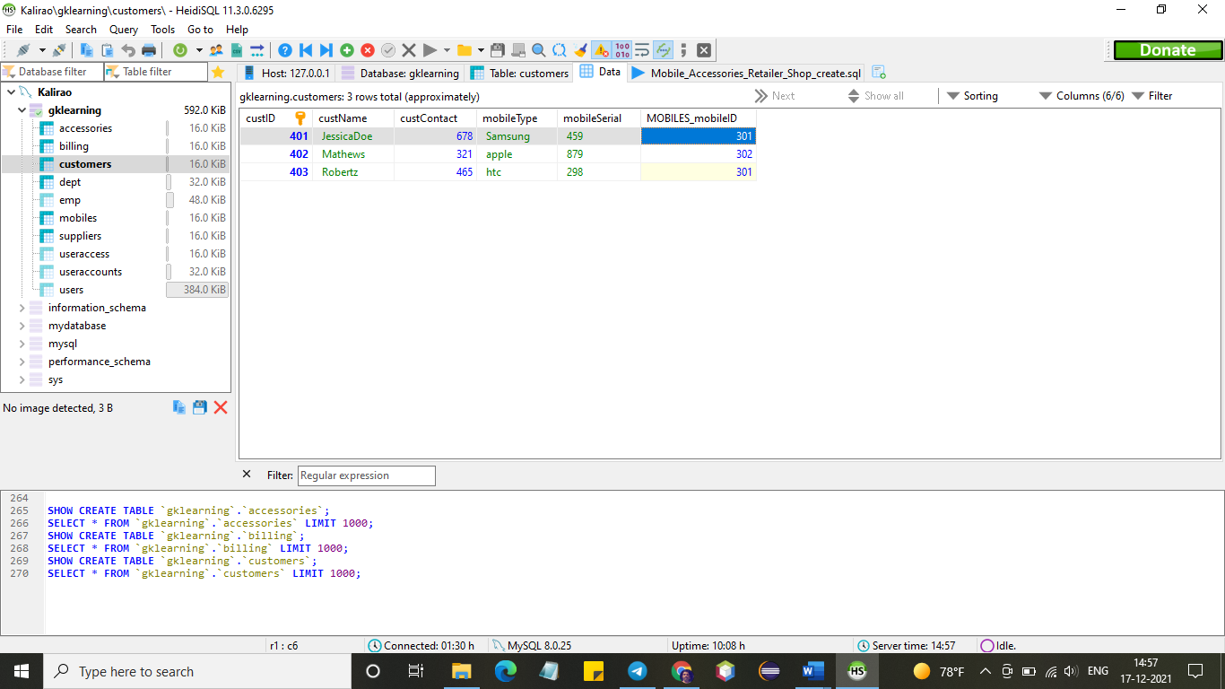

**Mobiles accepted at reception and made entries to see data flow into tables**

mobiles

**SELECT** * **FROM** `gklearning`.`mobiles` **LIMIT** 1000;

**INSERT** **INTO** `gklearning`.`mobiles` **VALUES** ('301', 'samsung', 'flipflap', '102', '235', '201', '101');

**INSERT** **INTO** `gklearning`.`mobiles` **VALUES** ('302', 'apple', 'seethru', '657', '348', '202', '101');

**INSERT** **INTO** `gklearning`.`mobiles` **VALUES** ('303', 'htc', 'camfit', '712', '456', '201', '102');

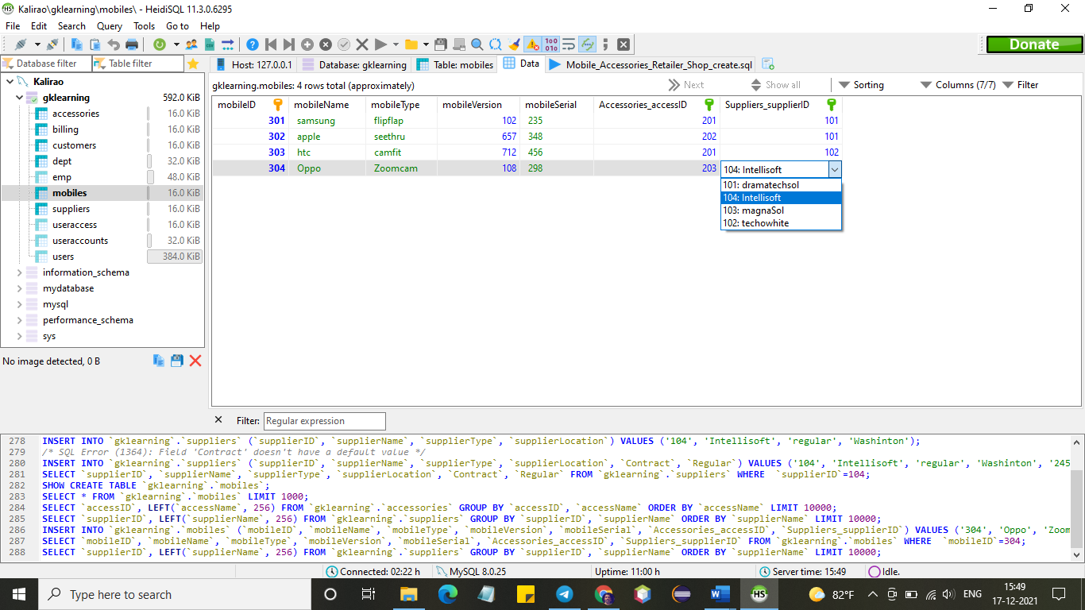

**Accessories data already available in database**

accessories

**SELECT** * **FROM** `gklearning`.`accesories` **LIMIT** 1000;

**INSERT** **INTO** `gklearning`.`accessories` **VALUES** ('201', 'game card', 'yes', 'no');

**INSERT** **INTO** `gklearning`.`accessories` **VALUES** ('202', 'zoomer', 'yes', 'no');

**INSERT** **INTO** `gklearning`.`accessories` **VALUES** ('203', 'externpower', 'no', 'yes');

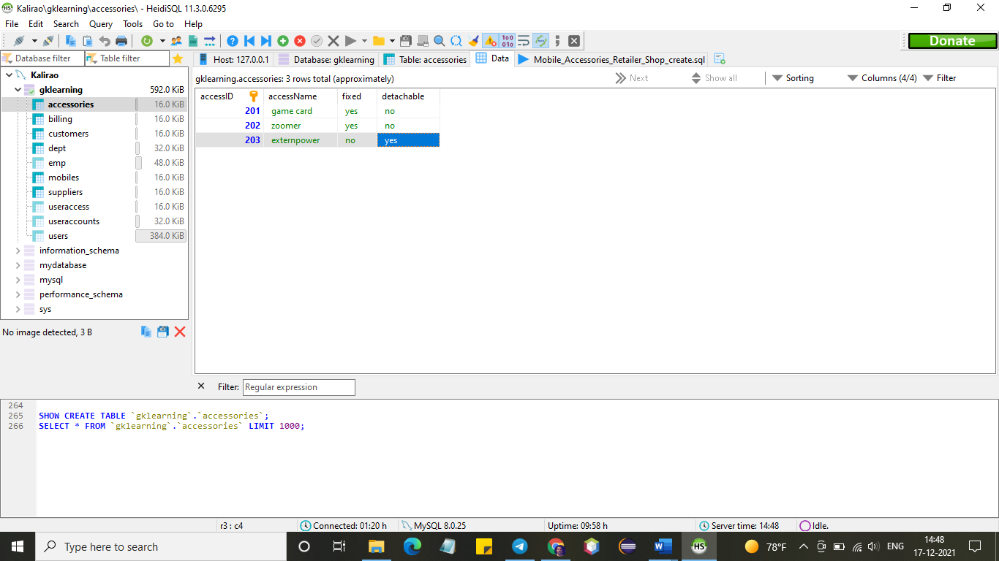

**Post servicing mobile data flow into tables view**

Billing

**SELECT** * **FROM** `gklearning`.`billing` **LIMIT** 1000;

**INSERT** **INTO** `gklearning`.`billing` **VALUES** ('501', '2021-12-17', '5', '100', '500', '500', '401');

**INSERT** **INTO** `gklearning`.`billing` **VALUES** ('502', '2021-12-17', '1', '35', '35', '535', '402');

**INSERT** **INTO** `gklearning`.`billing` **VALUES** ('503', '2021-12-17', '4', '60', '240', '775', '401');

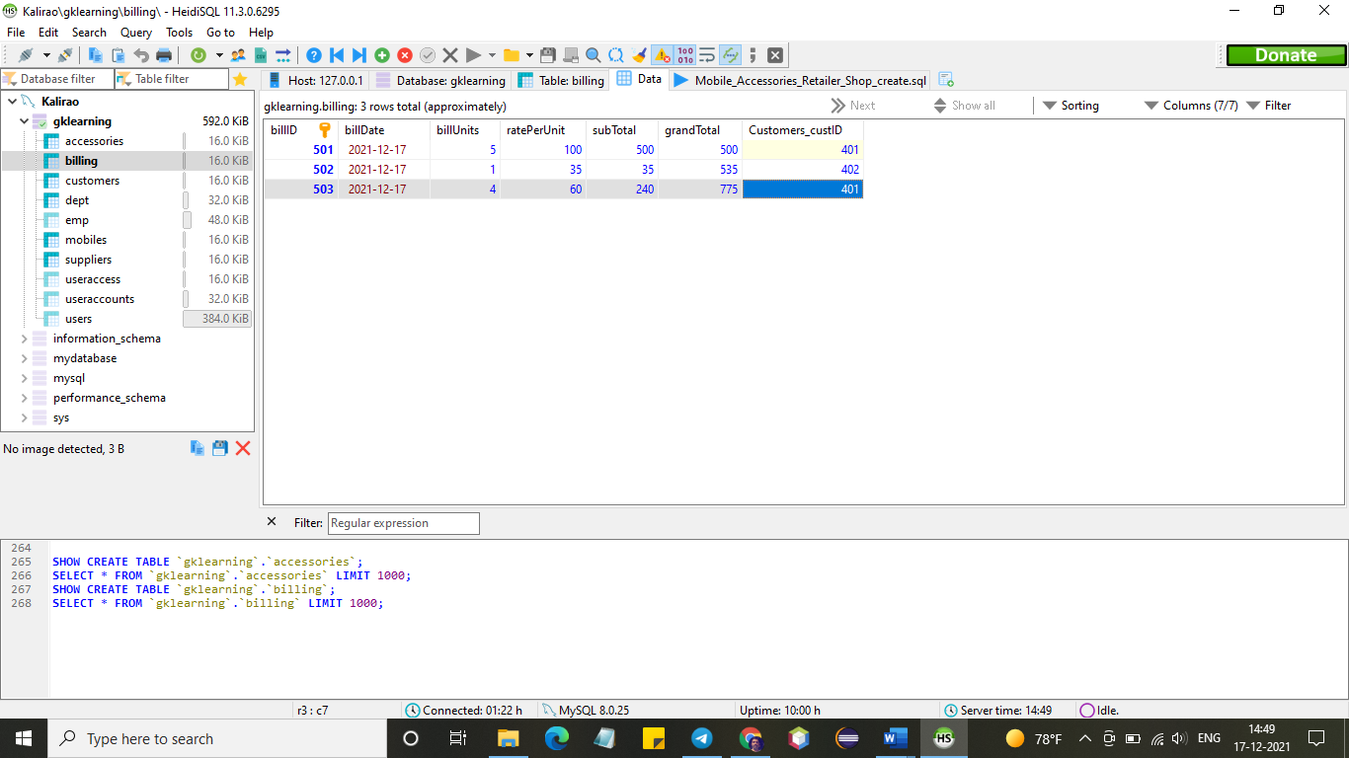

**TABLE CREATION using VERTABELO**

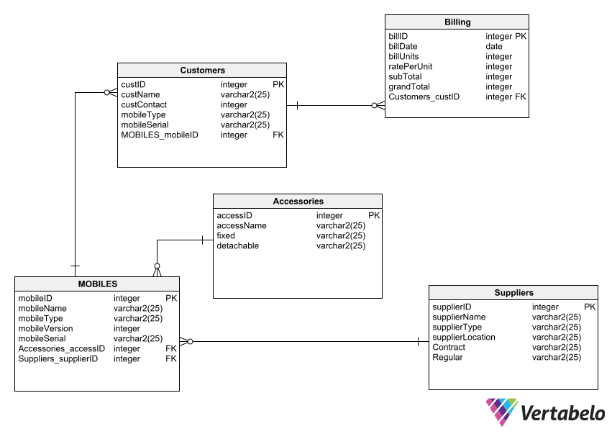

**Database and table creation statements (manual or Vertebelo) saved as an sql script file. Upload to GitHub. 8 points**

I have used one of mySql developer tool HeidiSQL for monitoring database table access and input related



**The SQL commands for populating the tables and what they do (explain each of the commands and options that you used in the script) documented in your report: 8 points**

I have used one of mySql developer tool HeidiSQL for monitoring database table access and input related

Create table is a command for creating table

Integer, Varchar data types used for specifying the type of data that we are going to capture.

Primary Key is a key defining the key field of respective table

Foreign Key is a key defined to fetch data from a second table

Select is statement to view/ retrieve data from an existing table.