**Data Manipulation Language Scripts**

Two queries should be insert statements,

**INSERT** **INTO** `gklearning`.`mobiles` (`mobileID`, `mobileName`, `mobileType`, `mobileVersion`, `mobileSerial`, `Accessories_accessID`, `Suppliers_supplierID`) **VALUES** ('305', 'iBall', 'zamgame', '856', '623', '201', '101');

**INSERT** **INTO** `gklearning`.`mobiles` (`mobileID`, `mobileName`, `mobileType`, `mobileVersion`, `mobileSerial`, `Accessories_accessID`, `Suppliers_supplierID`) **VALUES** ('304', 'Oppo', 'Zoomcam', '108', '298', '203', '104');

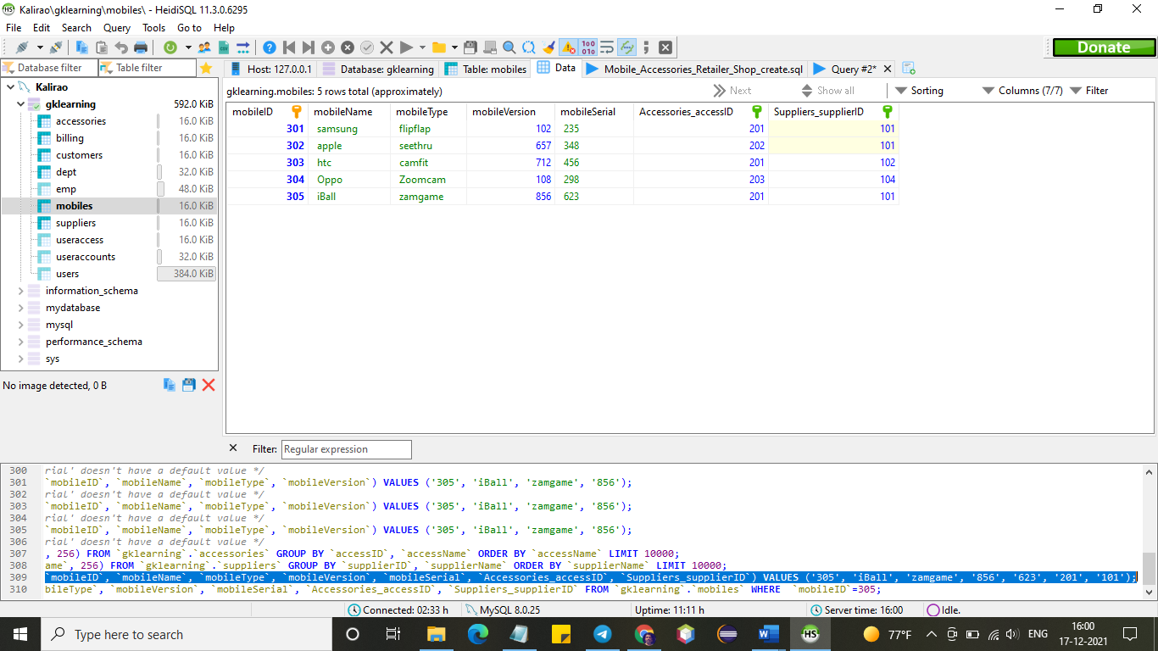

two should update statements

**UPDATE** customers

**SET** custName = 'MathewJr', custContact= '322'

**WHERE** custID = 402;

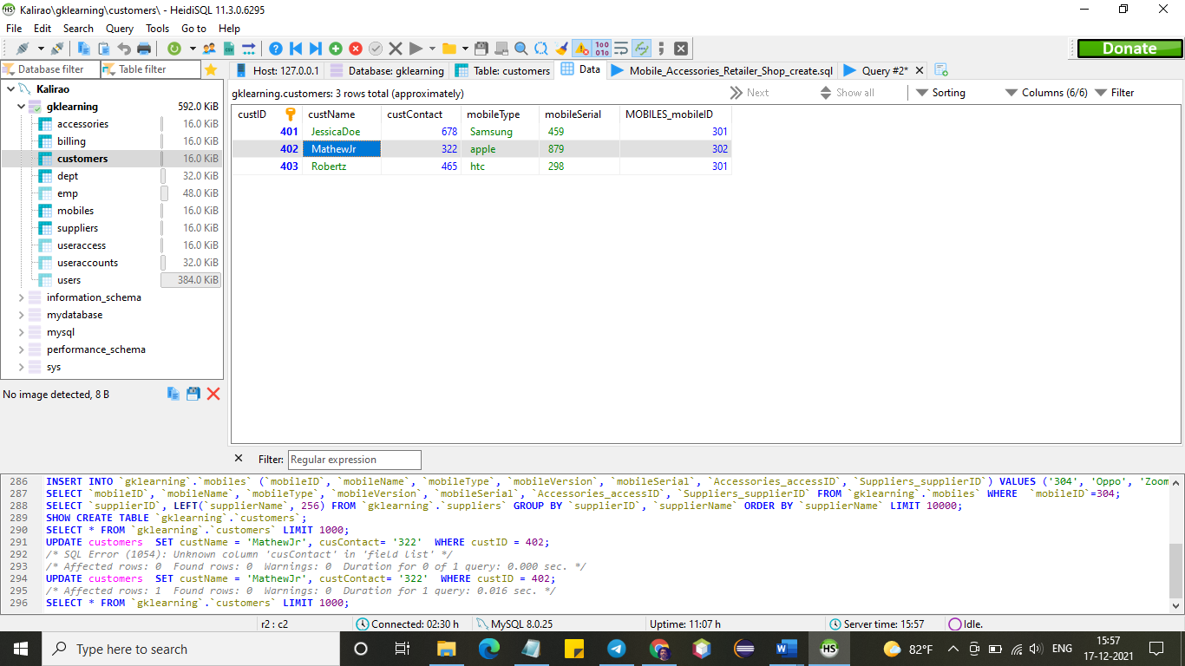

one should be a delete statement

**DELETE** **FROM** mobiles **WHERE** mobileID='305';

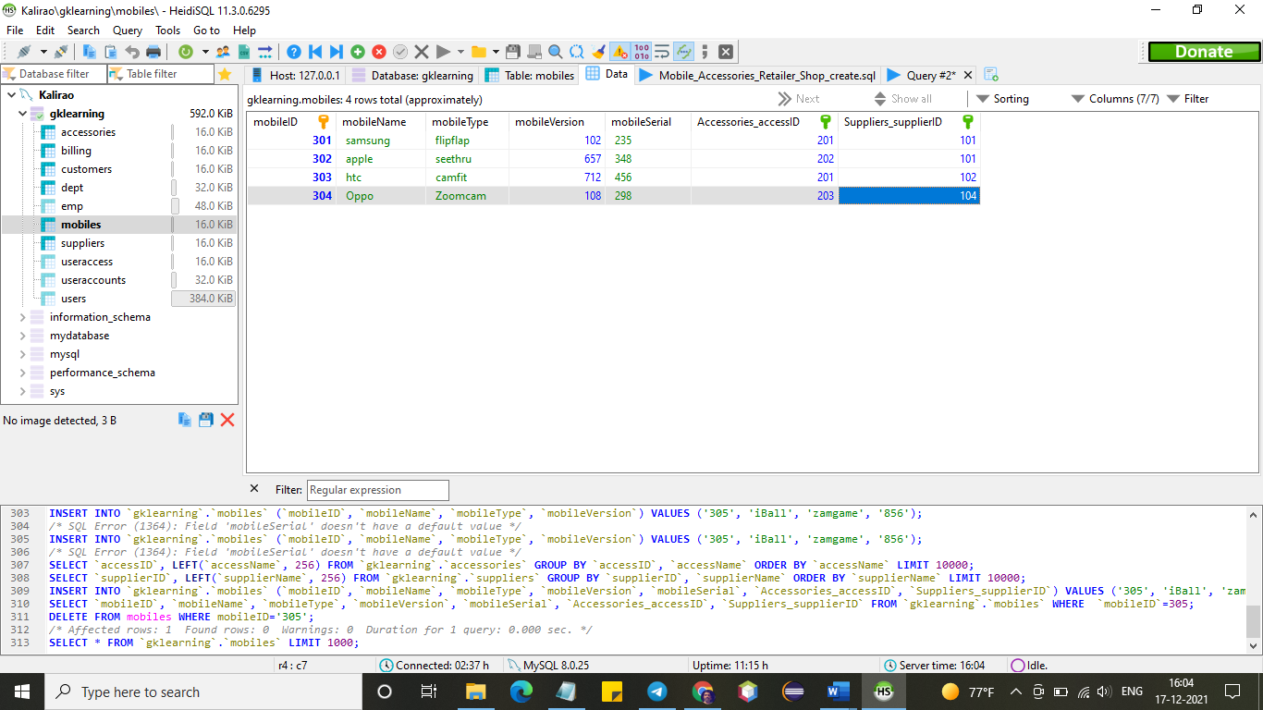

one should be a simple select statement that selects a subset of the rows and columns from one table

**SELECT** **DISTINCT** Suppliers_supplierID **FROM** mobiles;

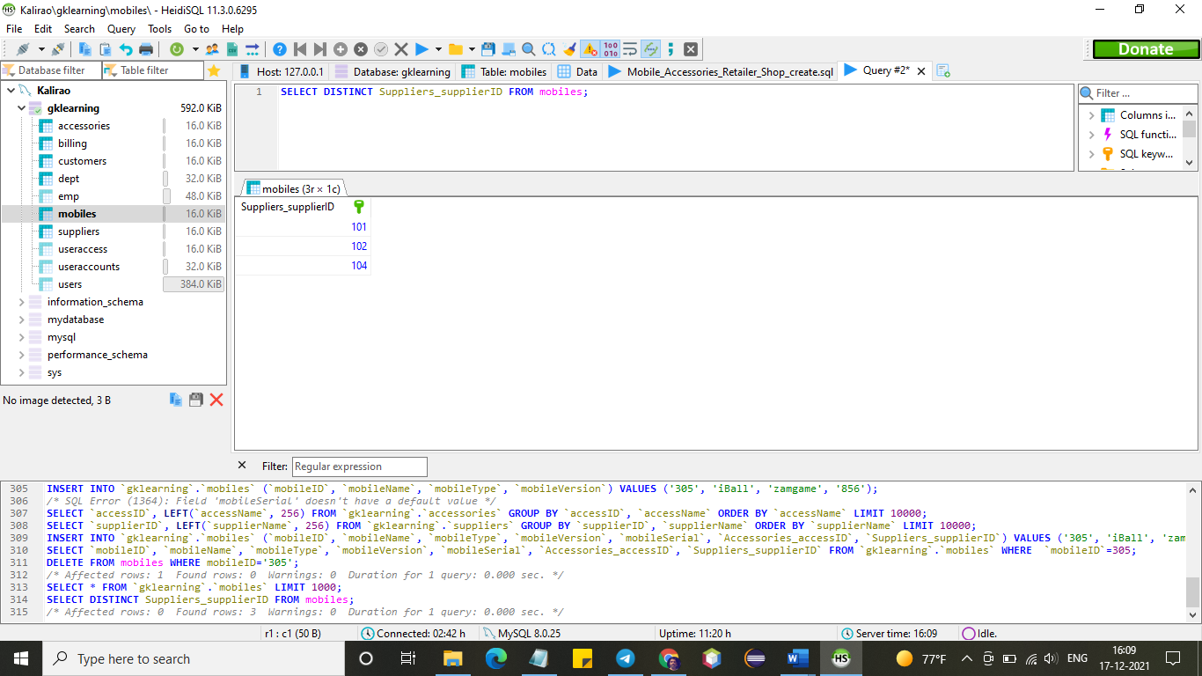

two should be a select statements that select data from a joining of two tables

**SELECT** Suppliers_supplierID, suppliers.supplierName **FROM** mobiles

**INNER** **JOIN** suppliers **ON** mobiles.Suppliers_supplierID=suppliers.supplierID;

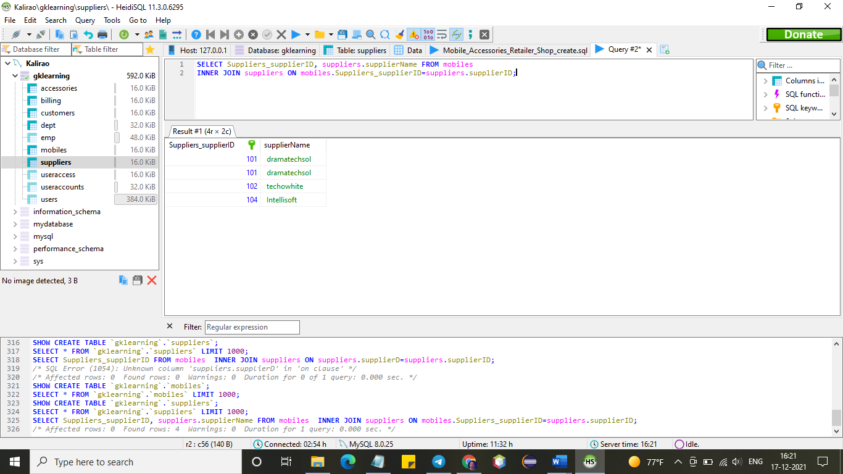

**SELECT** Suppliers_supplierID, suppliers.supplierLocation **FROM** mobiles

**INNER** **JOIN** suppliers **ON** mobiles.Suppliers_supplierID=suppliers.supplierID;

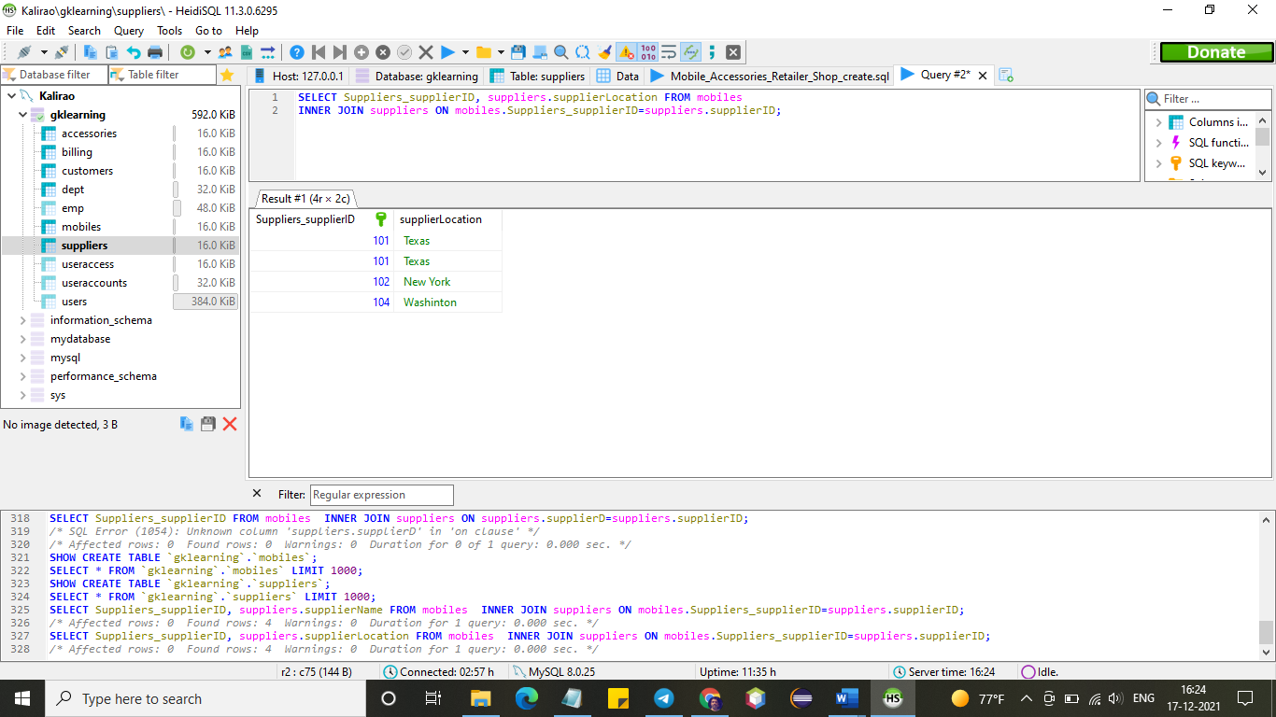

two should use summary functions to generate statistics about the data

**SELECT** **COUNT**(supplierName)

**FROM** suppliers;

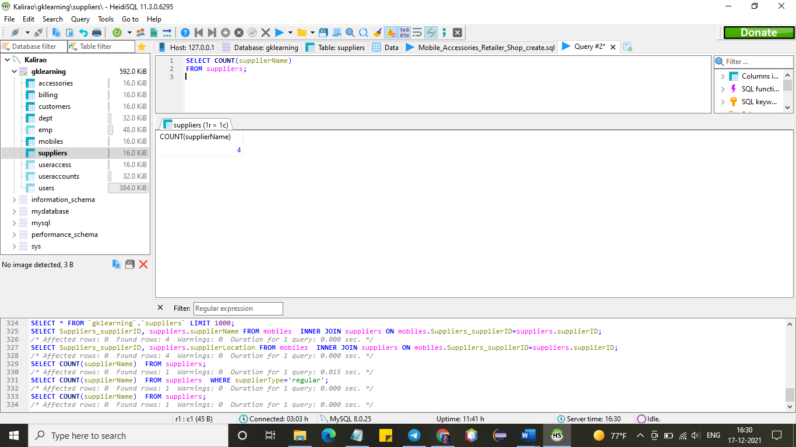

**SELECT** **COUNT**(supplierName)

**FROM** suppliers

**WHERE** supplierType='regular';

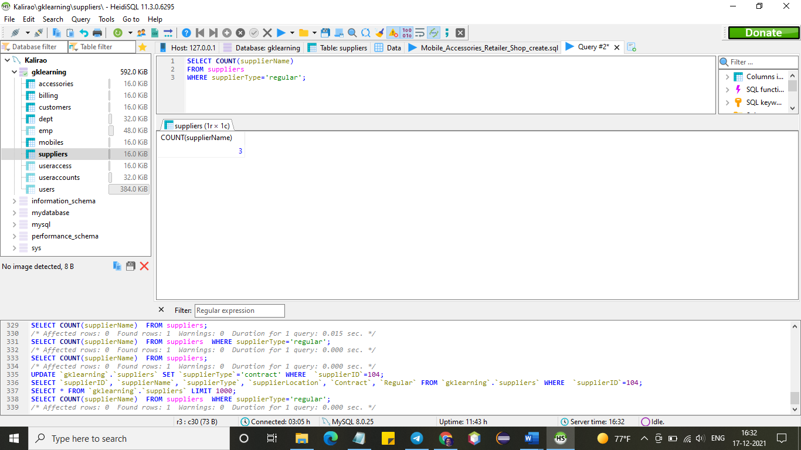

one should be a multi-table query

one should be another query of your choice

**SELECT** Accessories_accessID, accessories.accessName **FROM** mobiles

**INNER** **JOIN** accessories **ON** mobiles.Accessories_accessID=accessories.accessID;

