**Views**

Please look at the below mentioned 3 entities with respective attributes, ideally speaking all are individual, but internally connected.

Billing table is connected with customers table &

Customers table is connected with mobiles table

Each invoice is generated against every customerID where billID is unique with respective customer.

Coming to customers table, every customer visits the stores for specific purpose of his mobile either getting it repaired or servicing/ replacing latest accessories. In that case tracking of customers with their property at data store becomes quite sensitive because same mobiles of other customers also might have come for similar type of service. So, tracking of individual customers with their respective mobile devices be better monitored here.

Coming to mobiles table, tracking of individual mobile with unique id that matches with mobile type, version and serial number that linked to foreign keys of accessoryID and supplierID because same accessory may be supplied by other suppliers also, hence tracking of this information would be crucial at this table.

*-- Table: Billing*

**CREATE** **TABLE** Billing (

billID **integer** **NOT** **NULL**,

billDate **date** **NOT** **NULL**,

billUnits **integer** **NOT** **NULL**,

ratePerUnit **integer** **NOT** **NULL**,

subTotal **integer** **NOT** **NULL**,

grandTotal **integer** **NOT** **NULL**,

Customers_custID **integer** **NOT** **NULL**,

**CONSTRAINT** Billing_pk **PRIMARY** **KEY** (billID)

) ;

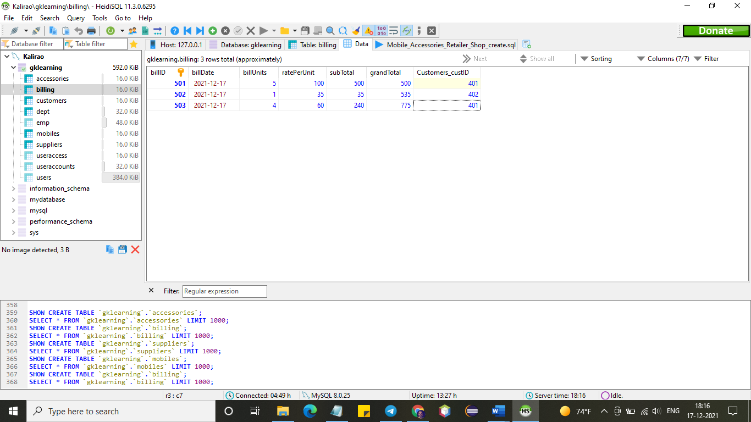

*-- Table: Customers*

**CREATE** **TABLE** Customers (

custID **integer** **NOT** **NULL**,

custName **varchar**(25) **NOT** **NULL**,

custContact **integer** **NOT** **NULL**,

mobileType **varchar**(25) **NOT** **NULL**,

mobileSerial **varchar**(25) **NOT** **NULL**,

MOBILES_mobileID **integer** **NOT** **NULL**,

**CONSTRAINT** Customers_pk **PRIMARY** **KEY** (custID)

) ;

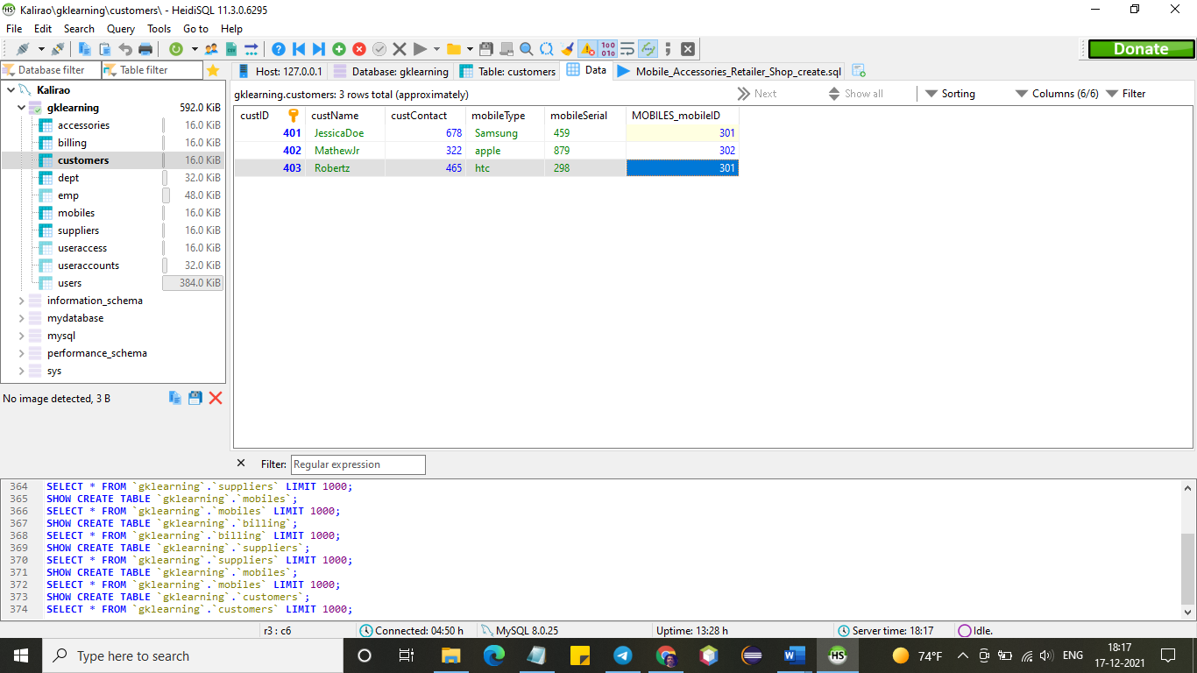

*-- Table: MOBILES*

**CREATE** **TABLE** MOBILES (

mobileID **integer** **NOT** **NULL**,

mobileName **varchar**(25) **NOT** **NULL**,

mobileType **varchar**(25) **NOT** **NULL**,

mobileVersion **integer** **NOT** **NULL**,

mobileSerial **varchar**(25) **NOT** **NULL**,

Accessories_accessID **integer** **NOT** **NULL**,

Suppliers_supplierID **integer** **NOT** **NULL**,

**CONSTRAINT** MOBILES_pk **PRIMARY** **KEY** (mobileID)

) ;

