Triggers

Triggers are special type of stored procedures that activates automatically in response to events like insert, delete, update tables.

Triggers are a step ahead than stored procedures which activates with every modification event occurs no need of calling that procedure again.

The insert statement here is called as row-level trigger where-in one row will get effected.

**INSERT** **INTO** `gklearning`.`mobiles` (`mobileID`, `mobileName`, `mobileType`, `mobileVersion`, `mobileSerial`, `Accessories_accessID`, `Suppliers_supplierID`) **VALUES** ('305', 'iBall', 'zamgame', '856', '623', '201', '101');

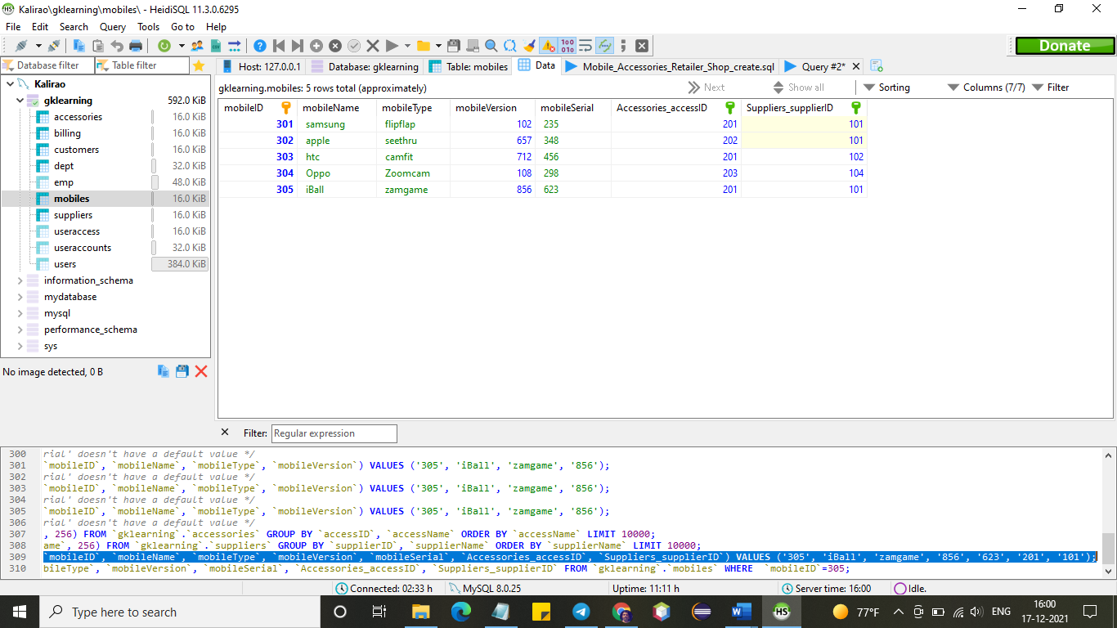

**DELETE** **FROM** mobiles **WHERE** mobileID='305';

