Security

Activities into the Retailer Mobile Accessories Shop includes, helpdesk where customer queries will be registered into database, allotting required accessories from stores to service, managing inventory and preparing invoicing for the completed services. Currently listing out only limited activities, but this may go to any extent along with volumes.

Now comes to allocation of data preparation and access services to roles, this includes the help desk representative is supposed to receive complaints/ service calls and give input to data system. He has limited accesses to the extent of entering data to system, generating invoices and reports.

Whereas the store’s manager have admin powers-operations level only where he will be allowed to create/ add new fields, modify data, delete records wherever is necessary etc.,

One more role that we can relate to it is admin with data management. I strongly believe that the data backing-up, data management, data warehousing are the activities that should be assigned to a person who are highly skilled related to specific activities.

Thus, in this Mobile Accessories Retailer Stores we can **assign help-desk executive for handling customers table and generating invoices.**

*-- Table: Customers*

**CREATE** **TABLE** Customers (

custID **integer** **NOT** **NULL**,

custName **varchar**(25) **NOT** **NULL**,

custContact **integer** **NOT** **NULL**,

mobileType **varchar**(25) **NOT** **NULL**,

mobileSerial **varchar**(25) **NOT** **NULL**,

MOBILES_mobileID **integer** **NOT** **NULL**,

**CONSTRAINT** Customers_pk **PRIMARY** **KEY** (custID)

) ;

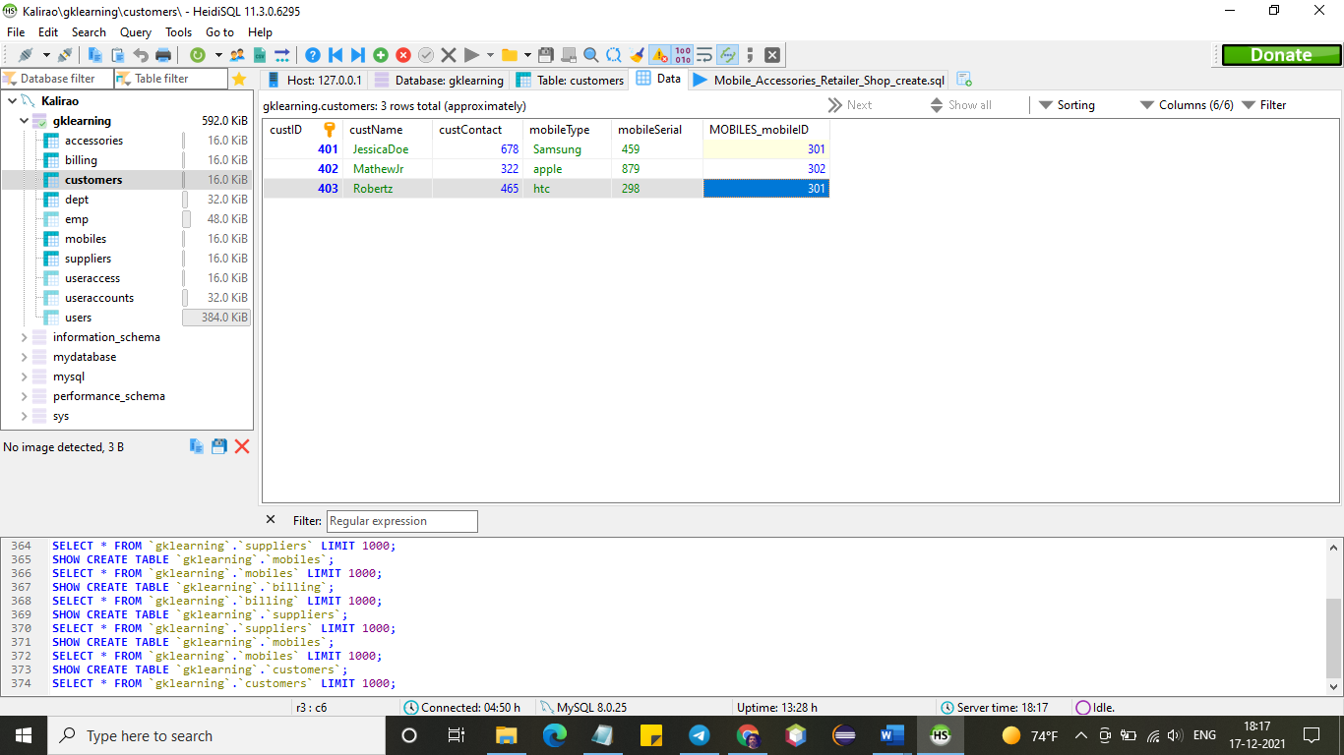

*-- Table: Billing*

**CREATE** **TABLE** Billing (

billID **integer** **NOT** **NULL**,

billDate **date** **NOT** **NULL**,

billUnits **integer** **NOT** **NULL**,

ratePerUnit **integer** **NOT** **NULL**,

subTotal **integer** **NOT** **NULL**,

grandTotal **integer** **NOT** **NULL**,

Customers_custID **integer** **NOT** **NULL**,

**CONSTRAINT** Billing_pk **PRIMARY** **KEY** (billID)

) ;

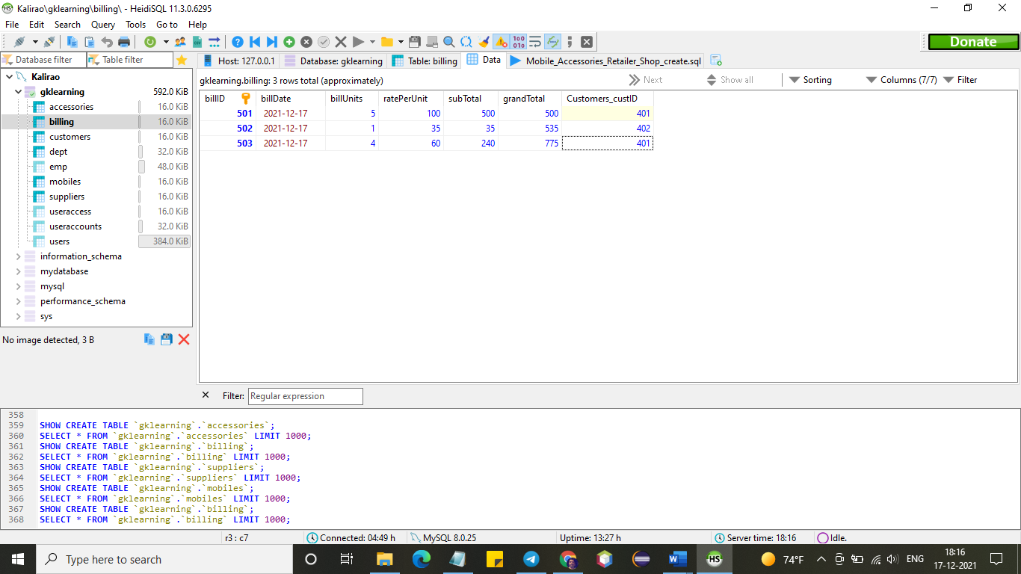

**Stores manager be assigned the below mentioned**

*-- Table: MOBILES*

**CREATE** **TABLE** MOBILES (

mobileID **integer** **NOT** **NULL**,

mobileName **varchar**(25) **NOT** **NULL**,

mobileType **varchar**(25) **NOT** **NULL**,

mobileVersion **integer** **NOT** **NULL**,

mobileSerial **varchar**(25) **NOT** **NULL**,

Accessories_accessID **integer** **NOT** **NULL**,

Suppliers_supplierID **integer** **NOT** **NULL**,

**CONSTRAINT** MOBILES_pk **PRIMARY** **KEY** (mobileID)

) ;

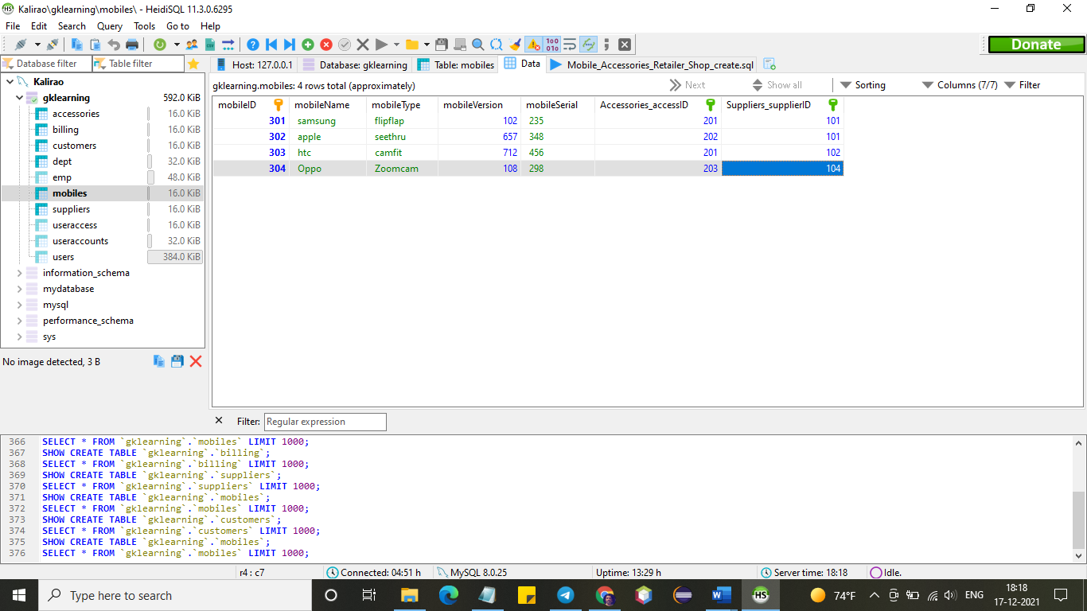

*-- Table: Accessories*

**CREATE** **TABLE** Accessories (

accessID **integer** **NOT** **NULL**,

accessName **varchar**(25) **NOT** **NULL**,

**fixed** **varchar**(25) **NOT** **NULL**,

detachable **varchar**(25) **NOT** **NULL**,

**CONSTRAINT** Accessories_pk **PRIMARY** **KEY** (accessID)

) ;

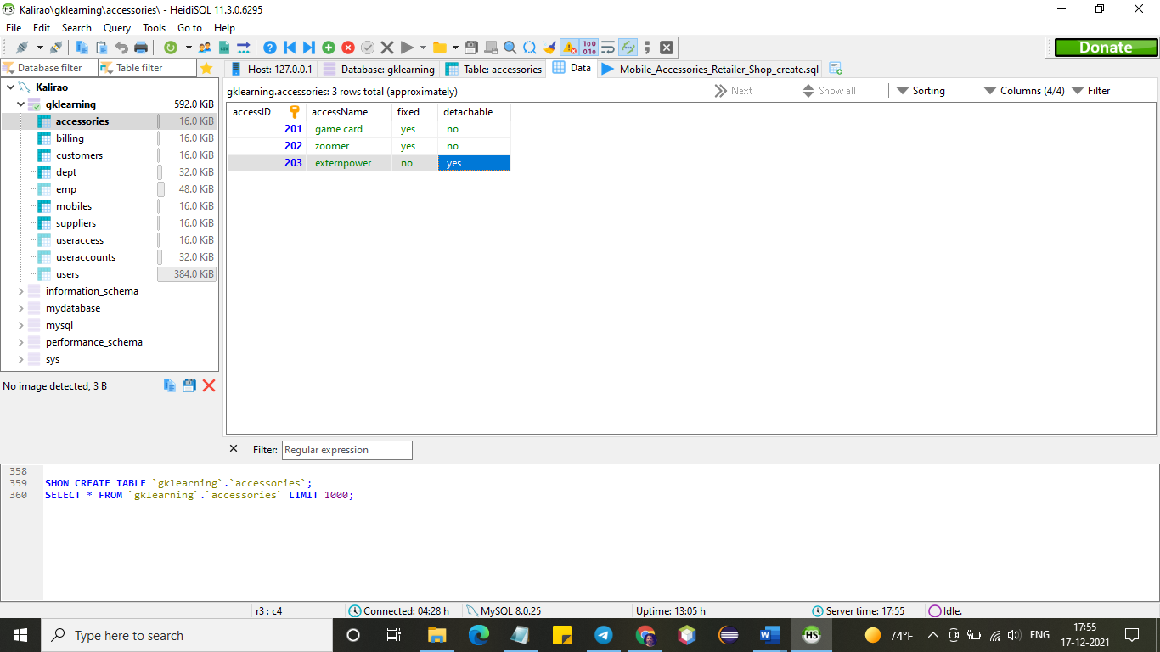

**Marketing and BD team can handle**

*-- Table: Suppliers*

**CREATE** **TABLE** Suppliers (

supplierID **integer** **NOT** **NULL**,

supplierName **varchar**(25) **NOT** **NULL**,

supplierType **varchar**(25) **NOT** **NULL**,

supplierLocation **varchar**(25) **NOT** **NULL**,

Contract **varchar**(25) **NOT** **NULL**,

Regular **varchar**(25) **NOT** **NULL**,

**CONSTRAINT** Suppliers_pk **PRIMARY** **KEY** (supplierID)

) ;

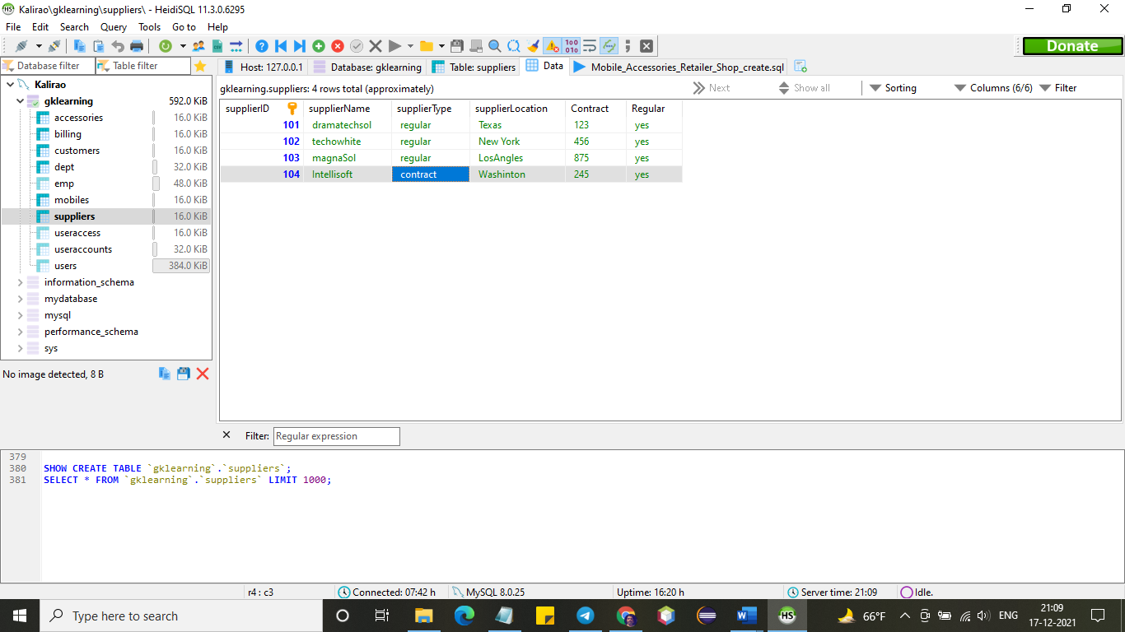

Thus by assigning role to specific category of people to handle related data will give more security to the overall eco-system and make it healthier.