**Installing Python on Kali Linux**

**We need to go to the Download section of the official Python website.

We will execute the command to check for updates

After the update (if available), we need to go to the Downloads section using the following command:

Then we enter the following command:



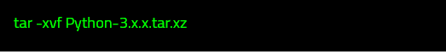

Then we need to configure Python before installing. So we configure it with the following command:





Then we need to run make to compile the Python source code before installing.

Then we can install Python with the following command

It will take time.

When this process is completed, we will check the python version.