Report
This assignment tests the validity of the Capital Asset Pricing Model (CAPM) using the Fama–MacBeth (1973) procedure, which assumes that the expected returns are determined solely by systematic risk ($β$). Using monthly stock return data for 438 U.S. companies from 1980–2015, this procedure has three stages: portfolio formation, estimation, and testing. The years of these stages are shown in Table 1:
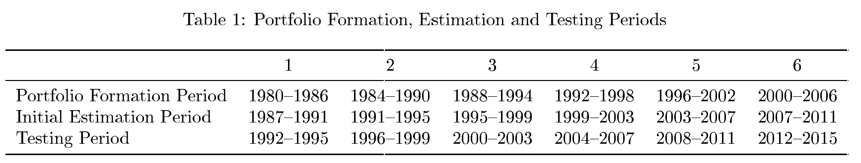
Firms were sorted into 20 portfolios based on their estimated $β$ during the portfolio formation period. In the estimation phase, updated $β$ estimates and the residual risk ($σ$) are computed. During the testing phase, one–month–ahead portfolio returns ($R_{p}$) were regressed on the portfolio averages of $β$, $β^{2}$, and $σ$ using the equation:
$$R_{p}=γ_{0t}+γ_{1t}β_{p}+γ_{2t}β_{p}^{2}+γ_{3t}σ_{p}\left(ε\right)+η_{pt}$$
Where $γ$ represents the regression coefficients and $η$ is the error term. If the CAPM holds, the excess intercept ($γ0​-rˉf$), $γ2$​, and $γ3$​ should all be zero, while $γ1$​ should be positive and statistically significant.
The regression results are shown in table 2:
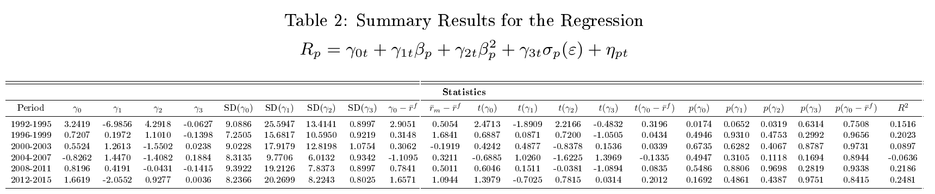
In the 1992–1995 period, the estimated intercept ($γ0​$​) is 3.2419 with a t-statistic of 2.4713 and a p-value of 0.0174, indicating statistical significance. However, when adjusted by subtracting the average risk‐free rate ($γ0​-rˉf$ =2.9051), the t-statistic drops to 0.3196 with a p-value of 0.7508, showing that the excess intercept is not significantly different from zero. In the subsequent periods, both $γ0​$​​ and $γ0​-rˉf$ have low t-statistics and high p-values, remaining insignificant. Although the unadjusted intercept in one subperiod may appear significant, once the risk-free rate is adjusted, it does not strongly reject CAPM.
For the linear beta coefficient ($γ1$), in the 1992–1995 period $γ1$​ is estimated at -6.9856 with a t-statistic of -1.8909 and a p-value of 0.0652, indicating significance in a negative direction, which contradicts CAPM expectations. In later periods, the estimated $γ1$​ values become positive but with low t-statistics and high p-values, suggesting beta- return lacks robustness. These results reject the CAPM due to the absence of linearity.
For the squared beta term ($γ2$​), the results show mixed evidence of nonlinearity in the risk–return relationship. In the 1992–1995 period, $γ2$​ is estimated at 4.2918 with a t-statistic of 2.2166 and a p-value of 0.0319, suggesting statistical significance and implying some nonlinearity. However, in subsequent periods the estimated $γ2$​ values are lower, with low t-statistics and high p-values, indicating that any nonlinearity captured by this term is not consistently evident over time.
The coefficient on idiosyncratic risk ($γ3$​) remains statistically insignificant throughout all subperiods with low t-statistics and high p-values. Thus, idiosyncratic risk does not contribute to expected returns.
The overall explanatory power of the model ($R^{2}$), is small ranging from about 9% to 25% across the periods. These low $R^{2}$ values capture some cross-sectional variation in returns. However, much remains unexplained, indicating other factors likely contribute beyond the CAPM.
Overall, only $γ0$ and idiosyncratic risk $γ3$ align with CAPM by being insignificant, whereas $γ1$ is unstable and often significant in the wrong direction supporting CAPM’s rejection. $γ2$ shows significance in only one subperiod, providing mixed evidence for nonlinearity. Combined with low $R^{2}$, these findings indicate that CAPM does not fully explain cross-sectional returns and should be rejected.
In addition to the main Fama–MacBeth procedure, several additional tests were conducted to validate the findings.
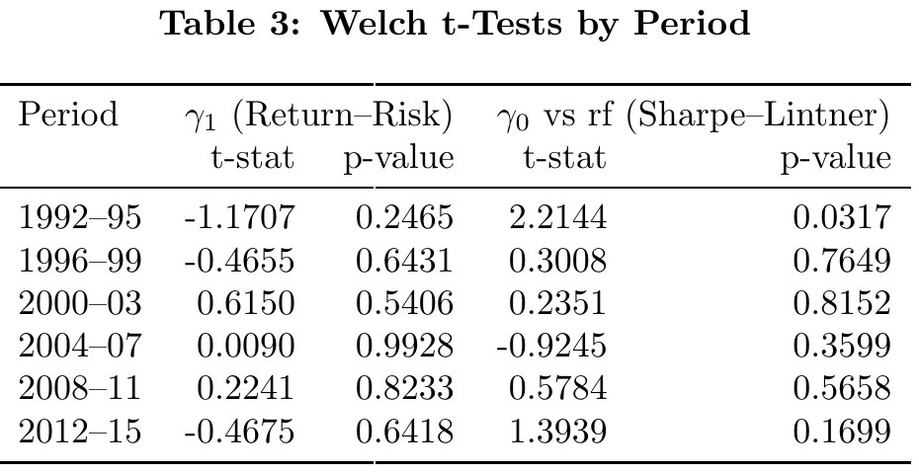
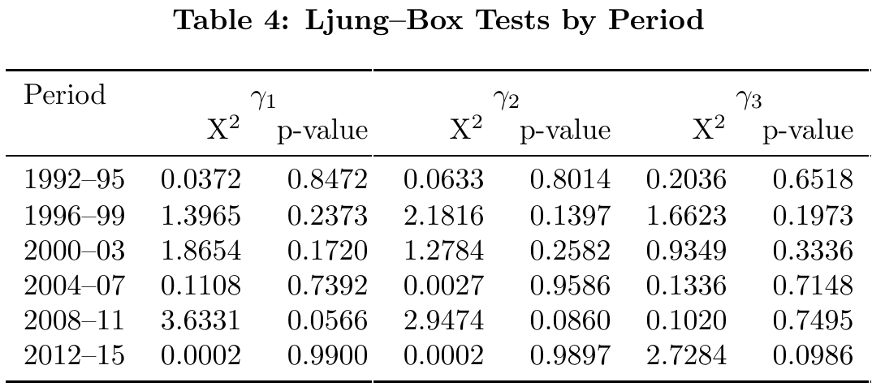
Table 3 shows the Welch t-tests including the Sharpe–Lintner comparison of the intercept (​$γ0$) to the risk-free rate and the test of the beta premium ($γ1$​). While the Sharpe–Lintner intercept is significant in 1992–95 (t = 2.2144, p = 0.0317), it never remains so thereafter, and $γ1$​ consistently fails to produce a positive, significant slope (all p-values > 0.24). This negative beta premium directly contradicts CAPM’s core prediction and provides evidence to reject the model.

Table 4 shows the Ljung–Box tests for autocorrelation in each coefficient; none are significant (all p > 0.10), confirming weak-form market efficiency. However, because beta never consistently predicts higher returns, the CAPM’s risk–return prediction fails and must be rejected.
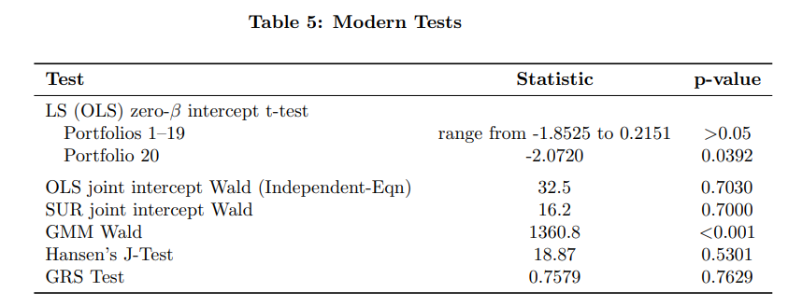
Table 5 reports modern tests of the zero-alpha hypothesis. The LS test shows that t-statistics for portfolios 1–19 range from -1.8525 to 0.2151, with p-values above 0.05, indicating no significant pricing errors. Portfolio 20, however, has a significant t-statistic of -2.0720 and a p-value of 0.0392, suggesting potential mispricing for high-beta stocks. By contrast, the joint Wald tests fail to reject that all portfolio intercepts are zero. Likewise, Hansen’s J-test (p = 0.5301) and the GRS test (p = 0.7629) find no evidence against zero alphas. Only the GMM Wald test rejects strongly (1360.8, p < 0.001). These mixed outcomes raise further doubts about the validity of CAPM.
Methodological issues may influence findings. Historical beta estimates can contain measurement errors, and multicollinearity among beta terms inflates standard errors, affecting statistical significance. Additionally, potential heteroscedasticity and autocorrelation in residuals indicate that robust standard errors would yield more reliable inferences.
According to the empirical evidence in this report, CAPM should be rejected. Across all tests the expected positive beta-risk premium never appears consistently, $γ1$ is unstable and often negative. Although the LS test (except for portfolio 20), joint SUR and OLS Wald tests, Hansen’s J, and GRS fail to reject zero intercepts, only the GMM Wald test finds significance. Combined with low R² values and inconsistent results for non-linearity, these findings contradict CAPM’s core predictions.
Bibliography.
Fama, E. F., & French, K. R. (1973). Risk, Return, and Equilibrium: Empirical Tests. Journal of Political Economy, 81(3), 607–636. https://www.journals.uchicago.edu/doi/10.1086/260061

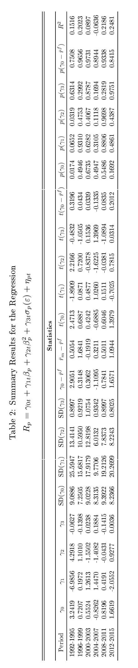
Appendix.
R script.
# -----------------------------------------------------------------------------
# Load Required Libraries
# -----------------------------------------------------------------------------
library(tidyverse)
library(broom)
library(systemfit)
library(gmm)
library(aod)
library(GRS.test)
library(lubridate)
library(car)
library(knitr)
library(htmltools)

# -----------------------------------------------------------------------------
# Load the Dataset
# -----------------------------------------------------------------------------
df <- read_csv("USstocks_balanced.csv")

# -----------------------------------------------------------------------------
# Define Base Periods and Number of Periods (6 Periods)
# -----------------------------------------------------------------------------
base_formation_start <- 1980
base_formation_end <- 1986
base_estimation_start <- 1987
base_estimation_end <- 1991
base_testing_start <- 1992
base_testing_end <- 1995

n_periods <- 6

# -----------------------------------------------------------------------------
# Fama–MacBeth Procedure: Portfolio Formation, Estimation, Testing, and Summary
# -----------------------------------------------------------------------------
results <- list()

for(i in 0:(n_periods - 1)){

# Define Period Boundaries for the Current Iteration
formation_start <- base_formation_start + 4 * i
formation_end <- base_formation_end + 4 * i
estimation_start <- base_estimation_start + 4 * i
estimation_end <- base_estimation_end + 4 * i
testing_start <- base_testing_start + 4 * i
testing_end <- base_testing_end + 4 * i

# Portfolio Formation: Estimate each firm's beta in the formation period and rank into 20 portfolios
pf_groups <- df %>%
filter(between(year, formation_start, formation_end)) %>%
group_by(permno) %>%
nest() %>%
mutate(betaest = map(data, ~ coef(lm(ri ~ rm, data = .x))[2])) %>%
unnest(betaest) %>%
ungroup() %>%
mutate(pfid = ntile(betaest, 20)) %>%
select(permno, betaest, pfid)

# Merge Portfolio Assignments with Data for Estimation and Testing Periods
df_withpfid <- df %>%
filter(between(year, estimation_start, testing_end)) %>%
left_join(pf_groups, by = "permno")

# Portfolio Estimation: For each firm, re-estimate beta and compute residual std. error (sigma)
n_years <- testing_end - testing_start + 1
beta_sigma_period <- data.frame()
for(j in 0:(n_years - 1)){
beta_sigma <- df_withpfid %>%
filter(year <= (estimation_end + j)) %>%
group_by(permno) %>%
nest() %>%
mutate(
betas = map(data, ~ coef(lm(ri ~ rm, data = .x))[2]),
sigmas = map(data, ~ sigma(lm(ri ~ rm, data = .x))),
yeartesting = testing_start + j
) %>%
unnest(c(betas, sigmas)) %>%
ungroup() %>%
select(permno, betas, sigmas, yeartesting)
beta_sigma_period <- bind_rows(beta_sigma_period, beta_sigma)
}
beta_sigma_period <- rename(beta_sigma_period, year = yeartesting)

# Merge Beta and Sigma Estimates with Testing Period Data
df_testingperiod <- df_withpfid %>%
filter(between(year, testing_start, testing_end)) %>%
left_join(beta_sigma_period, by = c("permno", "year"))

# Portfolio Testing: Compute Monthly Portfolio Averages
testing_period <- df_testingperiod %>%
group_by(pfid, year, month) %>%
summarise(
rp = mean(ri, na.rm = TRUE),
betap = mean(betas, na.rm = TRUE),
betap_squared = mean(betas^2, na.rm = TRUE),
sigmap = mean(sigmas, na.rm = TRUE),
.groups = "drop"
)

# Run Month-by-Month Cross-Sectional Regressions:
# Regress lead(rp) on portfolio averages: betap, betap_squared, and sigmap.
testing_period_gammas <- testing_period %>%
group_by(year, month) %>%
nest(data = !c(year, month)) %>%
mutate(
estim = map(data, ~ lm(lead(rp) ~ betap + betap_squared + sigmap, data = .x)),
estim = map(estim, tidy)
) %>%
unnest(estim) %>%
select(year, month, term, estimate) %>%
ungroup()

# Summarize Cross-Sectional Regression Results
summary_results <- testing_period_gammas %>%
group_by(term) %>%
summarise(
mean_est = mean(estimate, na.rm = TRUE),
sd_est = sd(estimate, na.rm = TRUE),
n = n(),
t_stat = mean_est / (sd_est / sqrt(n))
) %>%
ungroup()

# Save results for the current period
results[[as.character(i+1)]] <- list(
period = i + 1,
formation = c(formation_start, formation_end),
estimation = c(estimation_start, estimation_end),
testing = c(testing_start, testing_end),
df_testingperiod = df_testingperiod,
gammas = testing_period_gammas,
summary = summary_results
)
}

# Combine and Print Summary Statistics Across All Periods
all_summary <- map_df(results, ~ .x$summary, .id = "period")
print(all_summary, n = 24)

# Hypothesis Testing on the Cross-Sectional Regression Estimates
hypothesis_tests <- map(results, function(res) {
gammas <- res$gammas
# Test for non-linearity (beta^2 term)
gamma2 <- gammas %>% filter(term == "betap_squared") %>% pull(estimate)
t_test_gamma2 <- t.test(gamma2, mu = 0)
# Test for additional risk (sigma)
gamma3 <- gammas %>% filter(term == "sigmap") %>% pull(estimate)
t_test_gamma3 <- t.test(gamma3, mu = 0)
# Test for positive return-risk tradeoff (beta coefficient)
gamma1 <- gammas %>% filter(term == "betap") %>% pull(estimate)
gamma0 <- gammas %>% filter(term == "(Intercept)") %>% pull(estimate)
rm_val <- res$df_testingperiod %>%
filter(permno == unique(res$df_testingperiod$permno)[1]) %>%
pull(rm)
rm_r0 <- rm_val - gamma0
t_test_gamma1 <- t.test(gamma1, rm_r0)
# Sharpe-Lintner test (comparing intercept to rf)
rf_val <- res$df_testingperiod %>%
filter(permno == unique(res$df_testingperiod$permno)[1]) %>%
pull(rf)
t_test_gamma0 <- t.test(gamma0, rf_val)
# Market efficiency tests via Ljung-Box on each coefficient
lb_gamma1 <- Box.test(gamma1, lag = 1, type = "Ljung-Box")
lb_gamma2 <- Box.test(gamma2, lag = 1, type = "Ljung-Box")
lb_gamma3 <- Box.test(gamma3, lag = 1, type = "Ljung-Box")

list(
"Linearity Test" = t_test_gamma2,
"No Systematic Non-Beta Risk" = t_test_gamma3,
"Positive Return-Risk Tradeoff" = t_test_gamma1,
"Sharpe-Lintner Test" = t_test_gamma0,
"Market Efficiency Test - 1 (Ljung-Box)" = lb_gamma1,
"Market Efficiency Test - 2 (Ljung-Box)" = lb_gamma2,
"Market Efficiency Test - 3 (Ljung-Box)" = lb_gamma3
)
})
print(hypothesis_tests)

# -----------------------------------------------------------------------------
# Modern Tests of Factor Models using Portfolio Excess Returns
# -----------------------------------------------------------------------------

# Compute Excess Portfolio Returns (EPR) and Excess Market Returns (EMR)
excess_returns_results <- list()
for (i in 1:n_periods) {
testing_period_data <- results[[as.character(i)]]$df_testingperiod
excess_returns <- testing_period_data %>%
group_by(pfid, year, month) %>%
summarise(
rp = mean(ri, na.rm = TRUE), # Portfolio return
erp = rp - mean(rf, na.rm = TRUE), # Excess Portfolio Return
erm = mean(rm, na.rm = TRUE) - mean(rf, na.rm = TRUE), # Excess Market Return
.groups = "drop"
)
excess_returns_results[[as.character(i)]] <- excess_returns
}

all_excess_returns <- bind_rows(excess_returns_results, .id = "period") %>%
mutate(date = lubridate::ym(paste0(year, "-", month)))

# -----------------------------------------------------------------------------
# LS Approach: Estimate SCL for each portfolio
# -----------------------------------------------------------------------------
ls_test_modern <- all_excess_returns %>%
group_by(pfid) %>%
nest(data = !pfid) %>%
mutate(estim = map(data, ~ lm(erp ~ erm, data = .x)),
estim = map(estim, tidy)) %>%
unnest(estim) %>%
select(-data) %>%
arrange(pfid) %>%
filter(term == "(Intercept)")

knitr::kable(ls_test_modern, digits = 4)

mean_alpha <- mean(ls_test_modern$estimate)
sd_alpha <- sd(ls_test_modern$estimate)
t_ls <- t.test(ls_test_modern$estimate, mu = 0)

ls_summary <- tibble(
Test = "LS (OLS) zero-β intercept t-test (mean α_p=0)",
Statistic = round(as.numeric(t_ls$statistic), 4),
p_value = signif(t_ls$p.value, 4)
)

knitr::kable(ls_summary, col.names = c("Test", "Statistic", "p-value"))
# -----------------------------------------------------------------------------
# SURE Approach - Independent Equations
# -----------------------------------------------------------------------------
sure_independent <- all_excess_returns %>%
group_by(pfid) %>%
nest(data = !pfid) %>%
mutate(estim = map(data, ~lm(erp ~ erm, data = .x)),
estim = map(estim, tidy)) %>%
unnest(estim) %>%
select(-data) %>%
ungroup() %>%
filter(term == "(Intercept)") %>%
summarise(wald = sum(statistic^2))
print(sure_independent)
print(qchisq(p = 0.05, df = 20, lower.tail = FALSE))
print(pchisq(2.13, df = 20, lower.tail = FALSE))

# -----------------------------------------------------------------------------
# SURE Approach - Dependent Equations
# -----------------------------------------------------------------------------
df_final_wide <- all_excess_returns %>%
select(pfid, date, erp, erm) %>%
pivot_wider(names_from = pfid, values_from = erp, names_glue = "erp_{pfid}") %>%
arrange(date)
print(head(df_final_wide))

system_equations <- map(1:20, ~paste0("erp_", .x, " ~ erm"))
system_equations <- map(system_equations, as.formula)
print(system_equations)

results_sure_modern <- systemfit(system_equations, method = "SUR", data = df_final_wide)
summary(results_sure_modern)

waldtest_sure_modern <- aod::wald.test(
Sigma = vcov(results_sure_modern),
b = coef(results_sure_modern),
Terms = seq(1, 39, by = 2)
)
print(waldtest_sure_modern)
print(coef(results_sure_modern))
print(coef(results_sure_modern)[1])
print(coef(results_sure_modern)[2])
print(coef(results_sure_modern)[5])
print(seq(1, 39, by = 2))

# -----------------------------------------------------------------------------
# Convert Excess Portfolio Returns into Matrix Form
# -----------------------------------------------------------------------------
erp_matrix <- df_final_wide %>%
select(contains("erp")) %>%
as.matrix()
erm_matrix <- df_final_wide %>%
select(erm) %>%
as.matrix()

# -----------------------------------------------------------------------------
# GMM Approach
# -----------------------------------------------------------------------------
results_gmm_modern <- gmm(erp_matrix ~ erm_matrix,
x = cbind(1, erm_matrix),
vcov = "HAC",
type = "twoStep")
summary(results_gmm_modern)
n_coef <- length(coef(results_gmm_modern))
print(paste("Number of estimated coefficients:", n_coef))
R <- diag(n_coef)
c_vec <- rep(0, n_coef)
if (nrow(R) != length(coef(results_gmm_modern))) {
stop("Error: Dimensions of R and coefficient vector do not match!")
}
waldtest_gmm_modern <- aod::wald.test(
Sigma = vcov(results_gmm_modern),
b = coef(results_gmm_modern),
Terms = 1:n_coef
)
print(waldtest_gmm_modern)
print(coef(results_gmm_modern))
print(coef(results_gmm_modern)[1])
print(coef(results_gmm_modern)[2])
print(coef(results_gmm_modern)[5])
print(seq(1, n_coef, by = 2))

# Test for Restrictions on the Intercepts using linearHypothesis()
R_intercept <- diag(n_coef)
c_intercept <- rep(0, n_coef)
if (ncol(R_intercept) != length(coef(results_gmm_modern))) {
stop("Error: Dimensions of R_intercept and coefficient vector do not match!")
}
linear_test_result <- car::linearHypothesis(results_gmm_modern, R_intercept, c_intercept, test = "Chisq")
print(linear_test_result)

# -----------------------------------------------------------------------------
# J-Test for Over identification Restrictions
# -----------------------------------------------------------------------------
results_gmm_jtest <- gmm(erp_matrix ~ erm_matrix - 1, x = cbind(1, erm_matrix))
j_test_result <- specTest(results_gmm_jtest)
print(j_test_result)

# -----------------------------------------------------------------------------
# GRS Test
# -----------------------------------------------------------------------------
grstest_results <- GRS.test(erp_matrix, erm_matrix)
print(grstest_results$GRS.stat)
print(grstest_results$GRS.pval)

# -----------------------------------------------------------------------------
# Create Summary Results Table for the Regression
# Rp = γ0t + γ1tβp + γ2tβp^2 + γ3tσp(ε) + ηpt
# -----------------------------------------------------------------------------
# Collect and process results from all periods
summary_table <- data.frame()

for(i in 1:n_periods) {
period_data <- results[[as.character(i)]]

# Extract summary statistics
period_summary <- period_data$summary

# Get gamma estimates
gamma0 <- period_summary %>% filter(term == "(Intercept)") %>% pull(mean_est)
gamma1 <- period_summary %>% filter(term == "betap") %>% pull(mean_est)
gamma2 <- period_summary %>% filter(term == "betap_squared") %>% pull(mean_est)
gamma3 <- period_summary %>% filter(term == "sigmap") %>% pull(mean_est)

# Get standard deviations of gamma estimates
sd_gamma0 <- period_summary %>% filter(term == "(Intercept)") %>% pull(sd_est)
sd_gamma1 <- period_summary %>% filter(term == "betap") %>% pull(sd_est)
sd_gamma2 <- period_summary %>% filter(term == "betap_squared") %>% pull(sd_est)
sd_gamma3 <- period_summary %>% filter(term == "sigmap") %>% pull(sd_est)

# Get t-statistics
t_gamma0 <- period_summary %>% filter(term == "(Intercept)") %>% pull(t_stat)
t_gamma1 <- period_summary %>% filter(term == "betap") %>% pull(t_stat)
t_gamma2 <- period_summary %>% filter(term == "betap_squared") %>% pull(t_stat)
t_gamma3 <- period_summary %>% filter(term == "sigmap") %>% pull(t_stat)

# Calculate p-values from t-statistics
df <- period_data$summary$n[1] - 4

# Calculate p-values (two-tailed test)
p_gamma0 <- 2 * pt(-abs(t_gamma0), df = df)
p_gamma1 <- 2 * pt(-abs(t_gamma1), df = df)
p_gamma2 <- 2 * pt(-abs(t_gamma2), df = df)
p_gamma3 <- 2 * pt(-abs(t_gamma3), df = df)

# Calculate market return and risk-free rate for the testing period
market_data <- period_data$df_testingperiod %>%
group_by(year, month) %>%
summarise(
rm = mean(rm, na.rm = TRUE),
rf = mean(rf, na.rm = TRUE),
.groups = "drop"
)

avg_rm <- mean(market_data$rm, na.rm = TRUE)
avg_rf <- mean(market_data$rf, na.rm = TRUE)

# Calculate additional statistics shown in the table
rm_minus_rf <- avg_rm - avg_rf

# Calculate gamma0 minus risk-free rate
gamma0_minus_rf <- gamma0 - avg_rf

# Calculate t-statistic for gamma0 minus risk-free rate
t_gamma0_minus_rf <- gamma0_minus_rf / sd_gamma0

# Calculate p-value for gamma0 minus risk-free rate
# Using two-tailed t-test with degrees of freedom from the original regression
p_gamma0_minus_rf <- 2 * pt(-abs(t_gamma0_minus_rf), df = df)

# Calculate average R-squared
r_squared_values <- numeric()
monthly_data <- period_data$gammas %>%
group_by(year, month) %>%
tidyr::nest() %>%
mutate(
model_data = map2(year, month, function(y, m) {
# Extract the month's data from the original testing period
month_data <- period_data$df_testingperiod %>%
filter(year == y, month == m)

# Get coefficients for this month from gammas data
month_gammas <- period_data$gammas %>%
filter(year == y, month == m)

gamma0 <- month_gammas$estimate[month_gammas$term == "(Intercept)"]
gamma1 <- month_gammas$estimate[month_gammas$term == "betap"]
gamma2 <- month_gammas$estimate[month_gammas$term == "betap_squared"]
gamma3 <- month_gammas$estimate[month_gammas$term == "sigmap"]

list(
month_data = month_data,
coeffs = list(gamma0 = gamma0, gamma1 = gamma1, gamma2 = gamma2, gamma3 = gamma3)
)
})
)

# Calculate R-squared for each month
r_squared_list <- monthly_data$model_data %>%
map(function(md) {
# Skip if we don't have data or coefficients
if(is.null(md$month_data) || is.null(md$coeffs$gamma0)) {
return(NA)
}

# Calculate portfolio actual and fitted returns
pf_data <- md$month_data %>%
group_by(pfid) %>%
summarise(
actual_rp = mean(ri, na.rm = TRUE),
fitted_rp = md$coeffs$gamma0 +
md$coeffs$gamma1 * mean(betas, na.rm = TRUE) +
md$coeffs$gamma2 * mean(betas^2, na.rm = TRUE) +
md$coeffs$gamma3 * mean(sigmas, na.rm = TRUE),
.groups = "drop"
)

# Calculate R-squared
tss <- sum((pf_data$actual_rp - mean(pf_data$actual_rp, na.rm = TRUE))^2, na.rm = TRUE)
rss <- sum((pf_data$actual_rp - pf_data$fitted_rp)^2, na.rm = TRUE)

if(tss > 0) {
return(1 - (rss/tss))
} else {
return(NA)
}
})

# Calculate average R-squared across all months
avg_r_squared <- mean(unlist(r_squared_list), na.rm = TRUE)

# Create a row for this period
period_row <- data.frame(
period = paste0(period_data$testing[1], "-", period_data$testing[2]),
gamma0 = gamma0,
gamma1 = gamma1,
gamma2 = gamma2,
gamma3 = gamma3,
sd_gamma0 = sd_gamma0,
sd_gamma1 = sd_gamma1,
sd_gamma2 = sd_gamma2,
sd_gamma3 = sd_gamma3,
gamma0_minus_rf = gamma0_minus_rf,
rm_minus_rf = rm_minus_rf,
t_gamma0 = t_gamma0,
t_gamma1 = t_gamma1,
t_gamma2 = t_gamma2,
t_gamma3 = t_gamma3,
t_gamma0_minus_rf = t_gamma0_minus_rf,
p_gamma0 = p_gamma0,
p_gamma1 = p_gamma1,
p_gamma2 = p_gamma2,
p_gamma3 = p_gamma3,
p_gamma0_minus_rf = p_gamma0_minus_rf,
r_squared = avg_r_squared
)

summary_table <- bind_rows(summary_table, period_row)
}

# -----------------------------------------------------------------------------
# Create a nicer formatted table for presentation in the R viewer
# -----------------------------------------------------------------------------
# Format numbers to 4 decimal places for better presentation
formatted_table_display <- summary_table %>%
mutate(across(where(is.numeric), ~round(., 4)))

# Create HTML table for the R viewer - with all periods in a single table
formatted_html <- kable(formatted_table_display %>%
select(period, gamma0, gamma1, gamma2, gamma3,
sd_gamma0, sd_gamma1, sd_gamma2, sd_gamma3,
gamma0_minus_rf, rm_minus_rf,
t_gamma0, t_gamma1, t_gamma2, t_gamma3, t_gamma0_minus_rf,
p_gamma0, p_gamma1, p_gamma2, p_gamma3, p_gamma0_minus_rf,
r_squared),
col.names = c("Period",
"γ₀", "γ₁", "γ₂", "γ₃",
"SD(γ₀)", "SD(γ₁)", "SD(γ₂)", "SD(γ₃)",
"γ₀-r̄ᶠ", "r̄ₘ-r̄ᶠ",
"t(γ₀)", "t(γ₁)", "t(γ₂)", "t(γ₃)", "t(γ₀-r̄ᶠ)",
"p(γ₀)", "p(γ₁)", "p(γ₂)", "p(γ₃)", "p(γ₀-r̄ᶠ)",
"R²"),
format = "html",
caption = "<strong>Summary Results for the Regression:</strong><br>Rp = γ0t + γ1tβp + γ2tβp² + γ3tσp(ε) + ηpt")

# Display in R viewer
html_print(HTML(formatted_html))

