Name: Naila Naz

Course: Digital Marketing

Student ID: 17160

Batch: 601

Mentor: Haris Alam

**Final Project for Digital Marketing  
Course**  
  
  
**Project:01 (part:01)** Design a **Social and Digital Marketing Campaign** for  
 **Facebook & and YouTube** channels. want maximum reach and engagement.  Budget is **3 Million Rupees for Campaigns.**

**Presentation for the Proposal**

There are several reasons why businesses and organizations apply campaigns on Facebook.

1. **Reach a Large Audience**
2. **Targeted Advertising**
3. **Cost-Effective Marketing**
4. **Engagement and Interaction**
5. **Measurable Results**
6. **Drive Website Traffic and Conversions**
7. **Build Brand Loyalty and Awareness**

Facebook offers various types of campaigns to cater to different marketing objectives and target audiences.

**Awareness Campaigns**: These campaigns are designed to increase brand awareness and reach a broader audience.

**Engagement Campaigns**: These campaigns aim to encourage interaction with your content, such as likes, comments, shares, and reactions. They are effective for building a community around your brand and increasing visibility.

**Traffic Campaigns**: Traffic campaigns are focused on driving users to your website or a specific landing page. They are designed to increase the number of visitors to your site and can be optimized for link clicks or landing page views.

**Video View Campaigns**: Video view campaigns are focused on promoting video content and increasing views.

 Screenshots or Mockups



Facebook campaign

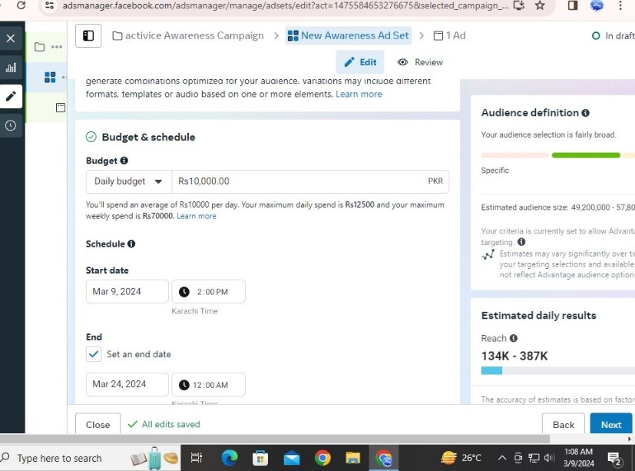

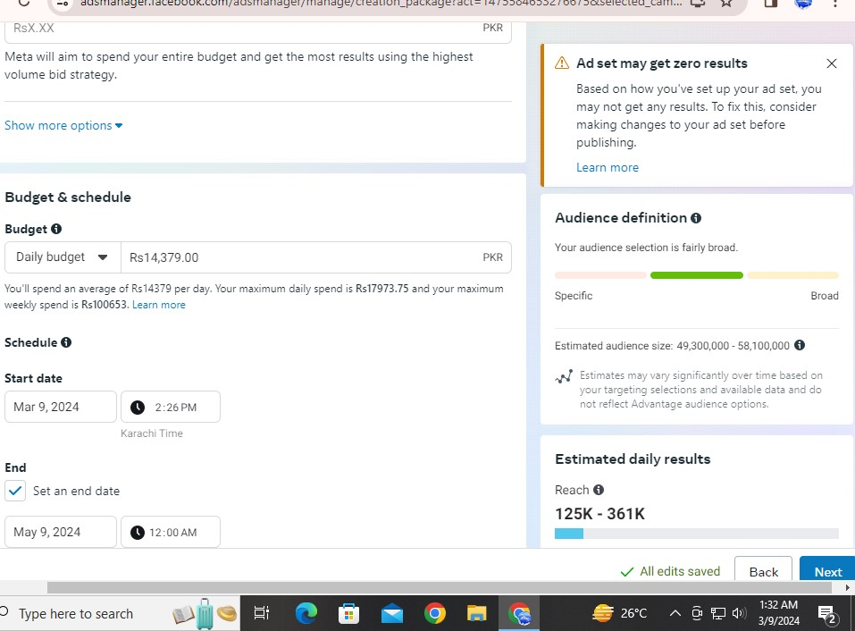

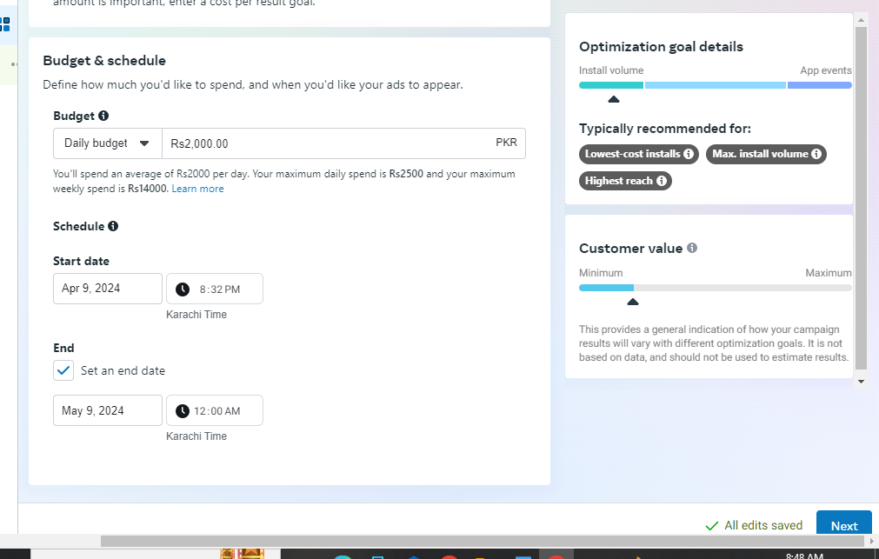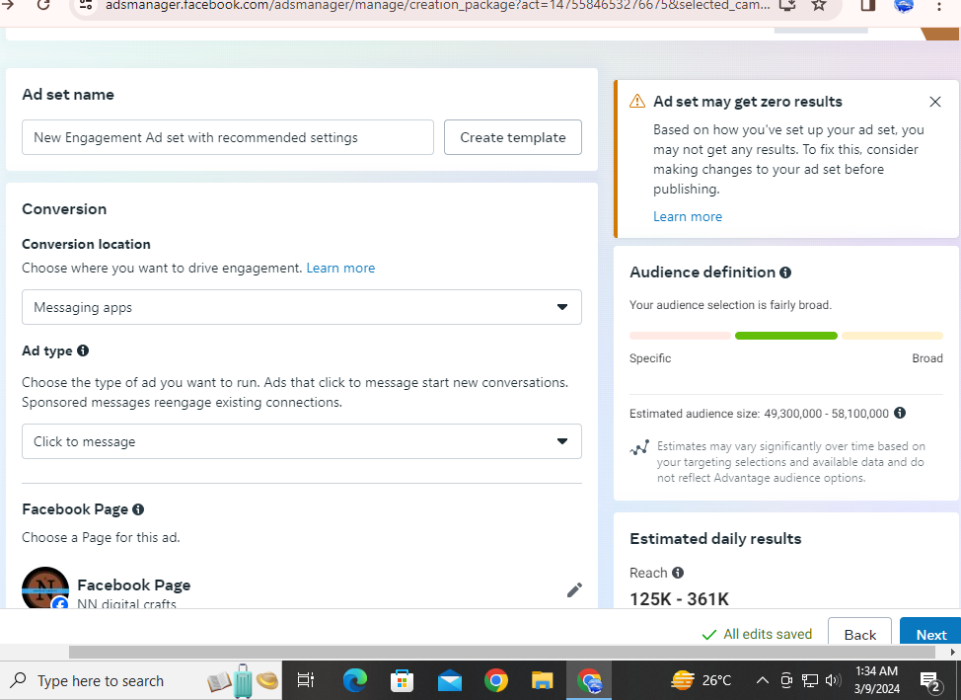

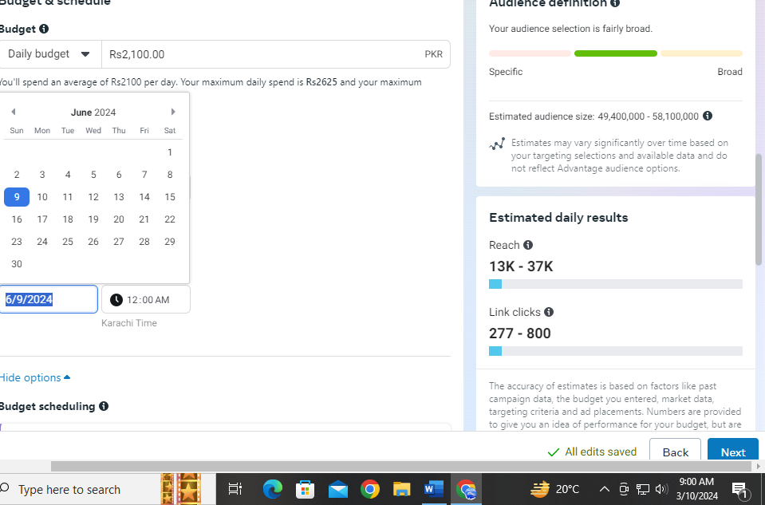

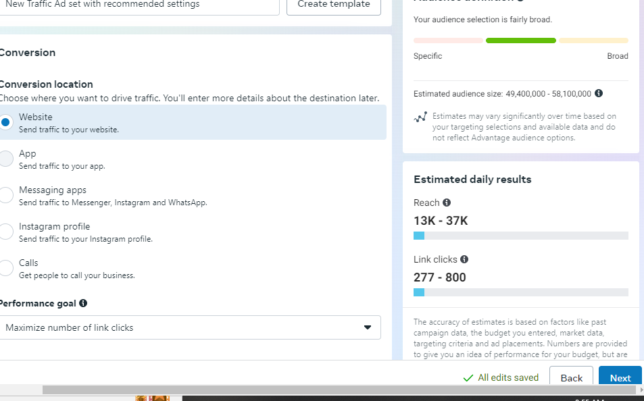

You tube ads campaign 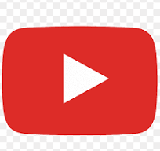 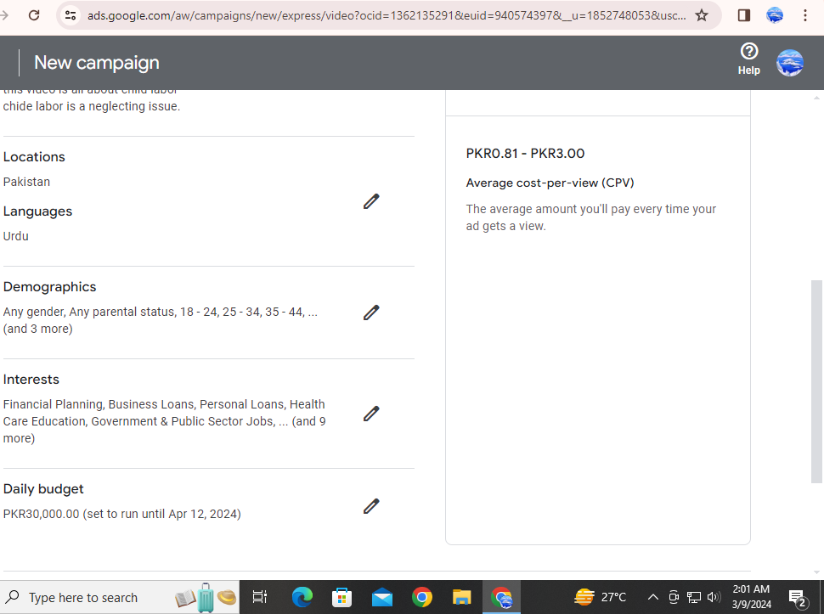

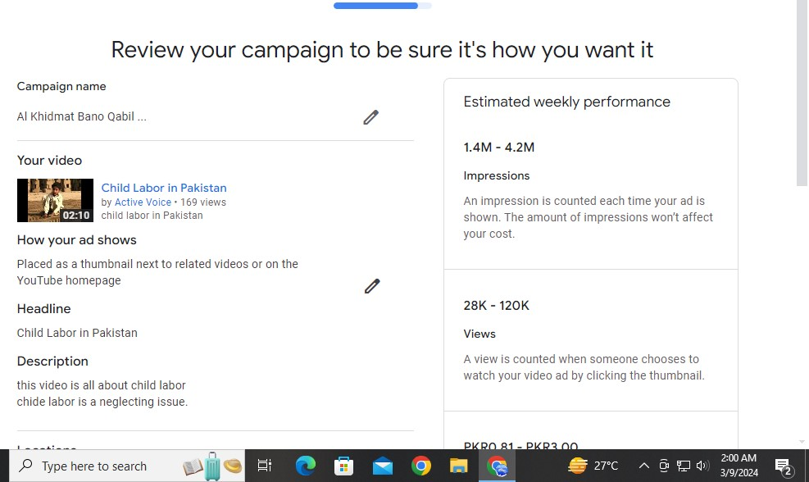



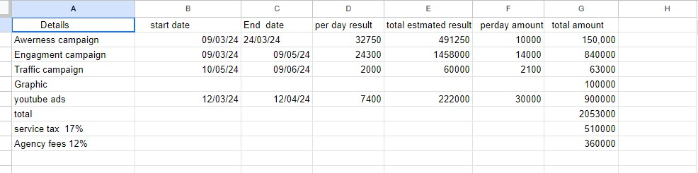

Initial Audit

Reviewed Active Voice's Facebook and YouTube channels. • Identified strengths: Engaging content, loyal audience. • Identified weaknesses: Limited reach, inconsistent posting schedule. Recent followers [**163 likes**](https://www.facebook.com/activevoice.news/friends_likes/) • [**249 followers**](https://www.facebook.com/activevoice.news/followers/)

Audience Research Report:

• Target audience: Active generation (youth and adults) interested in social issues and democratic values

. • Demographics: Age (18-45), interests (social activism, politics, entrepreneurship), location (urban areas).

• Engagement habits: Active on social media platforms, prefer visual content and interactive engagement.

Target Audience:

• Students, social workers, politicians, entrepreneurs, and socially conscious individuals.

• Interested in promoting democratic values, social justice, and human rights

Estimated Budget:

Campaigns: 3,000,000 Rupees

• Social Media Management (6 months): 1,000,000 Rupee

• Agency Fee (12%): 360,000 Rupees

• Services Tax (17%): 510,000 Rupees

. Total Budget: 2923,000 Rupees

Estimated Results:

• Increase in Facebook and YouTube channel subscribers by 22%.

• Engagement rate on posts to increase by 31%.

• Reach of paid advertising campaigns to exceed 1 million impressions per month

• Positive sentiment towards the brand to increase by 35%.

Project: 01(part 02)

Creating a comprehensive 6-month social media campaign calendar within a budget of 1,000,000 INR requires strategic planning, creativity, and efficient resource allocation. Below is a suggested outline for your campaign, spanning six months:

**Month 1: Brand Awareness**

* Week 1: Launch teaser posts introducing the campaign theme.
* Week 2: Share engaging content about your brand's story and values.
* Week 3: Host a giveaway or contest to encourage user participation.
* Week 4: Collaborate with influencers or brand ambassadors to amplify reach.

**Month 2: Product Highlight**

* Week 1: Showcase your flagship product with visually appealing content.
* Week 2: Share user-generated content featuring satisfied customers.
* Week 3: Highlight product features and benefits through video tutorials.
* Week 4: Offer exclusive discounts or promotions for social media followers.

**Month 3: User Engagement**

* Week 1: Conduct polls or surveys to gather feedback from your audience.
* Week 2: Host a live Q&A session to interact with followers and address inquiries.
* Week 3: Share behind-the-scenes content, giving followers a glimpse into your brand.
* Week 4: Run a user-generated content campaign, encouraging followers to share their experiences.

**Month 4: Community Building**

* Week 1: Spotlight loyal customers or brand advocates through user testimonials.
* Week 2: Create branded hashtags and encourage followers to share their posts.
* Week 3: Partner with local businesses or organizations for cross-promotion.
* Week 4: Organize a virtual event or webinar related to your industry.

**Month 5: Social Impact**

* Week 1: Share stories about your brand's social responsibility initiatives.
* Week 2: Collaborate with a charitable organization and donate a portion of sales.
* Week 3: Encourage followers to participate in a community service challenge.
* Week 4: Highlight the positive impact your brand is making on society.

**Month 6: Campaign Finale**

* Week 1: Recap the highlights of the previous months, showcasing key achievements.
* Week 2: Launch a limited-time offer or product bundle as a campaign finale.
* Week 3: Host a virtual event or webinar featuring industry experts or influencers.
* Week 4: Express gratitude to your followers with exclusive discounts or giveaways.

**Budget Allocation:**

* Content Creation: 40%
* Influencer Collaborations: 20%
* Paid Advertising: 20%
* Giveaways/Contests: 10%
* Analytics Tools: 5%
* Miscellaneous (e.g., platform fees, graphic design): 5%

This plan provides a balanced approach to building brand awareness, engaging with your audience, and driving conversions over a six-month period, all while staying within your budget constraints. Adjustments can be made based on the specific goals and target audience of your campaign. Additionally, regularly monitor the campaign's performance and make data-driven decisions to optimize results.

Creating a comprehensive 6-month social media campaign calendar within a budget of 1,000,000 INR requires strategic planning, creativity, and efficient resource allocation. Below is a suggested outline for your campaign, spanning six months:

**Month 1: Brand Awareness**

* Week 1: Launch teaser posts introducing the campaign theme.
* Week 2: Share engaging content about your brand's story and values.
* Week 3: Host a giveaway or contest to encourage user participation.
* Week 4: Collaborate with influencers or brand ambassadors to amplify reach.

**Month 2: Product Highlight**

* Week 1: Showcase your flagship product with visually appealing content.
* Week 2: Share user-generated content featuring satisfied customers.
* Week 3: Highlight product features and benefits through video tutorials.
* Week 4: Offer exclusive discounts or promotions for social media followers.

**Month 3: User Engagement**

* Week 1: Conduct polls or surveys to gather feedback from your audience.
* Week 2: Host a live Q&A session to interact with followers and address inquiries.
* Week 3: Share behind-the-scenes content, giving followers a glimpse into your brand.
* Week 4: Run a user-generated content campaign, encouraging followers to share their experiences.

**Month 4: Community Building**

* Week 1: Spotlight loyal customers or brand advocates through user testimonials.
* Week 2: Create branded hashtags and encourage followers to share their posts.
* Week 3: Partner with local businesses or organizations for cross-promotion.
* Week 4: Organize a virtual event or webinar related to your industry.

**Month 5: Social Impact**

* Week 1: Share stories about your brand's social responsibility initiatives.
* Week 2: Collaborate with a charitable organization and donate a portion of sales.
* Week 3: Encourage followers to participate in a community service challenge.
* Week 4: Highlight the positive impact your brand is making on society.

**Month 6: Campaign Finale**

* Week 1: Recap the highlights of the previous months, showcasing key achievements.
* Week 2: Launch a limited-time offer or product bundle as a campaign finale.
* Week 3: Host a virtual event or webinar featuring industry experts or influencers.
* Week 4: Express gratitude to your followers with exclusive discounts or giveaways.

**Budget Allocation:**

* Content Creation: 40%
* Influencer Collaborations: 20%
* Paid Advertising: 20%
* Giveaways/Contests: 10%
* Analytics Tools: 5%
* Miscellaneous (e.g., platform fees, graphic design): 5%

This plan provides a balanced approach to building brand awareness, engaging with your audience, and driving conversions over a six-month period, all while staying within your budget constraints. Adjustments can be made based on the specific goals and target audience of your campaign. Additionally, regularly monitor the campaign's performance and make data-driven decisions to optimize results.

Here's a detailed plan for a 2-month digital campaign:

**Month 1: Brand Awareness and Engagement**

**Week 1: Campaign Launch**

* Develop and share teaser posts across all social media platforms to create anticipation for the campaign.
* Launch a branded hashtag and encourage followers to use it in their posts.
* Allocate a portion of the budget for paid ads on social media platforms to reach a wider audience.

**Week 2: Introduce the Brand**

* Share engaging content about the brand's history, values, and mission.
* Create visually appealing posts featuring your products or services.
* Engage with followers by responding to comments and messages promptly.

**Week 3: User-generated Content (UGC)**

* Launch a UGC contest encouraging followers to share photos or videos featuring your products/services.
* Offer incentives such as discounts or giveaways for participation.
* Share UGC submissions on your social media channels to showcase customer satisfaction and build trust.

**Week 4: Collaborations and Influencer Partnerships**

* Identify relevant influencers or micro-influencers in your industry.
* Collaborate with influencers to create sponsored content promoting your brand or products.
* Monitor the performance of influencer posts and adjust the strategy if necessary.

**Month 2: Conversion and Retention**

**Week 5: Product Highlights and Offers**

* Showcase your best-selling products or services through high-quality visuals and engaging captions.
* Offer limited-time discounts or promotions to encourage immediate action from your audience.
* Utilize retargeting ads to reach users who have previously interacted with your brand but haven't made a purchase.

**Week 6: Customer Testimonials and Reviews**

* Share testimonials and reviews from satisfied customers to build credibility and trust.
* Encourage customers to leave reviews on your website or social media pages.
* Respond to both positive and negative reviews in a timely and professional manner.

**Week 7: Loyalty Programs and Exclusive Content**

* Launch a loyalty program to reward repeat customers and encourage brand loyalty.
* Provide exclusive access to behind-the-scenes content, product sneak peeks, or VIP discounts for loyal customers.
* Share user-generated testimonials and stories highlighting the benefits of being a part of your brand community.

**Week 8: Campaign Recap and Future Plans**

* Recap the highlights of the campaign, including key metrics, successful strategies, and user engagement.
* Thank your followers for their participation and support throughout the campaign.
* Tease upcoming promotions or product launches to maintain momentum and anticipation.

**Budget Allocation (for 2 months):**

* Content Creation: 35%
* Influencer Collaborations: 20%
* Paid Advertising: 25%
* Contests/Giveaways: 10%
* Customer Service/Community Management: 5%
* Analytics Tools: 5%

This plan is designed to create brand awareness, engage with your audience, and drive conversions over the course of two months. Adjustments can be made based on the specific goals and target audience of your campaign, as well as real-time performance data

THANK YOU