1. create a directory. Enter a directory. Create an empty file named blank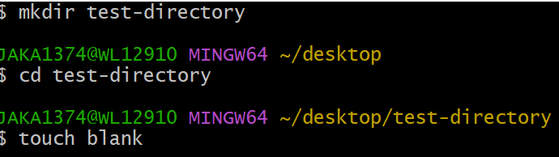
2. Then write the content "Hello" five times to the file greetings.txt.

Then copy the file greetings.txt and paste its contents into 1.txt, 2.txt, 3.txt, 4.txt and 5.txt.

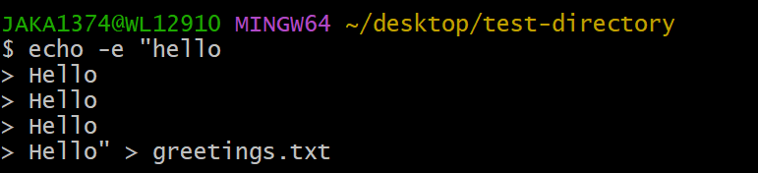

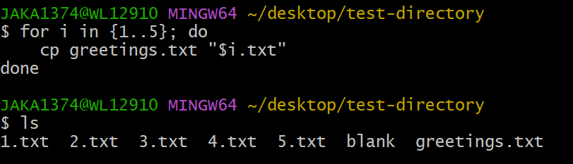

1. Then write the text "cat" to pets.txt

Then append the text "dog" to pets.txt

Then append the text "hamster" to pets.txt

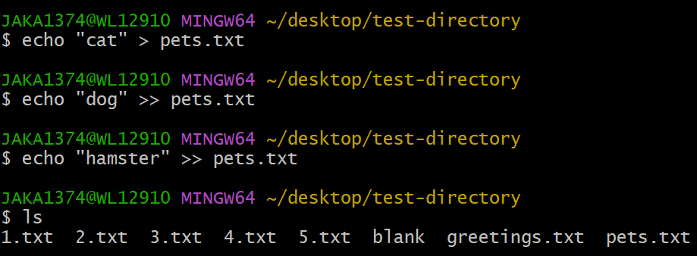

4. Then write the text "cat" to commands.txt

Then append the text "ls" to commands.txt

Then append the text "pwd" to commands.txt

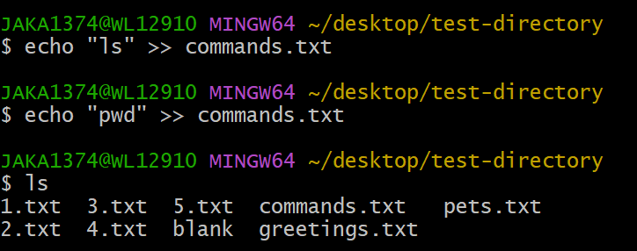

5. Then find unique strings from these two files pets.txt and commands.txt

and store the unique strings in lovelyCommands.txt

