🏛
CityConnect
Municipal Services Portal
─────────────────────────────────────
TECHNICAL DOCUMENTATION
Full-Stack Web Application | PHP | MySQL | HTML / CSS / JS / Bootstrap

Field | Details
Student Name | Naila Shehzadi
Roll Number | 08
Semester | 8th Semester
Instructor | Mam Imaan
Subject | Web Technologies / Full-Stack Development
Submission Date | June 2026
Project Title | CityConnect — Municipal Services Portal

1 | Project Overview & System Architecture
1.1 Introduction
CityConnect is a full-stack Municipal Services Portal developed for the City of Islamabad. The system enables citizens to report civic issues, view official announcements, and access public service information through a modern web interface. It also provides a secure administrative dashboard where municipal staff can manage complaints and publish official notices.

1.2 Homepage — Public Portal
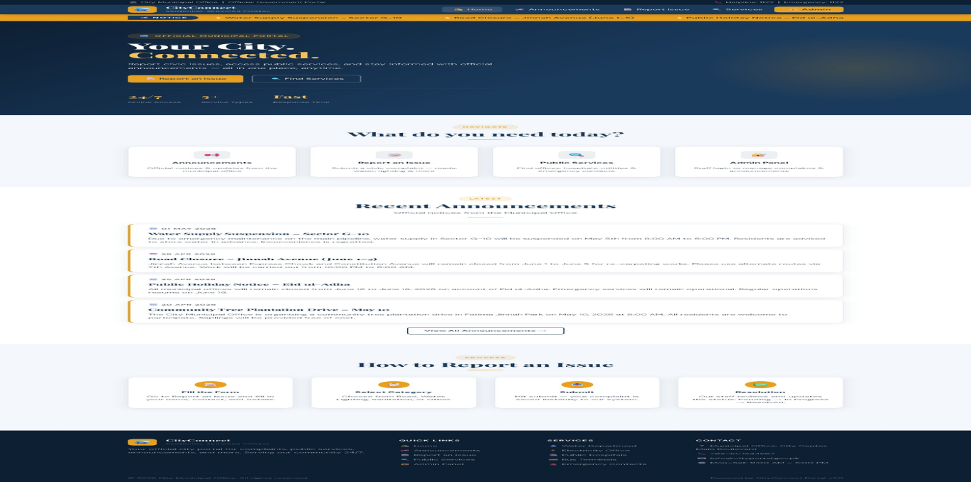
Figure: CityConnect Homepage (index.php) — Hero section, navigation cards, announcements & how-to steps

1.3 Project Objectives
- Allow citizens to submit civic complaints without requiring user registration
- Provide a real-time admin dashboard for managing complaints and announcements
- Display a searchable public services directory with government office contact details
- Publish official announcements visible to all citizens on the public portal
- Ensure responsive design across desktop, tablet, and mobile devices
- Implement secure admin login and PHP session-based access control

2 | File Structure & Technology Stack

2 Technology Stack
Layer | Technologies Used
Front-End | HTML5, CSS3, Bootstrap 5, JavaScript (ES6+)
Back-End | PHP 8.2 running on Apache (XAMPP)
Database | MySQL / MariaDB 10.4 via phpMyAdmin
Dev Environment | XAMPP on Windows, VS Code
Web Server | Apache 2.4.58 (Win64) with OpenSSL 3.1.3
PHP Version | PHP 8.2.12 with mysqli, curl, mbstring

2.3 System Architecture
CityConnect uses a classic three-tier architecture. The Presentation Tier consists of HTML/CSS/Bootstrap/JavaScript pages rendered in the browser. The Application Tier is PHP scripts on Apache handling business logic, form processing, and session management. The Data Tier is a MySQL relational database (city_portal) with three tables: announcements, complaints, and services.

3 | Question 1 — Front-End Design: HTML5 & CSS3
CLO-03 | PLO-05 | P3 Practice | WK2 | EC3,5 | SDG 9 | Rubric: Correctness | Points: 08

3.1 HTML5 Semantic Structure
Every page uses HTML5 semantic elements for proper document structure and accessibility. The <header> contains the navigation bar, <main> holds the page content, <section> divides logical blocks, <article> wraps individual announcements, and <footer> provides site-wide contact information. The viewport meta tag ensures mobile responsiveness.

3.2 Announcements Public Page
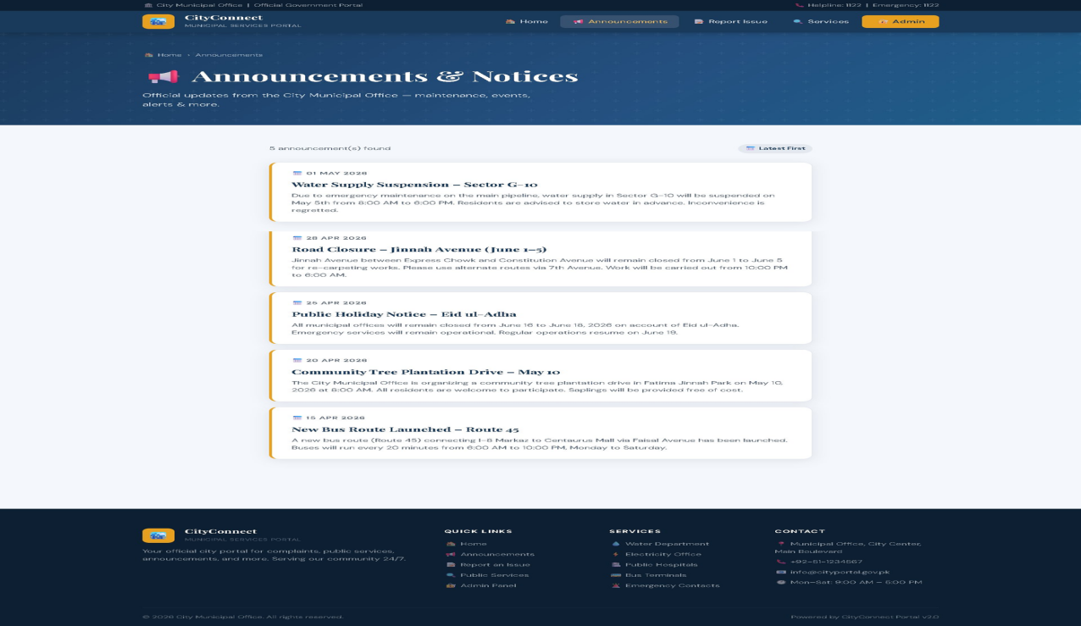
Figure: Public Announcements page (announcements.php) — listing of 5 official municipal notices with dates

3.3 CSS Design System
A custom stylesheet defines the CityConnect brand identity using a dark navy (#1B2A4A) and gold (#E8A020) color scheme. CSS custom properties (variables) are used for consistent theming. Card hover effects use CSS transitions (transform: translateY, box-shadow) for interactive visual feedback. The hero section uses a linear-gradient background for a professional government portal appearance.

4 | Bootstrap 5 Responsive Layout & Navigation

4.1 Bootstrap Grid System
Bootstrap 5's 12-column grid is used throughout. The navigation cards use col-12 col-sm-6 col-lg-3 making them display 4 per row on desktop, 2 per row on tablet, and stacked on mobile. Admin tables use Bootstrap's table-responsive wrapper for horizontal scrolling on small screens.

4.2 Public Services Directory
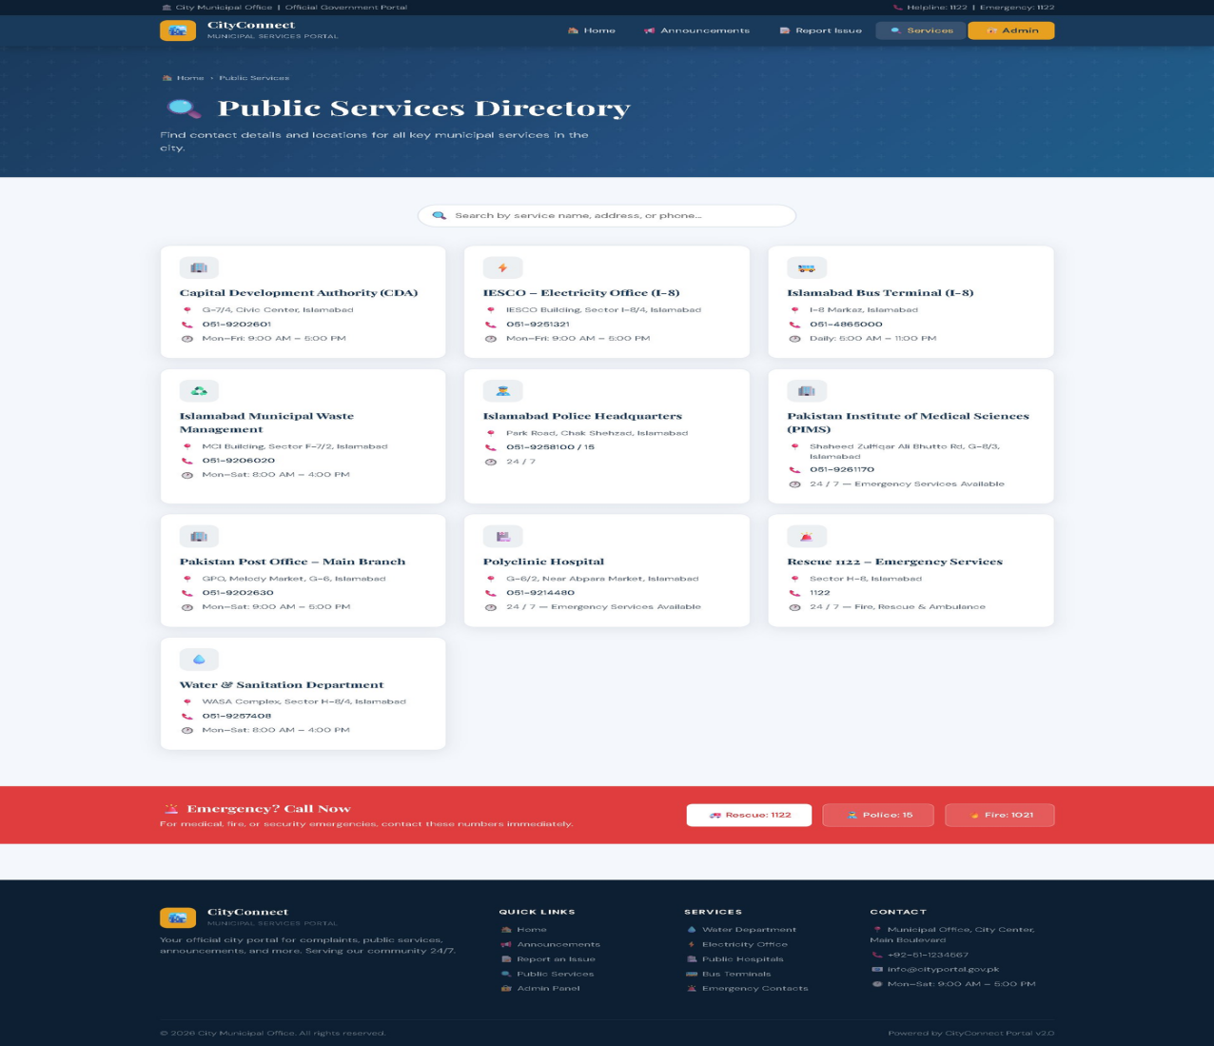
Figure: Public Services Directory (services.php) — 10 service cards with live search and emergency contacts section

4.3 Bootstrap Components
Component | Usage in CityConnect
Navbar (navbar-expand-lg) | Responsive collapsing navigation with hamburger menu on mobile
Grid (col-12/sm-6/lg-3) | Responsive card layouts that adapt to all screen sizes
Table (table-responsive) | Admin complaint tables with horizontal scroll on mobile
Badge | Status indicators: Pending (amber), In Progress (blue), Resolved (green)
Alert | Privacy notice on complaint form and admin authorization message
Button (btn-warning) | Golden Admin button in navbar; primary navy submit buttons

5 | Question 2 — Client-Side Scripting & Validation (JavaScript)
CLO-03 | PLO-05 | P3 Practice | WK2 | EC3,5 | SDG 9 | Rubric: Logic | Points: 04

5.1 Complaint Form — Empty State
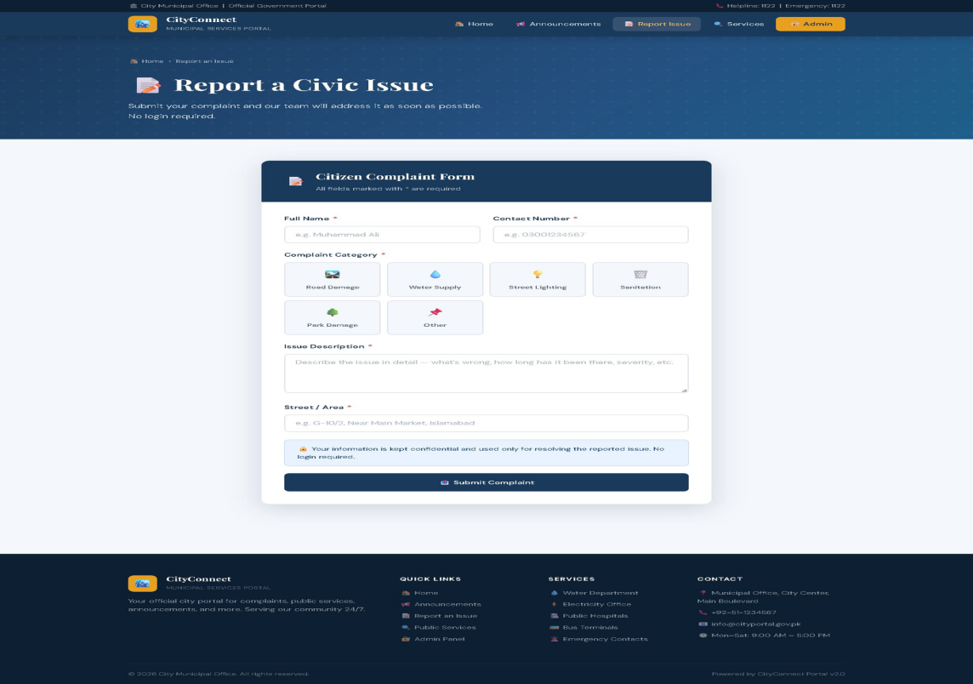
Figure: Citizen Complaint Form (complaint.php) — empty form showing category tiles, input fields, and privacy notice

5.2 How JavaScript Improves Performance & UX
JavaScript handles form validation on the client side before any data is sent to the PHP server. This eliminates unnecessary server requests for invalid submissions, provides instant feedback to the user without page reloads, and creates a more fluid, app-like experience. Key JavaScript features include: real-time field validation, interactive category tile selection, live search filtering in the services directory, and admin complaint status filtering.

6 | JavaScript Form Validation & Dynamic Interactions

6.1 Complaint Form — Filled & Validated
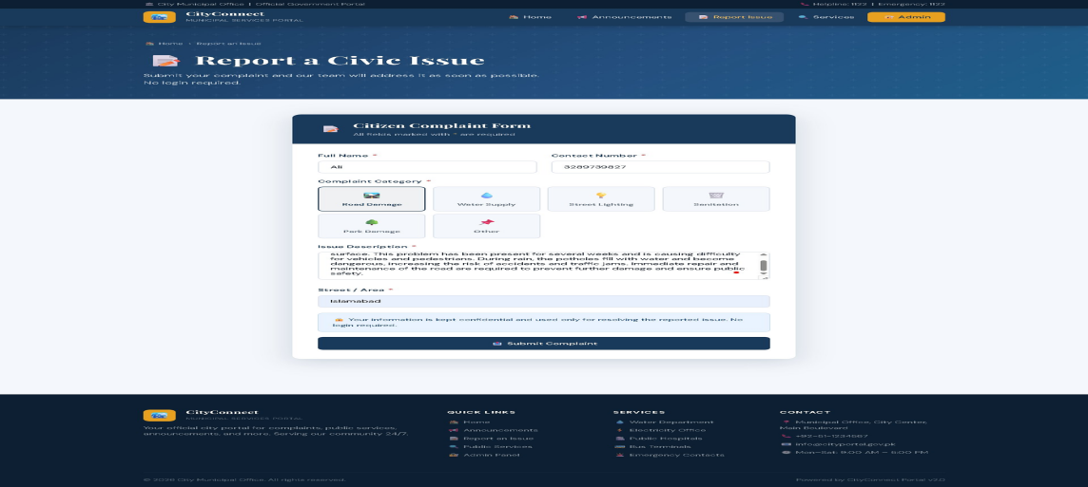
Figure: Complaint form filled with data — Road Damage category selected (highlighted tile), description and area entered

6.2 JavaScript Validation Features
- Full Name validation: minimum 2 characters, whitespace trimmed before check
- Contact Number: Pakistan mobile regex /^03[0-9]{9}$/ — enforces 11-digit format starting with 03
- Category selection: JavaScript highlights clicked tile and stores value in a hidden input field
- Description: minimum 20 characters required before submission is allowed
- Street/Area: required field, cannot be empty or whitespace-only
- Live search in services.php: filters all 10 service cards in real-time as user types
- Admin filter buttons: show All / Pending / In Progress / Resolved complaints without page reload

6.3 Category Tile Interaction
The complaint category selector replaces standard radio buttons with a grid of clickable icon tiles. When a user clicks a category (Road Damage, Water Supply, Street Lighting, Sanitation, Park Damage, Other), JavaScript removes the 'selected' CSS class from all tiles and adds it to the clicked one, creating a visible highlight border. The category value is simultaneously stored in a hidden HTML input for form submission.

7 | Question 3 — Server-Side Development & Data Handling (PHP)
CLO-03 | PLO-05 | P3 Practice | WK2 | EC3,5 | SDG 9 | Rubric: Syntax | Points: 04

7.1 PHP Role in CityConnect
PHP serves as the complete back-end of CityConnect. It handles HTTP POST requests from forms, sanitizes all user input using htmlspecialchars() and trim(), processes data with business logic, executes prepared SQL statements against MySQL, manages admin sessions, and returns updated HTML pages to the browser. A centralized db.php include file manages the database connection using MySQLi, ensuring DRY (Don't Repeat Yourself) architecture.

7.2 Admin Login Page

Figure: Admin Login (admin/login.php) — secure authentication form with staff-only notice

7.3 PHP Key Features
- Prepared statements with bind_param() used for all INSERT and UPDATE queries — prevents SQL injection
- htmlspecialchars() applied to all user inputs before output — prevents XSS attacks
- session_start() and $_SESSION variables control admin authentication state
- POST-Redirect-GET pattern: after successful form submission, PHP redirects to prevent duplicate submissions on page refresh
- PHP date() function formats all dates consistently (e.g., 01 May 2026) across all pages

8 | Database Design — MySQL / phpMyAdmin

8.1 city_portal Database Overview
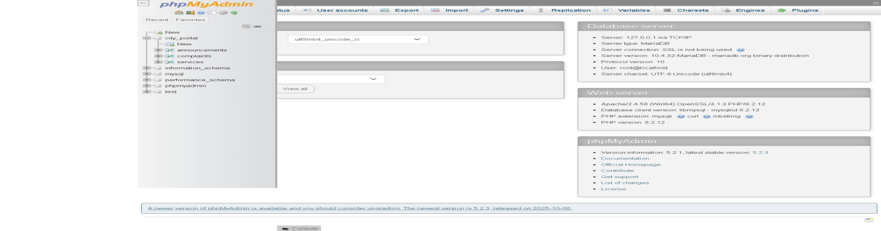
Figure: phpMyAdmin showing city_portal database with 3 tables: announcements, complaints, services

8.2 Announcements Table Data
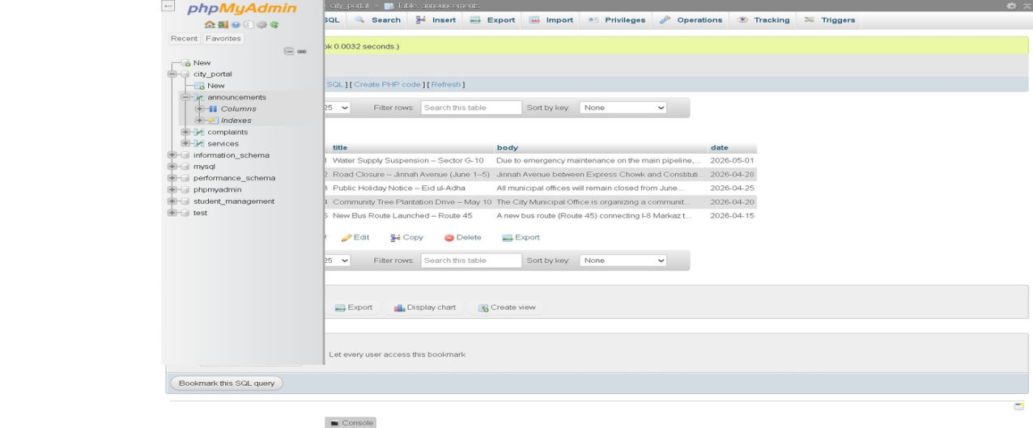
Figure: announcements table — 5 records with id, title, body (truncated), and date columns

8 | Database Tables — Complaints & Services

8.3 Complaints Table Data
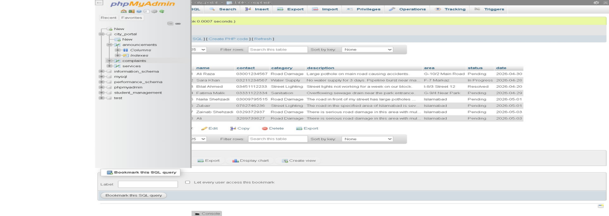
Figure: complaints table — 8 records showing name, contact, category, description, area, status, date

8.4 Services Table Data
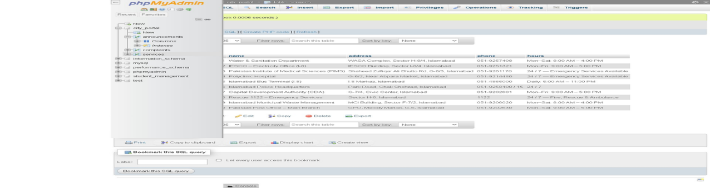
Figure: services table — 10 Islamabad municipal services with name, address, phone, and hours

8.5 Database Schema Summary
Table | Columns & Key Design
complaints | id (PK), name, contact, category, description, area, status ENUM('Pending','In Progress','Resolved'), date
announcements | id (PK), title VARCHAR(255), body TEXT, date DATE
services | id (PK), name, address, phone, hours — static reference data for public directory

9 | Admin Panel — Dashboard & Complaint Management

9.1 Admin Dashboard
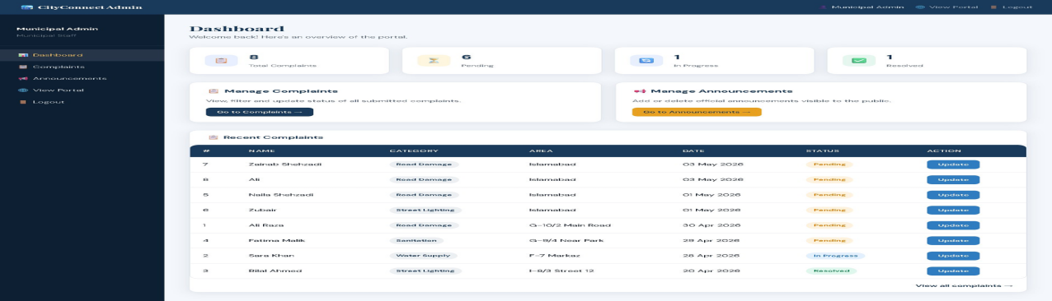
Figure: Admin Dashboard (admin/dashboard.php) — summary statistics, quick action cards, recent complaints table with Update buttons

9.2 Admin Complaints Management
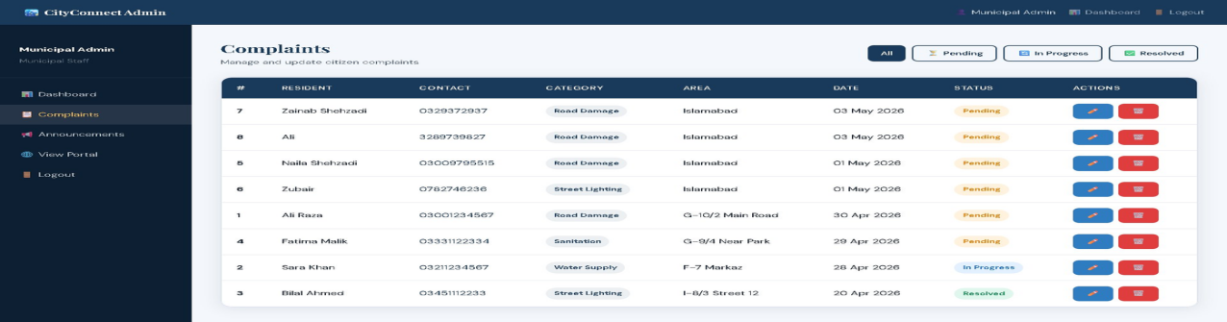
Figure: Admin Complaints (admin/complaints.php) — full table with All/Pending/In Progress/Resolved filter buttons, edit & delete actions

9.3 Dashboard Features
- 4 summary stat cards: Total Complaints (8), Pending (6), In Progress (1), Resolved (1)
- Quick action buttons: Go to Complaints and Go to Announcements
- Recent Complaints table with inline Update buttons for quick status changes
- Color-coded status badges: amber Pending, blue In Progress, green Resolved

10 | Admin Announcements + Question 4: Integration & Conclusion

10.1 Admin Announcements Management
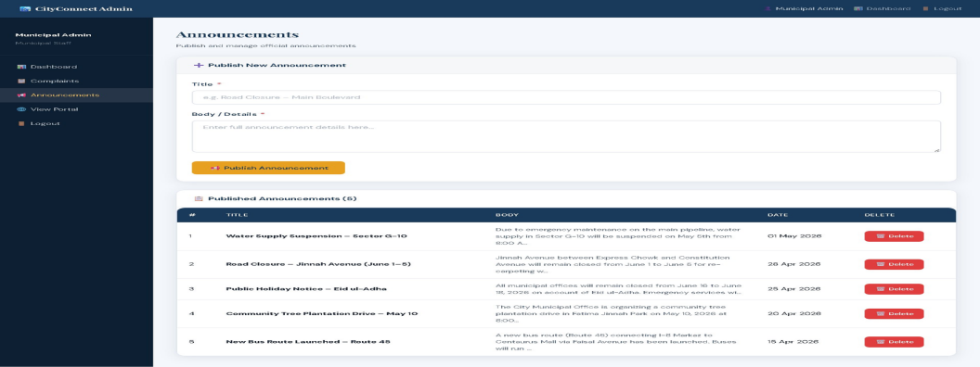
Figure: Admin Announcements (admin/announcements.php) — publish form with title/body fields and Published Announcements table with Delete buttons

Question 4: CLO-03 | PLO-05 | P3 Practice | WK2 | EC3,5 | SDG 9 | Rubric: Syntax | Points: 04

10.2 System Integration
CityConnect demonstrates complete front-to-back integration. Citizens fill the HTML form → JavaScript validates inputs client-side → HTTP POST sends data to PHP → PHP sanitizes inputs and uses prepared statements to INSERT into MySQL → PHP redirects to show a success message. The admin can log in → PHP session is set → dashboard loads live data queried from MySQL → admin updates complaint status → PHP executes a parameterized UPDATE query → the page refreshes with the new status.

10.3 Security & Performance
Area | Implementation
SQL Injection | All queries use mysqli prepared statements with bind_param()
XSS Prevention | htmlspecialchars() applied to all displayed user input
Session Security | PHP session check on every admin page; redirect if unauthenticated
Performance | Client-side search/filter eliminates unnecessary server requests
Scalability | InnoDB tables support indexing; db.php centralizes connection config

10.4 Conclusion
CityConnect successfully implements a complete full-stack municipal portal addressing all four assignment questions. The system demonstrates professional engineering practices including semantic HTML5, responsive Bootstrap layout, JavaScript client-side validation, PHP server-side processing with prepared statements, MySQL relational database design, secure session management, and a clean separation between presentation, logic, and data layers.

