**Ногтиков Никита Алексеевич**

**Лабораторная работа №2**

1)

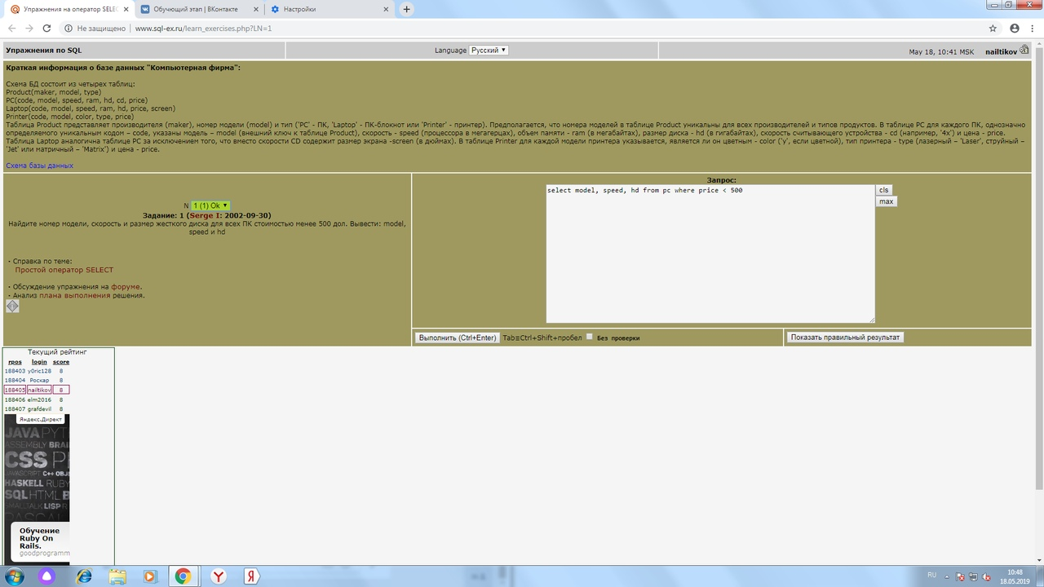

2)

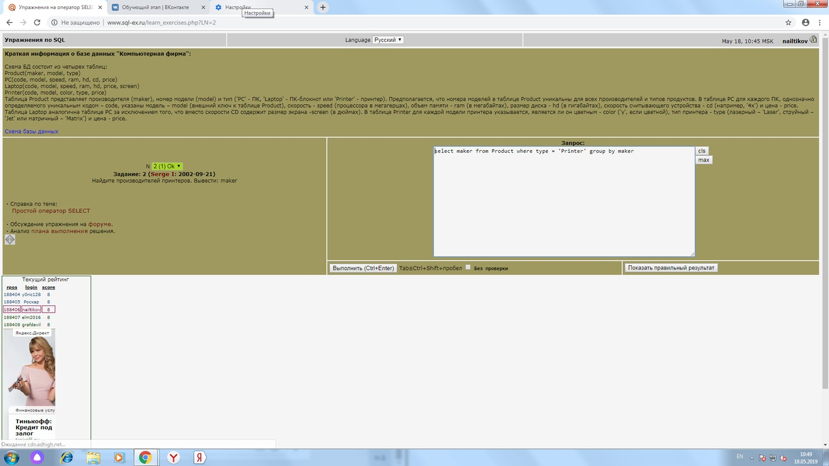

3)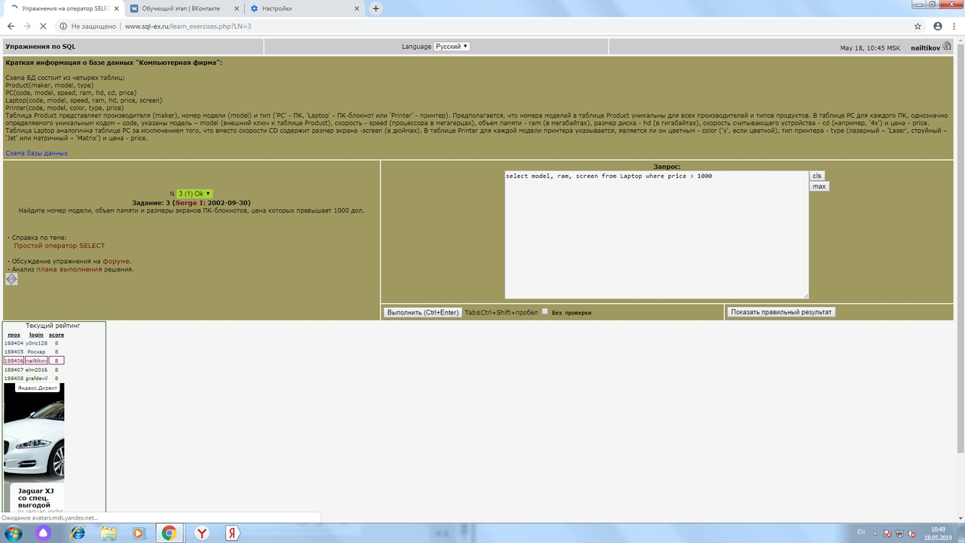

4)

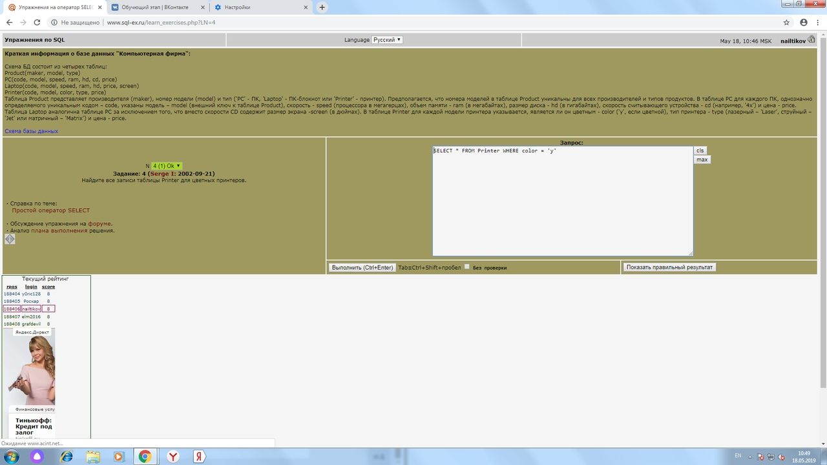

5)

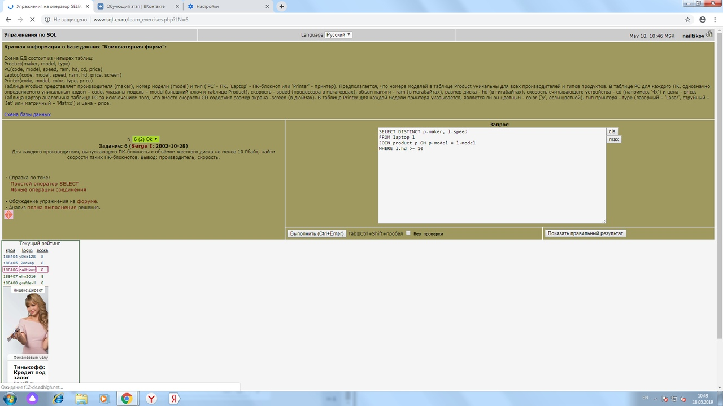

6)

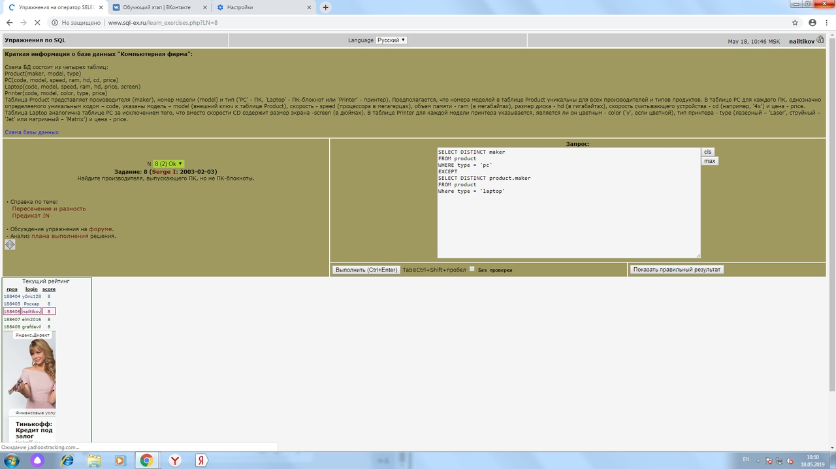

**Лабораторная работа №4**

select p.pname,bad, satisfact, good, fine

from predmet p left join (select usp.upnum, count (umark) as bad

from usp

where usp.mark = 2

group by usp.upnum) Mark2 on p.pnum= Mark2.upnum

left join (select usp.upnum, count (umark) as satisfact

from usp

where usp.mark = 3

group by usp.upnum) Mark3 on p.pnum= Mark3.upnum

left join (select usp.upnum, count (umark) as good

from usp

where usp.mark = 4

group by usp.upnum) Mark4 on p.pnum= Mark4.upnum

left join (select usp.upnum, count (umark) as fine

from usp

where usp.mark = 5

group by usp.upnum) Mark5 on p.pnum= Mark5.upnum

**Лабораторная работа №3**

select th_surename, th_name, th_midlename, count(m_value)

from teach th join mark m on th_num = m_tnum

where m_snum in

{

select m_snum

from mark m

group by (m_snum)

having avg(m_value) < 4

}

and m_value = 2

group by th_surename, th_name, th_midlename

Задание 2.

вариант 1

select st_surename, st_name, st_midlename, count(m_value)

from student st join mark m on st_num in

{

select m_snum

from mark m

group by (m_snum)

having (m_value) <>2

}

вариант 2

select S.s_Surename, S.s_Name,S.s_Midlename

from Stud S

where not exists

(

select *

from mark m

where m.m_value = 2 and s.s_num = m.m_snum

)

group by s.s_surename, s.s_name,s.s_midlename

Задание 1.

select count(m_snum)

from mark m

where m_tnum in

{

select m_tnum

from mark m

where m_value = 2

group by m_tnum

order by count(m_tnum) desc

}

and m_value = 5