**Q1.**

`timescale 1ns/1ps // Add time unit and time precision

module nand_using_mux (

input A, // First input

input B, // Second input

output Y // Output (A NAND B)

);

wire not_B;

// Invert B (NOT B)

assign not_B = ~B;

// 2:1 MUX logic

// If A = 0, Y = 1

// If A = 1, Y = not_B

assign Y = (A) ? not_B : 1'b1;

endmodule

`timescale 1ns/1ps // Add time unit and time precision

module test_nand_using_mux;

// Inputs

reg A;

reg B;

// Output

wire Y;

// Instantiate the NAND gate using MUX module

nand_using_mux uut (

.A(A),

.B(B),

.Y(Y)

);

// Test cases

initial begin

// Monitor the inputs and output

$monitor("Time = %0t | A = %b | B = %b | Y (A NAND B) = %b", $time, A, B, Y);

// Test case 1: A = 0, B = 0 -> Y = 1

A = 0; B = 0;

#10;

// Test case 2: A = 0, B = 1 -> Y = 1

A = 0; B = 1;

#10;

// Test case 3: A = 1, B = 0 -> Y = 1

A = 1; B = 0;

#10;

// Test case 4: A = 1, B = 1 -> Y = 0

A = 1; B = 1;

#10;

// End the simulation

$finish;

end

endmodule

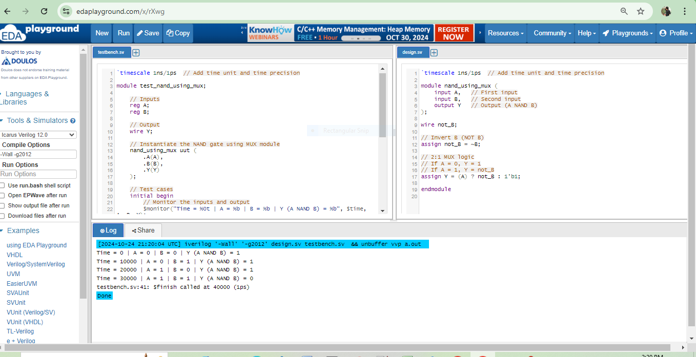

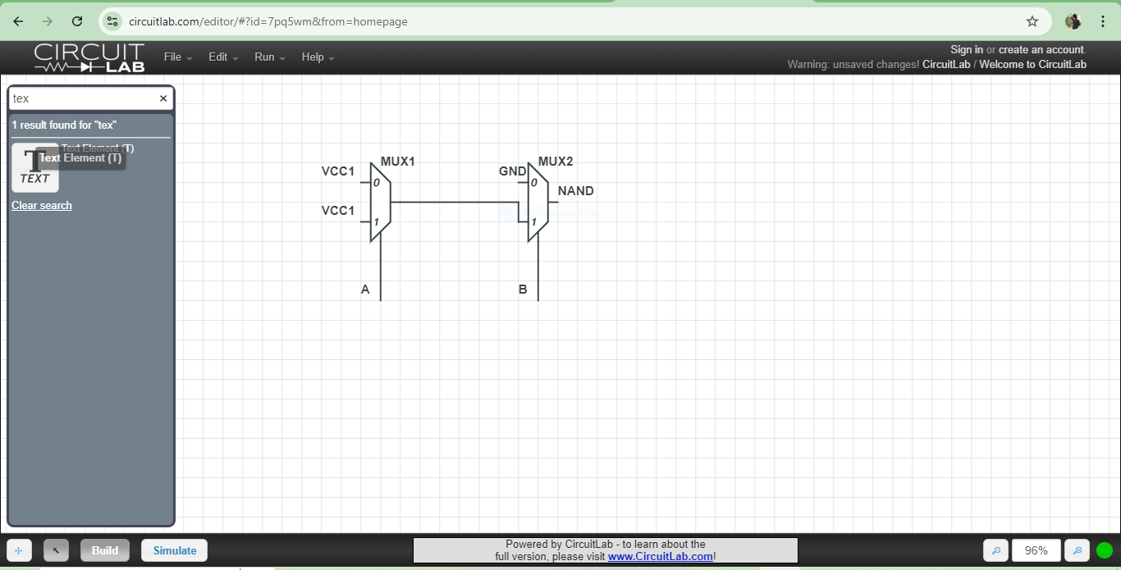

**Q2.**

module swap_registers (

input wire [7:0] A_in, // Input to register A (8 bits)

input wire [7:0] B_in, // Input to register B (8 bits)

input wire clk, // Clock signal

input wire rst, // Reset signal

input wire swap_en, // Enable signal for swap operation

output reg [7:0] A_out, // Output of register A (after swap)

output reg [7:0] B_out // Output of register B (after swap)

);

reg [7:0] A_temp, B_temp;

always @(posedge clk or posedge rst) begin

if (rst) begin

// Reset both registers to initial values

A_out <= 8'b0;

B_out <= 8'b0;

A_temp <= 8'b0;

B_temp <= 8'b0;

end

else if (swap_en) begin

// XOR swap logic in 3 steps

// Step 1: A_out = A_in ^ B_in

A_temp <= A_in ^ B_in;

// Step 2: B_out = A_in

B_temp <= A_in;

end

else begin

// Step 3: Swap the final values

A_out <= A_temp ^ B_temp;

B_out <= A_temp ^ B_in;

end

end

endmodule

module test_swap_registers;

reg [7:0] A_in;

reg [7:0] B_in;

reg clk;

reg rst;

reg swap_en;

wire [7:0] A_out;

wire [7:0] B_out;

// Instantiate the swap_registers module

swap_registers uut (

.A_in(A_in),

.B_in(B_in),

.clk(clk),

.rst(rst),

.swap_en(swap_en),

.A_out(A_out),

.B_out(B_out)

);

// Clock generation

always #5 clk = ~clk; // 10ns clock period

initial begin

// Initialize inputs

clk = 0;

rst = 1;

swap_en = 0;

A_in = 8'hAA; // Example value for A (0xAA)

B_in = 8'h55; // Example value for B (0x55)

// Release reset after 10ns

#10 rst = 0;

// Enable swapping

#10 swap_en = 1;

#10 swap_en = 0; // Disable after one clock cycle

// Wait and observe results

#50 $finish;

end

initial begin

// Monitor changes in the signals

$monitor("Time = %0t | A_in = %h, B_in = %h | A_out = %h, B_out = %h", $time, A_in, B_in, A_out, B_out);

end

endmodule

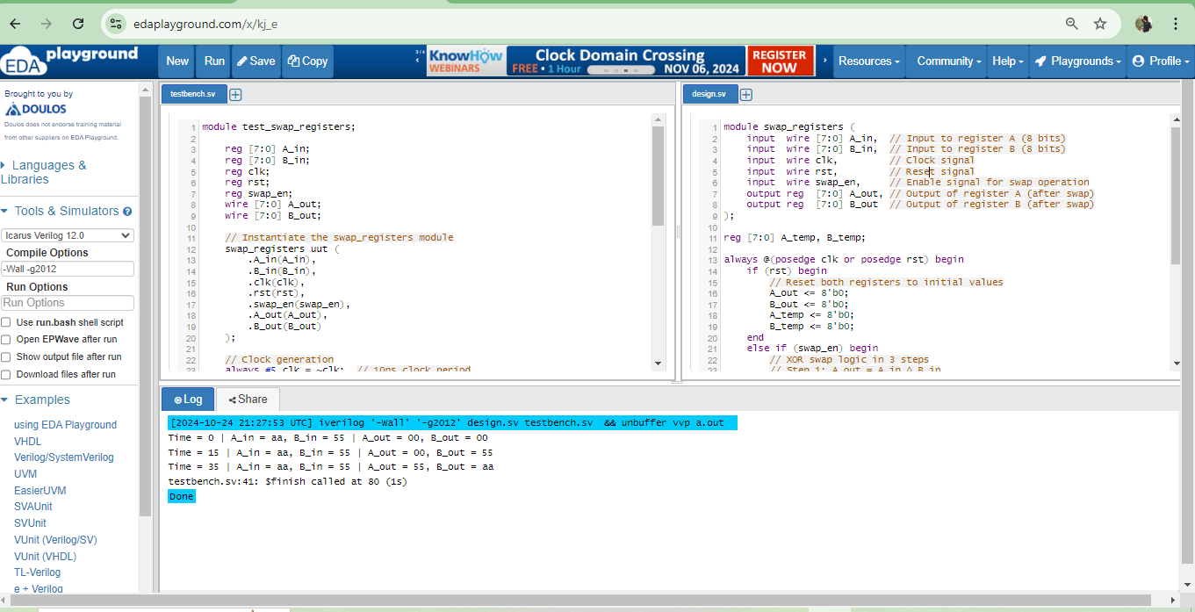

**Q3.**  
`timescale 1ns / 1ps // Time unit is 1 nanosecond, time precision is 1 picosecond

module t_ff (

input wire clk, // Clock input

input wire rst, // Asynchronous reset input

input wire t, // Toggle control input

output reg q // Output of the T-FF

);

// Always block triggered on the rising edge of the clock or reset

always @(posedge clk or posedge rst) begin

if (rst)

q <= 1'b0; // Reset output to 0

else if (t)

q <= ~q; // Toggle output when t is high

else

q <= q; // Hold state when t is low

end

endmodule

`timescale 1ns / 1ps // Time unit is 1 nanosecond, time precision is 1 picosecond

module t_ff_tb;

reg clk, rst, t;

wire q;

// Instantiate the T-FF module

t_ff my_tff(

.clk(clk),

.rst(rst),

.t(t),

.q(q)

);

// Clock generation: toggle clock every 10 ns (20 ns period)

always #10 clk = ~clk;

// Stimulus block to test the T-FF

initial begin

// Initialize signals

clk = 0;

rst = 1; t = 0;

#15 rst = 0; // Release reset after 15 ns

#20 t = 1; // Enable toggle after 35 ns

#40 t = 0; // Disable toggle after 75 ns

#20 t = 1; // Enable toggle again after 95 ns

#60 t = 0; // Disable toggle after 155 ns

#20;

$finish; // Finish simulation after 175 ns

end

// Monitor changes during simulation

initial begin

$monitor("Time = %t, rst = %b, t = %b, q = %b", $time, rst, t, q);

end

endmodule

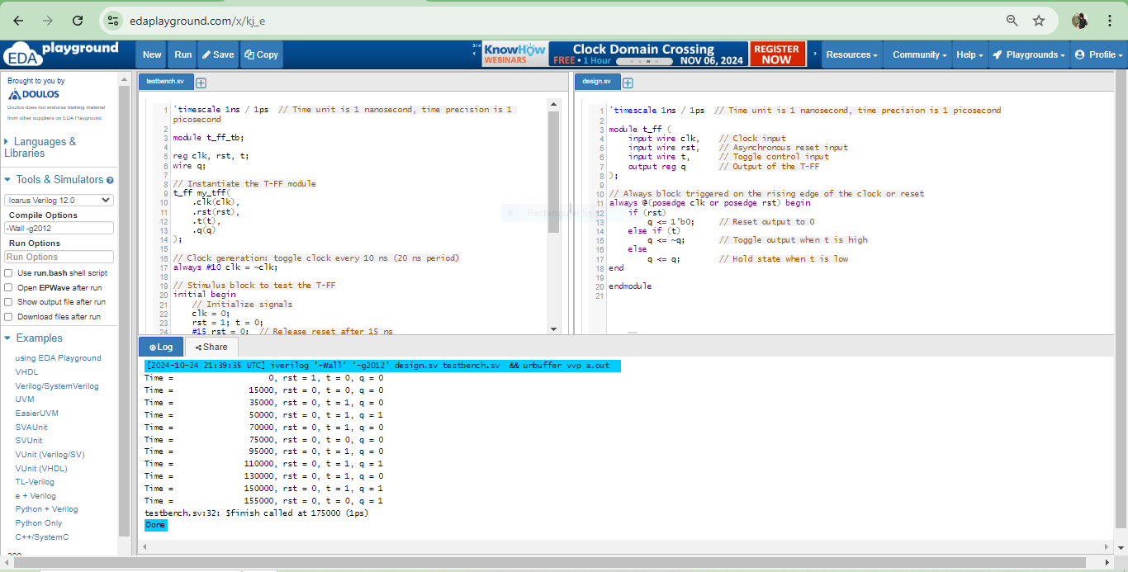

**Q4.**

`timescale 1ns / 1ps // Time unit is 1 nanosecond, time precision is 1 picosecond

module comparator_1bit(

input wire A, // 1-bit input A

input wire B, // 1-bit input B

output wire A_greater_B, // Output is 1 if A > B

output wire A_equal_B, // Output is 1 if A == B

output wire A_less_B // Output is 1 if A < B

);

// A > B happens when A is 1 and B is 0

assign A_greater_B = A & ~B;

// A == B happens when both A and B are either 0 or both are 1

assign A_equal_B = ~(A ^ B); // XNOR gate (A equals B)

// A < B happens when A is 0 and B is 1

assign A_less_B = ~A & B;

endmodule

`timescale 1ns / 1ps // Time unit is 1 nanosecond, time precision is 1 picosecond

module comparator_1bit_tb;

reg A, B;

wire A_greater_B, A_equal_B, A_less_B;

// Instantiate the comparator

comparator_1bit uut(

.A(A),

.B(B),

.A_greater_B(A_greater_B),

.A_equal_B(A_equal_B),

.A_less_B(A_less_B)

);

// Stimulus block

initial begin

// Test case 1: A = 0, B = 0

A = 0; B = 0;

#10;

// Test case 2: A = 0, B = 1

A = 0; B = 1;

#10;

// Test case 3: A = 1, B = 0

A = 1; B = 0;

#10;

// Test case 4: A = 1, B = 1

A = 1; B = 1;

#10;

$finish;

end

// Monitor changes

initial begin

$monitor("At time %t: A = %b, B = %b => A_greater_B = %b, A_equal_B = %b, A_less_B = %b",

$time, A, B, A_greater_B, A_equal_B, A_less_B);

end

endmodule

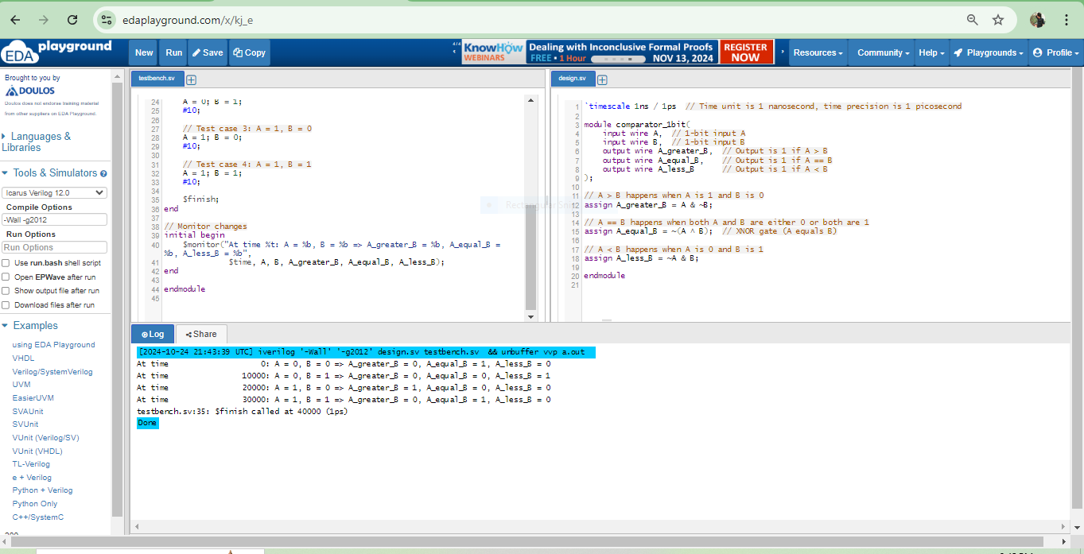

**Q5.**

`timescale 1ns / 1ps // Time unit is 1 nanosecond, time precision is 1 picosecond

module dff_gatelevel (

input wire D, // Data input

input wire CLK, // Clock input

output wire Q, // Q output

output wire Qn // Q-bar output (negation of Q)

);

wire Dn; // Inverted D

wire S, R; // Outputs of the AND gates

// Instantiate NOT gate for D negation

not U1 (Dn, D);

// Instantiate AND gates

and U2 (S, D, CLK); // Set input: D AND CLK

and U3 (R, Dn, CLK); // Reset input: NOT D AND CLK

// Instantiate NOR gates for SR latch

nor U4 (Q, R, Qn); // NOR gate for Q

nor U5 (Qn, S, Q); // NOR gate for Q-bar

endmodule

`timescale 1ns / 1ps // Time unit is 1 nanosecond, time precision is 1 picosecond

module dff_gatelevel_tb;

reg D, CLK; // Inputs for the DFF

wire Q, Qn; // Outputs from the DFF

// Instantiate the DFF module

dff_gatelevel uut (

.D(D),

.CLK(CLK),

.Q(Q),

.Qn(Qn)

);

// Generate clock signal with a 20 ns period (toggle every 10 ns)

always #10 CLK = ~CLK;

// Initial block to set input stimulus

initial begin

// Initialize inputs

D = 0;

CLK = 0;

// Apply input stimulus

#15 D = 1; // Set D to 1

#30 D = 0; // Set D to 0

#30 D = 1; // Set D to 1 again

#20 D = 0; // Set D to 0 again

#50 $finish; // End simulation

end

// Monitor to observe output changes

initial begin

$monitor("Time = %t | D = %b | CLK = %b | Q = %b | Qn = %b",

$time, D, CLK, Q, Qn);

end

endmodule

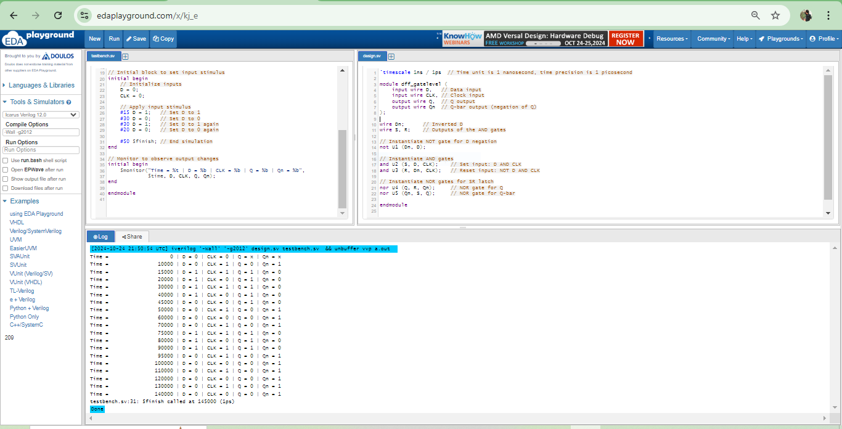

**Q6.**

// UDP for NAND Gate

primitive nand_gate (out, a, b);

output out;

input a, b;

table

// a b : out

0 0 : 1;

0 1 : 1;

1 0 : 1;

1 1 : 0;

endtable

endprimitive

// UDP for AND Gate

primitive and_gate (out, a, b);

output out;

input a, b;

table

// a b : out

0 0 : 0;

0 1 : 0;

1 0 : 0;

1 1 : 1;

endtable

endprimitive

// UDP for OR Gate

primitive or_gate (out, a, b);

output out;

input a, b;

table

// a b : out

0 0 : 0;

0 1 : 1;

1 0 : 1;

1 1 : 1;

endtable

endprimitive

// UDP for NOT Gate

primitive not_gate (out, a);

output out;

input a;

table

// a : out

0 : 1;

1 : 0;

endtable

endprimitive

`timescale 1ns / 1ps // Time unit is 1 nanosecond, time precision is 1 picosecond

`include "udp_definitions.sv" // Include the UDP definitions

module top_module (

input wire A, B, C, // Inputs

output wire X, Y // Outputs

);

wire nand_out, and_out;

// Instantiate the NAND gate (inputs A, C)

nand_gate U1 (nand_out, A, C);

// Instantiate the AND gate (inputs B, nand_out)

and_gate U2 (and_out, B, nand_out);

// Instantiate the OR gate (for X output)

or_gate U3 (X, and_out, B);

// Instantiate the NOT gate (for Y output)

not_gate U4 (Y, nand_out);

endmodule

`timescale 1ns / 1ps // Time unit is 1 nanosecond, time precision is 1 picosecond

module top_module_tb;

reg A, B, C;

wire X, Y;

// Instantiate the top module

top_module uut (

.A(A),

.B(B),

.C(C),

.X(X),

.Y(Y)

);

// Apply test vectors

initial begin

// Test Case 1

A = 0; B = 0; C = 0;

#10;

// Test Case 2

A = 0; B = 1; C = 0;

#10;

// Test Case 3

A = 1; B = 0; C = 1;

#10;

// Test Case 4

A = 1; B = 1; C = 0;

#10;

$finish;

end

// Monitor outputs

initial begin

$monitor("Time = %t | A = %b | B = %b | C = %b | X = %b | Y = %b",

$time, A, B, C, X, Y);

end

endmodule

