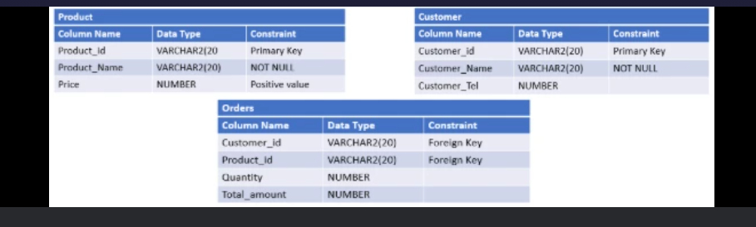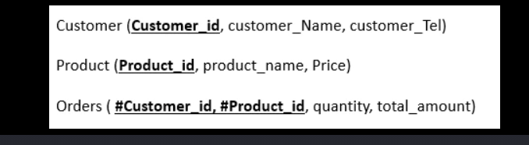

<-----------------------------Création des tables------------------------------------>

CREATE TABLE PRODUCT (

Product_id VARCHAR2(20) CONSTRAINT Pk_product PRIMARY KEY,

Product_name VARCHAR2(20) CONSTRAINT Name_cons NOT NULL,

Price NUMBER CONSTRAINT Positive CHECK (Price>0);

);

CREATE TABLE CUSTOMER (

Customer_id VARCHAR2(20) CONSTRAINT Pk_customer PRIMARY KEY,

Customer_name VARCHAR2(20) CONSTRAINT Name_cons NOT NULL,

Customer_tel Number

);

CREATE TABLE ORDERS (

CONSTRAINT Fk_product FOREIGN KEY (Product_id) REFERENCES PRODUCT (Product_id),

CONSTRAINT Fk_customer FOREIGN KEY (Customer_id) REFERENCES PRODUCT (Customer_id),

Quantity Number,

Total_amount

);

<---------Add a column Category (VARCHAR2(20)) to the PRODUCT table-------->

ALTER TABLE PRODUCT ADD Category VARCHAR2(20);

<---Add a column OrderDate (DATE) to the ORDERS table which have SYSDATE as a default value.-------->

ALTER TABLE ORDRES ADD OrderDate DATE  DEFAULT sysdate;