Naima Aqeel

A marketing data Analyst

To increasing brand awareness, market share, and product development.

CodeX is a German beverage company that is aiming to make its mark in the Indian market. A few months ago, they launched their energy drink in 10 cities in India.

**Task**

A marketing data analyst is tasked to convert these survey results to meaningful insights which the team can use to drive actions. Marketing team is responsible for increasing brand awareness, market share, and product development.

**Introduction**

In this report, we will explore effective strategies to enhance brand awareness, improvement and drive market share growth for energy drink. Our goal is to provide innovative ideas that will captivate target audience and differentiate brand from competitors. By implementing these strategies, establish a strong market presence, attract new customers, and ultimately achieve significant business growth.

**Statistical Analysis**

Statistical methods and techniques are applied in many fields of study. Special techniques are derived for specific problems, but the basic strategies and principles are common in most applications. The appropriate statistical techniques, to achieve the objective of the study, include descriptive analysis by using Pivot Table to gain insights from the survey data. Descriptive analysis involves summarizing and organizing data to gain insides and understand patterns and understand the relationship between variables. This descriptive analysis using a pivot table provides a comprehensive overview of the survey findings and enhances the understanding of the data.

Additionally, created charts based on these pivot tables to visually represent the insights. These charts provide clear relationships between variables and the patterns. It enhances the understanding of the data and makes it easier.

**Methodology**

Conduct a survey in 10 cities by designing a questionnaire and received results from 10k respondents. The questionnaire was distributed to participants in each city, and they filled it. We took steps to ensure the validity and reliability of the questionnaire, such as pilot testing and using standardized scales.

**Data Analysis and Findings**

**Brand Improvement& Brand Awareness**

To enhance brand improvement and awareness, I conduct an analysis of customer brand perception. This analysis allows me to gain insights into how customers perceive the brand. By understanding their perceptions, I identify areas for improvement and develop strategies to boost brand awareness.

**Current Situation**

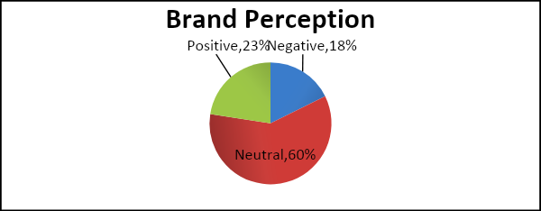In current situation, it appears that the majority of customers have a neutral opinion about our brand. To delve deeper into this matter, we inquire whether customers have ever tried our drinks. We collect information; they have ever tried our drinks. If yes, how would they rate the taste? If they haven’t tried, we inquire the reasons why.

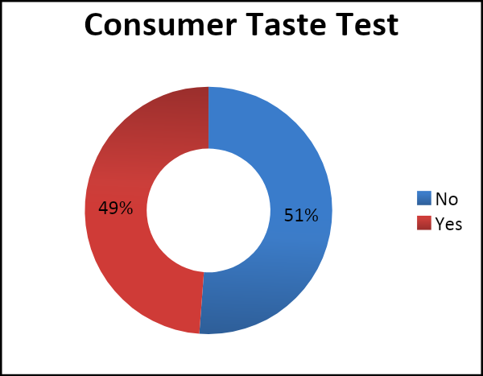

Based on the Doughnut, we observed that 51% of customers have never tried our energy drink.

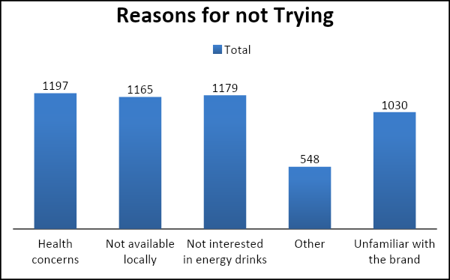

Bar-Chart represents the distribution of different factors, why customers have never tasted our Energy Drinks.

The top reasons for not trying our drinks include health concerns, lack of interest, and availability. These factors play a significant role in influencing customers' decisions. By understanding these reasons, we can better tailor our marketing strategies and address these concerns to encourage more people to try our drinks.

|  |  |  |
| --- | --- | --- |
| a) 1 (Poor)  b) 2 (Below Average)  c) 3 (Average)  d) 4 (Good)  e) 5 (Excellent)    Based on the taste experiences of those who have tried our products, that customers have a 30% positive sentiment towards their taste experience. This analysis indicates that needs serious improvement in terms of taste, which could potentially enhance customer satisfaction and brand loyalty. |  | |
| To gain further insights, we conducted a survey asking Ingredients they mostly like in energy drinks. The majority of individuals who consume energy drinks prioritize ingredients such as caffeine and vitamins.  .  Pie-Chart show energy drinks are a popular choice for many due toIngredients  Bar-Chart shows the improvements consumers needed.  Our analysis reveals that customers’ desire drinks are with reduce sugar, natural ingredients and a wide range of flavors.  To further improve our brand, we gathered packaging preferences for energy drinks.    Pie-Chart Represent the packaging preferences.    Bar-Chart Shows the ideal price suggestion.  This Analysis indicate 42% of respondents suggest a price range of 50-99, and 32% suggests 100-150, so 50-150 would be ideal price.  **Conclusion**  Based on our analysis, it appears that our taste is generally rated as not really good by those who have tried our products. The majority of individuals who consume energy drinks prioritize ingredients such as caffeine and vitamins. Our analysis also reveals that customers’ desire drinks are those that have reduce sugar, natural ingredients and a wide range of flavors.  However, by focusing on customer preferences for ingredients in energy drinks; we can develop products that better align with their tastes and ingredients that attract a larger customer.  For Brand Packaging Improvement as customers showed strong preferences for compact and portable cans (40%) and innovative bottle design (30%). These packaging options resonated well with their preferences.  Ideal Price range they suggested between 50-150.  Approximately 51% of customers have never tried our drink due to unavailability and unfamiliarity with the brand. This indicates a significant portion of potential customers who have yet to experience our product. By addressing these factors through improved distribution and increased brand awareness.  We have identified some areas for improvement, specifically in terms of availability brand familiarity and taste. This data-driven approach will help us enhance brand awareness and increase customer satisfaction.  **Marketing & Advertisement**  To increasing brand awareness and availability it is crucial to focus on marketing.  In our analysis, we conducted a survey to examine the target audience for energy drinks, their preferred platforms for seeing advertisements and purchases locations, and their age and gender demographics. |  | |
|  |  | |
|  |  | |
| Our analysis reveals that a significant portion of males aged 19-30 have a preference for energy drinks. This finding suggests that targeting this demographic with marketing efforts could yield favorable results. |  | |
| Clustered- Chart shows, energy drinks are a popular choice for many due to their ability to provide a quick boost in energy, enhance focus and combat fatigue and enhance sports performances.    Bar-chart shows, Consume Time when mostly consumer drink energy drinks. Mostly they consume energy drinks to stay awake during work/study and before exercise. |  | |
|  |  | |
|  | |
| Bar-Chart shows, current trends, online ads and TV commercials to reach a large audience compared to other channels |  | |
|  |  | |
| . | |
| Pie-Chart shows the majority of people prefer purchasing their drinks from supermarkets (45%) followed by online retailers (25%). |  | |
| **Conclusion**  Based on our analysis, we found that the key demographic of males aged 19-30 predominantly consume energy drinks to boost energy level, combat fatigue and enhance sports performance.  They mostly consume energy drinks to stay awake during work/study and before exercise.  They rely heavily on online ads and TV commercials for brand exposure. Their preferred purchasing channels are supermarkets and online retailers.  These insights help us by providing a clear understanding of our target audience's preferences and their behaviors. With this knowledge; we can tailor our marketing strategies to focus on online ads and TV commercials to reach our target demographic effectively. Additionally, by ensuring our brand is available in supermarkets and online retail platforms, we can make it more convenient for our target audience to purchase our products. |  | |
|  |  | |

**Marketing Share Increase**

We have analyzed the market share leaders and identified the reasons why people are choosing their brand. By understanding their winning formula, we can enhance our own brand awareness and market share.

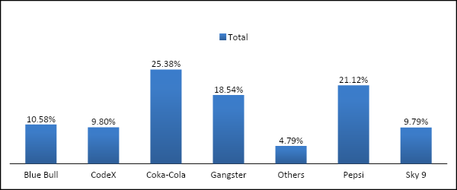

Bar-Chart is representing the current market leaders.Coka-Cola (25.38%) and Pepsi (21.12%) most favorite drinks.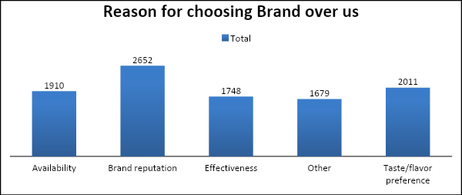

Bar-chart presents that customer reasons for choosing brand over us. As chart shows due to brand reputation and taste mostly they choose other brands than us.

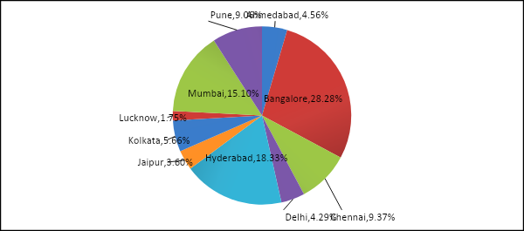

Pie-chart represent customers drink preferences city by city.

Based on the data, it appears that Lucknow and Jaipur have shown lower preferences for our drinks. To overcome this, it is crucial for us to intensify our marketing efforts and establish a strong brand presence in these cities. By implementing targeted marketing strategies and increasing brand awareness, we can capture the attention and interest of potential customers in these regions.

**Conclusion**

To increase our market share and effectively compete with our competitors, we need to prioritize two key areas: taste and availability. The data clearly indicates that our competitors, who currently hold a 25% and 21% market share, have gained popularity due to their exceptional taste and strong brand reputation. In order to expand our presence in the market, it is crucial that we focus on improving the taste of our drinks and ensuring widespread availability. By doing so, we can attract more customers and establish a stronger foothold in the industry.

To effectively reach our targeted audience, we should prioritize our advertising efforts, especially through online ads and TV commercials. These platforms provide a significant reach and engagement with our desired customer base. By leveraging the power of digital marketing and television advertising, we can effectively communicate our brand message, increase brand awareness, and attract potential customers.

**Marketing Campaign & Brand Ambassador**

Our analysis indicates that people primarily consume energy drinks to increase their energy levels. This insight is valuable for shaping our marketing strategies and messaging to effectively communicate the energizing benefits of our drinks. By highlighting the boost in energy and vitality our products provide, we can better connect with our target audience and meet their needs.

A fitness influencer would be an excellent choice as a brand ambassador. Their expertise in promoting a healthy and active lifestyle aligns perfectly with our energy drinks. They can showcase the benefits of our products in terms of boosting energy levels for workouts, providing hydration, and enhancing performance. With their knowledge and credibility in the fitness industry, they can effectively endorse our brand and attract our target audience.

**Discounts and Offers**

Collaborations with local gyms or fitness studios to offer discounted memberships or classes to customers who purchase our energy drink

"Refer a Friend" program where customers get a discount for every friend they refer who makes a purchase.

**Summary**

Our main goals for this analysis are to increase brand awareness, market share, and drive product development.

Based on our analysis, we have identified two key areas for improvement: taste and availability. Improving the taste of our drinks will enhance customer satisfaction and increase the likelihood of repeat purchases. We can achieve this by refining our recipes, using high-quality ingredients, and conducting taste tests with our target audience.

In terms of availability, we need to ensure that our drinks are easily accessible to our customers. This could involve expanding distribution channels, partnering with retailers, and optimizing our supply chain to meet demand efficiently.

To increase customer familiarity with our brand, we should focus on advertising through online ads and TV commercials. These platforms allow us to reach a wide audience and showcase the unique benefits of our drinks, particularly their energy-boosting properties. Engaging and captivating advertisements will help create brand recognition and attract new customers.

By aligning our marketing efforts with the energy aspect of our drinks, we can effectively target the needs and desires of our target audience. This means highlighting the benefits of increased energy, improved focus, and enhanced performance that our drinks provide.

In summary, by improving taste, enhancing availability, and implementing targeted marketing strategies, we can increase brand awareness, capture a larger market share, and drive product development.