Richter's Predictor:
Modeling Earthquake Damage

CAS – applied data science
Final project
Naima Gutknecht
naima.gutknecht@gmail.com

Abstract :
This datascience project aim at predicting level of damage to building based on data collected after the 2015 Gorkha earthquake in Nepal. Descriptive statistic give a general understanding of the data and their quality. Different model for machine learning from simple to more complicated were used and compared. Logistic regression, random forest, decision tree and neural netwrok were tested and compared. The data being unbalanced, performance were limited on the less represented classes. Oversampling and principal composant analysis was added as a preprocessing of the data to compare the different performance.

Random forest classification perfomed the best and oversampling of minority class produce a model performing at 76 % accuracy. Random forest classification using oversampling and reduction of dimensionality as preparation of the data perform at 99 % accuracy, but there is suspicion of overfitting on a restrint dataset. The relevance of our results for earthquake damage prevention is as well limited, due to a dataset collected for a different purpose, thus not containing the relevant data for the goal of the project.

Table of Contents
I. Introduction 3
Background information on the Nepal Earthquake project 3
Problem statement and objectives of the analysis 3
II. Data 3
Data description and source 3
Data flow and data quality assessment 5
Feature engineering techniques applied 5
III. Exploratory Data Analysis 6
Descriptive statistics of the dataset 6
Visualization of key variables through plots and graphs 7
IV. Machine Learning Analysis 11
Description of the chosen analytical approach and evaluation criteria 11
Training on models and testing procedures 12
V. Results and discussion 17
Significance of the obtained results 17
VI. Conclusion and Outlook 18
VII. References 18

Introduction

Background information on the Nepal Earthquake project
In April 2015, Nepal was striked by a 7.8 magnitude earthquake known as the “Gorkha Earthquake”. Countless lives were lost and any infrastructures, including homes, schools, and hospitals were damaged. As in many natural disasters impacting highly populated areas, rapid and efficient responses from the authorities is necessary to limit post-disaster complication and increases in damages due to lack of facilities and amenities.

In 2016, the Nepalese Central Bureau of Statistics conducted a survey to assess building damage and identify the most affected population to distribute housing reconstruction funds. The data collected contain information about the building’s construction and socio-economic information about the users of the buildings. Realizing the value of the data collection, the National Planning Commission mandates the Open Data Portal(1)to present the data in a comprehensible way to be used by NGOs and local municipalities. The platform Drivendata(2) provides a light version of the dataset with 39 features of the building’s structure and legal ownership for use in an open competition for learners to practice Data Science projects in real-life cases.

Problem statement and objectives of the analysis
The problem statement of the analysis is to understand the factors that contributed to the severity of the damage and establish predictive models that can estimate the potential impact of future earthquakes in different regions of Nepal or other areas around the globe.

Data

Data description and source
The data were collected between January 2016 and May 2016 by the Nepalese Central Bureau of Statistics and made available through the Open Data Portal(3). The anonymized data are available under the Drivendata platform(4) in CSV format. Two dataset are provided : the labels for “damage_grade“ and the values for the features. They are connected with “building_id” as a random identifier of the building. A test dataset is provided for the predictions to submit for the competition. We are not using this set as we are not participating in the competition.

The target labels for the analysis is “damage_grade” which is an ordinal variable that represents the level of damage to the building.
1 = low damage
2 = medium amount of damage
3 = almost complete destruction

There are 39 columns in the dataset.
- geo_level_1_id, geo_level_2_id, geo_level_3_id (type: int): geographic region in which building exists, from largest (level 1) to most specific sub-region (level 3).
- count_floors_pre_eq (type: int): number of floors in the building before the earthquake.
- age (type: int): age of the building in years.
- area_percentage (type: int): normalized area of the building footprint.
- height_percentage (type: int): normalized height of the building footprint.
- land_surface_condition (type: categorical): surface condition of the land where the building was built. Possible values: n, o, t.
- foundation_type (type: categorical): type of foundation used while building. Possible values: h, i, r, u, w.
- roof_type (type: categorical): type of roof used while building. Possible values: n, q, x.
- ground_floor_type (type: categorical): type of the ground floor. Possible values: f, m, v, x, z.
- other_floor_type (type: categorical): type of constructions used in higher than the ground floors (except of roof). Possible values: j, q, s, x.
- position (type: categorical): position of the building. Possible values: j, o, s, t.
- plan_configuration (type: categorical): building plan configuration. Possible values: a, c, d, f, m, n, o, q, s, u.
- has_superstructure_adobe_mud (type: binary): flag variable that indicates if the superstructure was made of Adobe/Mud.
- has_superstructure_mud_mortar_stone (type: binary): flag variable that indicates if the superstructure was made of Mud Mortar - Stone.
- has_superstructure_stone_flag (type: binary): flag variable that indicates if the superstructure was made of Stone.
- has_superstructure_cement_mortar_stone (type: binary): flag variable that indicates if the superstructure was made of Cement Mortar - Stone.
- has_superstructure_mud_mortar_brick (type: binary): flag variable that indicates if the superstructure was made of Mud Mortar - Brick.
- has_superstructure_cement_mortar_brick (type: binary): flag variable that indicates if the superstructure was made of Cement Mortar - Brick.
- has_superstructure_timber (type: binary): flag variable that indicates if the superstructure was made of Timber.
- has_superstructure_bamboo (type: binary): flag variable that indicates if the superstructure was made of Bamboo.
- has_superstructure_rc_non_engineered (type: binary): flag variable that indicates if the superstructure was made of non-engineered reinforced concrete.
- has_superstructure_rc_engineered (type: binary): flag variable that indicates if the superstructure was made of engineered reinforced concrete.
- has_superstructure_other (type: binary): flag variable that indicates if the superstructure was made of any other material.
- legal_ownership_status (type: categorical): legal ownership status of the land where building was built. Possible values: a, r, v, w.
- count_families (type: int): number of families that live in the building.
- has_secondary_use (type: binary): flag variable that indicates if the building was used for any secondary purpose.
- has_secondary_use_agriculture (type: binary): flag variable that indicates if the building was used for agricultural purposes.
- has_secondary_use_hotel (type: binary): flag variable that indicates if the building was used as a hotel.
- has_secondary_use_rental (type: binary): flag variable that indicates if the building was used for rental purposes.
- has_secondary_use_institution (type: binary): flag variable that indicates if the building was used as a location of any institution.
- has_secondary_use_school (type: binary): flag variable that indicates if the building was used as a school.
- has_secondary_use_industry (type: binary): flag variable that indicates if the building was used for industrial purposes.
- has_secondary_use_health_post (type: binary): flag variable that indicates if the building was used as a health post.
- has_secondary_use_gov_office (type: binary): flag variable that indicates if the building was used fas a government office.
- has_secondary_use_use_police (type: binary): flag variable that indicates if the building was used as a police station.
- has_secondary_use_other (type: binary): flag variable that indicates if the building was secondarily used for other purposes.

Data flow and data quality assessment
As a readily available dataset for educative training, the dataset is clean and simplified from the original dataset, but no mention of the precise steps is available on the website. On the webpage of the 2015 Nepal Earthquake open data portal, the damage grades are presented in 5 categories and the features available include many socio-economic factors that were not present in the dataset provided for this project. The Nepal Earthquake open data portal mentions that the data available comes from the first phase of the survey that collected data from the 11 severely affected districts which implies oversampling of the highest damage grade. The DrivenData portal does not mention the different phases and how they converted the damage level from 5 to 3 classes.

We are not able to identify the accuracy and reliability of the dataset. As it comes from government sources, we can assume that the collection of technical information was performed by competent surveyors. The goal of the collect was to identify needs for distribution of ressources for reconstruction and not to identify features influencing damage-grades, which makes the dataset possibly not adapted for the goal of the project as planned by DataDriven. Some features are subject to inconstitences in the collection that is not discussed in the portals, such as the assessment of the criteria “count_families”. In fact, the definition of families can change from culture to culture and it is not specified if the Western nuclear family model is used or if the extended family model more typical for South Asian cultures was applied. However, most of the other socio-economical features were taken out of the dataset, which limits the need to apply culture-specific knowledge to asses the possible bias of the dataset.

It is not mentioned either that an earthquake of magnitude 8,2 damaged many buildings in Nepal in 1934(5), thus making the information provided from buildings older than that biased to the fact that they already survived a greater earthquake and probably went through reparation or partial replacement since then.

The data were extracted from the original CSV file in panda dataframes and no empty data was detected in the datasets.

Feature engineering techniques applied
Thirty nine features are presented in the dataset, many concern construction techniques of the building and their localisation. As some data could be redondant a principal composant analysis was applied to see if a reduction of the data dimension was possible.

When needed the training data and the labels were merged in a panda DataFrame using the “building_id” as a merging entry and dummies were extracted to transform all the data in numerical. The shape of the dataset with dummies is 260601*70.

A heatmap of the data was generated, but no strong correlation was visible. The values of the marged dataset were standardised using the “StandardScaler” function of scikit-learn and the principal composant analysis (PCA) was applied for the 70 components. The explained variance for the 70 components was ploted and no elbow is visible. There is apparently no component which strongly influence the variation.

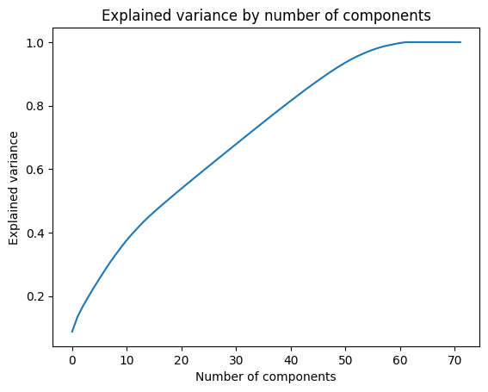

When applying the principal composant analysis to preserve 99% of the variance, the 58 first components are to be preserved. This implies a reduction of 18% of the dataset, which can be used later to save computing ressources or improve models.

Exploratory Data Analysis

Descriptive statistics of the dataset
The damage grades labeled 1, 2 and 3 were transformed in “Low”, “Medium” and “High” for the descriptive statistics. The data are unevenly distributed as 9,6% are low damage, 56.9 % medium and 33,5% are high damage.
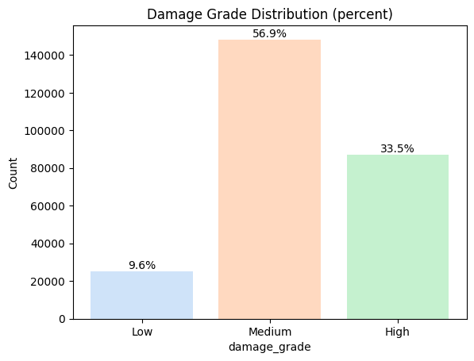

Visualization of key variables through plots and graphs
Repartition of the damage grade over construction features was isolated. For most of the criteria, unbalanced data were presented. Conversion of the graphe in pourcent was used when relevant to correct for over-representation of some criteria.

- Age of the building
A presentation of the age of the building indicate outliers for above 200 years old buildings.
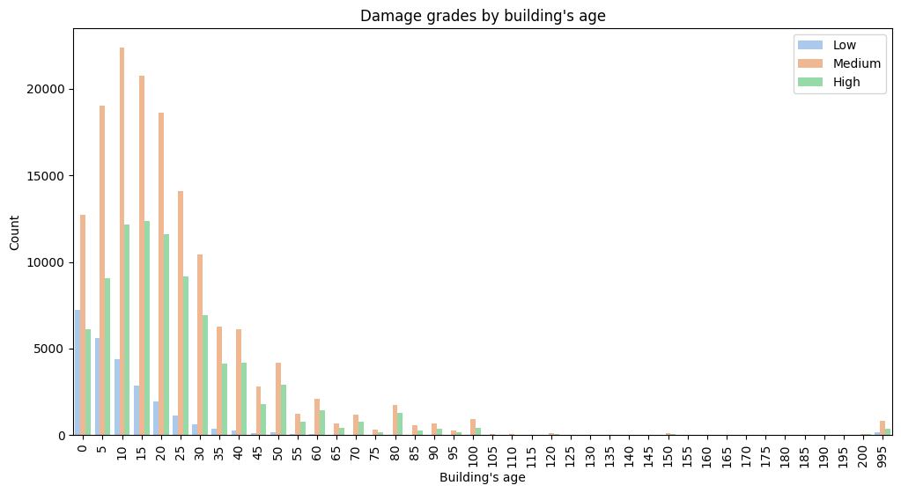

- Number of floors before earthquake
Presentation of the data according to their count seems to indicate that medium and high damage were documented in higher proportion for the building with 2 floors before the earthquake, but a presentation of the data as a stacked bar with pourcent indicate little variation of the damage grade of building except for building higher that 7 and 9 floors, which are underrepresented into the dataset.

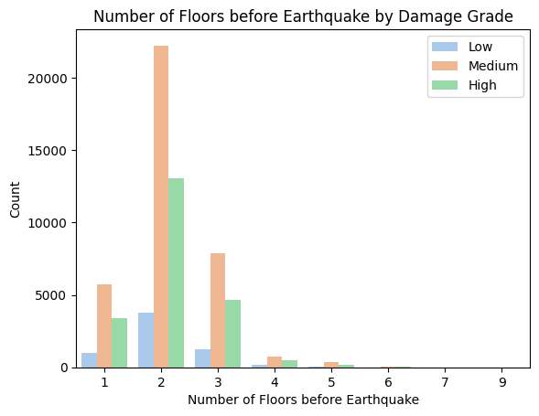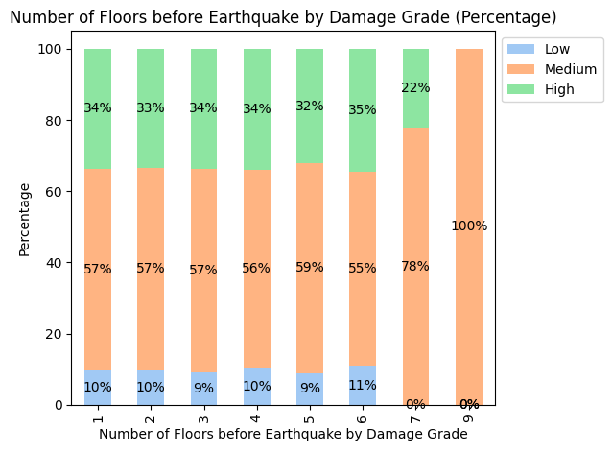

- Architectural features
When converted in percent, criteria like land surface condition, foundation type, roof type ground floor type, position of the building and plan configuration present a different level of variation in the damage grade.

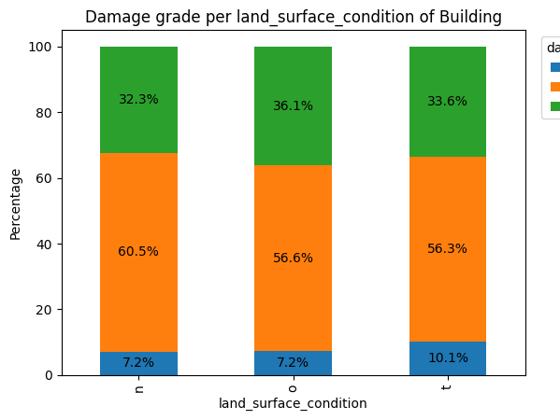 | 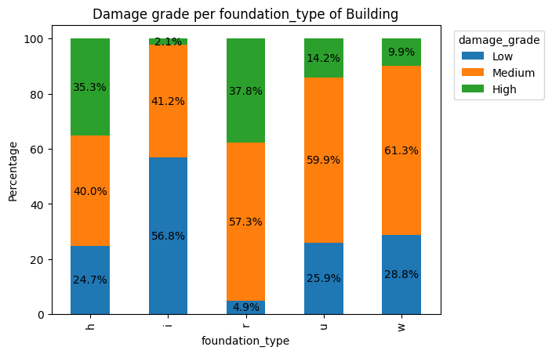
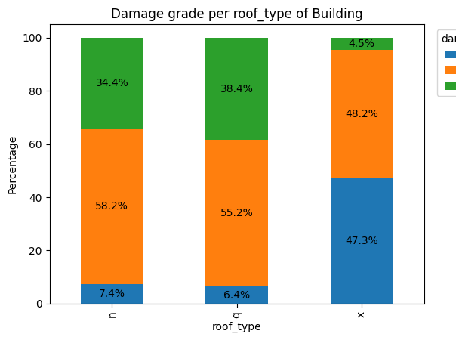 | 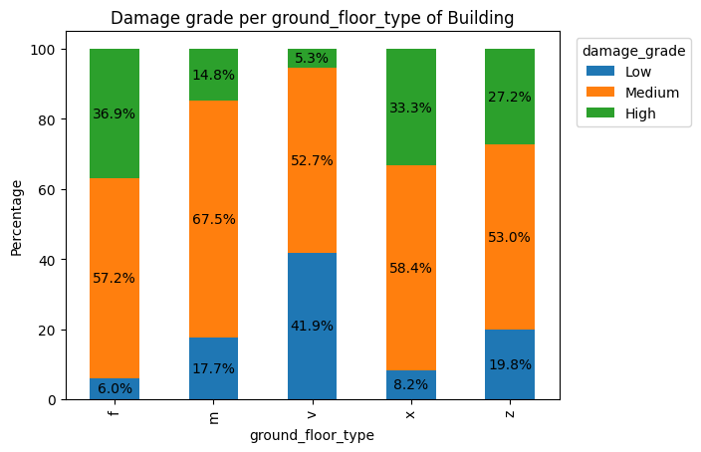
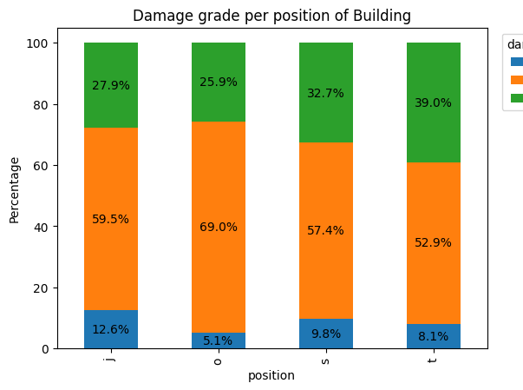 | 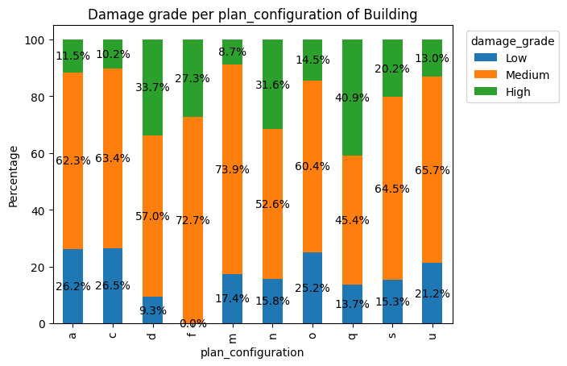

- Construction material
Even if the type of architectural features seems to have influence on the damage grade, the construction material of the superstructure seems to have little influence on the repartition of the level of damage.

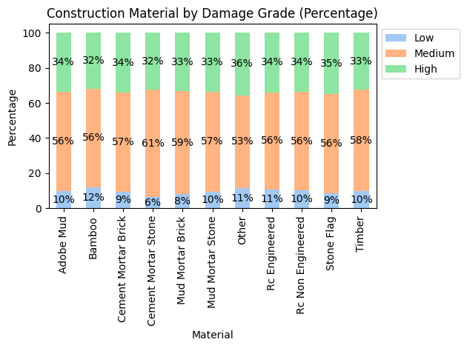

- Legal ownership of the building
Ownership of the building seems to have an influence on the damage grade as from the type W, 46.4% of the building present a high level of damage, when only 16.8% of the type a presented high damage. The ownership statue is certainly linked to socio-economical parameters that are not included in the dataset.

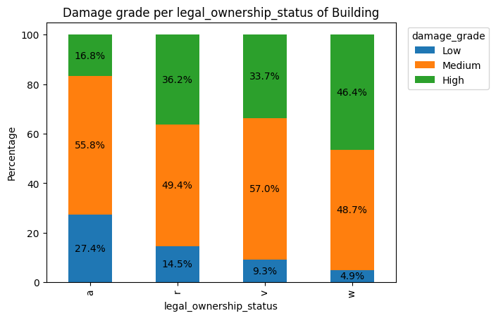

- Secondary use of the building
Economical parameters will influence the use of the building. Repartition of the secondary use of the building is unbalanced as more building with no secondary use where documented. The damage grade does not present high variation between the building with or without secondary use.

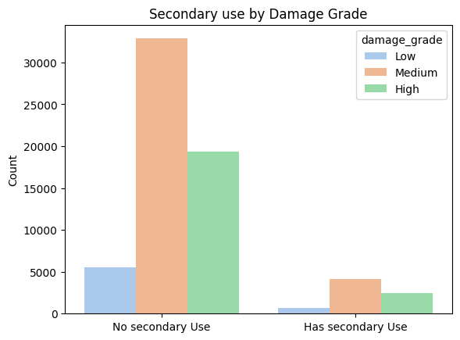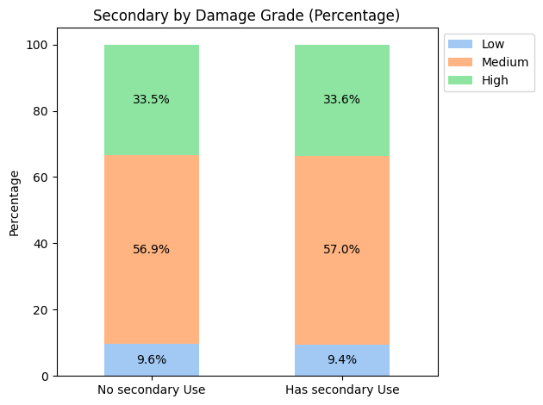

- Type of secondary use of the building
The type of secondary use was agriculture in most case (95%). The use for agriculture will probably influence the type of construction and the socio-economic situation of the users, which influence the investment possible for maintaining the building.

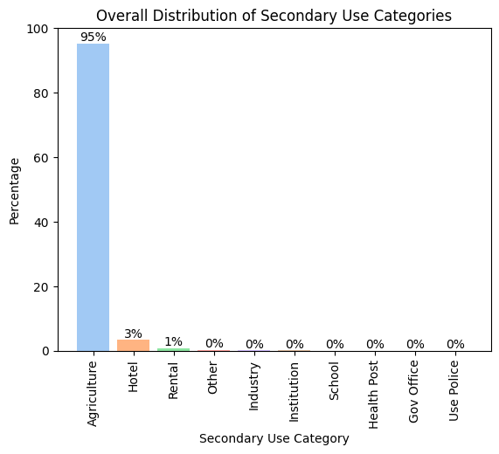

The damage grade are similar distributed between a secondary use for agricultue, hotel, industry, institution, rental and schools. However the building used for government and police are showing a higher count of high and medium damage. Nevertheless, the undersampling of those buildings (38 government office use and 23 police use) against 248222 for agriculture use make a possible overreppresentation possible.

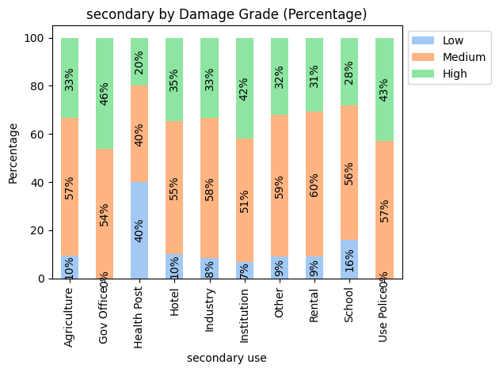

Machine Learning Analysis

Description of the chosen analytical approach and evaluation criteria
The training data and the labels were merged in a panda DataFrame using the “building_id” as a merging entry and dummies were extracted to transform all the data in numerical. The shape of the dataset with dummies is 260601*69. The dataset is standardized using the “StandardScaler” function of scikit-learn. The dataset is splitted into a train and test dataset (80/20%).

We are tesing and comparing different model to predict the class target “damage_grade”. There is 3 possible classes, which are ordinal. Logistic regression, random forest and decision tree in entropy and gini was tested as simple models and then neural networks for classification as a deep learning system. We apply PCA and SMOTE on our best-performing model as a last phase to improve performances limited by imbalance in the original dataset.

The performenace were compared using accuracy and F1 score for the predicted “damage_grade” label for our test set versus the true label of the test set. In the competition from the DataDriven plateform, the best performance so far was by the profile “innody” with a F1 score of 0.75.

Training on models and testing procedures
- Logistic regression
Logistic regression is usually used on binary classes but can be used as an Ordinal logistic regression when the classes to predict are on a continuum. The ordinal labels for “damage_grade” are encoded and used as a target for training and test. The logistic regression is applied with “multi_class='multinomial' and solver='lbfgs'.

An accuracy and F1 score of 0.57 is acquired. The confusion matrix indicates that the classes predicted were “damage_grade”= 2. Since this classe was overpresented in our dataset, the accuracy is high, even though it only predict one class.

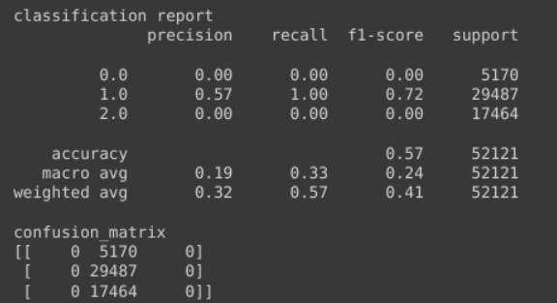

- Random forest
Random Forest is a supervised machine learning, It performs with an accuracy and F1 score of 0,72. The F1 score is higher for class 2, but is well performing for class 3 and 1 too.

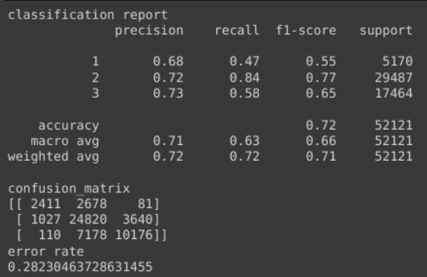

- Decision tree
Decision is a supervised classification method that choose the optimum split between features to predict the classifications. Decision tree can be used with gini and entropy method. Gini tends to be faster because it use less computational ressources and entropy tend to be more precise.

The same preprocessing as for logistic regression was applied and both decision tree for a maximal depth of 5 were chosen. Both method shows similar results. We tried to increase the depth, but there was not much improvement in our models.
  - gini
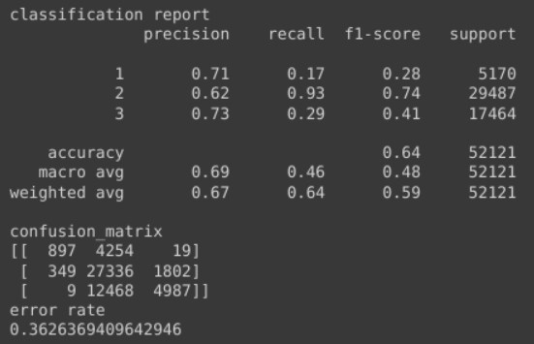
  - entropy
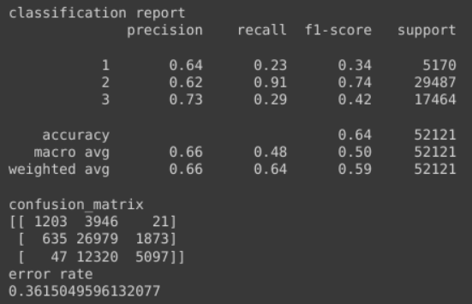

- Neural Network for classification
For classification with neural network, the target classes are encoded using “LabelEncoder” and the rest of the data preparation is similar as for precedent models. The features were converted in numpy array. The target data were converted using one-hot encoding before being converted in numpy array as well.

Different deep learning models were tested modifying the number and type of layers, as well as the sizes of the batches and the epochs, but none shows satisfying accuracy above the Random Forest one. Our best performing deep learning models used dense layers with relu activation, dropout and batch normalization with a final dense layer using softmax activation.
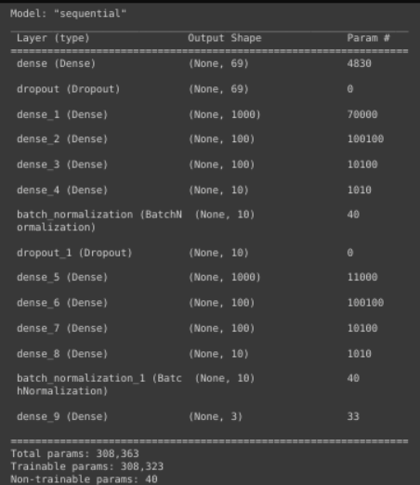

Variation in the number of layers, their order and the batch size were done to prevent a too step dive of the training loss in the first epochs, but none of the variation performed better. Batch size of 150 and 20 epochs was chosen as best performing features with an accuracy and F1 score of 0.66, even though the plotting of history of training loss and validation loss indicate a need for more optimisation due to a too fast training from the data.

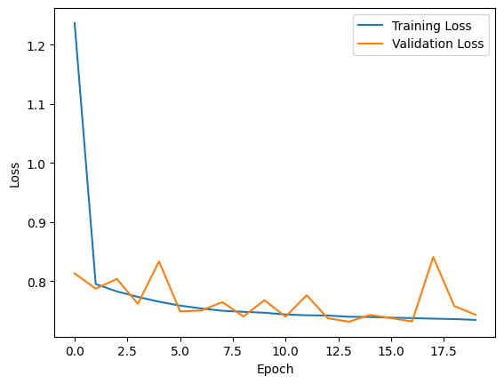

Classification report and confusion matrix indicate a performance quite similar for the three classes.
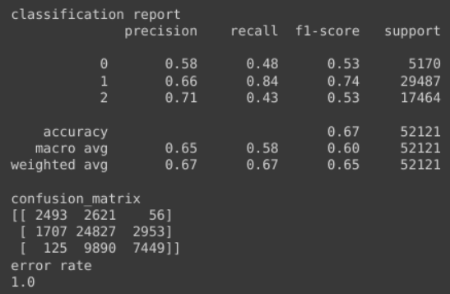
- Random Forest with Synthetic Minority Oversampling Technique
As the best working model, we tested using Random Forest method with synthetic Minority Oversampling Technique (SMOTE) for compensate for the imbalance data between the three classes of “damage_grade” to predict.This can add noise to the data, but can offer a better classification of the less represented data.

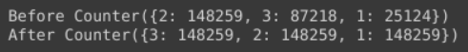

With balanced data the accuracy and F1 score was improved to 0,78 with similar performance for all the “damage_grades”.

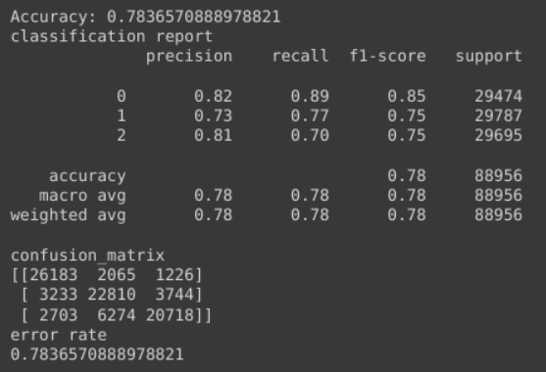

- Random Forest with Smote and PCA
PCA was used to reduce the dimensionality of the dataset while keeping 99 % of the variance. This can reduce the noise of the less relevant data by keeping only the one relevant for 99 % of the variation, here 58 of the 70 features (including dummies for non ordinal data. Smote was applied afterward.

The Random Forest presented an accuracy and F1 score of 0.99. The classification report and confusion matrix shows a really efficient classification of the data.

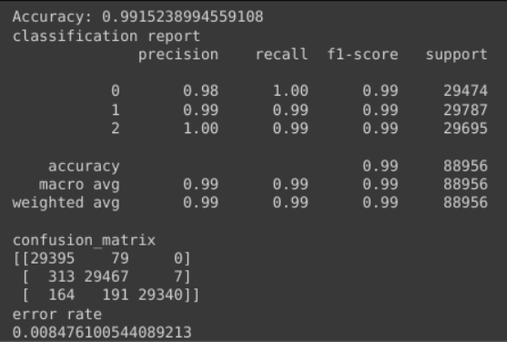

Such a high accuracy seems to indicate an overfitting to the provided data. A test over a bigger dataset could clarify this point.

Results and discussion

Significance of the obtained results
Our goal was to go above the best presented models of the DataDriven competition using F1 score as a comparison. The best subbmision has a F1 score of 0.76. Our random forest model with SMOTE has a F1 score of 0.78 and the with PCA and SMOTE has a 0.99 score.

Model | Accuracy | F1 score
Logistic regression | 0.56 | 0.56
Random forest | 0.71 | 0.71
Decision tree - gini | 0.63 | 0.63
Decision tree - entropy | 0.63 | 0.63
Neural Network | 0.65 | 0.65
Random Forest with SMOTE | 0.78 | 0.78
Random Forest with PCA and SMOTE | 0.99 | 0.99

The high accuracy obtained for the last model with PCA and SMOTE hint for an overfitting. A submission into the website competition to compare our trained model with the test data delivered for the competition would allow a better vision above this problem.

As seen for the logistic regression, our unbalanced dataset limited the training of models for “damage_grade” 1 and 3. SMOTE method corrected this problem, even thoug an overfitting can then occur, since the data a syntheticly generated. The low occurrences of certains criteria like “second use of the building” generate uncertainty about the relevance of many criteria. PCA could correct this by droping features that are not relevant to the expected results, but the absence of strongly influencing composants make this method less efficient.

The dataset was collected by the nepalese government in order to improve financial aid distribution in rebuilding the country. Our dataset didn’t include many of the social and economical parameters collected and was concentrated of the most damaged area of nepal. Thus the use of thos data to predict damage due to earthquake is a usage that was not foreseen at the moment of collection. A more targeted collection aimed at the assessment of the damage would probably have collected other type of data such as earthquake magnitudes (above more than one occurrence of earthquake), structural types, and distance between epicenter and building. The data collected for this magnitude 7.8 earthquake are therefore biased to the type of earthquake and building presented in the region. Generating a more generalized model from our dataset for other area of the world, such as China or Turkey is therefore limited, when not simply irrelevant. Other projects are collecting and analysing data with more insight into the construction and with variation of the magnitude of the earthquake in order to apply machine learning method to forsee possible damage.

Conclusion and Outlook

In ours different models, the complexity of the model was not correlated with an increase of the accuracy of the prediction. In fact the feature engineering before fitting the model influences greatly the accuracy. Oversampling and reduction of the dimension of the model improve greatly our accuracy.

The project chosen is presented as a socially engaged project to train literacy in datascience. Nevertheless, the use of those data for damage assesment is greatly limited due to the different initial goal when collecting the data. A generalized conclusion of the intervention needed from the application of our models to limit damage to building for the next similarly intense earthquake seems to be an hazardous extrapolation from this dataset. Generally known criteria about construction seems to be a better guideline.

Usage of dataset coming for specific area and specific conditions to extrapolate a “fit all” solution is not possible as the model only analyse what already exist in the data. As machine learning and data science literacy is increasing all over the world a collection of data aimed at a more generalized usage could become a new best practice. In fact, as in many field of sciences, data collection was always limited to the project initialy funded with a specify goal and then data tend to be reused for other project, thus limiting the relevance of those research. With an new field of possiblities, data collection could shift to a more untargeted research question with insight of the future possible usage from those data.

References

(1) 2015 Nepal Earthquake Open Data Portal, National planning commision [consulted on 7 June 2023], [http://eq2015.npc.gov.np/#/about]
(2) Richter’s Predictor: Modeling Earthquake Damage, DrivenData [consulted on 5 June 2023], [https://www.drivendata.org/competitions/57/nepal-earthquake]
(3) Data - Richter’s Predictor: Modeling Earthquake Damage, DrivenData [consulted on 5 June2023], [https://www.drivendata.org/competitions/57/nepal-earthquake/data/]
(4) Data - Richter’s Predictor: Modeling Earthquake Damage, DrivenData [consulted on 5 June2023], [https://www.drivendata.org/competitions/57/nepal-earthquake/data/]
(5) Sapkota, S.N., Bollinger, L., Perrier, F. « Fatality rates of the M w ~8.2, 1934, Bihar–Nepal earthquake and comparison with the April 2015 Gorkha », In Earth, Planets and Space. n°68 – 40, 2016. https://doi.org/10.1186/s40623-016-0416-2
(6) Hansapinyo, C., Latcharote, P., Limkatanyu, S. « Seismic Building Damage Prediction From GIS-Based Building Data Using Artificial Intelligence System. », In Frontiers in Built Environ. N°6, 2020. https://doi.org/10.3389/fbuil.2020.576919

