**Printed Graphs in 2D and 3D using the CVS file data**

21i-0642

CS2001-Data structures

Naima Zafar

[Year]

**Question 1**

**2D Graph**

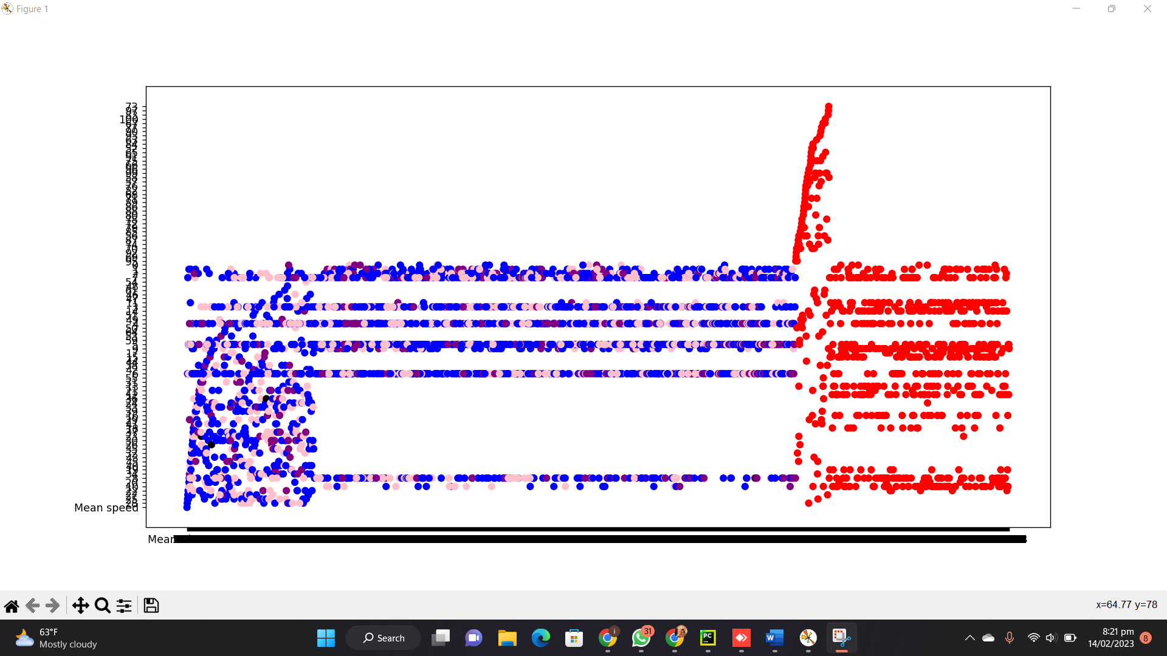

**DATA AFTER CLUSTERING ALGORITHM IS APPLIED**

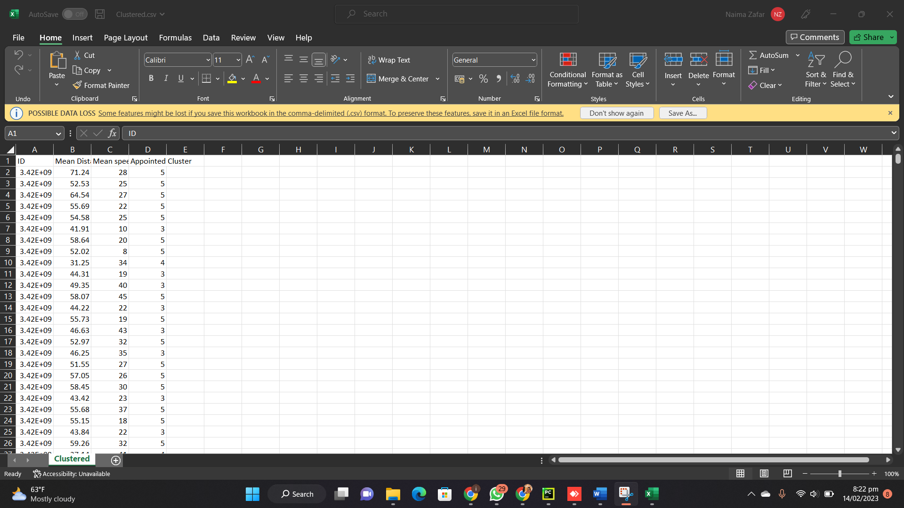

**Question 2**

**3D Graph**

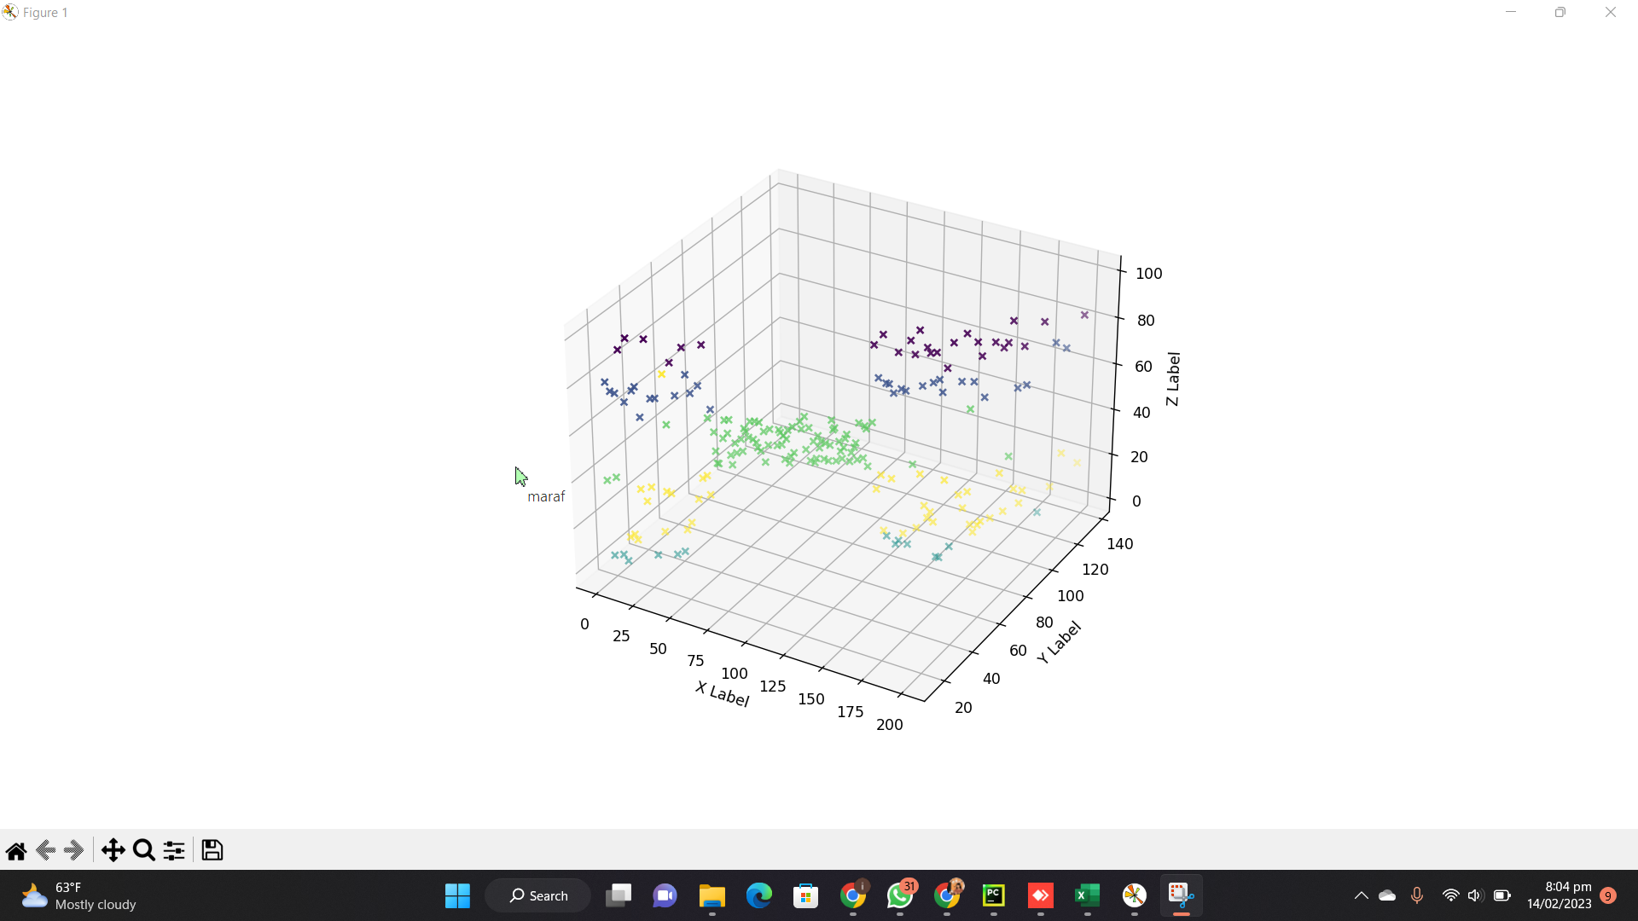

**DATA AFTER CLUSTERING ALGORITHM IS APPLIED**

