

**DOCTORAL THESIS OF LYON UNIVERSITY**

**Delivered by**

University Claude Bernard Lyon 1

**Doctoral school:**

Neurosciences and Cognitive Sciences (ED476)

**PhD specialty**:

Neurosciences

Publicly defended on the XXXXX, by

**Raphaël Vallat**

The cerebral correlates of dream recall frequency

**Jury**

Dr. Sophie Schwartz Reviewer

Pr. Michael Schredl Reviewer

Pr. Yves Rossetti Examiner

Dr. Perrine Ruby PhD director

*À Isabelle et Alain*

*« J’ai rêvé tant et plus, mais je n’y entends note. »*

François Rabelais*, Pantagruel,* 1532

*« Je croyais entendre,*

*Une vague harmonie enchanter mon sommeil,*

*Et près de moi s'épandre un murmure pareil,*

*Aux chants entrecoupés d'une voix triste et tendre. »*

Charles Brugnot, *Les Deux Génies*, 1833

RÉSUMÉ

ABSTRACT

Since the dawn of time, men and women have been fascinated by their dreams, and have sought to understand their nature and meaning. However, despite millennia of philosophical speculation and more than a century of scientific exploration, several questions regarding dreams remain pending.

TABLE OF CONTENT

RÉSUMÉ 6

ABSTRACT 7

TABLE OF CONTENT 8

LIST OF PUBLICATIONS 10

LIST OF ACRONYMS 11

FIGURES AND TABLES 12

ACKNOWLEDGMENTS 13

GENERAL INTRODUCTION 14

I. The science of sleep and dreams 18

I. 1. Dreams 18

I. 1. A. Modern definition 18

I. 1. B. Scientific conceptualization 18

I. 2. Sleep 19

I. 2. A. Definition 19

I. 2. B. Polysomnographic recordings 20

I. 2. C. Sleep stages 20

I. 2. D. Sleep architecture 22

I. 2. E. Methodology: ERP ? 23

I. 3. Link between dreaming and sleep stages 23

I. 3. A. The REM sleep hypothesis of dreaming 23

I. 3. B. The new hypothesis: a continuum of mentation during sleep? 23

I. 4. Neurophysiological correlates of dreaming 25

I. 4. A. Brain lesion studies 25

I. 4. B. Brain activity during REM sleep 25

I. 4. C. Brain activity during lucid dreaming 25

I. 4. D. Brain activity in the minutes preceding a dream report 25

I. 4. E. Dreaming and the default mode network: a conceptual framework 25

I. 4. F. Methodology; fMRI and functional connectivity 25

II. Dream recall 26

I. 5. Why do we forget our dreams? 26

I. 5. A. The state-shift hypothesis 26

I. 5. B. Psychanalysis 26

I. 5. C. Sleep inertia? 26

I. 6. Dream recall frequency 26

I. 6. A. Intra-individuals variability 26

I. 6. B. Inter-individuals variability 26

I. 7. Parameters correlated with DRF 26

I. 7. A. Psychological factors 26

I. 7. B. Physiological parameters 26

I. 7. C. Sleep parameters 26

I. 8. Brain activity associated with a high or low DRF 27

I. 8. A. EEG studies 27

I. 8. B. PET study 27

I. 8. C. Summary and future outlook 27

III. Dream content and dream function 28

I. 9. Dream content 28

I. 9. A. Methodology: basic principles of dream content analysis 28

I. 9. B. Experimental results 28

I. 9. C. The memory sources of dreams 28

I. 10. The function(s) of dreams 28

I. 10. A. Historical perspective 28

I. 10. B. Emotional regulation 28

I. 10. C. Memory processing 28

I. 10. D. Others hypotheses 28

IV. Hypothesis and objectives 29

I. 11. Unresolved issues 29

I. 11. A. Differences between HR and LR at awakening 29

I. 11. B. Differences in the micro-structure of HR and LR 29

I. 11. C. What are the memory sources of dreaming? 29

EXPERIMENTAL RESULTS 30

METHODOLOGICAL DEVELOPMENT 31

GENERAL DISCUSSION 32

ANNEXES 33

REFERENCES 34

LIST OF PUBLICATIONS

**Peer-reviewed publications**

**Submitted or under review**

**In preparation**

**\*** The authors contributed equally to this work

LIST OF ACRONYMS

FIGURES AND TABLES

ACKNOWLEDGMENTS

GENERAL INTRODUCTION

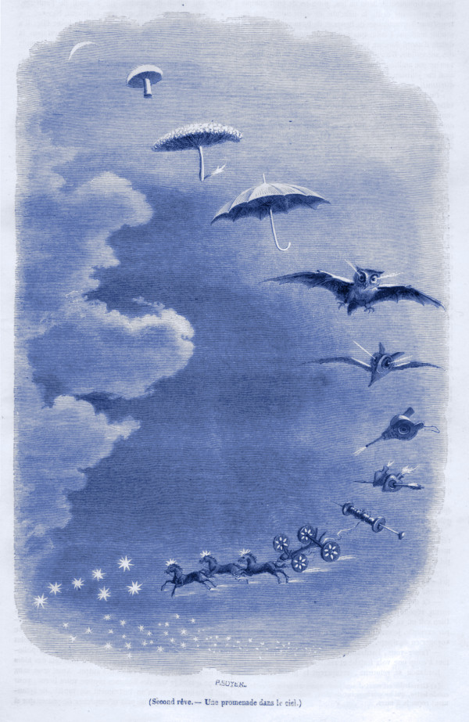

Jean-Jacques Grandville. *Second rêve –Une promenade dans le ciel*, 1847

1. The science of sleep and dreams

« Dream science holds an intermediate position between history and biology. It is a science of observation, because observation is an essential part of it, but it is also an historical science in the sense that the elapsed dream can never be reenacted and is therefore investigated, not directly, but through memory. »

Yves Delage. Le rêve. Etude psychologique, philosophique et littéraire. 1920

# Dreams

## Modern definition

According to the Cambridge Dictionary, a dream is a *“series of events or images that happen in the mind when one is sleeping”*. This vague definition illustrates quite clearly how little we know about dreams, despite more than a century of experimental research and millennia of religious and philosophical speculation on their nature and meaning. The main reason for this lack of a clear and consensual definition (Pagel et al. 2001) is due to the fact that dreaming is, by nature, elusive, or, to say it in other words, *“a phenomenon that we can observe only during its absence”* (Paul Valery, *Analecta*, 1926). Indeed, we still do not know precisely when dreaming occurs during sleep, and the dreamer alone is witness to his or her dream. For that reason, the study of dreaming relies critically on the introspective recall, or *“retrospection”* (Schwartz et al. 2005), of the dreamer.

## Scientific conceptualization

This observation led Guénolé to distinguish three successive forms of the dreaming phenomenon, intertwined like nesting dolls (Guénolé 2009). The primordial state is the dream-experience, which occurs during sleep, and of which very little is known because the dreamer has no means to communicate in real-time his or her oneiric travels to the external world. With the notable exception of lucid dreaming, the dream-experience is unobservable to the waking consciousness, be it that of an external observer, but also that of the dreamer him- or herself. The second form is the memory of the dream-experience as we recall it after awakening. Importantly, the dream recall occur in a consciousness state different from the one in which the dream was experienced. As a memory object, dream recall is therefore likely to be influenced by several mechanisms such as forgetting, reconstruction, verbal description difficulties and censorships (Schwartz and Maquet 2002; Schwartz et al. 2005). The third and last element of the model is the verbal report of the dream memory, using words or pictures. The dream report is the only one that can actually be communicated to others and therefore the only one eligible to empirical investigation. As a consequence, most of the dream research has in fact focused on dream reports.

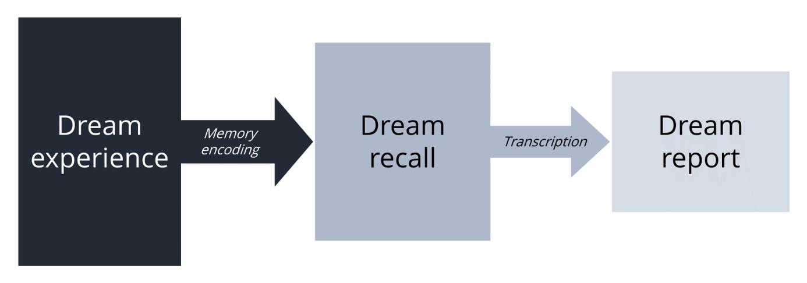

Figure 1: Guénolé’s model of dreaming (Guénolé, 2009)

Because of this inherent constraint, dreaming still remains one of the great mystery of the human cognition. Several questions on its nature and meaning are still not answered: do we dream every nights? For how long? Why do we sometimes recall our dreams and sometimes not? Are dream reports accurate and exhaustive transcriptions of the dream experience? What is, or what are, the function(s) of dreaming? What are the neurophysiological correlates of dreaming?

The aim of the present thesis is to offer a modest contribution to the ongoing effort to solve these questions. Our first research axis concerned the neurophysiological correlates of dream recall frequency.

# Sleep

## Definition

Sleep is a normal physiological and periodic state characterized by vigilance suspension, which generally occurs during night time in humans. Sleep is a vital need that allows restoration of the immune, nervous, skeletal and muscular systems, leading some authors to postulate that *“sleep is the price we pay for being alive”* (Tononi and Cirelli 2014). Long regarded as an idle state, it is becoming increasingly evident that sleep is *“first and foremost a brain process”* (Hirshkowitz 2004) in which the brain is “*hard at work and helps makes something of the world”,* to borrow the words of Heraclitus’s famous aphorism (for an exhaustive review of the cognitive processes occurring during sleep, see (Andrillon 2016).

## Polysomnographic recordings

The invention of electro-encephalography (EEG) by Hans Berger in 1928 has paved the way for the scientific study of sleep. It was indeed soon after that discovery that Alfred Loomis first described a global slowing down of the brain rhythm during sleep, associated with the apparition of several grapho-elements such as K-complexes. Since then, sleep researchers have used EEG to monitor brain waves, electrooculography (EOG) to monitor eye movements and electromyography (EMG) to measure skeletal muscle activity. The simultaneous collection of these measurements is called polysomnography (PSG) and provides sufficient information to identify sleep stages according to standard international established guidelines. PSG is the gold standard in modern sleep science and is used in both clinical and research settings.

## Sleep stages

A first set of rules were published by Rechtschaffen and Kales (R&K) in 1968 (Kales and Rechtschaffen 1968) and proposed to divide sleep into 5 stages with distinct electrophysiological properties, named rapid-eye movement (REM) and non-REM (NREM) stages 1, 2, 3, 4. This nomenclature was updated in 2007 by the American Academy of Sleep Medicine (Iber 2007) and sleep stage 3 and 4 have been merged into stage N3. In humans, a normal night of sleep consists of a repetition of four or five cycles in which sleep stages tend to follow each other in a particular order. Sleep staging is generally done visually by inspecting consecutive polysomnographic segments of 30 seconds. It results in a hypnogram which represents the succession of sleep stages across time. Below are summarized EEG-EOG-EMG characteristics for wakefulness and the different sleep stages (see alsoFigure 2).

### Wakefulness

Before diving into sleep, we first need to define the state of wakefulness. Eyes-closed quiet wakefulness is accompanied by an EEG rhythm predominantly in the alpha range (8-12 Hz). Opening the eyes or engaging in a significant mental task (for example mental calculation) reduces or blocks the alpha activity. Fairly high muscle activity can be present and slow or rapid eye movements may occur.

### N1 sleep

Stage N1 corresponds to the transitional period between wakefulness and sleep. The brain rhythm progressively decreases from alpha to theta (5 – 7 Hz), and the EOG is characterized by slow, rolling eye movements. N1 sleep represents approximatively 5% of a normal night of sleep.

### N2 sleep

Each night, we spend more than half the night’s sleep in N2 sleep. The EEG activity during this stage is characterized by a predominance of theta waves, recurrently interrupted by two grapho-elements, the spindles and K-complexes, which are the landmarks of this sleep stage. K-complexes are defined as sharp negative waves followed by a positive component, prominent over frontal scalp electrodes and lasting more than 0.5 seconds. Spindles refer to burst of 12 to 14 Hz waves predominant over central scalp electrodes and lasting between 0.5 and 2 seconds. Beyond that, N2 sleep is characterized by an absence of eye movements as well as decreased muscle tone and brain metabolism.

### N3 sleep

N3 sleep, also referred to as deep sleep or slow-wave sleep, is the deepest sleep stage. It is characterized by a predominance (> 20 % of the epoch) of high amplitude (> 75 µV) delta waves (0.5 – 4 Hz). Eye motility, muscle tone and brain metabolism are even more decreased than in N2 sleep. N3 sleep represents approximatively 20% of a normal night of sleep.

### REM sleep (or paradoxical sleep)

As its name suggests, rapid eye movements (REM) sleep is characterized by rapid eye movements easily observable on the EOG channels. They consist of conjugate, irregular and sharply peaked eye movements, similar to some extent to those exhibited during wakefulness. Another fundamental aspect of REM sleep is its muscle atonia, as revealed by a low EMG activity. However, some transient muscle activity or muscle twitching (MTs) can also be observed. These short irregular bursts of EMG activity are superimposed on the background of low EMG activity. Brain metabolism is similar to that of wakefulness, and the EEG is marked by mixed low-amplitude waves predominantly in the theta band (saw-tooth waves), as well as a complete absence of delta rhythms. Other physiologic activities accompany REM sleep including middle ear muscle activity, periorbital integrated potentials, and sleep-related erections. REM sleep constitutes approximatively 20% of a normal night of sleep.

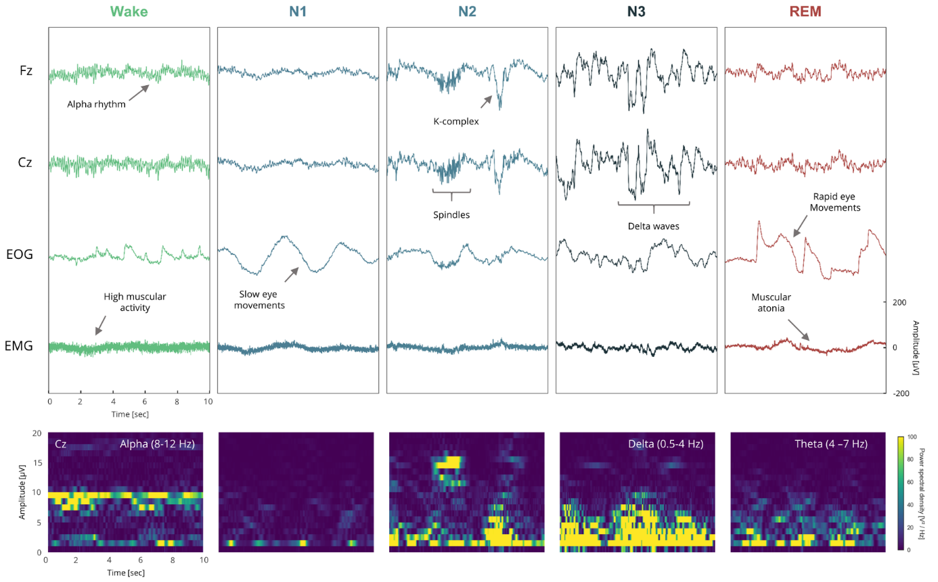

Figure 2: Polysomnographic recordings across sleep and wakefulness. Top: Scalp EEG, EOG and EMG performed in one healthy young adult during wakefulness, N1, N2, N3 and REM sleep. The main features of each vigilance state are described. Bottom: Spectral properties of each stage obtained by computing the spectrogram of the Cz EEG signal atop.

## Sleep architecture

Modern research has revealed that sleep is not a unitary, single block, but rather a cyclical succession of different brain states, which are all associated with specific functional roles. A normal night of sleep consists of a repetition of four or five 90 to 110 minutes long cycles in which sleep stages tend to follow each other in a particular order. The cycle properties evolve with each cycle reoccurrence. In his overview of the human sleep, Hirshkowitz described five generalizations about normal sleep architecture (Hirshkowitz 2004):

1. Sleep is entered through non-REM sleep
2. Non-REM and REM sleep alternate approximately every 90 to 120
3. Minutes
4. N3 sleep predominates in the first third of the night
5. REM sleep predominates in the last half of the night
6. REM sleep occurs in four to six discrete episodes each night with episodes generally lengthening as sleep period progresses

# Link between dreaming and sleep stages

## The REM sleep hypothesis of dreaming

In the early fifties, Nathaniel Kleitman and his doctoral student Eugene Aserinsky, discovered in humans the existence of periods of sleep with an EEG similar to wakefulness (low voltage and fast frequencies), rapid eye movements and neurovegetative responses (Aserinsky and Kleitman 1953). This discovery had a strong and persistent impact on dream and sleep research. The authors have indeed proposed that the rapid eye movements corresponded to the scanning of dream images. They reached this conclusion by comparing the proportion of dream reports obtained upon awakening in periods of eye motility and outside these periods, respectively 75% and 11% in their 1953’s study, and 80% and 7% in their 1957’s study (Dement and Kleitman 1957). They concluded that their newly-discovered REM sleep stage was the neurophysiological basis of dreaming. A few years later, the French neurophysiologist Michel Jouvet, who had started working on sleep in cats, found that REM sleep was associated with muscular atonia (Jouvet, Michel, and Courjon 1959), a finding that was soon after replicated in humans (Berger 1961). Pursuing his research on REM sleep, or “paradoxical sleep” as he named it, Jouvet had the idea to suppress the muscular atonia by injuring the brain stem of cats. To his astonishment, he found that the injured cats were performing, only during REM sleep, complex motor sequences, that he named “oneiric behavior” (Sastre and Jouvet 1979). For him and the scientific community at the time, it was clear that these motors sequences were directly related to the cat’s dreams, and this experiment provided a significant evidence in favor of the REM sleep hypothesis of dreaming.

## The new hypothesis: a continuum of mentation during sleep?

Even though equating dreaming with REM sleep provided a useful way to explore, with a scientific approach, the secrets of dreams, it soon became apparent that dreaming was not exclusively present during REM sleep but also during all the other sleep stages. Few years after the initial discovery of REM sleep, several researchers reported a much higher proportion of dream report in non-REM sleep than what was expected based on the findings of the Kleitman’s team (Goodenough et al. 1959; Foulkes 1962). Comparing the recall rate of people who never remembered their dreams with people who frequently recalled them, Goodenough and colleagues found respectively 34% and 54% of dream reports outside of REM sleep. The recall rate went up to 54% in Foulkes’s study which comprised 200 awakenings. Since then, numerous studies have replicated the finding of mentation outside of REM sleep (Nielsen 2000), even in the periods of non-REM sleep located before the first nocturnal episode of REM sleep (Noreika et al. 2009). As a counterpoint, it has become apparent that a significant proportion (~15%) of REM sleep awakenings were not followed by a dream report. There results show that REM sleep is not a necessary condition for dream report to occur.

Another strong evidence against the REM sleep hypothesis of dreaming comes from neuropsychology. Traditionally, the pons region of the brain stem, has been described as one generator of REM sleep. From this postulate, Solms conducted in his landmark work an exhaustive review, in humans, of studies reporting brain lesion and the associated symptomatology within this area (Solms 1997). He found that out of 26 case reports of REM sleep loss or alteration following a lesion in the pons area, 25 were not associated with subsequent alterations in dream reporting. Similarly, he reported that lesions in the temporo-parietal junction (TPJ) and medial prefrontal cortex (MPFC) were associated with a complete or partial cessation of dream reports, without any subsequent REM sleep disturbances. This double dissociation provides a clear argument that not only dreaming can occur outside of REM sleep, but it is also not dependent of the brain generators of REM sleep. Rather, Solms put forward the fore-brain hypothesis of dreaming, which proposes that dreaming is controlled through forebrain mechanisms involving at least TPJ and MPFC.

Based on these findings, some authors have postulated that instead of relying on REM sleep mechanisms, dreaming might be best described along a “continuum”, from the hypnagogic reveries typical of sleep onset to florid and vivid dreamlike experiences typical during REM sleep (Schwartz et al. 2005). A brief description of this continuum of mental activities during sleep is reported in Table 1.

Table 1: A brief description of sleep mentation in their typical order of placement during the sleep cycle. Modified from (De Koninck 2012).

|  |  |  |  |
| --- | --- | --- | --- |
| **Name** | **Description** | **Sleep stage** | **Recall rate** |
| Hypnagogic reverie | Simple images | Sleep onset mentation (N1 or early N2 sleep) | 80% |
| Reflections | Thoughts with no hallucinatory content | N2 sleep | 40-50% |
| Vivid dreams | Vivid imagery and sequences, presence of characters, interactions and emotions | REM and NREM sleep | Up to 80% in REM sleep |
| Lucid dreams | The dreamer is conscious of dreaming and can sometimes controls the dream scenario | REM sleep | - |
| Nightmares and bad dreams | Unpleasant and highly anxiogenic dream. The content of nightmare actually awakens the dreamer | REM sleep | - |
| Hypnopompic reverie | Characterized by elaborate imagery | Sleep offset mentation (REM or NREM sleep) | - |

# Neurophysiological correlates of dreaming

Thanks to the recent advances in neuroimaging techniques, we have the means to measure, with unprecedented spatial and temporal accuracy, what is happening in the brain at a specific moment in time (see Box neuroimaging). Yet, since it is now well-accepted that dreaming is not time-locked to a specific sleep stage, but can occur anytime during the night, we are currently unable to localize when a dream occurs during the night. This conceptual issue has not prevented sleep and dream researchers to try to to investigate the cerebral correlates of dreaming. The main methods and findings are summarized in the following paragraphs.

## Brain activity during REM sleep

On the basis of the REM sleep hypothesis of dreaming, which was predominant during the nineties, researchers used functional neuroimaging techniques such as positron emission tomography (PET) to investigate the brain activity during REM sleep. They reported that, despite strong similarities between the wake and REM sleep electrophysiological scalp signals, the brain metabolism in these two vigilance states was disparate (Braun et al. 1997; Maquet et al. 1996). Among the most notable findings, the regional cerebral blood flow (rCBF) was decreased in several brain regions including the dorsolateral prefrontal cortex (dlPFC), and was increased in other regions (occipital, temporal, and superior parietal cortices, hippocampal formation, anterior cingulate and the pons). Following these works, researchers postulated that these changes in the brain functional organization could explain the phenomenological characteristics of dream reports (Nir and Tononi 2010; Ruby 2011; Hobson, Pace-Schott, and Stickgold 2000). For instance, increased occipital cortex activity during REM sleep could explain the clear predominance of visual modality in dream reports, a phenomenon that Vincent van Gogh had already noticed when he wrote: *“I often think that the night is more alive and more richly colored than the day”* (Vincent van Gogh, 1888). Second, the increased activity during REM sleep in the hippocampal formation, a region well-known for its role in memory encoding and retrieval, could account for the presence of known images and characters in dreams. Finally, the decreased activity in the dorsolateral prefrontal cortex, a region involved in executive function, cognitive control and working memory, could account for the lack of consistency, voluntary control and logical reasoning over the dream story. This is consistent with studies on lucid dreaming which showed a partial reactivation of this area in lucid dreams compared to non-lucid dreams. We will return to these correspondences between the phenomenology of dreams and brain activity in the chapter on the default mode network.

## Brain activity during lucid dreaming

Long considered as a fantasy, lucid dreaming - the ability to become self-aware of dreaming during a dream, and in some cases, to control the dream scenario – has recently gained considerable interest among researchers and the public. The scientific study of lucid dreaming started in the nineteenth century when Hervey de Saint Denys, a learned oneirologist, published his landmark book “*Dreams and the Ways to Direct Them: Practical Observations”,* in which he described his own lucid dream experiences. More than a century later, more objective methods such as EEG and functional magnetic resonance imaging (fMRI) have become the technique of choice for understanding lucid dreams. Using a pre-determined ocular signal, Dresler was remarkably able to measure, in real-time, the brain activity during lucid REM sleep and non-lucid REM sleep (though only one subject out of four had lucid dreams of sufficient length; Dresler et al. 2012). Lucid REM sleep was associated with a reactivation of areas that are normally deactivated during REM sleep, such as bilateral precuneous, parietal lobules and prefrontal and occipito-temporal cortices. Phenomenologically, these regions are either involved in self-awareness and executive functions, and their reactivation during lucid dreaming could account for the resurgence of a certain level of self-awareness and voluntary control. Even more recently, Voss was able to induce self-reflective awareness during dream using fronto-temporal transcranial alternating current stimulation (Voss et al. 2014). They reported that lucid dreams were most prominent during stimulation in the lower gamma band (58% of lucid dreams following a stimulation at 25 Hz and 77% of lucid dreams following a stimulation at 40 Hz). However, the lucidity was not assessed directly by the dreamer but assumed a posteriori if the subjects reported elevated ratings on a lucidity scale. In conclusion, lucid dreaming provides an appealing and elegant way to study, in real time, the cerebral correlates of dreaming. Yet, the inherent problem with this method lies precisely in the fact that lucid dreams are, by nature, different from non-lucid dreams. As exciting as the results are, it would be however difficult to generalize them to the research on non-lucid dreams.

## Brain activity in the minutes preceding a dream report

Another line of research consists in comparing the EEG power in various frequency bands in the minutes preceding a morning awakening associated, or not, with a dream recall. This idea may seem attractive, but there remains the problem that we can never be sure whether the dream actually took place in the minutes just before awakening or several tens of minutes before. This paradigm has been used in several studies over the last decades, the findings of which are summarized as follows. In 2004, Esposito reported that in both REM and N2 sleep, dream recall was associated with a lower alpha and delta power in the 3 minutes preceding awakening. According to the authors, the alpha effect may reflect increased cognitive elaboration and visual imagery as well as increased attention and memory processes. A few years later, Marzano found that dream recall after morning awakening from REM sleep was associated with a higher frontal 5–7 Hz (theta) activity in the 5 minutes preceding awakening (Marzano et al. 2011). In N2 sleep, dream recall was associated with a decrease in alpha power, an observation consistent with Esposito’s results.

## Dreaming and the default mode network: a conceptual framework

Figure Christoff DMN

1. Dream recall

« We must also inquire what the dream is, and from what cause sleepers sometimes dream, and sometimes do not; or whether the truth is that sleepers always dream but do not always remember (their dream); and if this occurs, what its explanation is. »

Aristotle. On dreams. 350 B.C.

# Why do we forget our dreams?

Citation Roger Caillois sur pourquoi les rêves

## The state-shift hypothesis

## Psychanalysis

## Sleep inertia?

# Dream recall frequency

## Intra-individuals variability

## Inter-individuals variability

# Parameters correlated with DRF

## Psychological factors

## Physiological parameters

## Sleep parameters

# Brain activity associated with a high or low DRF

## EEG studies

## PET study

## Summary and future outlook

1. Dream content and dream function

“I often think that the night is more alive and more richly colored than the day”.

Vincent van Gogh, 1888

# Dream content

## Methodology: basic principles of dream content analysis

## Experimental results

## The memory sources of dreams

# The function(s) of dreams

## Historical perspective

Voir bouquin De Koninck

Plato: dreams express hidden desires and are dominated by negative emotions (in tune with Freud, see De Koninck).

Aristotle

## Emotional regulation

## Memory processing

## Others hypotheses

1. Hypothesis and objectives

# Unresolved issues

## Differences between HR and LR at awakening

## Differences in the micro-structure of HR and LR

## What are the memory sources of dreaming?

EXPERIMENTAL RESULTS

METHODOLOGICAL DEVELOPMENT

GENERAL DISCUSSION

ANNEXES

REFERENCES