Vegetable Types Guide

Tomato Types
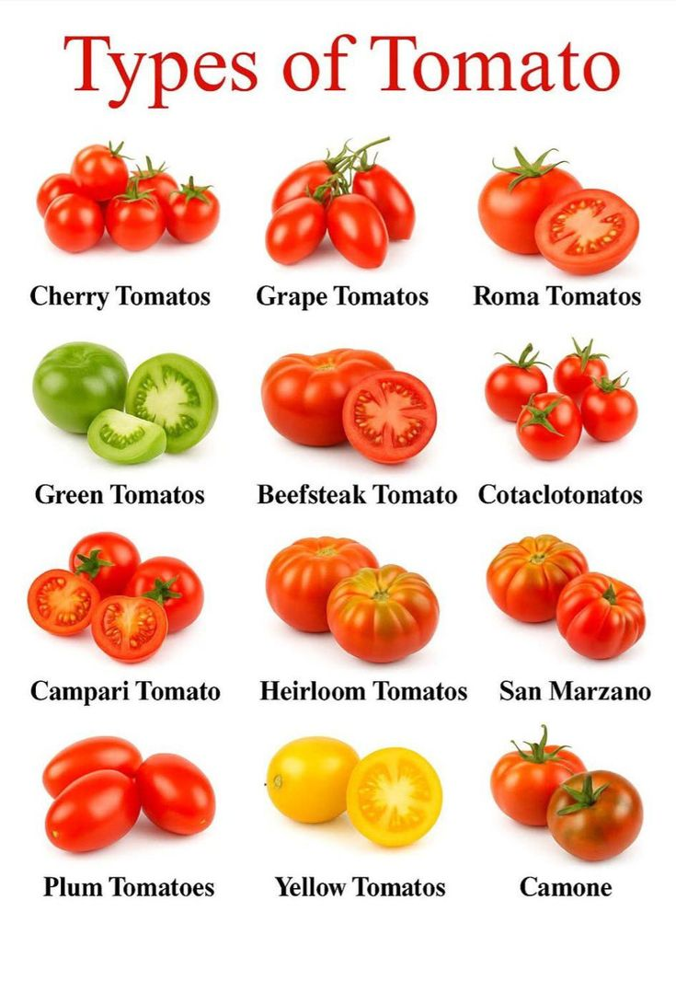
Includes Cherry, Grape, Roma, Beefsteak, Heirloom, San Marzano and others. Tomatoes grow best in mild weather; in Pakistan they are commonly sown from autumn into winter in many regions.

Eggplant (Brinjal) Types
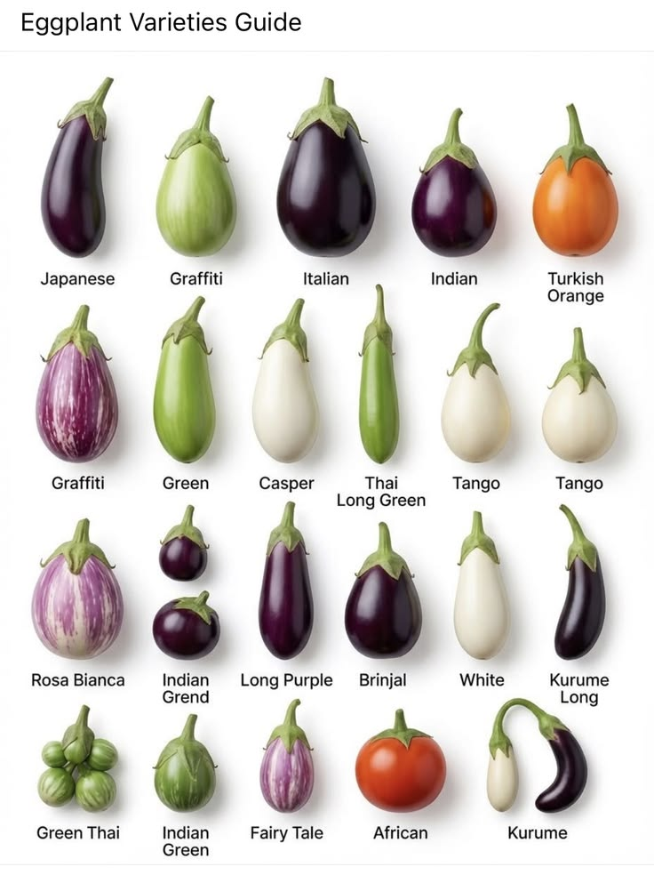
Includes Japanese, Italian, Indian, Rosa Bianca and more. Brinjal prefers warm conditions and is widely cultivated across South Asia.

Pepper Types
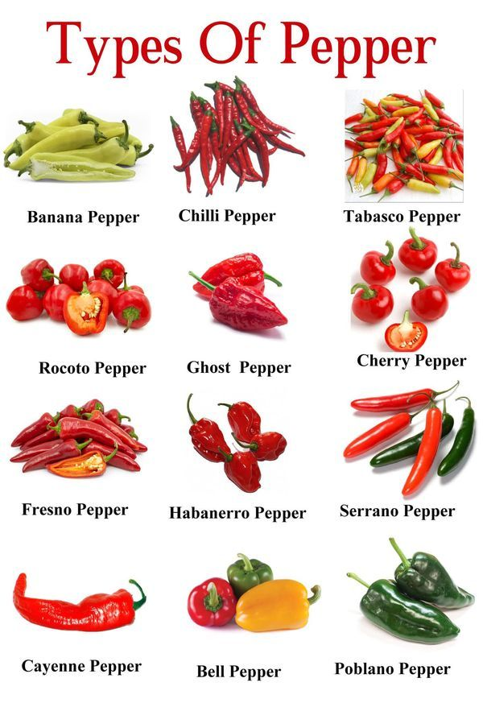
Includes Banana, Chilli, Ghost, Bell, Habanero and others. Peppers are warm-season crops requiring good sunlight.

Gourd Types
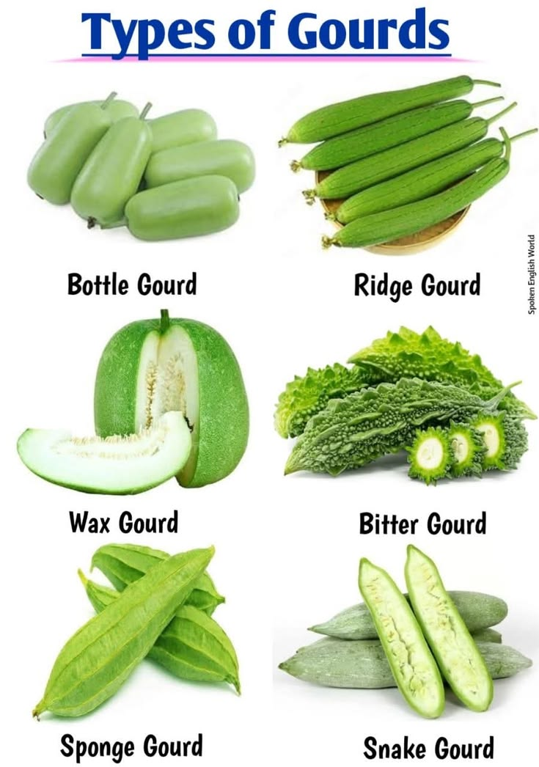
Includes Bottle Gourd, Ridge Gourd, Bitter Gourd, Sponge Gourd and Snake Gourd. Most gourds are summer vegetables in Pakistan.

