**Execution Snapshots** Naimisha

017538636

**Spatial Database Implementation:**

**createdb.sql**

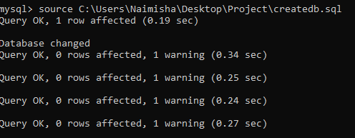

**dropdb.sql**

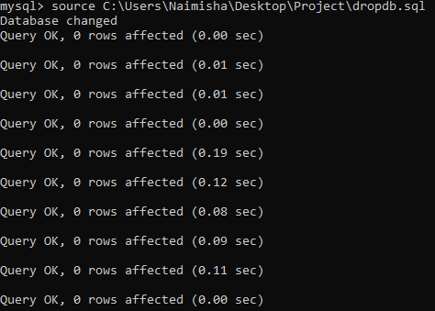

**Populating the Database:**

Loading data:

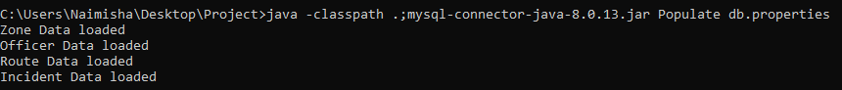

Following error messages are displayed if any of the properties are missing in db.properties file:

**Error message** being diplayed if **local host is missing** in db.properties file



**Error message** being diplayed if **port** is missing in db.properties file



**Error message** being diplayed if **Database** is missing in db.properties file



**Error message** being diplayed if **user name** is missing in db.properties file



**Error message** being diplayed if **password** is missing in db.properties file



SQL Exception thrown while connecting to database if **wrong password is entered**



**Query1: Range Query**

List of incidents that occurred within the given polygon

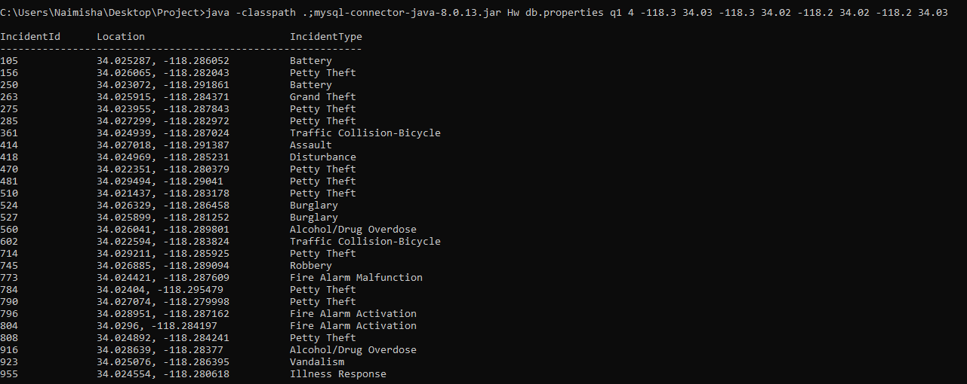

**Error message** is displayed, If there are no incidents in a given polygon



**Query2: Point Query**

List of officers found within a given distance of incident

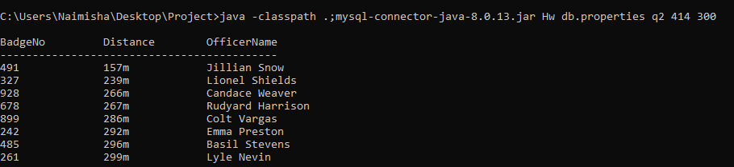

**Error Message** is displayed if there is an inexistent id



**Error Message** being displayed if there are no officers within the given distance of an incident



**Query 3: Find Squad**

List of officers for a given squad and location

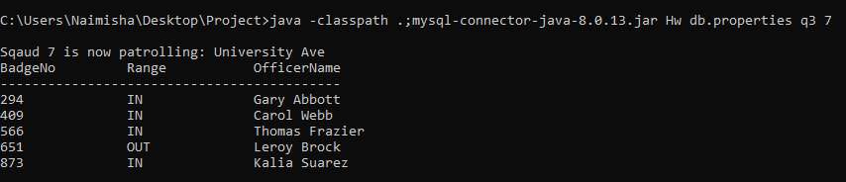

**Error message** displayed if the given squad doesn’t exist



**Error message** displayed if squad exists and is not assigned to any zone



**Query 4: Route Coverage**

List of Zones that patrol route passes through

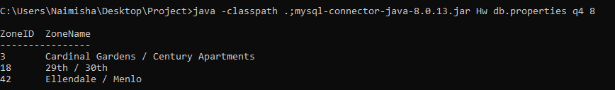

**Error message** is displayed If the route given is inexistent



**Error message** is displayed if there are no zones that patrol passes through for a given route

