Supplementary Materials
Skill-Validated Season-Stratified Rainfall Trigger Thresholds for Flash Flood Anticipatory Action in Sylhet Division, Bangladesh
Naimul Islam
Department of Civil Engineering, Chittagong University of Engineering and Technology

This document contains supplementary tables and figures supporting the main manuscript. Section S1 provides the complete extreme rainfall trend statistics across all three datasets. Section S2 presents the catalogue configuration sensitivity analysis referenced in Section 3.4. Section S3 details the full per-event cost-benefit breakdown under three return-on-investment scenarios. Sections S4 to S6 provide supporting figures.

S1. Complete extreme rainfall trend statistics
Table S1 provides the full trend statistics for the nine annual precipitation indices computed on three datasets. Trends significant at the 5 percent level are shown in bold.
Table S1. Complete trend statistics for nine annual precipitation indices. Sen slope, Mann-Kendall p-value, and Pettitt change year reported per dataset. PRCPTOT, RX1day, RX5day, R95p, R99p in mm; SDII in mm per day; CDD, CWD in days.
Index | CHIRPS slope | CHIRPS p | CHIRPS change yr | ERA5 Syl slope | ERA5 Syl p | ERA5 Syl change yr | ERA5 trans slope | ERA5 trans p | ERA5 trans change yr
PRCPTOT | -0.45 | 0.895 | 2017 | -8.89 | 0.012 | 2004 | -3.87 | 0.012 | 1974
RX1day | -0.27 | 0.379 | - | -1.02 | 0.089 | - | -0.34 | 0.256 | -
RX5day | -0.92 | 0.436 | - | -2.15 | 0.145 | - | -0.87 | 0.412 | -
R95p | -3.66 | 0.448 | - | -4.03 | 0.061 | - | -1.98 | 0.098 | -
R99p | 0.00 | 0.745 | - | -0.25 | 0.430 | - | -1.21 | 0.033 | 2003
SDII | -0.003 | 0.895 | - | -0.034 | 0.010 | 2004 | -0.014 | 0.025 | -
CDD | +0.30 | 0.017 | 2000 | +0.05 | 0.450 | - | +0.09 | 0.150 | -
CWD | 0.00 | 0.800 | - | 0.00 | 0.812 | - | 0.02 | 0.657 | -
Pre-mon | -3.24 | 0.357 | - | -3.52 | 0.100 | - | -0.95 | 0.332 | -

S2. Catalogue configuration sensitivity
Four catalogue configurations were tested to verify that the trigger threshold results are robust to residual date uncertainty in the events catalogue. Configuration Original uses the full reported start-to-end date range for each event (30 to 78 days per major event); Configurations B, C, and D collapse each event to a fixed 3-day, 5-day, or 7-day peak window centered on the reported start date. All configurations produce similar CSI values (0.11 to 0.14) on the pooled local-rainfall trigger, indicating that catalogue window precision is not the limiting factor. Season stratification combined with basin-appropriate rainfall source (final configuration) yields the substantial improvement to CSI 0.20 and POD 0.63 for the pre-monsoon regime.
Table S2. Trigger skill scores under four catalogue window configurations and the two final season-stratified configurations. Best CSI and HSS across 1 to 7 day windows shown, computed on blind 2011-2024 validation.
Configuration | Rainfall | Best CSI | Best POD | Best HSS
Original (30-78 day windows) | CHIRPS local | 0.135 | 0.55 | 0.215
Config B (3-day peak) | CHIRPS local | 0.113 | 0.50 | 0.198
Config C (5-day peak) | CHIRPS local | 0.128 | 0.33 | 0.220
Config D (7-day peak) | CHIRPS local | 0.122 | 0.38 | 0.211
Pre-monsoon (final) | Trans-boundary ERA5 | 0.196 | 0.627 | 0.321
Monsoon (final) | CHIRPS local | 0.163 | 0.347 | 0.270

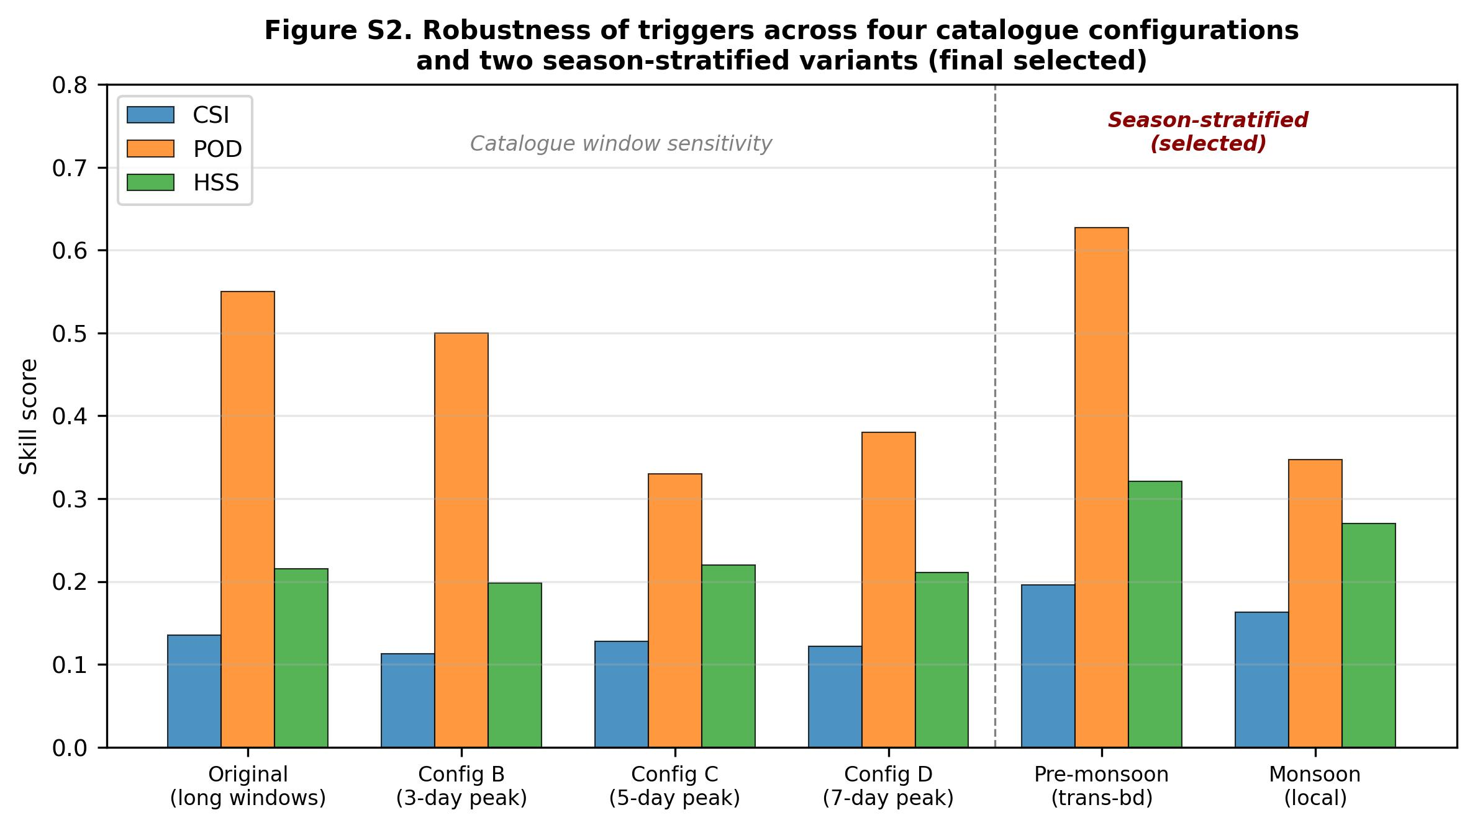
Figure S2. Robustness of derived triggers across four catalogue configurations. The four leftmost bar groups show CSI, POD, and HSS values for the pooled trigger under different event-labeling windows (Original 30-78 day, and 3/5/7-day peak subsets). All four values cluster near CSI 0.11 to 0.14, confirming that catalogue window precision is not the limiting factor. The two rightmost bar groups show the substantial improvement from season-stratified triggers with basin-appropriate rainfall source (pre-monsoon uses trans-boundary rainfall; monsoon uses local rainfall).

S3. SAR versus optical reference overlay analysis
Figure S1 visualizes the two structural asymmetries between Sentinel-1 change-based flood mapping and Sentinel-2 plus Landsat optical reference discussed in Section 5.2 of the main text. The top row shows the July 2020 event (small flash flood); the bottom row shows the June 2022 catastrophic event. Blue pixels indicate S1-detected flood, green pixels indicate optical-detected water, yellow pixels indicate both agree.
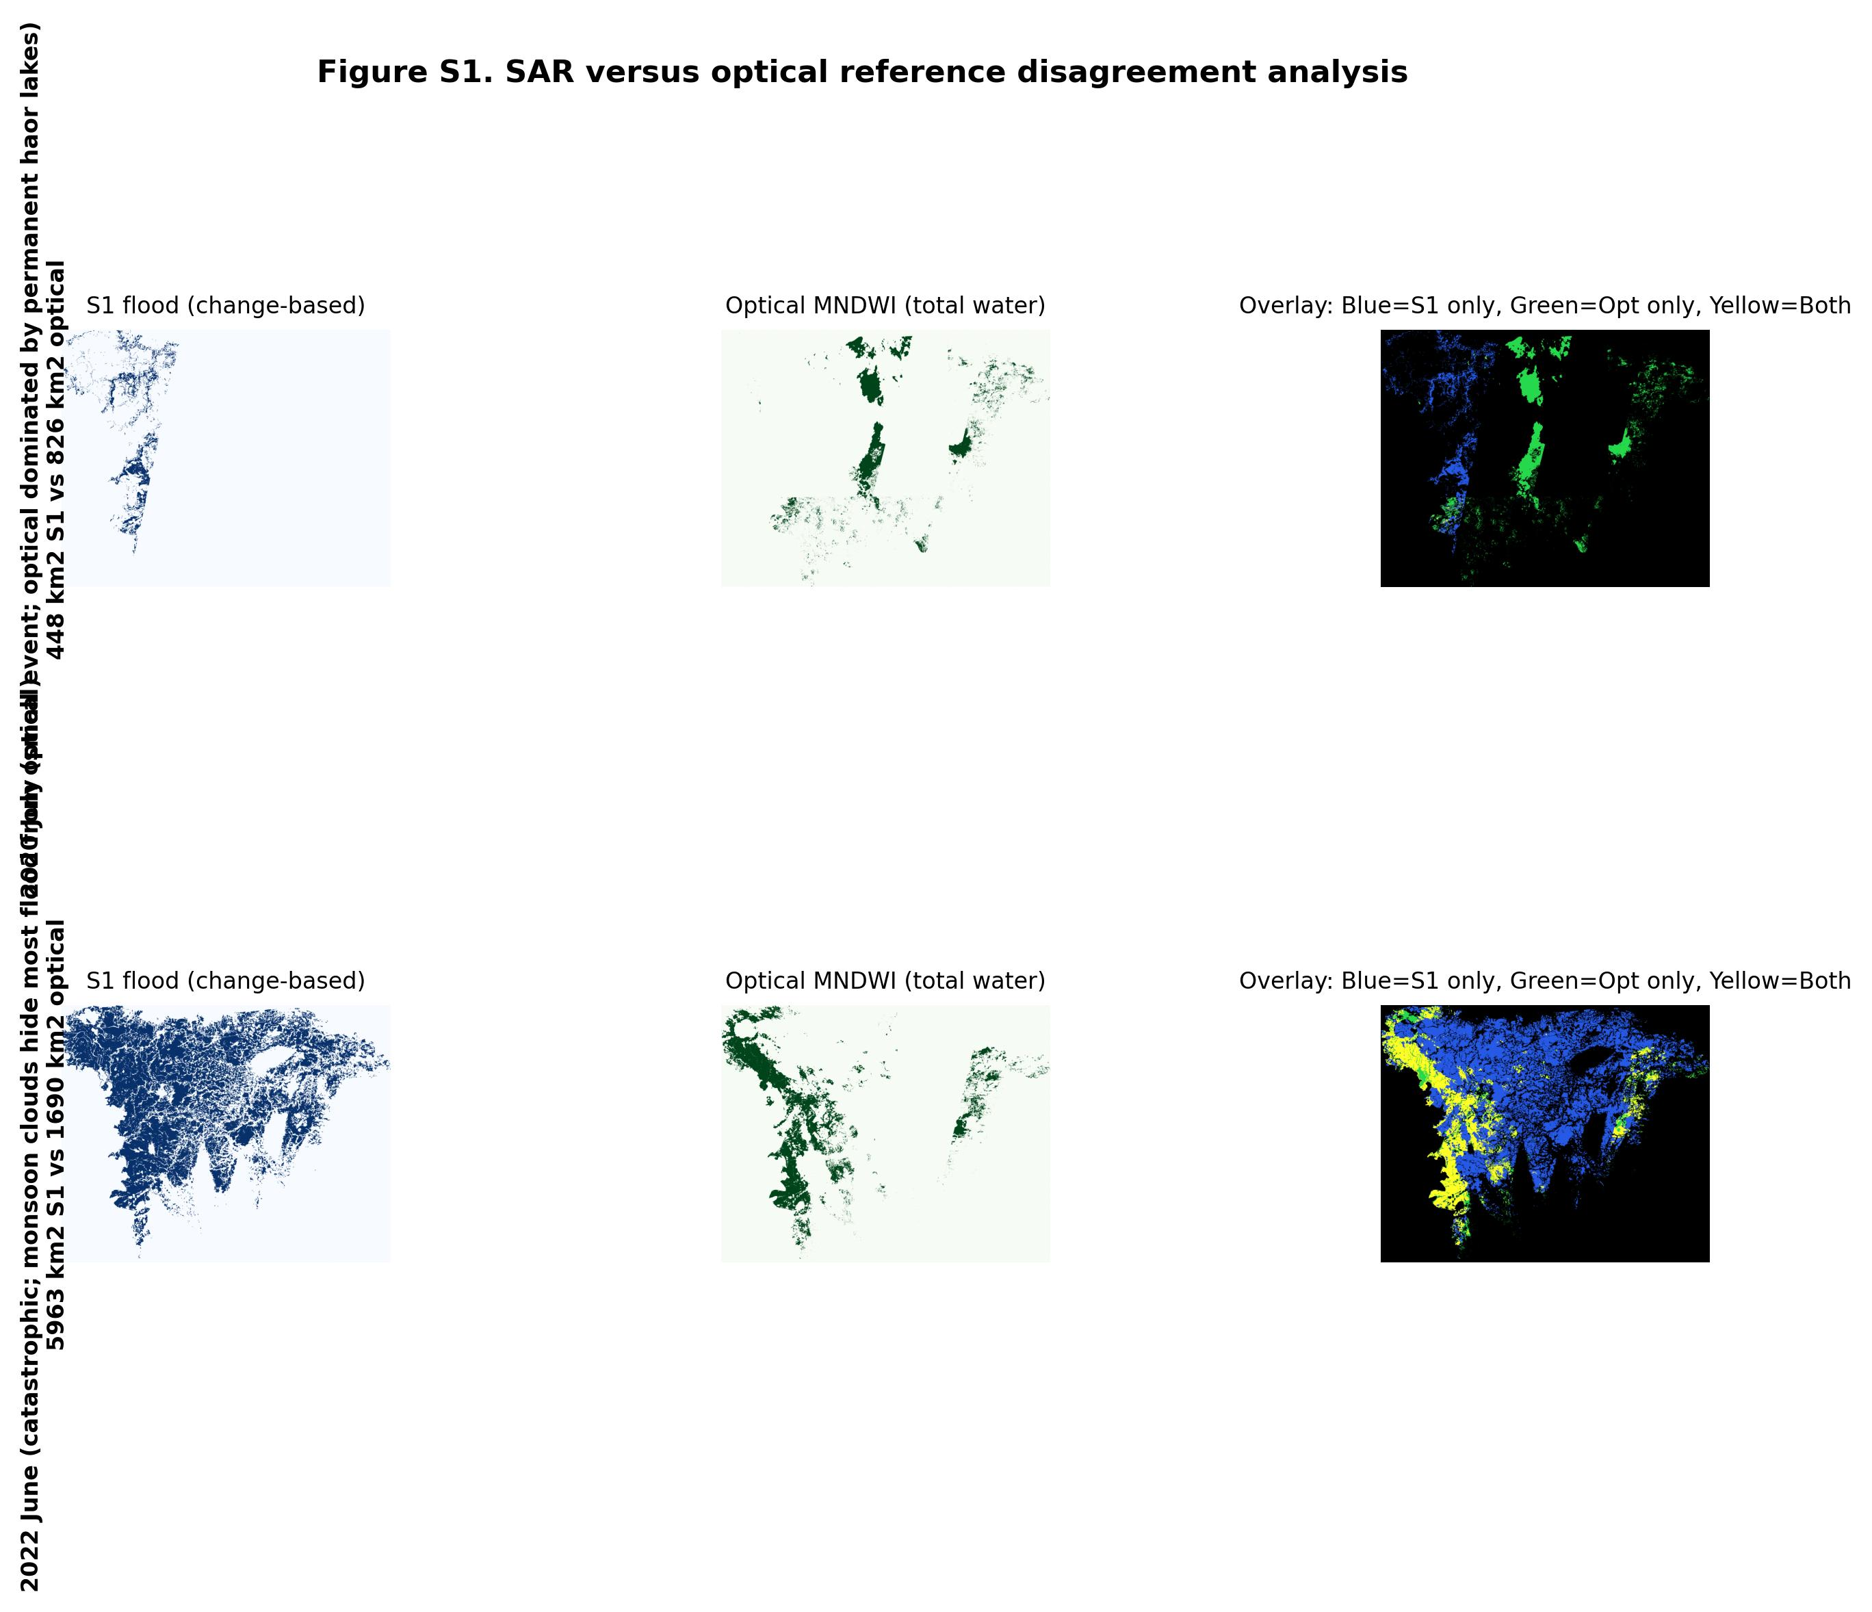
Figure S1. SAR versus optical reference disagreement analysis for two events. Top row (July 2020): the optical MNDWI (green, center) detects the Sylhet haor lakes as standing water; the S1 change-based mask (blue, left) correctly excludes these permanent water bodies via JRC Global Surface Water masking and pre-event water class subtraction, so it detects only new flood water along river channels. The two maps are therefore spatially disjoint even though both are internally correct. Bottom row (June 2022): the S1 method (blue) detects widespread catastrophic flooding across the eastern part of Sylhet Division, but the optical composite (green) is limited to isolated cloud-free pixels in the western strip where the yellow overlap agreement is strong. This confirms the S1 method produces physically meaningful extents where both sensors admit comparison.

S4. Complete cost-benefit breakdown
Table S3 provides the complete per-event cost-benefit calculation. Anticipatory action investment per event is estimated as exposed population divided by average household size (4.5) multiplied by the per-household intervention cost of USD 53 (Bangladesh Red Crescent Society and World Food Programme Jamuna 2020 programme). Avoided damages are reported under three return-on-investment scenarios: conservative 3:1, central 7:1 (Food and Agriculture Organization, World Food Programme, and OCHA 2025 multi-country evidence review), and optimistic 15:1.
Table S3. Per-event cost-benefit analysis, USD million.
Event | Households | AA cost | Cons 3:1 | Central 7:1 | Optim 15:1
2017 April | 414,080 | 21.95 | 65.8 | 153.6 | 329.2
2019 July | 126,563 | 6.71 | 20.1 | 46.9 | 100.6
2020 July | 69,729 | 3.70 | 11.1 | 25.9 | 55.5
2022 May | 410,232 | 21.74 | 65.2 | 152.2 | 326.1
2022 June | 891,401 | 47.24 | 141.7 | 330.7 | 708.5
2023 May | 68,564 | 3.63 | 10.9 | 25.4 | 54.5
2024 July | 755,716 | 40.05 | 120.2 | 280.4 | 600.8
TOTAL | 2,736,285 | 145.02 | 435.1 | 1,015.2 | 2,175.4

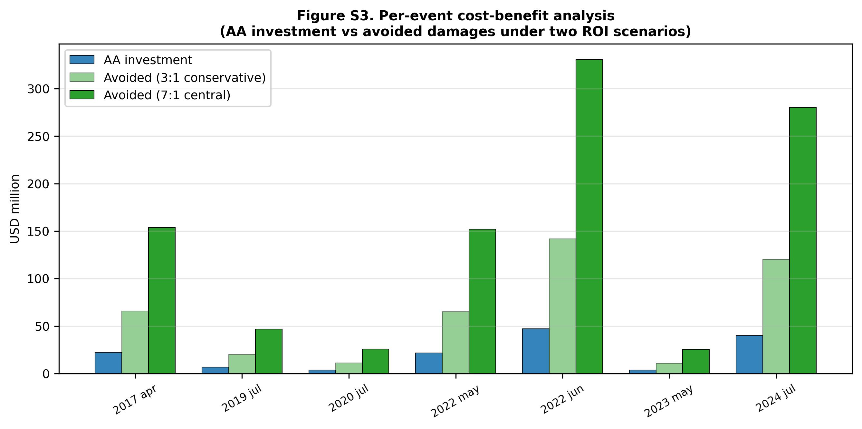
Figure S3. Per-event cost-benefit analysis comparing anticipatory action investment (blue) with avoided damages under conservative 3:1 (light green) and central 7:1 (dark green) return-on-investment scenarios. Under the central scenario, avoided damages exceed investment by an order of magnitude across all seven events.

