**Introduction:** This project proposes a closed loop speed control of induction motor where the speed control is based on V/F control with the help of SVPWM (Space Vector Pulse Width Modulation) method. The whole thing is illustrated in SIMULINK which is a design integration of MATLAB.

**Block Diagram:**

Three phase inverter

PWM

Speed Controller

Speed Reference

DC Bus/ Braking Chopper

Three phase Rectifier

Three phase AC Source

**Three phase AC source:** A single phase system has only one wave form whereas 3 phase system has 3 ac wave form, separated by 120 degrees each.

**Three phase rectifier:** A three-phase diode rectifier converts a three-phase AC voltage at the input to a DC voltage at the output.

**Chopper:** Chopper is a DC-DC converter circuit. It will convert a fixed DC into Variable DC.

**Three phase inverter:** Three phase inverters are used to convert DC to AC. In this project, IGBT (Insulated-gate bipolar transistor) inverter is used. This inverter is controlled by the pulse from PWM.

**Induction motor:** Asynchronous machine, 3HP squirrel-cage is used here.

**Speed Reference:** The desired speed of motor.

**Speed controller:** Speed controller (scalar controller) has two input terminals. One for the signal of speed reference and the other one is feedback (rotor speed). The fixed V/F ratio is set in the speed controller. Speed controller gives a signal to PWM accordingly.

**PWM:** Pulse width modulator. The algorithm used here for pulse width modulation is Space vector. PWM converts the output signal of speed controller into pulses. These pulses are sent to inverter to control the switch of inverters.

**Working techniques:**

1. The three phase AC source is converted into DC power supply with the help of three phase rectifier.

2. This fixed DC is converted to variable DC with the help of DC bus with braking chopper.

3. The desired speed of rotor is given as speed reference as the input of speed controller. Speed controller uses the fixed V/F ratio (3.2 here) and sends a signal to pulse width modulator by comparing the signals between speed reference and feedback.

4. Pulse width modulator converts this signal to pulses.

5. Pulses are then sent to IGBT inverter. These pulses controls the transistors of inverter. The larger the width, the longer the switch/transistor will be on.

6. By the continuous switching on-off process, variable DC is converted to variable AC from the inverter.

7. The motor is going to run now. The actual speed or rotor speed will be fed into the speed controller again and the loop goes on again.

**SIMULINK Implementation:**

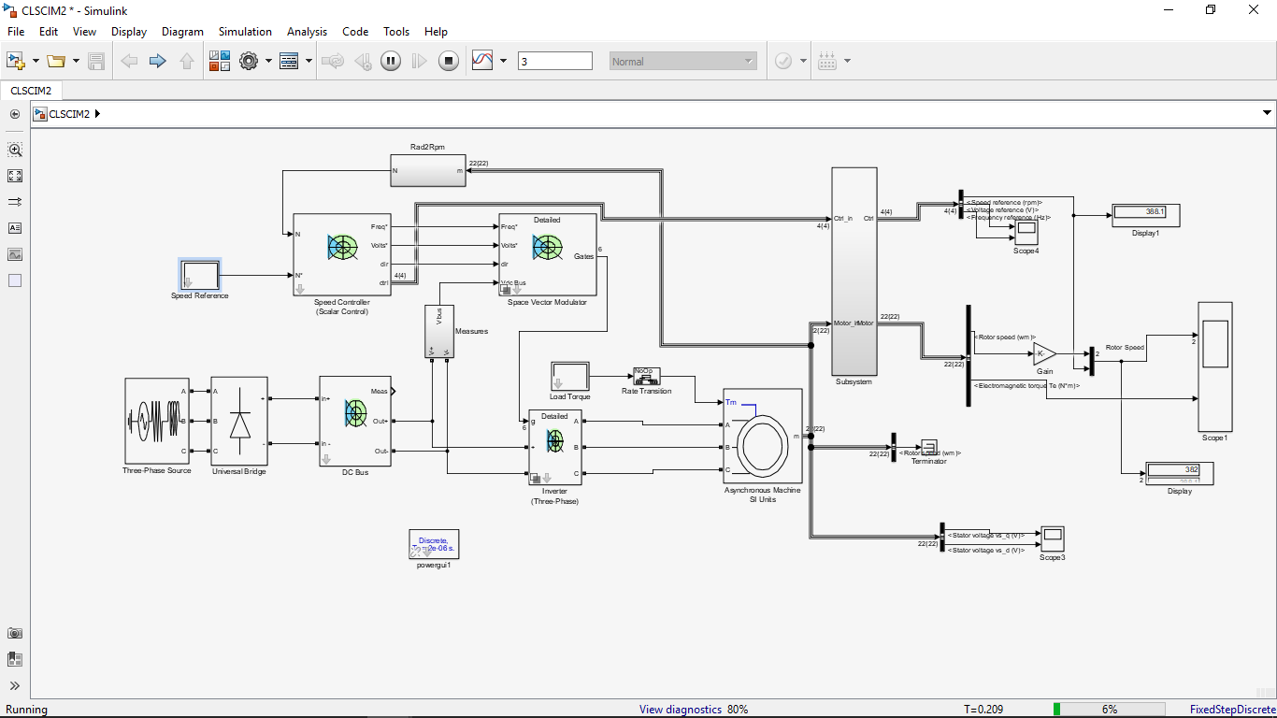

**Simulation Results:**

The simulation was run for 3 second with 2us step size. The reference speed was 1000 rpm for no load condition.

**Rotor Speed:**

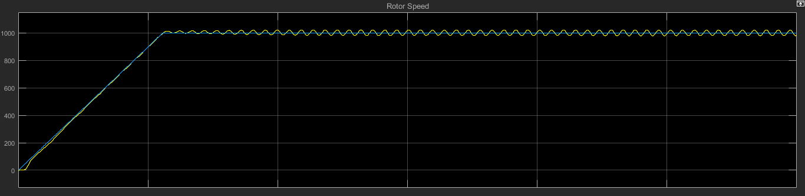

**Torque:**

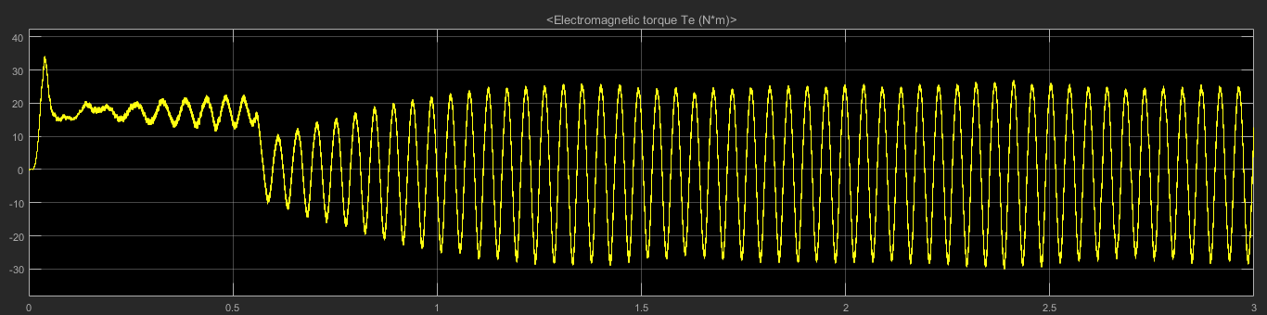

**Fixed V/F ratio: 3.2**

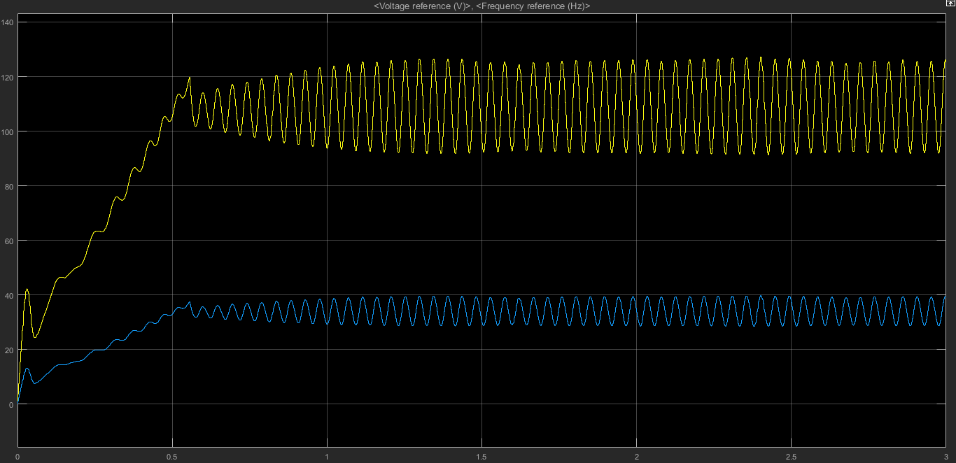

In the next step, mechanical load is increased to see how the controller recovers the speed of motor.

Load was applied after 0.5 second from the start in every case.

**Case 1:** Load torque= 10, Recover time= 699.42 ms

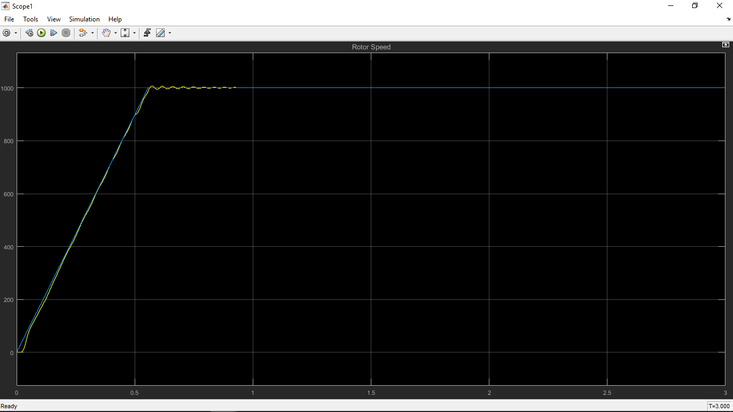

**Case 2:** Load torque= 20, Recover time= 852 ms

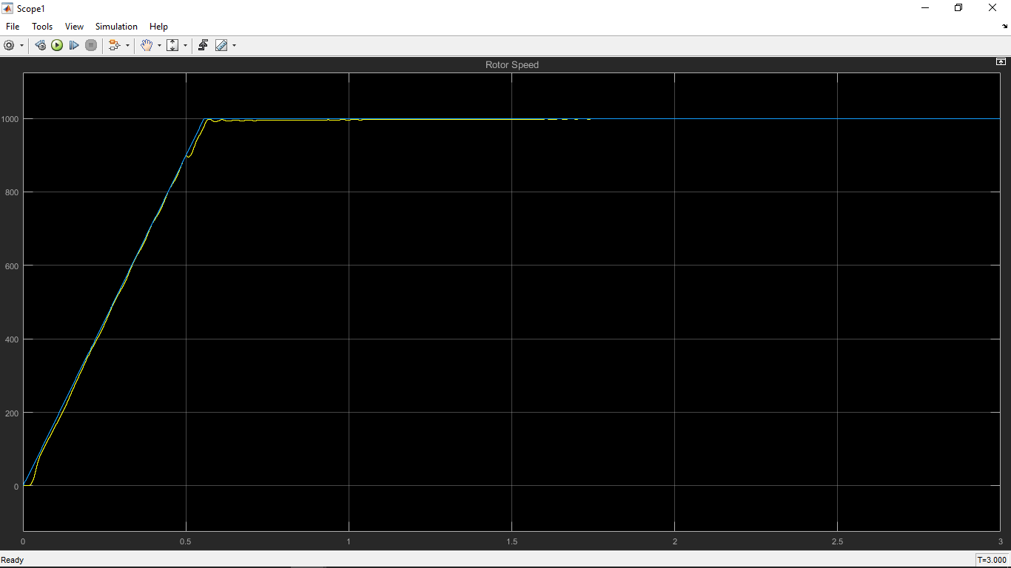

**Case 3:** Load torque= 30, Recover time= 1.061 s

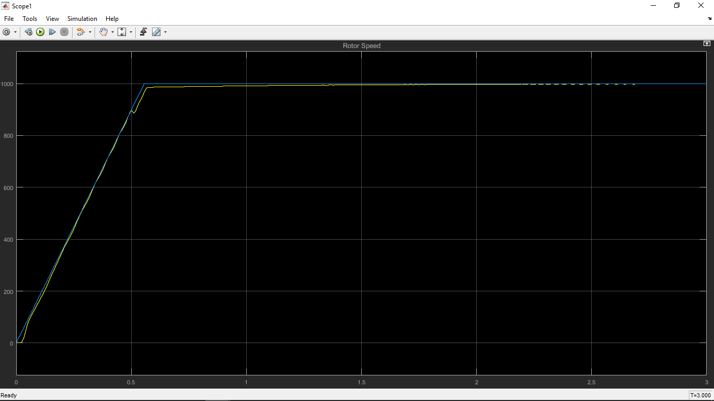

**Case 4:** Load torque=50, Recover time= 2.03

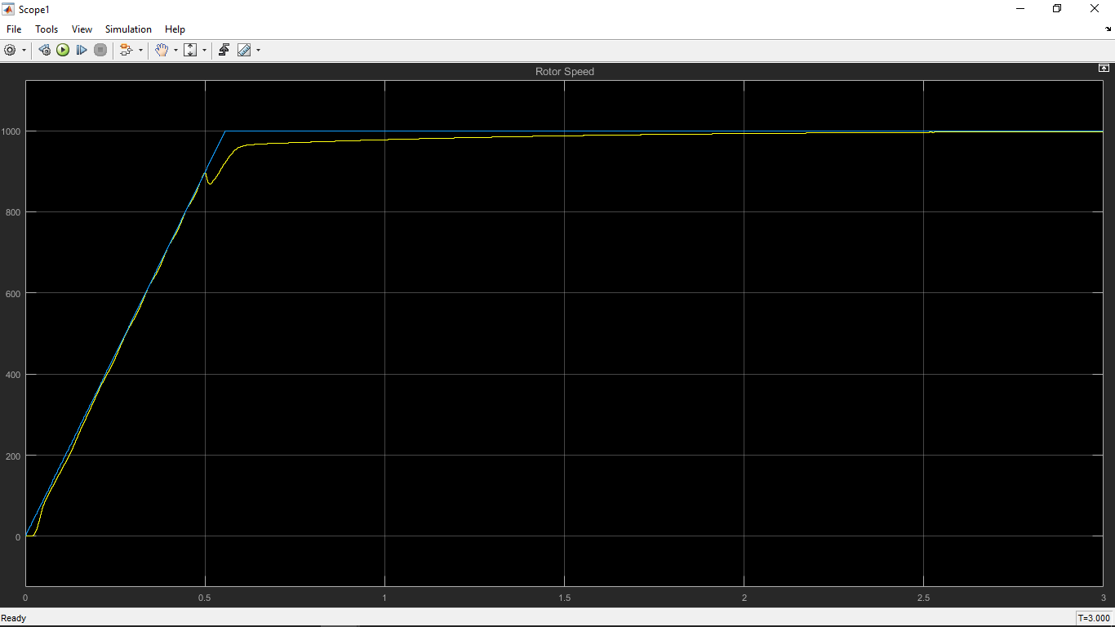

**Future improvements:**

The system can control motor’s speed by a closed loop. When mechanical load is applied on the motor, the speed decreases but the speed controller can quickly recover it and makes the rotor to run at the reference speed. But the main problem is that, if there is a very huge load, it becomes quite tough to control the speed. So, this speed works for a certain amount of load. This drawback should be improved. The dynamic analysis of recovering time was not completed in SIMULINK. It will be done in future by data exporting and importing.

**References:**

1. Mathworks

2. A Modified Closed Loop V/F Controlled Induction Motor Drive, ResearchGate

3. IEEE Xtreme