

**Objectives:**

* Recognize keywords, identifiers, literals, and operators in the source code
* Handle whitespace and comments gracefully
* Generate error tokens/messages for duplicate variables
* Optimize regular expressions for improved lexer performance
* Provide clear and informative error messages

**Introduction:**

Tokenization is a fundamental step in the process of translating human-readable source code into machine-executable instructions. In the realm of programming languages and compilers, tokenization involves breaking down a source code file into its smallest meaningful units, known as tokens. These tokens can represent keywords, identifiers, operators, literals, and other language constructs. Tokenization serves as the initial phase, laying the foundation for subsequent parsing and analysis, making it a crucial step in the compilation or interpretation of programming languages.

**ID and Type Design:**

Datatypes:

datatype “vari” similar to int | “varf” similar to float | “varc” similar to char

void “void”

Type Design:

Int [+-]?[0-9]+

Float [+-]?[0-9]+[.][0-9]+([eE][+-]?[0-9]+)?|[+-]?[1-9]+[eE][-+][0-9]+

String \"[A-Za-z0-9]+\"

ID [a-zA-Z][a-zA-Z0-9]*

Regular Expression for Types:

Variable Declaration {datatype}[ ]+{ID}("="({ID}|{int}|{float}|{string}))?([ ]*","[ ]*{ID}("="({ID}|{int}|{float}|{string}))?)*

Value Assignment {ID}[ ]*"="[ ]*({ID}|{int}|{float}|{string})

Array "array"[ ]+{datatype}[ ]+{ID}[ ]+"of"[ ]+{int}

**Loop and Directives:**

Loops and Syntax:

* “loopw” similar to while loop

loopw as {variable1} {relational operator} {variable2} {logical operator} . . . . . . .

begin

//statements

End

* “loopf” similar to for loop

loopf with {variable} {start range}...{end range} {increment/decrement}

begin

//statements

End

Loop Regular Expressions for Loop Conditions:

loopw "loopw"[ ]+"as"[ ]+({ID}|{int}|{float}|{string})[ ]+{Relational_operator}[ ]+({ID}|{int}|{float}|{string})([ ]+{Logical_operator}[ ]+({ID}|{int}|{float}|{string})[ ]+{Relational_operator}[ ]+({ID}|{int}|{float}|{string}))*[ ]*

loopf "loopf"[ ]+"with"[ ]+{ID}[ ]+{int}"..."{int}[ ]+[-]?{int}[ ]*

Directives:

Include "#include<".*">"

**Operator Handling:**

Arithmatic_operator "+"|"-"|"*"|"/"|"$"

Logical_operator "&&"|"||"

Not "!"

Unary_operator "++"|"--"

Relational_operator "ls"|"gr"|"eq"|"ge"|"le"|"ne"

Assignment_operator "="|"+="|"-="|"/="|"*="

Regular Expressions:

Unary Operator {ID}{Unary_operator}

{Unary_operator}{ID}

Relational Operator ({ID}|{int}|{float}|{string})[ ]+{Relational_operator}[ ]+({ID}|{int}|{float}|{string})

Assignment Operator {ID}[ ]*{Assignment_operator}[ ]*({ID}|{int}|{float}|{string})

Logical Operator ({ID}|{int}|{float}|{string})[ ]*{Logical_operator}[ ]*({ID}|{int}|{float}|{string})

Not {Not}[ ]*({ID}|{int}|{float}|{string})

Arithmetic Operator ({ID}|{int}|{float}|{string})[ ]*{Arithmatic_operator}[ ]*({ID}|{int}|{float}|{string})

**Conditional Operations:**

“is” similar to if

is {variable1} {relational operator} {variable2} {logical operator} . . . . . . .

{

//statements

}

“oris” similar to else if

oris {variable1} {relational operator} {variable2} {logical operator} . . . . . . .

{

//statements

}

“or” similar to else

{

//statements

}

“si” similar to fi

Regular Expressions for Conditions:

“is” “oris” ({ID}|{int}|{float}|{string})[ ]+{Relational_operator}[ ]+({ID}|{int}|{float}|{string})([ ]+{Logical_operator}[ ]+({ID}|{int}|{float}|{string})[ ]+{Relational_operator}[ ]+({ID}|{int}|{float}|{string}))*[ ]*

**Functions:**

main ({datatype}|{void})[ ]"main()"[ \n\t]*"{"

functions ({datatype}|{void})[ ]+"function"[ ]+{ID}"("({datatype}[ ]+{ID}([ ]*","[ ]*{datatype}[ ]{ID})*)?")"[ \n\t]*"{"

**Comments:**

Single Line Comment \/\/[^\n]*

Multi Line Comment \/\*([^*]|\*[^\/])*\*\/

**Source File:**

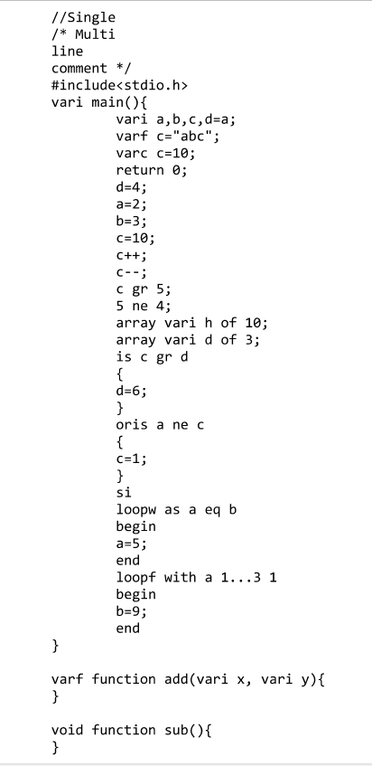

**Flex File:**

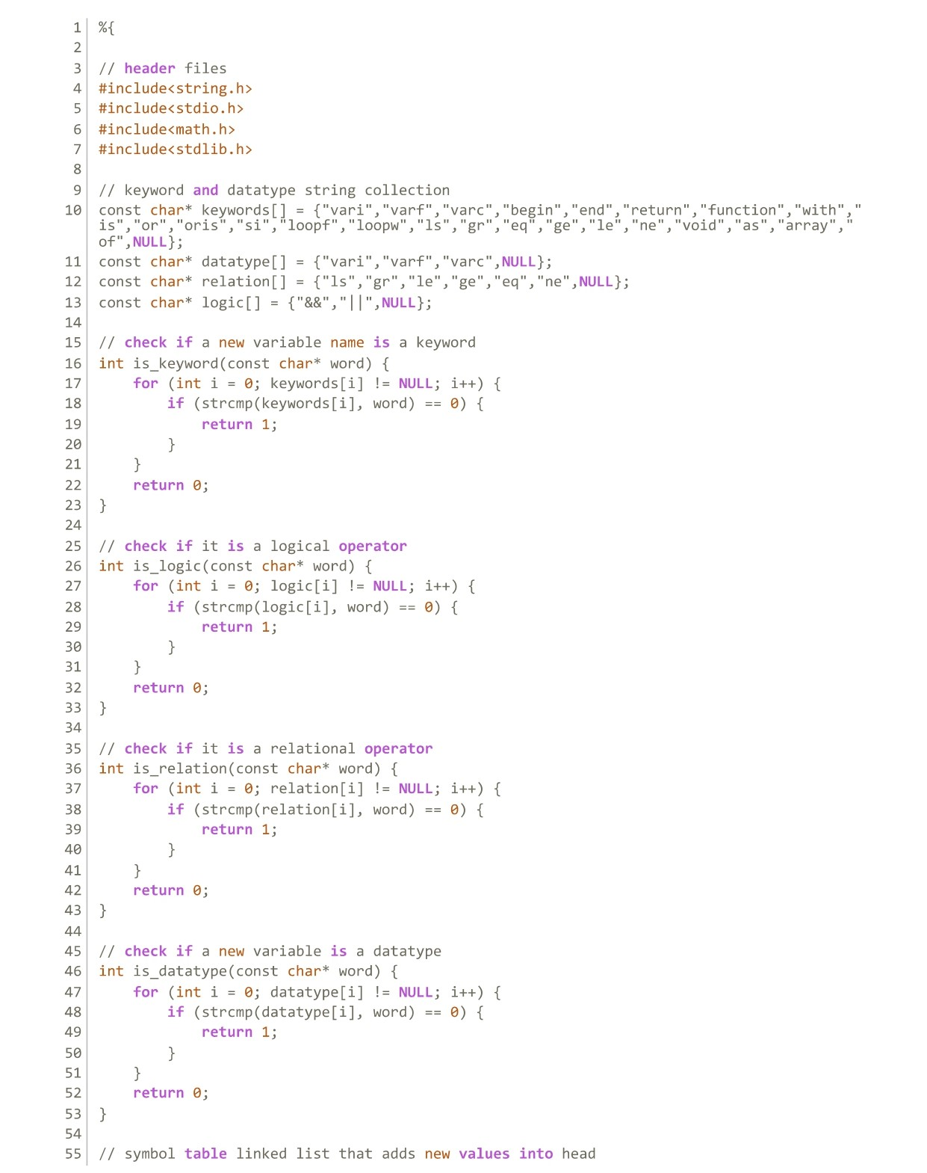

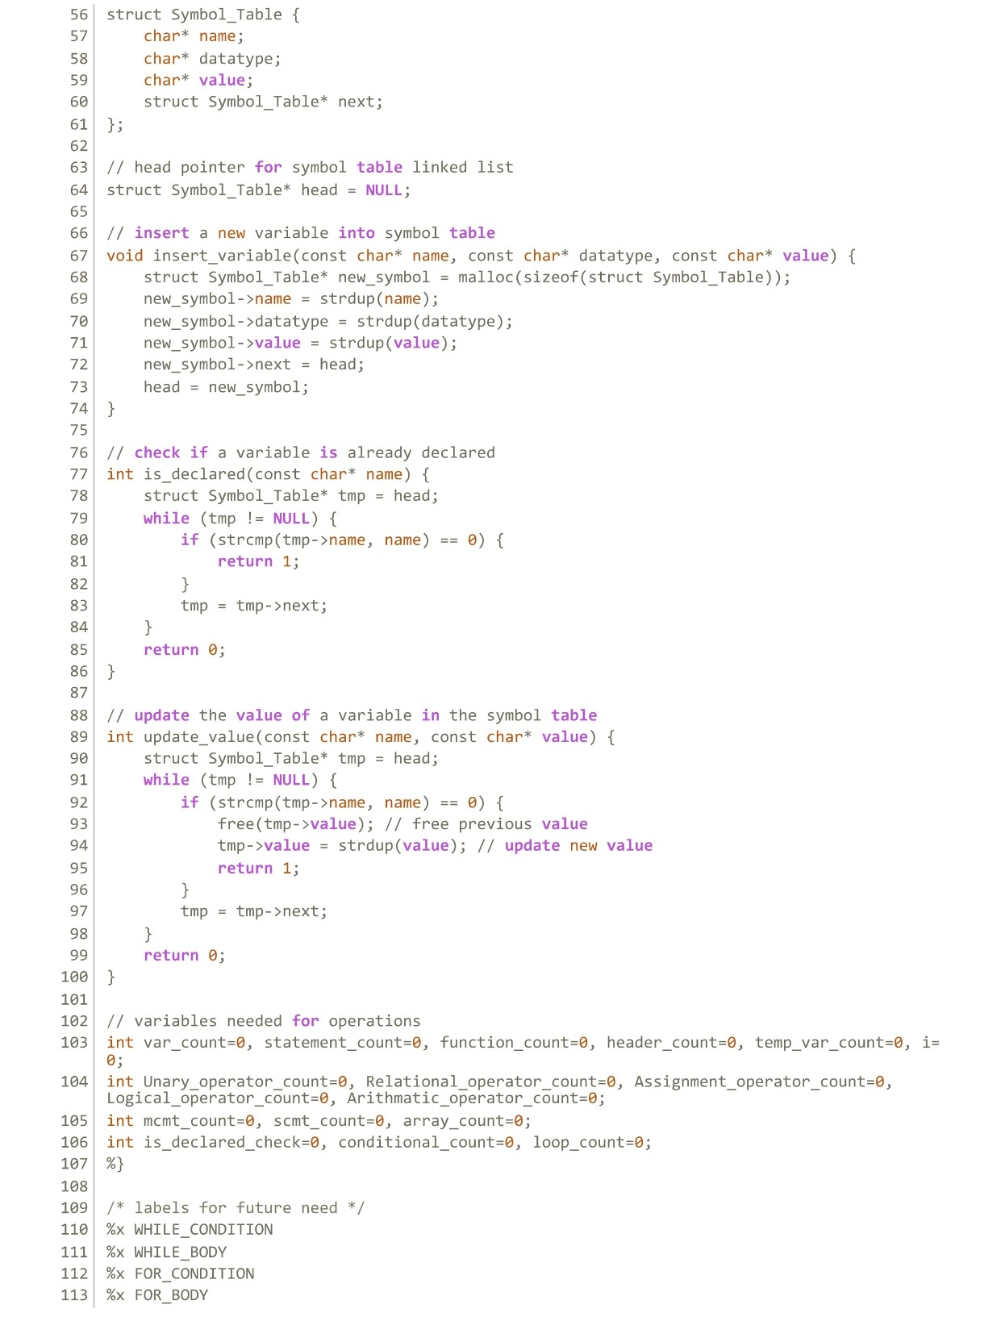

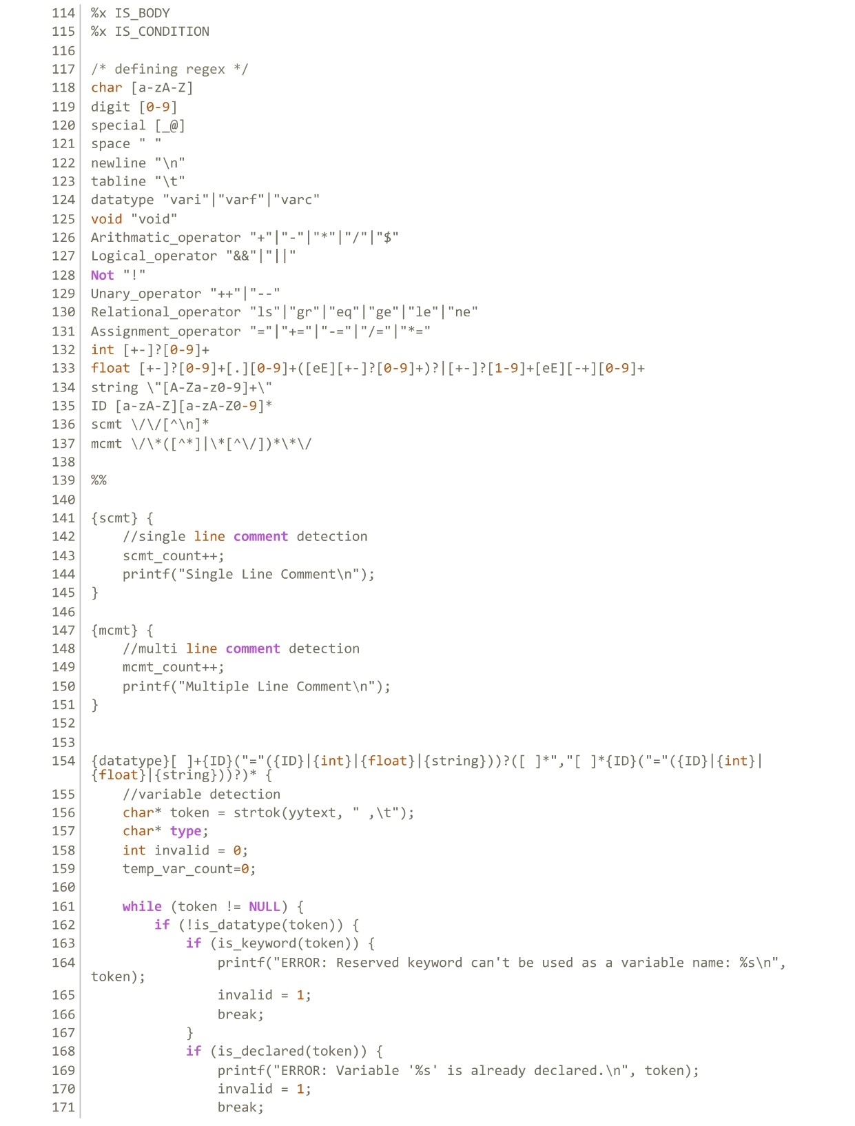

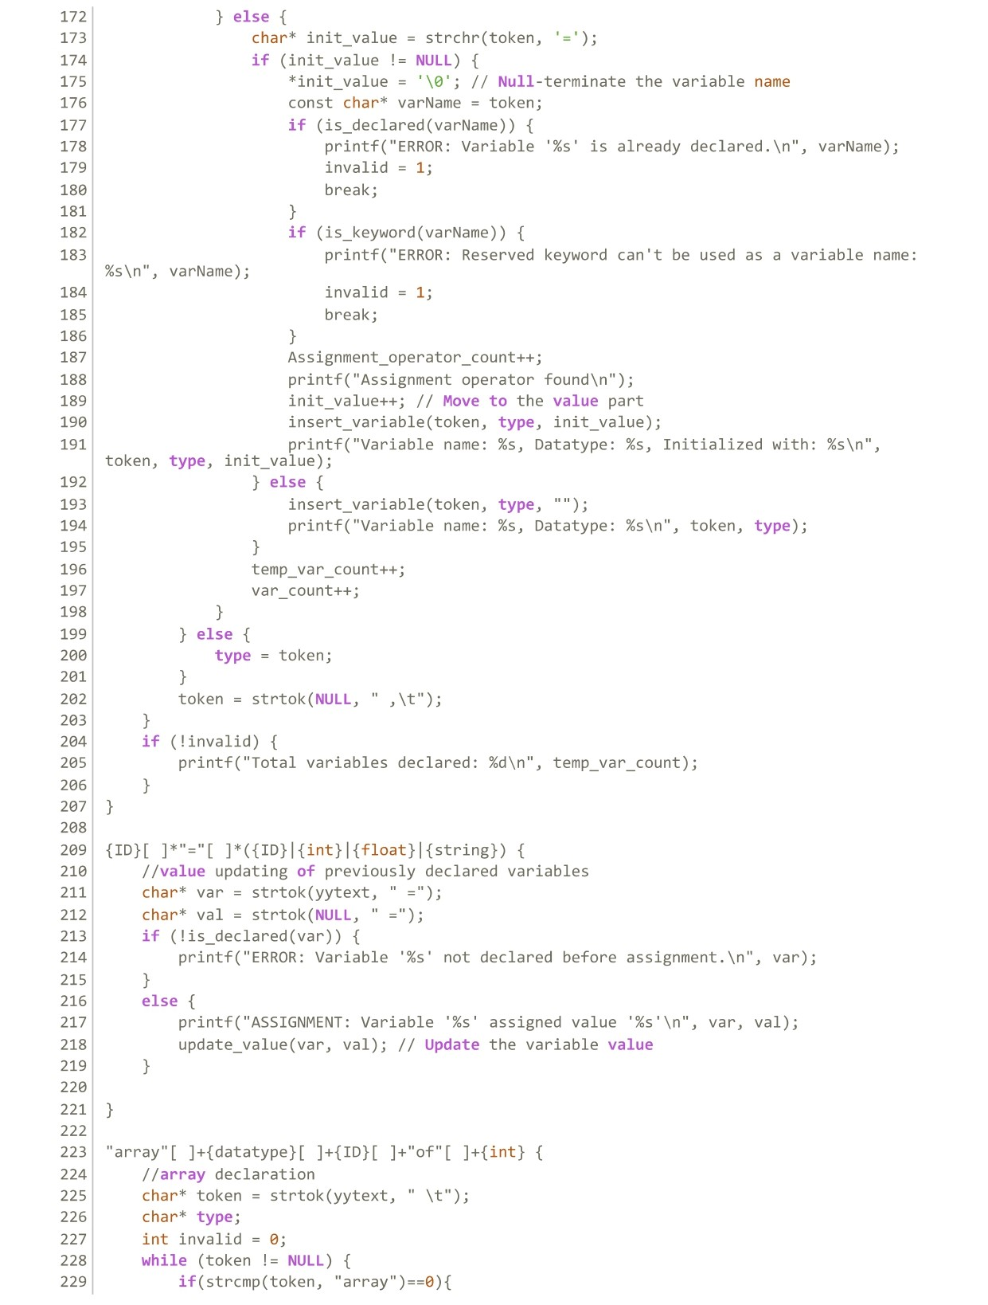

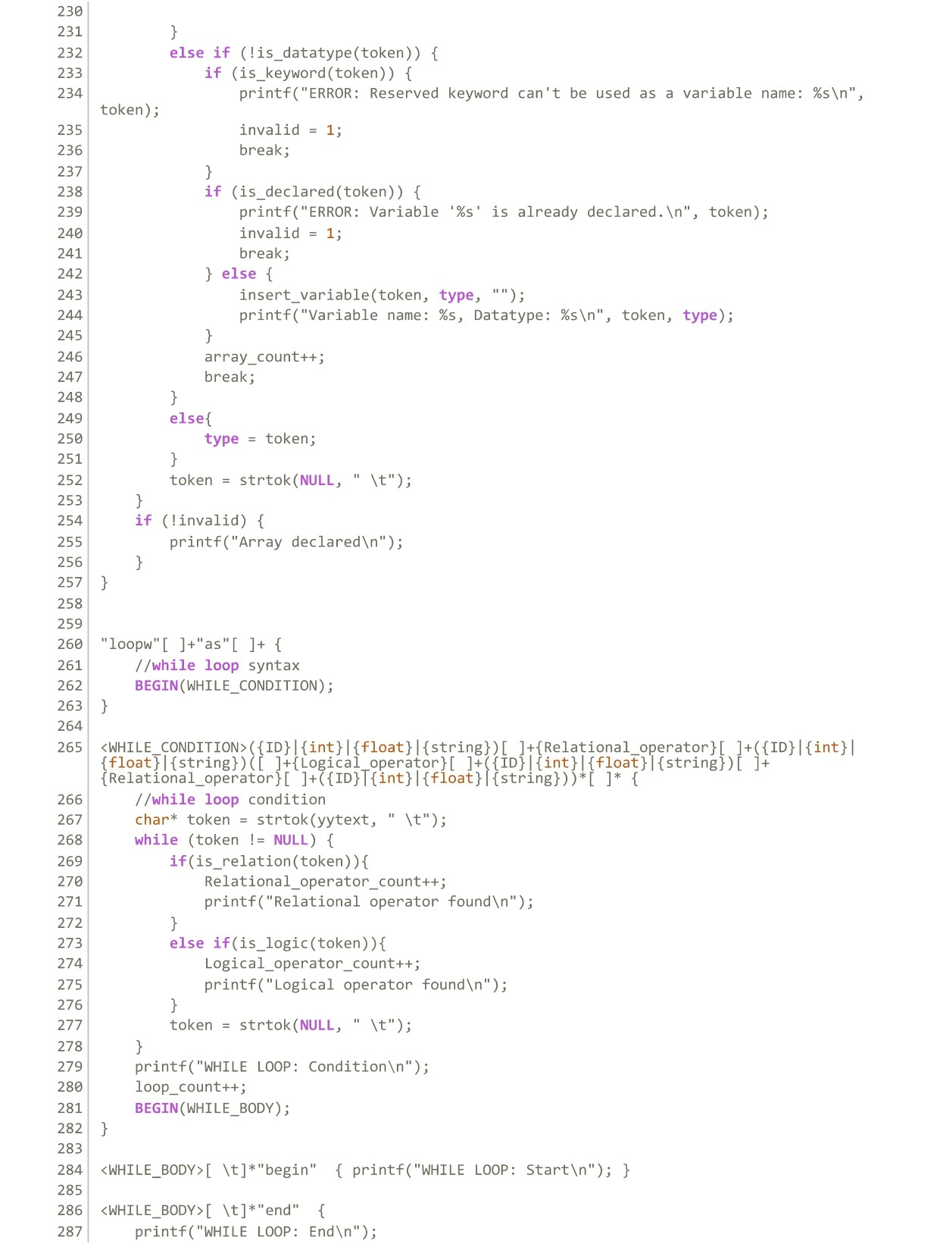

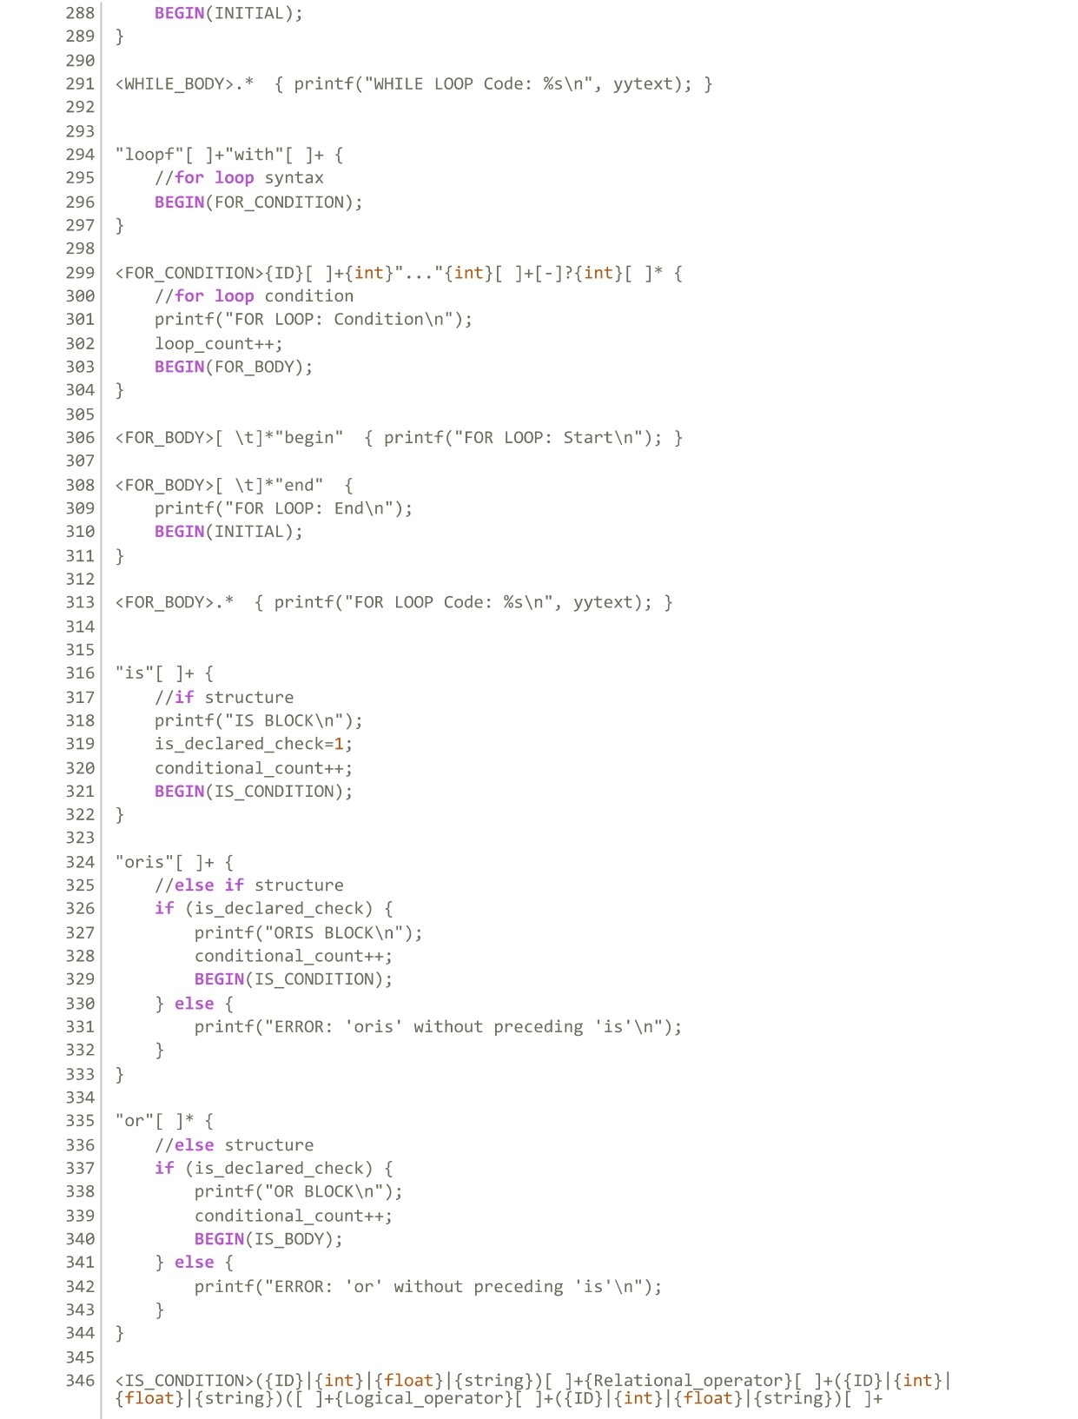

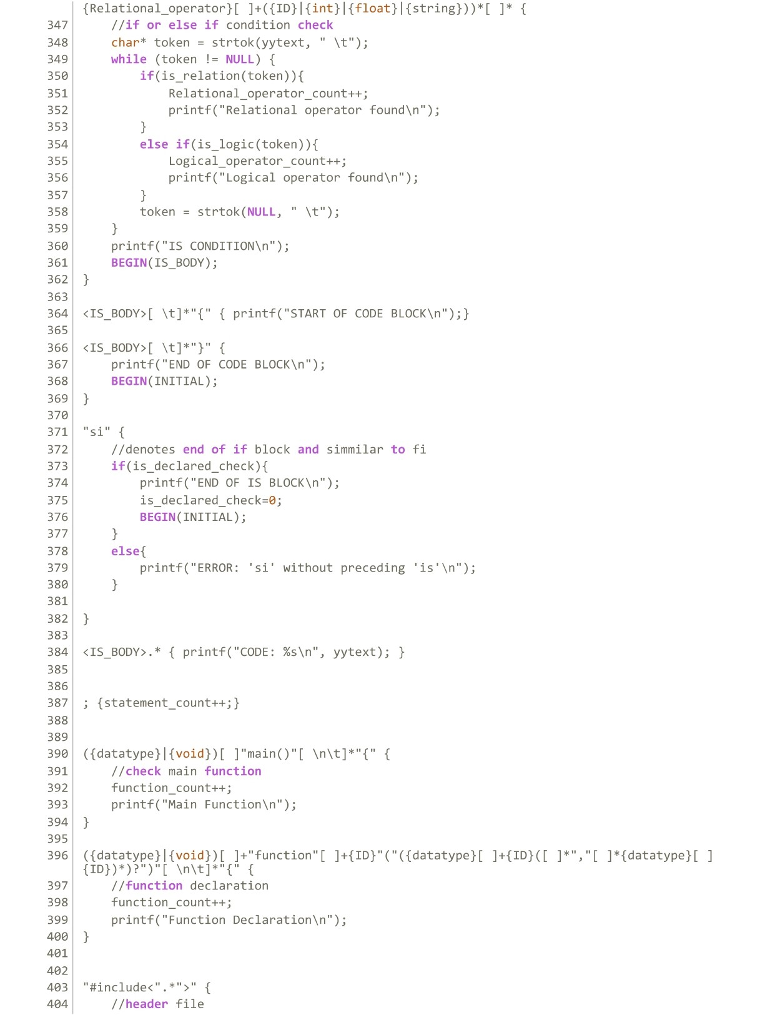

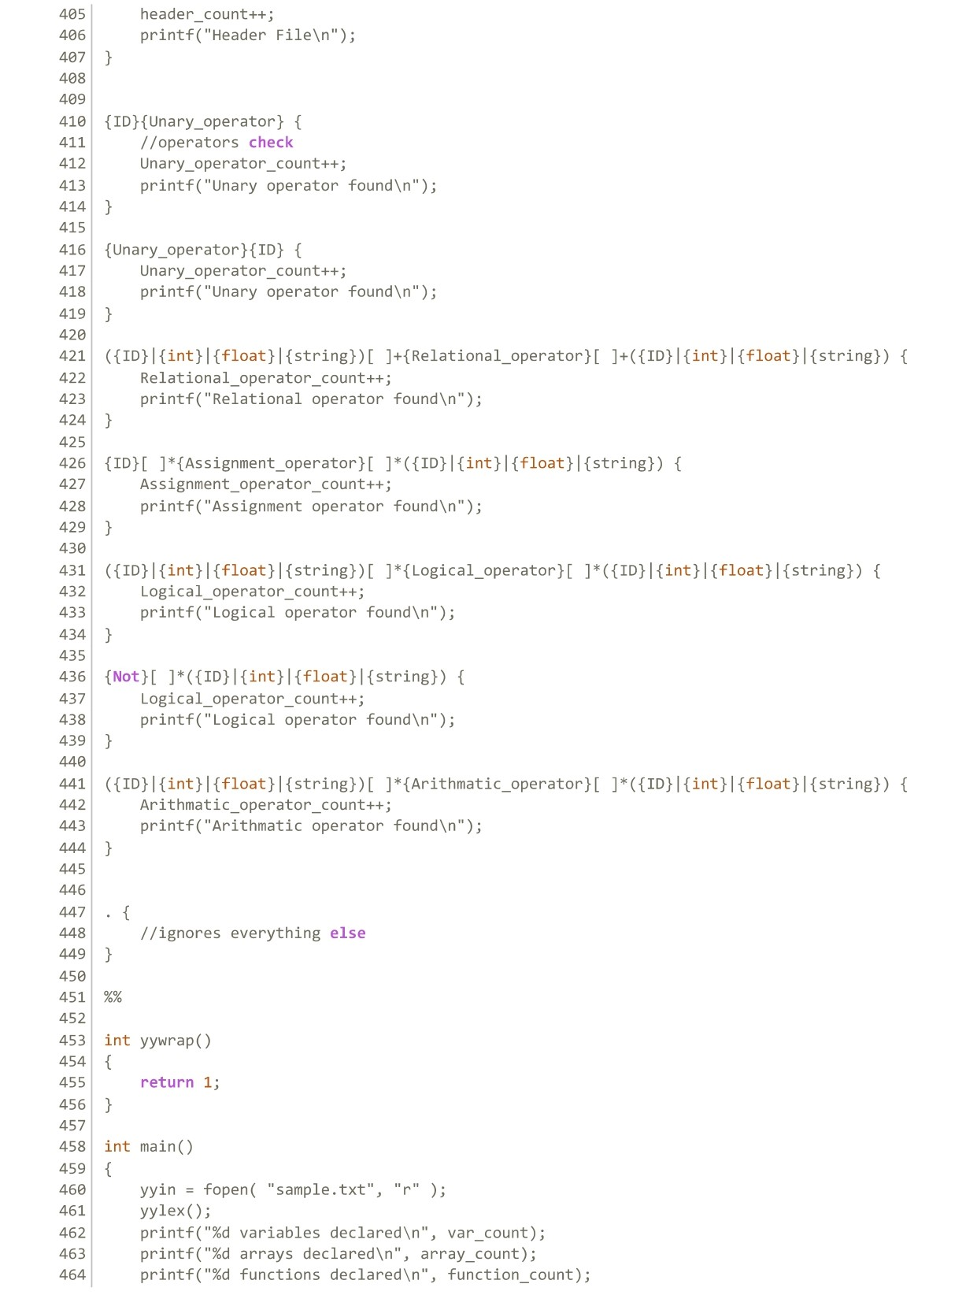

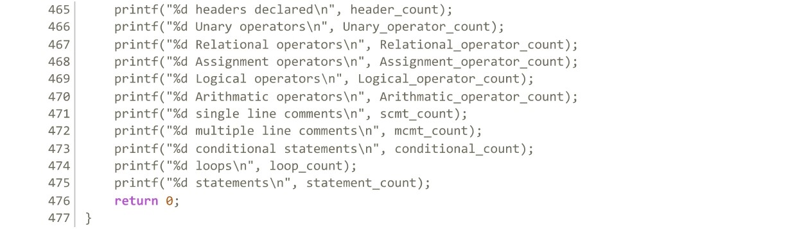

**Output File:**

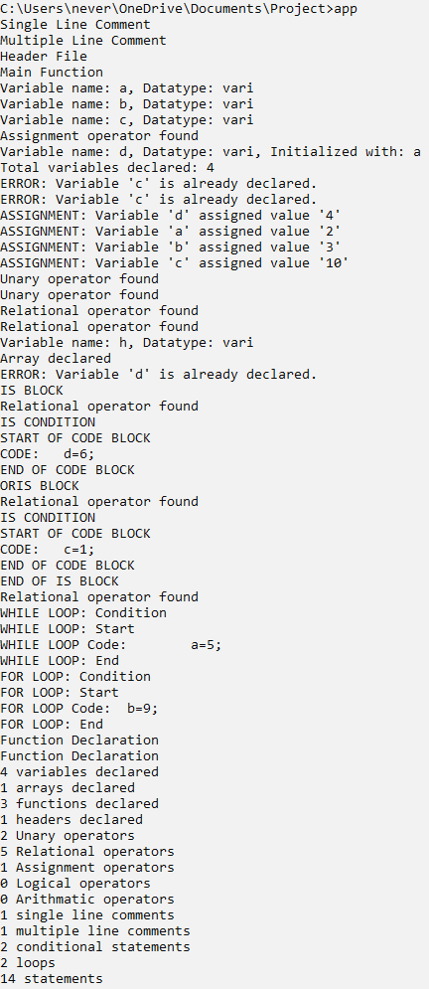

**Discussion:**

Tokenization is the process of breaking down a given text or source code into smaller, meaningful units known as tokens, with wide-ranging applications in fields like natural language processing, information retrieval, programming languages, data parsing, security, and machine learning. In NLP, it enables language analysis and understanding; in information retrieval, it facilitates efficient text searching; in programming languages and compilers, it transforms source code into language constructs; in data processing, it simplifies structured data handling; in security, it enhances data protection, and in machine learning, it's often a critical preprocessing step. The choice of tokenization strategy depends on the specific context and desired outcomes, making it a foundational step in various data processing and analysis tasks.

**Conclusion:**

Tokenization plays a vital role in transforming unstructured or structured data into manageable and meaningful units across diverse domains. Whether it's making human language computationally accessible, enabling efficient information retrieval, or serving as a fundamental step in compiling programming languages, tokenization is a foundational process that paves the way for more advanced data analysis and interpretation. Its flexibility and adaptability to specific contexts underscore its significance in modern data-driven applications, contributing to improved language understanding, search functionality, code execution, data security, and machine learning capabilities.

**Reference:**

* Lab Lectures
* CHAT GPT