**Assessing Disruptive Crises of Supply Chain in Firms Amidst Covid-19: An application of Multi Category-SVM using *k-*means Clustering**

**MD Ariful Islam, Shubho Roy, Nishat Farzana Supriti and Naimur Rahman Chowdhury**

Department of Mechanical & Production Engineering

Ahsanullah University of Science & Technology

Dhaka, Bangladesh.

[shaikatsameeh44@gmail.com](mailto:shaikatsameeh44@gmail.com), [shubhoroy529@gmail.com](mailto:shubhoroy529@gmail.com), [nishat.supriti@gmail.com](mailto:nishat.supriti@gmail.com) , [naimur20rahman.mpe@aust.edu](mailto:naimur20rahman.mpe@aust.edu)

**Abstract**

Supply chains are encountering more uncertain conditions and risks. Disruptions that impede the flow of material through a supply chain that can also result in failure to deliver end goods are a significant category of risks. The consequence of the Covid-19 outbreak has led to shut down production in the supply chain system, resulting in significant impediments for many foreign supply-dependent enterprises. The constraints cause substantial disruptions of the supply chain, production delays, and supplier delays. In recent years, managing supply chain risks has been given more importance to protect supply chains from interruptions by forecasts and prevention. The effects of disruptions on logistics, costs, demand, profits, and inventory levels of the supply chain are analyzed. SVM is one of the most convenient and effective supervised learning algorithms commonly used for classification and regression challenges. This paper presents a modernistic machine learning model, multi-category support vector machines (MC-SVM) algorithm through training on selected samples. In order to abet MC-SVM model to perform well on imbalanced data, *k-means* clustering algorithm has been proposed to classify clusters of nodes at-disruption, which share similar interruption profiles and can find the relationships between the data object, provide massive information and contribute significantly to accelerating classification and prediction of the SVM model. Data from portfolios of different firms in pharmaceutical industry has been used to train the MC-SVM model which maps the economic performance of a firm to a certain type of supply chain disruption (SCD). The potentiality of this research will privilege better management of the supply chain and thus will permit a network to approach faster response times to the customer, lower costs in all respects of the chain and to the end customer terrific levels of stretch-ability, lower inventories throughout the chain, and diminished the bottleneck effect in the supply chain logistics.

**Keywords**

Supply Chain Disruption, Multi Category SVM, Principal Component Analysis,Supply Chain Performance, Artificial Intelligence.

**1.Introduction**

The COVID 19 pandemic has escalated into the terrible health crisis of the 21st Century. As the global figure of Covid-19 infected physiques is still continuously progressing, including predictions tending to millions of existing cases at its zenith and with every case requiring similar daily dosages during the processing stage, there is a requirement for pharmaceutical firms to raise production (Yu, Razon, and Tan 2020).A pharmaceutical supply chain is a vital element of the health system in providing remedies, especially in the nations where the local pharmaceutical firms provide fundamental drugs. More than 82% of drug (in terms of volume) is supplied by local manufacturers in Bangladesh. In this meaning, any hazards affecting the pharmaceutical companies could disrupt medicines' supply and hit the health system performance. But no earlier investigations exist estimating uncertainties and disorders in pharmaceutical firms while appraising the pharmaceutical supply chain. Any contingencies influencing the pharmaceutical corporations could interrupt supply drugs and health system capability (Jaberidoost et al. 2015).

Additionally, due to this pandemic and the united global healthcare disaster, supply chains have encountered significant upstream disturbances. At the same time, hoarding and rush purchasing acted consistently as significant interruptions to the downstream. The stability of supply and demand was impacted by the travel limitations and lockdowns executed by different countries worldwide (Nikolopoulos et al. 2021). Medicines supply is one of the higher preferences in developing countries. Accordingly, active pharmaceutical supply chain control is of great significance. The suitable pharmaceutical supply chain furnishes medicines in the right amount and to the consumers in an adequate state, at the proper time, and at an optimum value to offer profits for all the stakeholders. The pharmaceutical supply chain is a significant ingredient of the health plan, encompassing all modes, data, supplies, and professionals such as suppliers, manufacturers, third-party service providers, logistics activities, marketing partners and selling activities, finance, and information technology.

The pharmaceutical and chemical industry is following critical load to secure pharmaceutical supply chain effectiveness. Research & Development charges are intertwisting, improvement periods are expanding, payer pushback is rising, and purchasers are maturing more conscious concerning care rights. An adequate supply chain will need to operate a higher imperative character in many pharmaceutical businesses (Wang and Jie 2020) . Disruptions can be repeated or exceptional, short- or long-term, and create obstacles for the involved parties differing from lesser to severe. A single setback accompanying the string may formulate a volatile risk, whereas an individual supplier owning up a manufacturer to make a rate increment that symbolizes a long-term risk. A machine that breaks down may have a comparatively insignificant impression on a manufacturing company with superfluous ability. In contrast, a pandemic that obstructs freight lanes can have a dominant impact on a transportation company (Chopra and Sodhi 2004).

Disruptions to material movement anyplace in the supply chain are random and unique but frequently pretty damaging. Unluckily, there is no elixir approach for guarding organizational supply chains. Instead, handlers necessitate knowing which remission strategy runs most beneficial on a dispensed uncertainty (Chopra and Sodhi 2004) . The evolution of modern methodological structures that would endeavor to blend adequate supply chain protection and disruption shield with fair efficiency while achieving a proper level of economic value added (EVA, a commercial metric that arrests unoccupied cash flows and is highly corresponded with a company’s stock value) resemble to be of high credit. Yet, there is still an audible absence of vital contingency policies and proper systematic methodologies to perceive their optimal parameters when examining the diverse tones of disruptions in a supply chain (Iakovou, Vlachos, and Xanthopoulos 2010)

Meantime, there are presently have some variations of models and algorithms functioned for the analysis of SCD. Machine learning and artificial intelligence are two leading approaches (Chitturi et al. 2010) . But those approaches have some restriction provisions such as the unit's volume, a type of flaws, and measures of attributes, which determine their goal in practice. One cause for the condition is that the data on pharmaceutical firms' economic appearance are usually issued intermittently and uncertain.

SVM is a supervised machine learning algorithm that helps in classification or regression problems. It seeks to find the optimum boundary between the possible outputs. In short, SVM performs complex data transformations according to the selected kernel function, and, on that basis, it attempts to optimize the separation boundaries between its data points according to labels or groups. The data points with the minimum distance to the hyperplane (closest points) are called Support Vectors. The rest of the feature set is not required if the supporting vectors are chosen, as the support vectors provide all the information-based classification requirement. In its most simple type, SVM doesn’t support multi-class classification natively. It supports binary classification and separating data points into two classes. The same principle is utilized for multi-class classification after breaking down the multiclassification problem into multiple binary classification problems. The idea is to map data points to high dimensions such that each of the two groups has a linear separation. This is called a one-to-one approach that breaks the multi-class problem down into many binary classification issues. Another method one can take is One-to-Rest, a binary classifier per pair of classes. Each class describes the breakdown as a binary classification. In order to help business decisions, Irfan et al. (2007) have proposed a k-means algorithm to locate cluster centers at various levels of the supply chain, including consumers, suppliers, distribution centers, and manufacturers. (Shalchi and Döring 2007). developed a k-means clustering approach to group State space in order to simplify the supply chain and production network. The *k-means* clustering is one of the most used methods to randomly segment a dataset into k groups where any data in the data set is identical to the group with the nearest mean.

**2. Objective**

This research focuses on exploring different kind of supply chain disruptions faced by firms under COVID-19 using a modified machine learning algorithm called MC-SVM. For better prediction and accuracy of classification, k-means is incorporated in the model. The output from the result will help in recognizing the critical disruption manner for firms which will be effective to make rapid decision to adopt sustainability and resilience in supply chain practice.

**3. Background Literature**

In Section 2.1, we provide a review of the literature on disruption crises in a supply chain in view of a pandemic's evolution. After that, in Section 2.2, we highlight different successful applications of Multi-Class SVM and K -Means Clustering Algorithm in various research areas.

**3.1 Supply chain disruptions due to a pandemic**

There have been many researches focusing on how to assess and mitigate the loss of supply chain disruptions. Still, previous research shows uncertainty about whether improving a firm's operational efficiency intensifies or lessens the effect of disruptions. So managers and investors need to identify the types of disruptions and organizational factors that can lead to failure (Schmidt and Raman 2012). Disruption risks generally have a low probability and the potential for a large loss. Some papers refer to them as ‘‘catastrophic events’’ (Knemeyer, Zinn, & Eroglu, 2009). They can seriously disrupt or delay material, information, and cash flows, which can ruin sales, increase costs, or both. Wilson (2006) investigates the effect of transportation disruption on supply chain performance by applying system dynamics. By Baghersad and Zobel, a new quantitative measure was used to measure the impact of disruption adapted from the systems resilience literature. Three hundred plus firms that suffered a disruption in the supply chain between 2005 and 2014 were evaluated to calculate the measure (Irfan et al. 2015). An empirical study was done on the effect of the 2011 Great East Japanese Earthquake based on a global sample of the financial performance of 470 firms to provide proof (Willemain, Smart, and Schwarz 2004)

Recently the outbreak of Covid-19 has led to more complexity in supply chain management for causing disruptions in the firms. The first study to inspect the COVID-19 epidemic and the impact of supply chain disruption on the stock market was proposed by Tang. He applied an empirical analysis to identify how the outbreak of coronavirus disease disrupted the supply chain. A connection between the COVID-19 outbreak and the disruption of logistics and supply chains is indicated from the study's findings (Tang, Chin, and Lee 2021). (Ivanov, 2020) fabricated a simulation study to find out some new research tensions on the globally affected supply chain. He first coherently determined the characteristics that pointed out the pandemic and indicated them as a unique type of disruption or risk. Second, by using any Logistics simulation and optimization software, he showed the way to use a simulation-based methodology to forecast the effect of the supply chain's performance on the samples of coronavirus. (Rahman, Kim, and Laratte 2021) used a scenario analysis technique to analyze the short-range and long-range term impact of COVID 19. A lack of global scale cognizance in SCD is identified using a circular economy framework to understand the disruption. As a result, Araz, Choi, Olson, and (Chopra and Sodhi 2004)asserted that COVID-19 is probably the most severe disruption to the global supply chain in the last decade.

**2.1 K Means- Multi Class SVM and its Extended Approaches**

Exploring the practical infliction of machine learning techniques in supply chain risk management is guided by artificial intelligence (AI) (Bartholomew 2010) . He was the first to proposed data-driven AL techniques to predict supply chain risk, leaning on the collaboration between AI and supply chain experts. (Carbonneau, Laframboise, and Vahidov 2008) applied a comparison to predict the bullwhip effect by using advanced machine learning techniques with other traditional methods. SVM was initially developed by Vapnik, V. (1995) as an optimal margin classifier, a new generation of learning algorithms, which constructs a separating hyperplane. The distance between the positive and negative samples is maximized. In order to improve the prediction time of SVM classifiers, (Nikolopoulos, Babai, and Bozos 2016)and (Shalchi and Döring 2007) have attempted to use the feature-selection method. ( Shao, 2012; Tang et al. 2021) used multi-category support vector machines (MC-SVM) to recognize the disruption in the supply chain. To determine disruption, they applied MC-SVM on irregular and intermittent data of the supply chain network, which were causing disruption. Some researchers have proposed using a clustering method to the SVM in order to reduce the training and prediction time, such as the hierarchical clustering (Between et al. 2015) .the k-means clustering (Tang et al. 2021) the minimum enclosing ball (MEB) clustering (Shalchi and Döring 2007), and the k-spatial medians clustering (Rahman et al. 2021)

Instead of the original dataset, the k-means clustering-based SVM (KM-SVM) utilizes cluster centers obtained from k-means clustering. The *K-mean* clustering almost maintains the structure of the original dataset appears to be a workable approach. (Jaberidoost et al. 2015) used SVM as classifiers to detect security attacks in intrusion detection. (Chitturi et al. 2010; Irfan et al. 2015) used k-means clustering to address the degradation of a performance problem. They used the K-means clustering to improve the sampling quality in the exponential mechanism, which improves the recommendation performance. (Aytaç 2020) investigated to identify the similarities of the samples with the help of the k-means clustering method. (Zhao, Hung, and Wu 2020) used K-means clustering in a direct injection engine to identify time-resolved vortex behavior and variation of a cycle. In accordance with the selected kernel function, SVM performs complex data transformations and thus tries to optimize its breakdown borders according to labels or groups between its data points.

**3. Methodology**

This article introduces a modernist machine learning model, the Multi-Category support vector machines (MC-SVM). In order to allow an MC-SVM model to work effectively on unequaled data, k-means clusters of disruption nodes, which share similar interruption profiles and find relationships between the data, provide massive information and contribute significantly in speeding up classification and prediction of the SVM model have been proposed to cluster k-means clustering algorithms.

Given a sample S = { x1,x2…..xr} , We allocated it into k clusters . i.e { C1, C2……Ck} by some clustering algorithms such as K means. Furthermore , we use ( xim,yim),i=1 ……..rm to index the example in the mth clusters , where rm  is the number of examples in the mth cluster. For each cluster , we are going to train a linear classifier fm(x) ,1 ≤ m ≤ k . the final classifier is defined with indicator function as follows –

$f(x)=\sum_{m=1}^{k}{f\left(x\right).1 (x∈}$ Cm) (1)

where (.)1 is an indicator function fm(x) is defined as

fm(x) = wmT x (2)

Notice that we don't introduce a bias term b explicitly. This can be accomplished by adding an additional dimension to each example: xT ← [xT; 1] and wT ← [wT; b].

The objective function of clustered support vector machine is as follows,

arg *min w, wm ,ξim≥ o* *∥w∥2 +*

S.t

*yim wmT xim ≥ 1- ξim , i =1……rm ∀m* (3)

where *ξim*  are slack variable , *w* is a globe reference $\frac{1}{2}\sum_{m=1}^{k}{{\left|\left|w_{m}-w\right|\right|}^{2}}$ is a global regularization , which requires the weight vector of each local linear svm *wm* aligning with global reference weight vector . w establishes a bridge between various clusters to exploit knowledge from one cluster to another. It can be prevented in each local cluster overfitting. Firms should be able to detect possible disruptions in the supply chain networks promptly to eliminate disruptions. The pair (*x, y*) could therefore be regarded as the SCD data that firms generated. Some disruptions arise from interdependent interactions between firms in a supply chain like contractual conflicts, sudden inoperative suppliers, firms' culture, etc.

Binary SVM problem can be extended to multi-class SVM problem in two widely used methods. One of them is called the one-against-all (OAA) method. OAA involves training a single classifier per class with samples of that class as positive samples and all other samples as negative. Here, a sample is given as input to all the SVMs. If this sample belongs to classP1; only the SVM trained to separate class P1from the others can have a positive 𝑃(𝑃−1)/2 response. Another method is called one-against-one (OAO) method. In OAO, for a P-class problem, 2 SVMs are constructed. Each of them is trained to separate one class from another class. While testing the system, one sample is input and it is tested for all the possible outputs of the classifier.

**4. Data Collection and Numerical Example**

In this paper, four SCD classes were shown at any time in daily activity and are induced both by interdependent connections between firms and by unforeseen external events. The classes are no disruption, inventory disruption, distribution disruption, demand disruption. To identification this classes we used inventory turnover ratio (*ITR*), percentage of order fulfillment on time(*POD*), customer service level (*CSL*), standard deviation demand(*Std*) as features .Fifty sample firms data are shown in table 1 and 2.

Table 1: Portfolio of the collected sample

|  |  |  |  |  |  |  |  |  |  |  |  |
| --- | --- | --- | --- | --- | --- | --- | --- | --- | --- | --- | --- |
| **Firms Operating Normally** | | | | | | **Demand Disrupted Critically** | | | | | |
| **Sample Firm** | ***POD*** | ***ITR*** | ***CSL*** | ***Std*** | ***Class Label*** | **Sample Firm** | ***POD*** | ***ITR*** | ***CSL*** | ***Std*** | ***Class Label*** |
| 1 | 0.972 | 1.038 | 0.930 | 0.877 | 1 | 1 | 0.936 | 1.236 | 0.807 | 3.276 | 2 |
| 2 | 0.964 | 1.069 | 0.931 | 0.969 | 1 | 2 | 0.911 | 1.230 | 0.821 | 2.742 | 2 |
| 3 | 0.974 | 1.027 | 0.959 | 0.986 | 1 | 3 | 0.936 | 1.219 | 0.820 | 2.842 | 2 |
| 4 | 0.979 | 1.064 | 0.949 | 0.916 | 1 | 4 | 0.943 | 1.167 | 0.771 | 2.299 | 2 |
| 5 | 0.961 | 1.035 | 0.937 | 0.981 | 1 | 5 | 0.950 | 1.288 | 0.823 | 2.501 | 2 |
| 6 | 0.972 | 1.052 | 0.953 | 0.898 | 1 | 6 | 0.937 | 1.154 | 0.800 | 3.231 | 2 |
| 7 | 0.931 | 1.038 | 0.932 | 0.966 | 1 | 7 | 0.914 | 1.205 | 0.789 | 2.922 | 2 |
| 8 | 0.949 | 0.984 | 0.937 | 0.994 | 1 | 8 | 0.936 | 1.162 | 0.792 | 2.659 | 2 |
| 9 | 0.937 | 1.051 | 0.943 | 0.980 | 1 | 9 | 0.924 | 1.283 | 0.817 | 2.960 | 2 |
| 10 | 0.973 | 1.012 | 0.936 | 0.911 | 1 | 10 | 0.932 | 1.226 | 0.800 | 3.398 | 2 |
| 11 | 0.979 | 1.059 | 0.949 | 0.955 | 1 | 11 | 0.937 | 1.170 | 0.822 | 2.525 | 2 |
| 12 | 0.974 | 1.000 | 0.953 | 0.996 | 1 | 12 | 0.950 | 1.227 | 0.757 | 3.331 | 2 |
| 13 | 0.934 | 1.009 | 0.949 | 0.963 | 1 | 13 | 0.913 | 1.258 | 0.765 | 2.829 | 2 |
| 14 | 0.934 | 0.985 | 0.951 | 0.974 | 1 | 14 | 0.920 | 1.295 | 0.819 | 2.602 | 2 |
| 15 | 0.931 | 1.061 | 0.949 | 0.962 | 1 | 15 | 0.918 | 1.243 | 0.799 | 2.488 | 2 |
| 16 | 0.980 | 1.037 | 0.948 | 0.935 | 1 | 16 | 0.930 | 1.165 | 0.773 | 2.804 | 2 |
| 17 | 0.950 | 1.004 | 0.941 | 0.854 | 1 | 17 | 0.918 | 1.291 | 0.812 | 2.128 | 2 |
| 18 | 0.944 | 0.984 | 0.936 | 0.916 | 1 | 18 | 0.935 | 1.278 | 0.759 | 2.407 | 2 |
| 19 | 0.968 | 1.022 | 0.941 | 0.966 | 1 | 19 | 0.918 | 1.254 | 0.829 | 3.169 | 2 |
| 20 | 0.958 | 1.006 | 0.931 | 0.935 | 1 | 20 | 0.921 | 1.222 | 0.809 | 3.258 | 2 |
| 21 | 0.960 | 1.048 | 0.933 | 0.865 | 1 | 21 | 0.919 | 1.177 | 0.798 | 2.868 | 2 |
| 22 | 0.957 | 1.006 | 0.933 | 0.980 | 1 | 22 | 0.912 | 1.269 | 0.795 | 3.255 | 2 |
| 23 | 0.977 | 1.024 | 0.932 | 0.872 | 1 | 23 | 0.942 | 1.295 | 0.819 | 2.292 | 2 |
| 24 | 0.944 | 0.993 | 0.954 | 0.902 | 1 | 24 | 0.911 | 1.166 | 0.791 | 3.015 | 2 |
| 25 | 0.969 | 1.009 | 0.958 | 0.890 | 1 | 25 | 0.909 | 1.277 | 0.757 | 3.231 | 2 |
| 26 | 0.954 | 1.015 | 0.940 | 0.861 | 1 | 26 | 0.938 | 1.214 | 0.763 | 2.170 | 2 |
| 27 | 0.957 | 1.027 | 0.951 | 0.949 | 1 | 27 | 0.916 | 1.164 | 0.814 | 2.998 | 2 |
| 28 | 0.967 | 0.992 | 0.956 | 0.866 | 1 | 28 | 0.901 | 1.202 | 0.760 | 2.735 | 2 |
| 29 | 0.932 | 1.019 | 0.959 | 0.862 | 1 | 29 | 0.910 | 1.226 | 0.763 | 2.767 | 2 |
| 30 | 0.947 | 1.067 | 0.947 | 0.969 | 1 | 30 | 0.925 | 1.196 | 0.768 | 2.736 | 2 |
| 31 | 0.966 | 1.065 | 0.937 | 0.896 | 1 | 31 | 0.903 | 1.236 | 0.782 | 2.927 | 2 |
| 32 | 0.965 | 1.036 | 0.938 | 0.976 | 1 | 32 | 0.906 | 1.270 | 0.807 | 2.773 | 2 |
| 33 | 0.931 | 1.026 | 0.956 | 0.916 | 1 | 33 | 0.932 | 1.152 | 0.792 | 3.062 | 2 |
| 34 | 0.951 | 1.019 | 0.958 | 0.902 | 1 | 34 | 0.908 | 1.185 | 0.799 | 2.700 | 2 |
| 35 | 0.980 | 1.037 | 0.939 | 0.852 | 1 | 35 | 0.939 | 1.175 | 0.774 | 2.588 | 2 |
| 36 | 0.934 | 1.026 | 0.935 | 0.902 | 1 | 36 | 0.906 | 1.225 | 0.772 | 2.291 | 2 |
| 37 | 0.957 | 1.016 | 0.952 | 1.017 | 1 | 37 | 0.906 | 1.172 | 0.788 | 2.478 | 2 |
| 38 | 0.953 | 0.985 | 0.943 | 0.864 | 1 | 38 | 0.911 | 1.285 | 0.804 | 2.568 | 2 |
| 39 | 0.944 | 1.002 | 0.933 | 0.966 | 1 | 39 | 0.934 | 1.281 | 0.815 | 2.509 | 2 |
| 40 | 0.971 | 1.040 | 0.932 | 0.929 | 1 | 40 | 0.932 | 1.173 | 0.791 | 2.741 | 2 |
| 41 | 0.942 | 0.989 | 0.940 | 0.984 | 1 | 41 | 0.914 | 1.167 | 0.820 | 2.431 | 2 |
| 42 | 0.936 | 1.028 | 0.953 | 0.936 | 1 | 42 | 0.931 | 1.154 | 0.798 | 2.780 | 2 |
| 43 | 0.960 | 1.035 | 0.937 | 0.966 | 1 | 43 | 0.909 | 1.155 | 0.767 | 2.532 | 2 |
| 44 | 0.974 | 1.051 | 0.947 | 1.018 | 1 | 44 | 0.942 | 1.200 | 0.778 | 2.669 | 2 |
| 45 | 0.949 | 1.059 | 0.936 | 0.943 | 1 | 45 | 0.935 | 1.169 | 0.816 | 2.445 | 2 |
| 46 | 0.978 | 1.062 | 0.936 | 0.940 | 1 | 46 | 0.921 | 1.273 | 0.793 | 2.280 | 2 |
| 47 | 0.945 | 1.061 | 0.959 | 0.927 | 1 | 47 | 0.915 | 1.170 | 0.762 | 2.300 | 2 |
| 48 | 0.951 | 1.031 | 0.950 | 0.944 | 1 | 48 | 0.941 | 1.173 | 0.770 | 2.350 | 2 |
| 49 | 0.977 | 1.026 | 0.936 | 1.001 | 1 | 49 | 0.922 | 1.240 | 0.802 | 2.713 | 2 |
| 50 | 0.980 | 1.004 | 0.936 | 0.906 | 1 | 50 | 0.907 | 1.202 | 0.829 | 2.699 | 2 |

Table 2 : Portfolio of the collected sample

|  |  |  |  |  |  |  |  |  |  |  |  |
| --- | --- | --- | --- | --- | --- | --- | --- | --- | --- | --- | --- |
| **Inventory Disrupted Critically** | | | | | | **Distribution Disrupted Critically** | | | | | |
| **Sample Firm** | ***POD*** | ***ITR*** | ***CSL*** | ***Std*** | ***Class Label*** | **Sample Firm** | ***POD*** | ***ITR*** | ***CSL*** | ***Std*** | ***Class Label*** |
| 1 | 0.887 | 0.917 | 0.713 | 1.548 | 3 | 1 | 0.753 | 0.903 | 0.869 | 1.109 | 4 |
| 2 | 0.919 | 0.916 | 0.712 | 1.539 | 3 | 2 | 0.708 | 0.927 | 0.872 | 1.189 | 4 |
| 3 | 0.896 | 0.900 | 0.676 | 1.369 | 3 | 3 | 0.766 | 0.902 | 0.896 | 1.181 | 4 |
| 4 | 0.901 | 0.903 | 0.722 | 1.505 | 3 | 4 | 0.771 | 0.918 | 0.867 | 1.154 | 4 |
| 5 | 0.905 | 0.885 | 0.652 | 1.416 | 3 | 5 | 0.740 | 0.915 | 0.899 | 1.171 | 4 |
| 6 | 0.890 | 0.916 | 0.669 | 1.423 | 3 | 6 | 0.756 | 0.907 | 0.871 | 1.123 | 4 |
| 7 | 0.893 | 0.906 | 0.704 | 1.429 | 3 | 7 | 0.788 | 0.908 | 0.860 | 1.174 | 4 |
| 8 | 0.909 | 0.908 | 0.651 | 1.519 | 3 | 8 | 0.732 | 0.908 | 0.857 | 1.165 | 4 |
| 9 | 0.896 | 0.897 | 0.627 | 1.412 | 3 | 9 | 0.778 | 0.902 | 0.863 | 1.108 | 4 |
| 10 | 0.883 | 0.899 | 0.637 | 1.317 | 3 | 10 | 0.734 | 0.903 | 0.878 | 1.191 | 4 |
| 11 | 0.884 | 0.911 | 0.650 | 1.423 | 3 | 11 | 0.765 | 0.903 | 0.866 | 1.194 | 4 |
| 12 | 0.909 | 0.919 | 0.620 | 1.551 | 3 | 12 | 0.793 | 0.923 | 0.867 | 1.137 | 4 |
| 13 | 0.881 | 0.889 | 0.603 | 1.417 | 3 | 13 | 0.757 | 0.904 | 0.898 | 1.101 | 4 |
| 14 | 0.896 | 0.890 | 0.723 | 1.538 | 3 | 14 | 0.712 | 0.911 | 0.863 | 1.160 | 4 |
| 15 | 0.882 | 0.918 | 0.621 | 1.522 | 3 | 15 | 0.800 | 0.922 | 0.856 | 1.197 | 4 |
| 16 | 0.901 | 0.899 | 0.659 | 1.499 | 3 | 16 | 0.723 | 0.904 | 0.852 | 1.173 | 4 |
| 17 | 0.894 | 0.914 | 0.713 | 1.548 | 3 | 17 | 0.770 | 0.911 | 0.864 | 1.191 | 4 |
| 18 | 0.897 | 0.891 | 0.646 | 1.442 | 3 | 18 | 0.744 | 0.912 | 0.877 | 1.183 | 4 |
| 19 | 0.895 | 0.882 | 0.712 | 1.432 | 3 | 19 | 0.710 | 0.922 | 0.878 | 1.107 | 4 |
| 20 | 0.915 | 0.912 | 0.694 | 1.372 | 3 | 20 | 0.733 | 0.929 | 0.852 | 1.133 | 4 |
| 21 | 0.899 | 0.894 | 0.729 | 1.467 | 3 | 21 | 0.769 | 0.919 | 0.872 | 1.105 | 4 |
| 22 | 0.892 | 0.888 | 0.624 | 1.567 | 3 | 22 | 0.713 | 0.909 | 0.859 | 1.145 | 4 |
| 23 | 0.915 | 0.895 | 0.610 | 1.381 | 3 | 23 | 0.755 | 0.909 | 0.873 | 1.171 | 4 |
| 24 | 0.912 | 0.919 | 0.653 | 1.324 | 3 | 24 | 0.704 | 0.926 | 0.884 | 1.151 | 4 |
| 25 | 0.903 | 0.910 | 0.703 | 1.493 | 3 | 25 | 0.711 | 0.919 | 0.853 | 1.108 | 4 |
| 26 | 0.890 | 0.920 | 0.700 | 1.350 | 3 | 26 | 0.712 | 0.921 | 0.873 | 1.123 | 4 |
| 27 | 0.890 | 0.902 | 0.673 | 1.508 | 3 | 27 | 0.794 | 0.919 | 0.871 | 1.160 | 4 |
| 28 | 0.883 | 0.906 | 0.650 | 1.339 | 3 | 28 | 0.711 | 0.916 | 0.871 | 1.133 | 4 |
| 29 | 0.887 | 0.919 | 0.603 | 1.382 | 3 | 29 | 0.761 | 0.917 | 0.880 | 1.171 | 4 |
| 30 | 0.902 | 0.891 | 0.696 | 1.598 | 3 | 30 | 0.778 | 0.902 | 0.859 | 1.110 | 4 |
| 31 | 0.902 | 0.905 | 0.632 | 1.523 | 3 | 31 | 0.713 | 0.930 | 0.857 | 1.137 | 4 |
| 32 | 0.907 | 0.916 | 0.670 | 1.547 | 3 | 32 | 0.721 | 0.928 | 0.898 | 1.116 | 4 |
| 33 | 0.919 | 0.888 | 0.680 | 1.450 | 3 | 33 | 0.721 | 0.921 | 0.871 | 1.170 | 4 |
| 34 | 0.897 | 0.887 | 0.634 | 1.390 | 3 | 34 | 0.793 | 0.901 | 0.899 | 1.138 | 4 |
| 35 | 0.906 | 0.898 | 0.713 | 1.395 | 3 | 35 | 0.787 | 0.928 | 0.899 | 1.170 | 4 |
| 36 | 0.885 | 0.918 | 0.649 | 1.407 | 3 | 36 | 0.762 | 0.914 | 0.877 | 1.165 | 4 |
| 37 | 0.885 | 0.906 | 0.667 | 1.396 | 3 | 37 | 0.741 | 0.910 | 0.870 | 1.106 | 4 |
| 38 | 0.918 | 0.909 | 0.654 | 1.323 | 3 | 38 | 0.744 | 0.928 | 0.853 | 1.164 | 4 |
| 39 | 0.896 | 0.915 | 0.697 | 1.368 | 3 | 39 | 0.741 | 0.929 | 0.851 | 1.127 | 4 |
| 40 | 0.910 | 0.914 | 0.633 | 1.583 | 3 | 40 | 0.790 | 0.925 | 0.873 | 1.157 | 4 |
| 41 | 0.902 | 0.904 | 0.655 | 1.484 | 3 | 41 | 0.785 | 0.915 | 0.899 | 1.137 | 4 |
| 42 | 0.909 | 0.912 | 0.733 | 1.347 | 3 | 42 | 0.777 | 0.907 | 0.887 | 1.184 | 4 |
| 43 | 0.909 | 0.910 | 0.704 | 1.313 | 3 | 43 | 0.769 | 0.919 | 0.872 | 1.189 | 4 |
| 44 | 0.906 | 0.905 | 0.638 | 1.517 | 3 | 44 | 0.780 | 0.922 | 0.854 | 1.178 | 4 |
| 45 | 0.917 | 0.915 | 0.679 | 1.475 | 3 | 45 | 0.792 | 0.915 | 0.858 | 1.114 | 4 |
| 46 | 0.919 | 0.918 | 0.604 | 1.444 | 3 | 46 | 0.761 | 0.911 | 0.873 | 1.134 | 4 |
| 47 | 0.890 | 0.915 | 0.611 | 1.491 | 3 | 47 | 0.770 | 0.904 | 0.857 | 1.116 | 4 |
| 48 | 0.883 | 0.886 | 0.700 | 1.321 | 3 | 48 | 0.792 | 0.910 | 0.869 | 1.106 | 4 |
| 49 | 0.881 | 0.894 | 0.709 | 1.508 | 3 | 49 | 0.753 | 0.918 | 0.882 | 1.188 | 4 |
| 50 | 0.907 | 0.919 | 0.606 | 1.522 | 3 | 50 | 0.775 | 0.929 | 0.890 | 1.181 | 4 |

Table 3 : Distribution of the sample of 2673 firms of SCD

|  |  |
| --- | --- |
| Type of Disruption | Number of Firms |
| Normally Operating | 915 |
| Demand Critically Disrupted | 577 |
| Inventory Critically Disrupted | 513 |
| Distribution Critically Disrupted | 668 |

Finally, a sample of 2673 firms was used as sampling firms. And the other 327 firms are being applied for the matching sample portfolio. The descriptive statistics of 2673 sample firms are shown in Table 1, which is composed in Table 3.

For a better prediction and accuracy of the classification, *k-means* was incorporated in the model and for the four clusters data from table 4 was obtained. For choosing the final class, an analysis between *k-means* cluster and MC-SCM classes has been employed. Final classes have been chose from maximum number of samples from a cluster that falls under a certain class. Data are shown in table 4.

Table 4: Data for choosing final classes for MC-SVM from *k-means* cluster

|  |  |  |  |  |  |
| --- | --- | --- | --- | --- | --- |
|  | Cluster 1 | Cluster 2 | Cluster 3 | Cluster 4 | Winner Class |
| Class 1 | 887 | 7 | 7 | 4 | **Class 1** |
| Class 2 | 3 | 566 | 2 | 6 | **Class 2** |
| Class 3 | 4 | 6 | 499 | 4 | **Class 3** |
| Class 4 | 1 | 1 | 6 | 660 | **Class 4** |

**5.1. Numerical Illustrations :**

Firstly, we employ the normally operating, inventory disruption, distribution disruption, demand disruption ratio from sample firms for matching portfolio for each sample firm. The distribution of normally operating- inventory disruption- distribution disruption -demand disruption ratio of firms is shown as Figure 1,2,3. In Figure 1,2,3 there are some data points above the others because the firms are selected randomly. In case of POD, firms having distribution disruption varies strongly from the normal operating firm. Slight variation is seen in case of firms having demand and inventory disruption. Value of ITR is greater in the firm’s having demand disruption whereas firms having demand and inventory disruption have lower ITR then Normal operating firms. Value of ITR are close in case of firms that have inventory and distribution disruption. All of the disruption type has higher STD value than the normal operating firm. Most varying result is seen in case of demand disruption from the normal operating firms. Value of CSL of all type disruption affected firm is lower than normal operating firms. Inventory disruptive firms have the most variance from the normal operating firms.

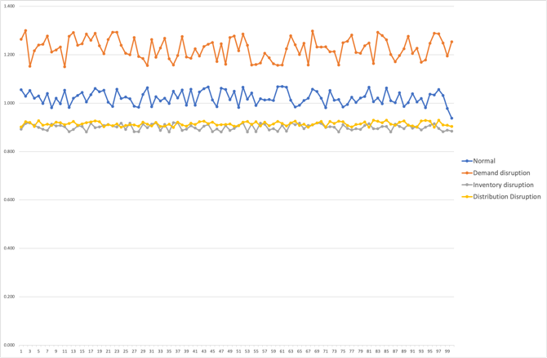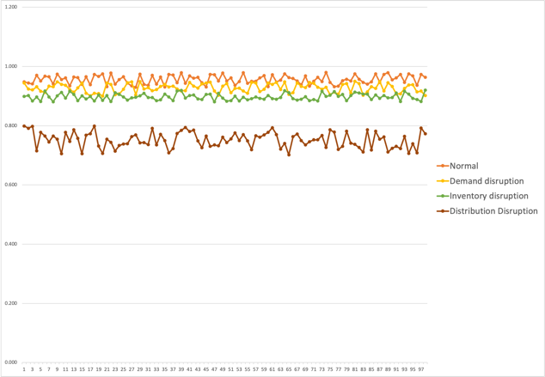

Figure 2: Values of ITR for 100 samples from all four categories

Figure 1: Values of POD for 100 samples from all four categories

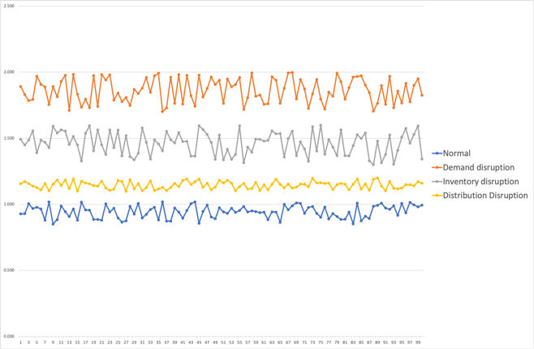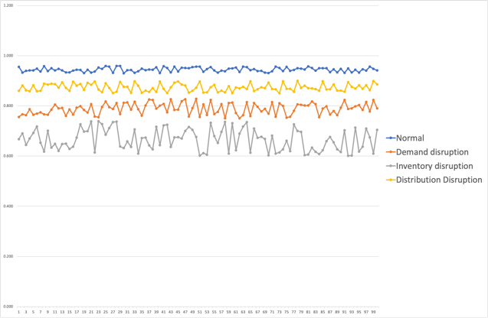

Figure 1: Values of Std for 100 samples from all four categories

Figure 2: Values of CSL for 100 samples from all four categories

**5.2 Error Analysis**

The *np* control chart is used to assess if there are a consistent number of defective items in the cluster of items over time. The average is the centerline. The top dotted line is the upper control limit. The bottom point is the bottom control limit. As long as all points are placed within control limits, and the points have no trends, statistical control will be carried out. In the future, we know what it produces. Stable relationships are shown in the np chart for error analysis. *UCL* and *LCL* set first control limits, and no sample is found outside the *UCL* and *LCL* ranges. For error analysis, 100 samples are taken. 100 sample is taken for error analysis. By setting all the sample in the graph chart, no outside range sample data is seen, so the result is not out of statistical control. A hundred samples are taken for error analysis. Setting all the sample in the graph chart, no outside range sample data is seen, so the result is not out of statistical control.

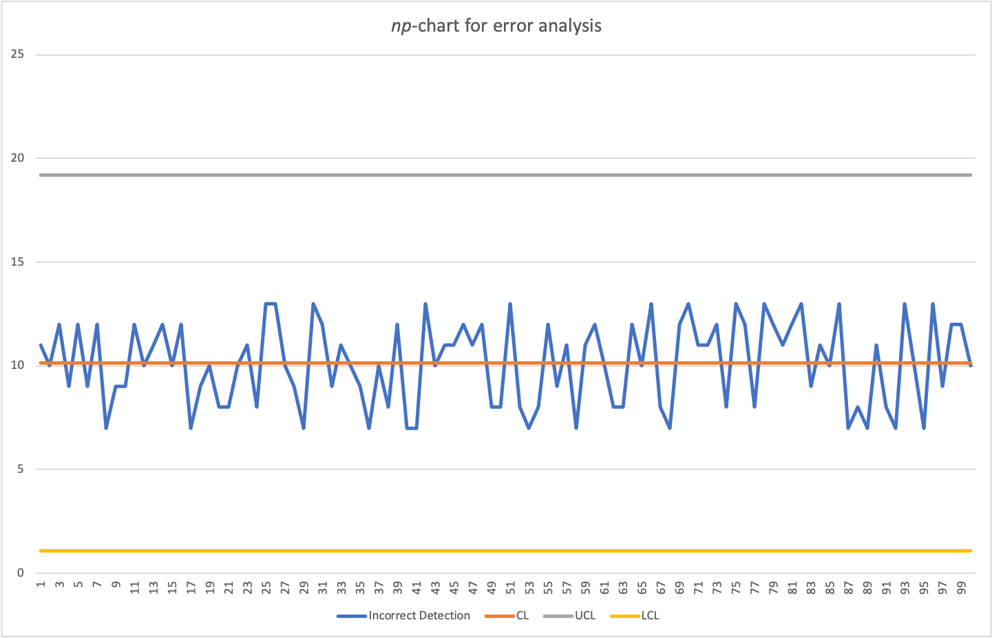

Figure 3 np-chart for incorrect detection

**Conclusion and Future Research :**

Covid-19 has caused a disruptive crisis in the supply chain which is why it is important to identify the types of disruption. In this paper, we used an MC-SVM and *k-means* clustering approach to recognize a particular type of disruption a firm is facing. To train the model, data collected from firms that faced critical disruptions were matched to a certain type of disruption matching their portfolios. Focusing on particular type disruption data was divided into 4 cluster types categorizing similar types as one. Then they were divided into multiclass by using the SVM model. Test datasets were used to find out the accuracy, random datasets caused varying accuracy. In this paper, we recognized the particular disruption a firm is facing. Identifying disruption type helps to focus on a certain aspect of the supply chain rather than the overall supply chain. This can help a firm to focus on decision making, to accurate corrective measure on certain criteria & necessary steps can be taken accordingly, also a known disruption type will help to respond quickly to take precaution & improve the certain aspect which needs correction. Improving the particular aspect that can lead to disruption will ensure the agility, resilience & economic productivity certainty of a firm. The results could have been more accurate if the data weren’t insufficient. Increasing data will help to improve the accuracy of the model also more features could be used for better accuracy. The model can only identify a certain type of disruption a firm is facing, the combination of multiple disruptions cannot be identified by this model. Our model cannot identify a combination of multiple disruptions, so if a firm is facing multiple type disruption then it is not possible to identify in this model, only a certain type that is causing the main disruption in the chain will be identified, so using a more improvised model of machine learning can be incorporated in support of this model in future researches. It is recommended that future research may irradicate the limitations in this paper by adding more features and providing large data will improve the accuracy of the model. More supervised and improved machine learning algorithms can be used for further improvement & to lessen the errors.

**Acknowledgements**

This research has been done under fully cooperation and resources of Department of Mechanical and Production Engineering, Ahsanullah University of Science & Technology (AUST). The authors express gratitude for all the efforts and cooperation to complete the research.

**Reference :**

Aytaç, Ersin. 2020. “Unsupervised Learning Approach in Defining the Similarity of Catchments: Hydrological Response Unit Based k-Means Clustering, a Demonstration on Western Black Sea Region of Turkey.” *International Soil and Water Conservation Research.*

Cortes, C., and Vapnik, V., “Support-Vector Networks”, *Machine learning*, vol. 20, no. 3, pp. 273–297, doi: 10.1109/64.163674, 1995.

Carbonneau, Real, Kevin Laframboise, and Rustam Vahidov. 2008. “Application of Machine Learning Techniques for Supply Chain Demand Forecasting.” European Journal of Operational Research.

Chitturi, Pallavi, Mark Gershon, Jing Chen, and John Boyarski. 2010. “Identification and Classification of Intermittent Demand Patterns.” *International Journal of Productivity and Quality Management*.

Chopra, Sunil, and Man Mohan S. Sodhi. 2004. “Managing Risk to Avoid: Supply-Chain Breakdown.” *MIT Sloan Management Review.*

Iakovou, Eleftherios, Dimitrios Vlachos, and Anastasios Xanthopoulos. 2010. “A Stochastic Inventory Management Model for a Dual Sourcing Supply Chain with Disruptions.” *International Journal of Systems Science.*

Irfan, Rizwana, Christine K. King, Daniel Grages, Sam Ewen, Samee U. Khan, Sajjad A. Madani, Joanna Kolodziej, Lizhe Wang, Dan Chen, Ammar Rayes, Nikolaos Tziritas, Cheng Zhong Xu, Albert Y. Zomaya, Ahmed Saeed Alzahrani, and Hongxiang Li. 2015. “A Survey on Text Mining in Social Networks.” *Knowledge Engineering Review.*

Jaberidoost, Mona, Laya Olfat, Alireza Hosseini, Abbas Kebriaeezadeh, Mohammad Abdollahi, Mahdi Alaeddini, and Rassoul Dinarvand. 2015. “Pharmaceutical Supply Chain Risk Assessment in Iran Using Analytic Hierarchy Process (AHP) and Simple Additive Weighting (SAW) Methods.” *Journal of Pharmaceutical Policy and Practice.*

Nikolopoulos, Konstantinos I., M. Zied Babai, and Konstantinos Bozos. 2016. “Forecasting Supply Chain Sporadic Demand with Nearest Neighbor Approaches.” *International Journal of Production Economics 177:139–48.*

Nikolopoulos, Konstantinos, Sushil Punia, Andreas Schäfers, Christos Tsinopoulos, and Chrysovalantis Vasilakis. 2021. “Forecasting and Planning during a Pandemic: COVID-19 Growth Rates, Supply Chain Disruptions, and Governmental Decisions.” *European Journal of Operational Research.*

Rahman, S. M. Mizanu., Junbeum Kim, and Bertrand Laratte. 2021. “Disruption in Circularity? Impact Analysis of COVID-19 on Ship Recycling Using Weibull Tonnage Estimation and Scenario Analysis Method.” *Resources, Conservation and Recycling.*

Schmidt, William, and Ananth Raman. 2012. “When Supply-Chain Disruptions Matter.” *Harvard Business School, Cambridge, MA.*

Shao, X., Recognition of control chart patterns using decision tree of multiclass SVM, *Advances in Intelligent Systems, 33–41, 2012.*

Tang, Chia Hsien, Chih Yu Chin, and Yen Hsien Lee. 2021. “Coronavirus Disease Outbreak and Supply Chain Disruption: Evidence from Taiwanese Firms in China*.” Research in International Business and Financ*e.

Wang, Michael, and Ferry Jie. 2020. “Managing Supply Chain Uncertainty and Risk in the Pharmaceutical Industry.” *Health Services Management Research.*

Xanthopoulos, P., Razzaghi, T., A weighted support vector machine method for control chart pattern recognition,

*Computers & Industrial Engineering*, 70:134-49, Apr 1, 2014..

Yu, Derrick Ethelbhert C., Luis F. Razon, and Raymond R. Tan. 2020. “Can Global Pharmaceutical Supply Chains Scale up Sustainably for the COVID-19 Crisis?” Resources, Conservation and Recycling.

Zhao, Fengnian, David L. S. Hung, and Shengqi Wu. 2020. “K-Means Clustering-Driven Detection of Time-Resolved Vortex Patterns and Cyclic Variations inside a Direct Injection Engine.” Applied Thermal Engineering.

**Biographies**

**MD Ariful Islam** is doing his B.Sc. in Industrial and Production Engineering at Ahsanullah University of Science and Technology. He is passionate about machine learning and supply chain management. Recently, he is working in a research group on machine learning and operation management. His research interests include operating systems, machine learning, advanced manufacturing, operation management, artificial intelligence, nano fabrication, additive manufacturing and lean production. He is a member of Industrial Engineering and Operations Management (IEOM) Society, Institute for Operations Research and the Management Sciences (INFORMS).

**Shubho Roy** is doing his B.Sc. in Industrial and Production Engineering at Ahsanullah University of Science and Technology. He is a mid-level analysist in supply chain, six sigma, machine learning, and excel for business data analysis. Currently, he is involved in some research projects on machine learning and supply chain management. Besides, he has excellent skills on advance machine learning algorithm and python. His research interest include forecasting, machine learning, optimization, scheduling, advanced manufacturing, nano composite operation management. He is a member of Industrial Engineering and Operations Management (IEOM) Society, Institute for Operations Research and the Management Sciences (INFORMS)

**Nishat Farzana Islam** is currently pursuing her B.Sc. in Industrial and Production Engineering at Ahsanullah University of Science and Technology (AUST), Dhaka, Bangladesh. Her research interests include operation research, supply chain management, manufacturing and materials engineering. She is also interested to broaden the knowledge in machine learning.

**Naimur Rahman Chowdhury** is a Lecturer in the Department of Mechanical and Production Engineering at Ahsanullah University of Science and Technology, Dhaka, Bangladesh. He previously worked as a Lecturer in the Department of Industrial and Production Engineering at Military Institute of Science and Technology, Dhaka, Bangladesh. He earned B.Sc. in Industrial and Production Engineering from Bangladesh University of Engineering and Technology, Dhaka, Bangladesh. He is an ongoing student of M.Sc. in Industrial and Production Engineering in Bangladesh University of Engineering and Technology. His research interests include optimization, machine learning, supply chain network design, and lean manufacturing.