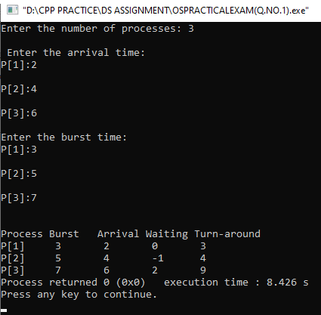 NAINA

UNIVERSITY ROLL.NO:20020570023

OS PRCATICAL EXAM OUTPUT

SET -1

OUTPUT 1(SJF IMPLEMENTATION)

OUTPUT 2 PARENT AND CHILD RUN DIFFERENT CODES AND PARENT PROCESS SHOULD BE EXECUTED

FIRST.S

