SUB QUERIES
- Display the CustomerID, SalesOrderID, and OrderDate for each Sales.SalesOrderHeader row as long as the customer has placed at least five orders.
SELECT CustomerID,
SalesOrderID,
OrderDate
FROM Sales.SalesOrderHeader
WHERE CustomerID IN
(
SELECT CustomerID
FROM Sales.SalesOrderHeader
GROUP BY CustomerID
HAVING COUNT(*) >= 5
);

Output
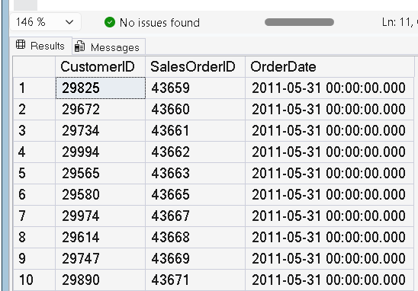

- Using a subquery, display the Product Name and ProductID from the Production.Product table that have been ordered.
SELECT ProductID,
Name
FROM Production.Product
WHERE ProductID IN
(
SELECT ProductID
FROM Sales.SalesOrderDetail
);

Output
ProductID | Name
680 | HL Road Frame - Black
707 | Sport Helmet
708 | Mountain Bike Socks

- Change the query written in Question 2 to display the products that have not been ordered.
SELECT ProductID,
Name
FROM Production.Product
WHERE ProductID NOT IN
(
SELECT ProductID
FROM Sales.SalesOrderDetail
);

Output
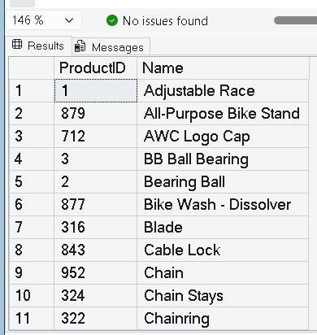

- Write a query that displays the colors used in the Production.Product table that are not listed in the Production.ProductColor table using a subquery. Use the keyword DISTINCT before the column name to return each color only once.
SELECT DISTINCT Color
FROM Production.Product
WHERE Color NOT IN
(
SELECT Color
FROM Production.ProductColor
);

Output
Color
Silver
Yellow

- Write a UNION query that combines the ModifiedDate from Person.Person and the HireDate from HumanResources.Employee.
SELECT ModifiedDate AS DateValue
FROM Person.Person

UNION

SELECT HireDate
FROM HumanResources.Employee;

Output
