Querying SQL Server
- Browse different system databases as well as user database.
SELECT name
FROM sys.databases;

Output
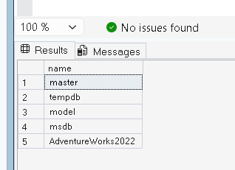

- Write a SELECT statement that lists the customers along with their ID numbers. Include the last names, first names, and company names.
SELECT
c.CustomerID,
p.LastName,
p.FirstName,
s.Name AS CompanyName
FROM Sales.Customer c
LEFT JOIN Person.Person p
ON c.PersonID = p.BusinessEntityID
LEFT JOIN Sales.Store s
ON c.StoreID = s.BusinessEntityID;

Output
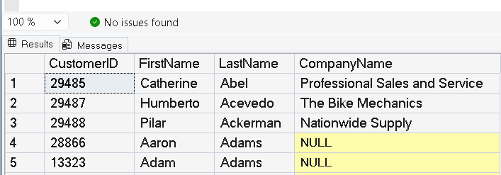

- Write a query that displays all the employees listed in the HumanResources.Employee table who have the job title Research and Development Engineer. Display the BusinessEntityID, LoginID, and JobTitle.
SELECT
BusinessEntityID,
LoginID,
JobTitle
FROM HumanResources.Employee
WHERE JobTitle = 'Research and Development Engineer';

Output
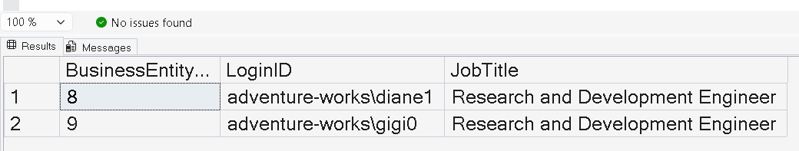

- Write a query displaying all the columns of the Production.ProductCostHistory table from the rows that were modified on June 17, 2003.
SELECT *
FROM Production.ProductCostHistory
WHERE ModifiedDate = '2003-06-17';

Output
ProductID | StartDate | EndDate | StandardCost | ModifiedDate
No rows returned (AdventureWorks2022)

- Rewrite the query written in Question 3, changing it so that employees who do not have the title Research and Development Engineer are displayed.
SELECT
BusinessEntityID,
LoginID,
JobTitle
FROM HumanResources.Employee
WHERE JobTitle <> 'Research and Development Engineer';

Output
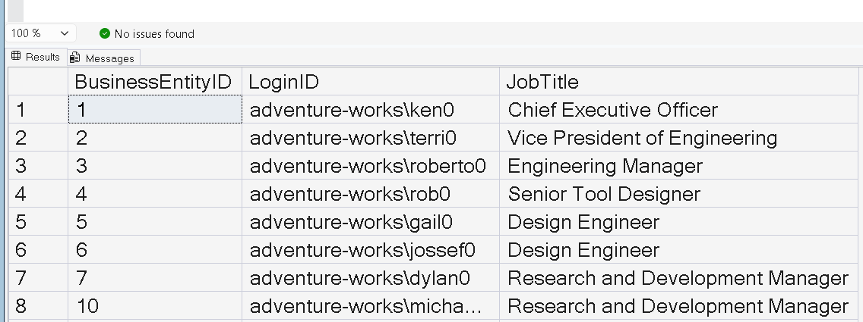

- The HumanResources.Employee table does not contain employee names. Join that table to the Person.Person table on the BusinessEntityID column. Display the job title, birth date, first name, and last name.
SELECT
e.JobTitle,
e.BirthDate,
p.FirstName,
p.LastName
FROM HumanResources.Employee e
INNER JOIN Person.Person p
ON e.BusinessEntityID = p.BusinessEntityID;

Output
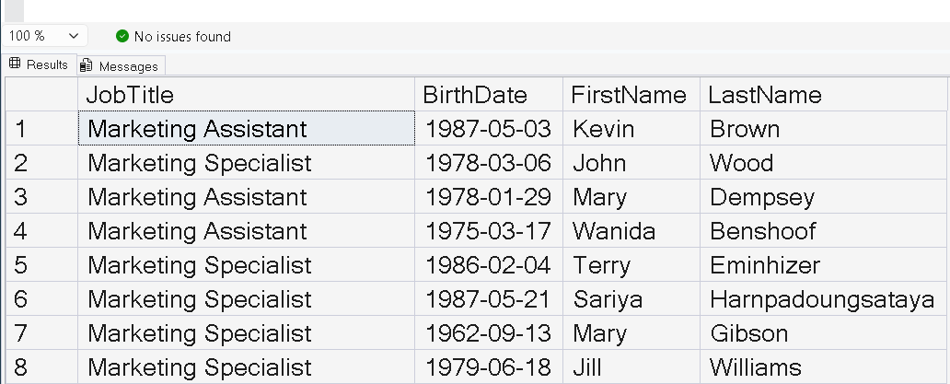

- Join the Sales.Customer table to the Person.Person table. Display the CustomerID, StoreID, and TerritoryID columns along with the customer name columns.
SELECT
c.CustomerID,
c.StoreID,
c.TerritoryID,
p.FirstName,
p.LastName
FROM Sales.Customer c
INNER JOIN Person.Person p
ON c.PersonID = p.BusinessEntityID;

Output
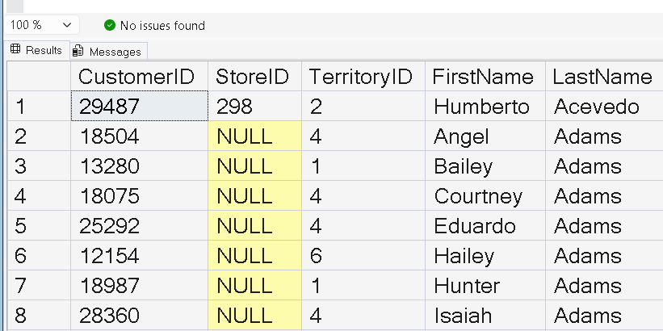

- Extend the query written in Question 2 to include the Sales.SalesOrderHeader table. Display the SalesOrderID column along with the columns already specified.
SELECT
c.CustomerID,
p.LastName,
p.FirstName,
s.Name AS CompanyName,
soh.SalesOrderID
FROM Sales.Customer c
LEFT JOIN Person.Person p
ON c.PersonID = p.BusinessEntityID
LEFT JOIN Sales.Store s
ON c.StoreID = s.BusinessEntityID
LEFT JOIN Sales.SalesOrderHeader soh
ON c.CustomerID = soh.CustomerID;

output
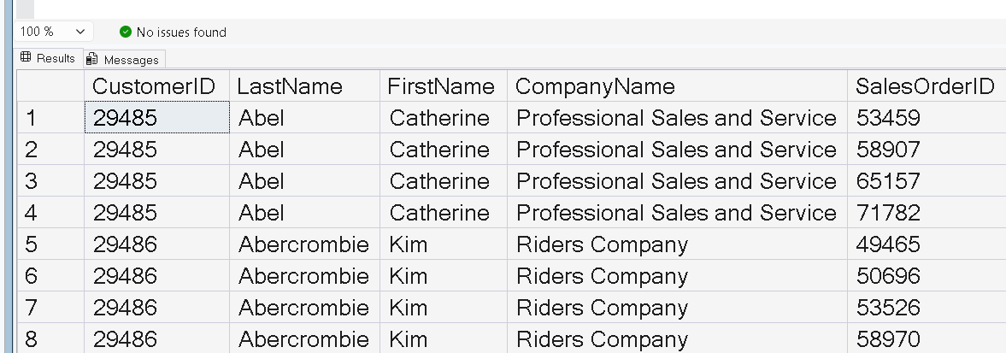

- Write a query that displays all the products along with the SalesOrderID even if an order has never been placed for that product. Join to the Sales.SalesOrderDetail table using the ProductID column.
SELECT
p.ProductID,
p.Name,
sod.SalesOrderID
FROM Production.Product p
LEFT JOIN Sales.SalesOrderDetail sod
ON p.ProductID = sod.ProductID;

output
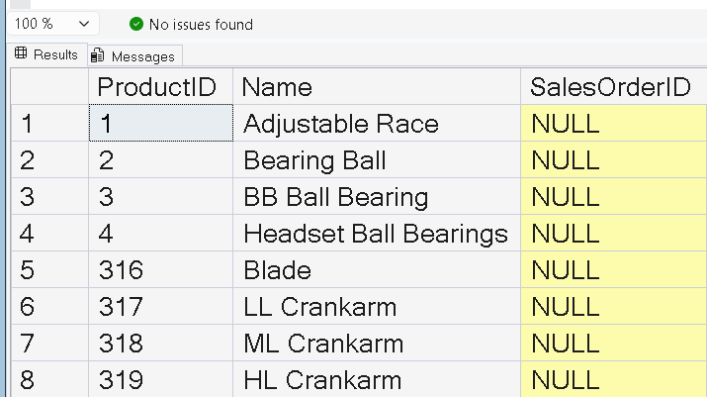

- Write a query that displays the BusinessEntityID, FirstName, MiddleName, and LastName from the Person.Person table for only those rows that have E or B stored in the MiddleName column.
SELECT
BusinessEntityID,
FirstName,
MiddleName,
LastName
FROM Person.Person
WHERE MiddleName IN ('E', 'B');

Output
