BUILT_IN FUNCTIONS
- Write a query using the Production.Product table displaying the ProductID, Color, and Name columns. If the Color column contains a NULL value, replace the color with 'No Color'.
USE AdventureWorks_Practice;
GO
SELECT
ProductID,
ISNULL(Color, 'No Color') AS Color,
Name
FROM Production.Product;

Output
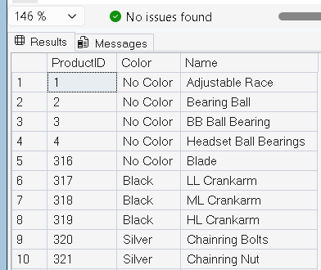

2) Write a query that displays the first 10 characters of the AddressLine1 column in the Person.Address table.
SELECT
AddressID,
LEFT(AddressLine1,10) AS First10Characters
FROM Person.Address;

Output
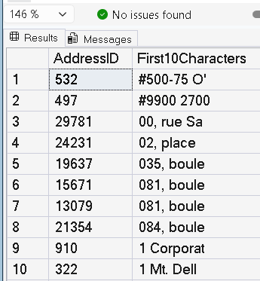

3)Write a query using the Sales.SpecialOffer table that multiplies the MaxQty column by the DiscountPct column. If MaxQty is NULL, replace it with the value 10. Include the SpecialOfferID and Description columns.
SELECT
SpecialOfferID,
Description,
ISNULL(MaxQty,10) AS MaxQty,
DiscountPct,
ISNULL(MaxQty,10) * DiscountPct AS Result
FROM Sales.SpecialOffer;

Output
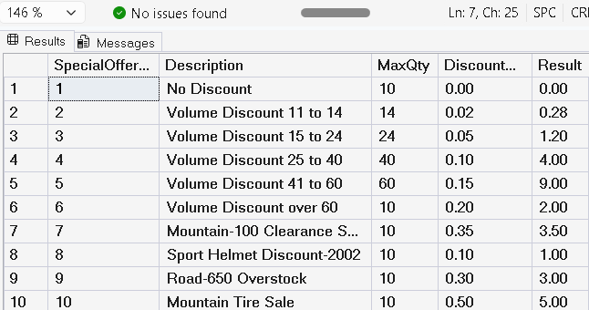

4) Write a query that calculates the number of days between the OrderDate and ShipDate using the Sales.SalesOrderHeader table. Include the SalesOrderID, OrderDate, and ShipDate columns.
SELECT
SalesOrderID,
OrderDate,
ShipDate,
DATEDIFF(DAY, OrderDate, ShipDate) AS DaysTaken
FROM Sales.SalesOrderHeader;

Output
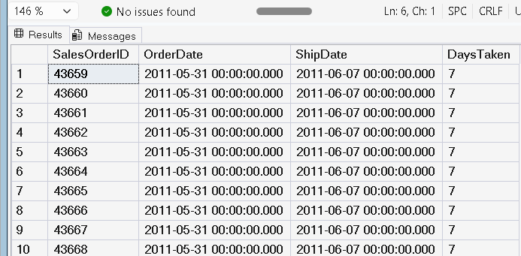

5) Write a query that displays the year and numeric month of each OrderDate. Include the SalesOrderID and OrderDate columns.
SELECT
SalesOrderID,
OrderDate,
YEAR(OrderDate) AS OrderYear,
MONTH(OrderDate) AS OrderMonth
FROM Sales.SalesOrderHeader;

Output
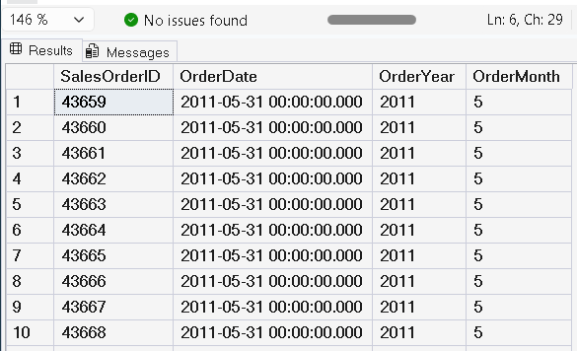

6) Write a query using the Sales.SalesOrderHeader table that displays the SubTotal rounded to 2 decimal places. Include the SalesOrderID.
SELECT
SalesOrderID,
ROUND(SubTotal,2) AS RoundedSubTotal
FROM Sales.SalesOrderHeader;

Output
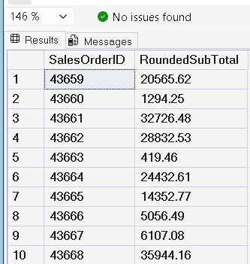

7) Write a statement that generates a random number between 1 and 10 each time it is run.
SELECT FLOOR(RAND() * 10) + 1 AS RandomNumber;
