## Checklist for creating effective goals

1. List down the areas of improvements suggested
   1. Review the feedbacks given by the colleagues
   2. Review the self evaluation
   3. Review the supervisor evaluation
   4. Analyze the strength and weakness of the employee
   5. And list down the areas of improvements
2. Review career ladder
   1. Compare the current performance of the employee with expected performance written in career ladder
   2. List down the areas that are still not covered in the employee’s performance as per the career ladder
3. Create the action items as goals from the AOIs
   1. Create the action items that directs the employee to overcome their AOIs
   2. Goals should be SMART ( **S**pecific, **M**easurable, **A**chievable, **R**elevant and **T**ime bound)

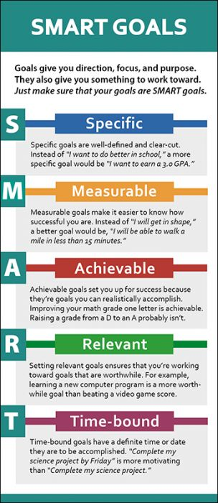

1. Create checklist for the goals, if needed
   1. If possible, create checklists for different scenarios to achieve the goal. For example if an employee is lacking in communicating about the updates in his task.
      1. Goal could be ‘ Frequently provide update about your task in channel’
      2. Checklists could be:
         1. When the task is assigned, post about their deadline he would complete it
         2. When the task is completed, inform that the task is completed
         3. If it takes more time than expected, request for the extended deadline with reasons
2. Verify the final goals with Project Manager and Tech Lead
   1. Since PM and tech leads are the one who have closely observed the mentees, and can have clear vision of what improvement they need to reach the next level, PM and tech lead can clearly identify if the goals set are relevant for their growth or not. So it's important to verify the goals of the employee by the PM and tech lead.
3. Regular review and update of the goals
   1. Once the goals are finalized and illustrated through 1 on 1 meeting, the employee should regularly check in to the goals and apply those in work
   2. Supervisor and employee should also meet regularly to review the goals and analyze what goals have been achieved and what are still remaining.
   3. Even after the goals are set already, if there are other areas of improvement discovered for the employee in future, supervisor can update those in the goals.