JAYPEE INSTITUTE OF INFORMATION TECHNOLOGY, SECTOR-62, NOIDA
DEPARTMENT OF ELECTRONICS AND COMMUNICATION ENGINEERING

MINOR PROJECT - 1 SYNOPSIS
PROJECT TITLE
DESIGN AND SIMULATION OF A PIPELINED FPGA-BASED IMAGE PROCESSING SYSTEM FOR NOISE REDUCTION AND SOBEL EDGE DETECTION
Submitted To:
Dr. Mandeep Narula
SUBMITTED BY:
S.NO | NAME | ENROLLMENT NO | BATCH
1 | Naina Sehgal | 2401180029 | A16

CONTENTS
PROJECT DETAILS 3
ABSTRACT 3
1. INTRODUCTION 4
2. PROBLEM STATEMENT 4
3. MOTIVATION 4
4. AIM 5
5. OBJECTIVES 5
6. PROPOSED SYSTEM 5
7. SYSTEM ARCHITECTURE 6
8. METHODOLOGY 7
8.1 Input image acquisition 7
8.2 Image noise addition 7
8.3 Noise removal 7
8.4 Sobel edge detection 7
8.5 FPGA implementation 7
8.6 Output generation 8
9. ALGORITHMS USED 8
9.1 Noise removal algorithm: 3×3 median filter (hardware method) 8
9.2 Sobel edge detection algorithm 9
10. FPGA AND VERILOG IMPLEMENTATION 9
11. HARDWARE AND SOFTWARE REQUIREMENTS 10
12. SIMULATION AND EXPERIMENTAL SETUP 11
13. PERFORMANCE EVALUATION 12
13.1 Image quality: effect of median filtering before Sobel 12
13.2 Hardware verification and timing 14
14. EXPECTED RESULTS 14
15. APPLICATIONS 15
16. ADVANTAGES 15
17. LIMITATIONS 15
18. FUTURE SCOPE 16
19. TECHNICAL SPECIFICATION 16
20. CONCLUSION 16
REFERENCES 17

PROJECT DETAILS
Table 1: Project details
Item | Detail
Project title | Design and Simulation of a Pipelined FPGA-Based Image Processing System for Noise Reduction and Sobel Edge Detection
Student | Naina Sehgal (Enrollment No. 2401180029, Batch A16)
Programme | BTech, Electronics and Communication Engineering, 3rd year
Project type | Minor Project - 1 (individual)
Supervisor | Dr. Mandeep Narula
Department and institute | Department of Electronics and Communication Engineering, Jaypee Institute of Information Technology, Sector-62, Noida
Domain | Digital image processing, VLSI and FPGA design
Target device | Xilinx Artix-7 (xc7a35tcpg236-1, the device on the Digilent Basys3 board)
Code repository | github.com/NainaS28/FPGA

ABSTRACT
Edge detection is a basic step in machine vision, but gradient operators such as Sobel respond to every sharp change in brightness, including impulse (salt-and-pepper) noise. This project builds an image processing chain in which a 3×3 median filter removes impulse noise before Sobel edge detection, and implements the noise-removal stage as a streaming, pipelined hardware design in Verilog HDL for an FPGA.
A bit-accurate software reference model was written in Python using integer arithmetic only. It was evaluated on three 128×128 grayscale test images at noise densities of 5%, 10% and 20%. Applying the median filter before Sobel reduced false edge pixels by 94% to 99% and raised the edge F1 score from 0.22–0.69 to 0.76–0.98. Image PSNR improved from about 12–19 dB to 24–34 dB.
The median filter was then designed in Verilog as a line-buffered sliding-window circuit followed by a 3-stage comparator pipeline. In Icarus Verilog simulation, the hardware processed one pixel per clock cycle with a latency of four register stages. It matched the software model on all 2,000 unit-test windows and on all 15,876 output pixels of a full 128×128 image, including a test with random pauses in the input stream. An interactive browser interface built on the same arithmetic demonstrates the system and shows the hardware's behaviour clock by clock.
Keywords: FPGA, Verilog HDL, median filter, salt-and-pepper noise, Sobel operator, edge detection, pipelining, line buffer, hardware verification.

1. INTRODUCTION
Digital images are captured, transmitted and stored as arrays of pixel intensities. Along the way they pick up noise. Faulty sensor elements, bit errors in transmission and analog-to-digital conversion faults all produce impulse noise, also called salt-and-pepper noise: isolated pixels forced to full white (255) or full black (0).
Edge detection finds the boundaries between regions of different brightness. It is used in object recognition, segmentation, inspection and driver assistance. The Sobel operator [2] is one of the most widely used edge detectors, alongside the Roberts [3] and Prewitt [4] operators, because it needs only a 3×3 neighbourhood and integer additions. However, Sobel measures local brightness change, and an impulse pixel is an extreme local change, so noisy images produce large numbers of false edges [1].
The median filter replaces each pixel by the median of its neighbourhood. Because an isolated extreme value can never be the median of nine values, impulse noise is removed while real edges are kept sharp. Placing a median filter before Sobel is therefore a natural pre-processing step [1], [6].
Both operations work on a 3×3 window that slides across the image. This makes them well suited to Field Programmable Gate Arrays (FPGAs): a stream of pixels can be processed in a deep pipeline, producing one result per clock cycle, with only two image rows stored on chip [8], [9], [10]. This project designs that processing chain, verifies a software reference model, and implements and verifies the noise-removal hardware in Verilog.

2. PROBLEM STATEMENT
Sobel edge detection applied directly to an image corrupted by salt-and-pepper noise marks thousands of noise pixels as edges. In this project's own tests at 10% noise, 4,684–5,231 false edge pixels appeared in a 124×124 edge map, and the true object outlines were largely lost. A software solution on a general-purpose processor handles one pixel after another and is not suited to low-latency, real-time embedded vision.
The problem addressed is therefore: to design a noise-robust edge detection chain (median filter followed by Sobel), evaluate it with a bit-accurate software reference model, and implement its noise-removal stage as streaming, pipelined digital hardware that processes one pixel per clock cycle, with correctness proven against that reference.

3. MOTIVATION
- Real-time vision needs hardware. Cameras in automotive, industrial and medical systems produce pixels continuously. A pipelined FPGA design processes each pixel as it arrives, with a fixed and very small delay.
- Edge detection is only as good as its input. In this project's experiments, removing impulse noise first raised edge accuracy (F1) from 0.42 to 0.81 on the cameraman image at 10% noise.
- Neighbourhood filters map naturally to FPGAs. A 3×3 window needs two line buffers, and the median and Sobel arithmetic needs only comparators, adders and shifts. No multipliers or frame buffers are required.
- Learning value. The project covers the complete digital design flow taught in ECE: algorithm modelling, RTL design, pipelining, testbench verification and waveform analysis.

4. AIM
To design and simulate an FPGA-oriented image processing system that removes salt-and-pepper noise with a pipelined 3×3 median filter before Sobel edge detection, and to evaluate its effect on edge quality and its hardware behaviour.

5. OBJECTIVES
- Build a bit-accurate software reference model (Python) of salt-and-pepper noise, the 3×3 median filter, the Sobel operator and thresholding, using only integer arithmetic.
- Quantify the benefit of median filtering before Sobel, using PSNR, SSIM, false edge pixels and edge F1 score on standard test images at 5%, 10% and 20% noise.
- Design the median filter as streaming, pipelined Verilog hardware with line buffers that accepts one pixel per clock cycle.
- Verify the hardware against the software model, bit for bit, through unit and full-image testbenches in RTL simulation.
- Measure the hardware's latency and throughput from simulation.
- Build an interactive interface that demonstrates the algorithms and the hardware's clock-by-clock operation.

6. PROPOSED SYSTEM
The system removes impulse noise with a 3×3 median filter and then detects edges with the Sobel operator. It is built in three layers that share exactly the same arithmetic:
Table 2: Layers of the proposed system
Layer | What it contains | Built with
Software reference model | Noise injection, median filter, Sobel, threshold, quality metrics | Python, NumPy, OpenCV, scikit-image
Hardware design | Streaming, pipelined median filter: line buffers, 3×3 window and a 3-stage comparator pipeline (median_stream) | Verilog HDL, simulated in Icarus Verilog
Interactive interface | Live demo of the full chain, pixel-level inspection and a clock-by-clock model of the hardware | HTML, CSS, JavaScript

Key design decisions
- Integer arithmetic everywhere, so that software and hardware outputs can be compared bit for bit.
- Gradient magnitude |Gx| + |Gy| instead of √(Gx² + Gy²), avoiding square roots and multipliers.
- Valid-window border rule: only pixels with a complete 3×3 neighbourhood produce an output. The median output is 126×126 and the edge output 124×124 for a 128×128 input.
- Streaming input: pixels arrive one per clock in raster order with a valid flag, as from a camera.
- Exact median without a full sort, using a row-sort / column-combine method that needs far fewer comparators than sorting nine values.

7. SYSTEM ARCHITECTURE
Overall flow of the work. The software model produces the experiments and the golden test data. The hardware is checked against that golden data.
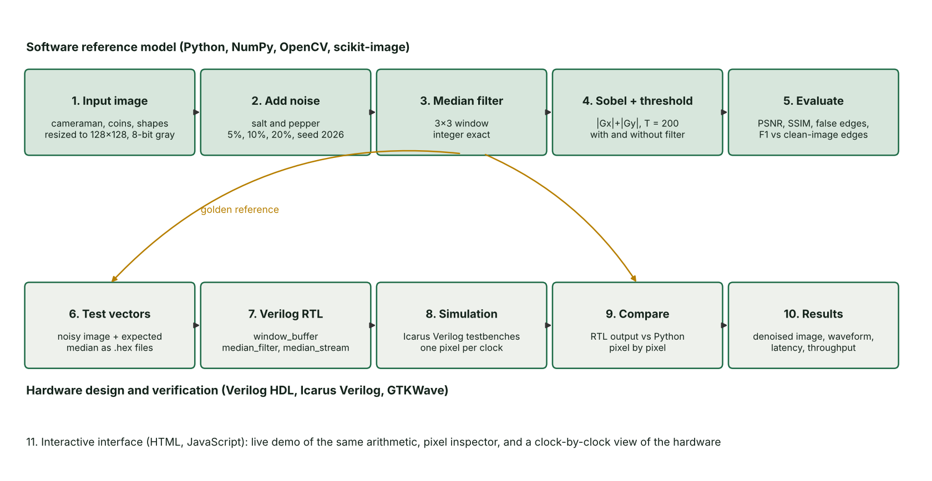
Figure 1: Overall flow. Top row: software reference model. Bottom row: hardware design and verification.
Implemented hardware architecture. The top-level module median_stream connects a window buffer to the pipelined median filter.
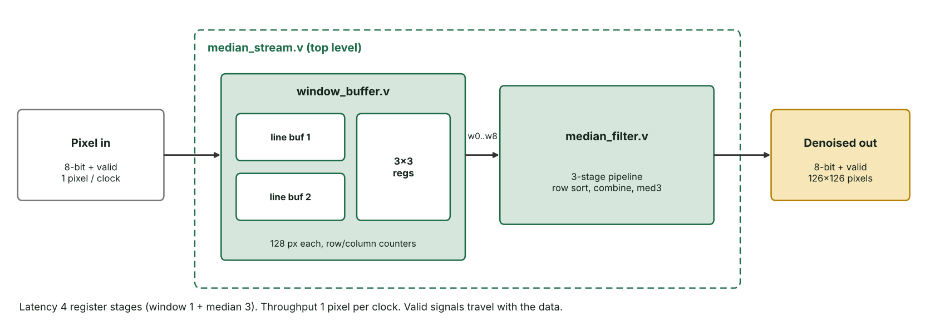
Figure 2: Hardware architecture of the implemented noise-removal stage.
Table 3: Functions of the hardware blocks
Block | Function | Clock cycles
window_buffer | Two line buffers store the previous two rows. Nine registers hold the 3×3 window, which shifts one column left on every new pixel. Row and column counters set valid_out only for interior windows. | 1
median_filter | Stage 1 sorts each row. Stage 2 combines the rows into A, B and C. Stage 3 outputs median(A, B, C). | 3
median_stream | Top level that connects the two blocks and passes the valid flag along | 4 in total

8. METHODOLOGY

8.1 Input image acquisition
Three test images are used: cameraman and coins from the scikit-image standard test set [14], and a synthetic shapes image with sharp, known boundaries (rectangle, circle, triangle). Each image is converted to 8-bit grayscale and resized to 128×128 pixels with area interpolation, giving 16,384 pixels per frame. This size keeps full-image RTL simulations short while still showing clear structure.

8.2 Image noise addition
Salt-and-pepper noise is added with a seeded random generator (seed 2026), so that every run is reproducible. For noise density d, each pixel independently becomes 0 with probability d/2, 255 with probability d/2, or stays unchanged. Densities of 5%, 10% and 20% are tested.

8.3 Noise removal
Each interior pixel is replaced by the median of its 3×3 neighbourhood. The software uses an exact sort for reference and also the hardware method (row sort, column combine, median of three). Both were checked to agree on every test window. Border pixels have no full window and are not filtered.

8.4 Sobel edge detection
The Sobel kernels are applied to the image (directly to the noisy image for the baseline, and to the median-filtered image for the proposed chain). The magnitude |Gx| + |Gy| is compared with a threshold T = 200 to give a binary edge map. The reference ("ground truth") edge map is Sobel with the same threshold on the clean, noise-free image. In this phase, Sobel is implemented in the software model and in the interactive interface.

8.5 FPGA implementation
The noise-removal stage is implemented in Verilog HDL as the streaming module median_stream (Section 10). The Python model exports test vectors in hexadecimal: the noisy input image, the expected median image, and 2,000 random 3×3 windows with their expected medians. Testbenches stream these into the design, one value per clock, and compare every output automatically.

8.6 Output generation
- Software: cleaned images, edge maps, five-panel comparison figures and a metrics table (CSV) for all 9 cases.
- Hardware: the simulated output stream is written to a file, converted back to an image, and compared with the software result. A VCD waveform file records all signals for inspection in GTKWave.
- Interface: the same results are shown live in a browser, with controls for image, noise level and threshold.

9. ALGORITHMS USED

9.1 Noise removal algorithm: 3×3 median filter (hardware method)
For a window with rows (w0, w1, w2), (w3, w4, w5) and (w6, w7, w8), the median of all nine values equals the median of three intermediate values:
where L, M and H are the low, middle and high values of each sorted row. A median of three needs three comparators: med3(a, b, c) = max(min(a, b), min(max(a, b), c)).
Algorithm 1: Pipelined 3x3 median (one window per clock)
Input : window w0..w8 (8-bit), valid_in
Output: median (8-bit), valid_out

Stage 1 (clock 1): for each row r in 0..2:
L[r] = min3(row r)
M[r] = med3(row r)
H[r] = max3(row r)
Stage 2 (clock 2): A = max3(L[0], L[1], L[2])
B = med3(M[0], M[1], M[2])
C = min3(H[0], H[1], H[2])
Stage 3 (clock 3): median = med3(A, B, C)
valid is delayed by 3 clocks alongside the data

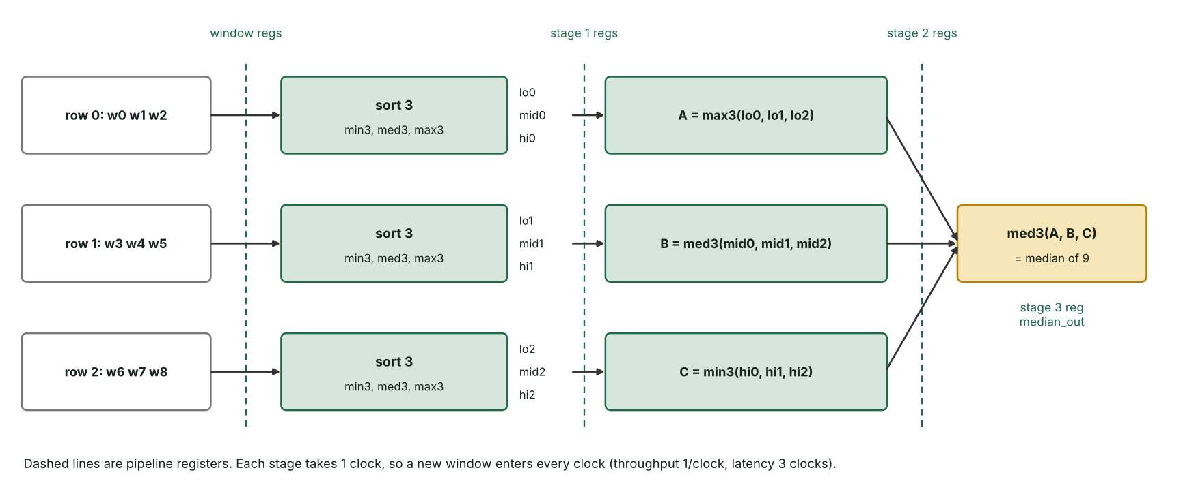
Figure 3: Median filter datapath. Each dashed line is a bank of pipeline registers.
This method uses 31 eight-bit comparators with multiplexers (21 in stage 1, 7 in stage 2, 3 in stage 3) and no memory, instead of a full sorting network of nine values [16]. It was verified to equal the exact median on 2,000 random windows in software and in hardware.

9.2 Sobel edge detection algorithm
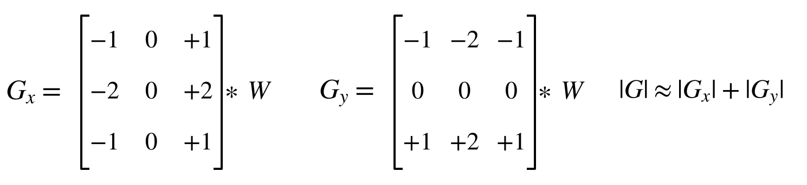
Algorithm 2: Sobel edge detection with threshold
Input : 3x3 window w0..w8 of the filtered image, threshold T
Output: edge bit

Gx = (w2 + 2*w5 + w8) - (w0 + 2*w3 + w6) # right column - left column
Gy = (w6 + 2*w7 + w8) - (w0 + 2*w1 + w2) # bottom row - top row
mag = |Gx| + |Gy| # 0 .. 2040
edge = 1 if mag >= T else 0 # T = 200

Bit widths. With 8-bit pixels, each weighted sum is at most 255 + 2×255 + 255 = 1020, so Gx and Gy lie between −1020 and +1020 (11-bit signed), and |Gx| + |Gy| is at most 2040 (11-bit unsigned). Multiplication by 2 is a one-bit left shift, so no multipliers are needed. In this phase, the Sobel algorithm runs in the integer-exact software model and the interactive interface.

10. FPGA AND VERILOG IMPLEMENTATION
The noise-removal stage is written in synthesisable Verilog (IEEE 1364-2005 [12]) as three modules. All registers are clocked on the rising edge with a synchronous, active-high reset. Every stage passes a valid flag along with its data, so the pipeline works correctly even when the input pauses.
Table 4: Verilog modules of the implemented design
File | Module | Parameters | Ports | Description
rtl/window_buffer.v | window_buffer | WIDTH = 128, HEIGHT = 128 | clk, rst, pix_in[7:0], valid_in, w0–w8[7:0], valid_out | Two line buffers (WIDTH × 8 bits each), 9 window registers, column and row counters
rtl/median_filter.v | median_filter | none | clk, rst, w0–w8[7:0], valid_in, median[7:0], valid_out | 3-stage comparator pipeline (Algorithm 1)
rtl/median_stream.v | median_stream | WIDTH, HEIGHT | clk, rst, pix_in[7:0], valid_in, median_out[7:0], median_valid | Top level connecting the two modules

How the window buffer works. On each valid pixel at column c:
- The values stored at column c in both line buffers are read (the pixels directly above, one and two rows up).
- The line buffers are updated: the row-above buffer moves into the two-rows-up buffer, and the new pixel is written into the row-above buffer.
- The 3×3 window shifts one column left, and the new column {two rows up, one row up, new pixel} enters on the right.
- valid_out is set only when the row and column counters are both at least 2, so that the window lies fully inside the image.

Testbenches.
Table 5: Testbenches used for verification
File | What it tests | Check
tb/tb_median.v | median_filter alone, 2,000 windows, one per clock | Each output against the expected median from Python
tb/tb_median_stream.v | Full image through median_stream, one pixel per clock | All 15,876 outputs against the Python median image; measures latency and frame time
tb/tb_median_stream.v with GAPS = 1 | Same, with about 25% random idle clocks in the input | Same, proving the valid handshake

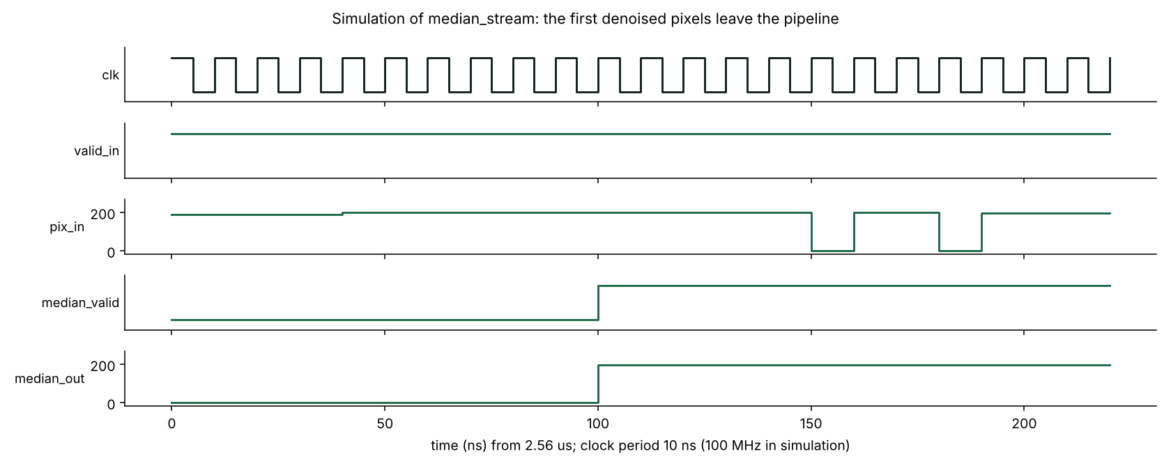
Figure 4: Simulation waveform (Icarus Verilog). Two black noise pixels enter on pix_in at about 150 ns and 180 ns, but median_out stays near 200: the impulses are removed.

11. HARDWARE AND SOFTWARE REQUIREMENTS
Hardware
Table 6: Hardware requirements
Item | Specification | Use
Computer | Laptop or PC, 64-bit Windows or Linux, 8 GB RAM recommended | Development and simulation
Target FPGA (design target) | Xilinx Artix-7 xc7a35tcpg236-1 (20,800 LUTs, 41,600 flip-flops, 50 block RAMs, 90 DSP slices [13]) | Device the RTL is written for

No FPGA board is required for this work: all hardware results come from RTL simulation.
Software
Table 7: Software requirements
Tool | Version used | Use
Python | 3.13 | Reference model, experiments, figures
NumPy | 2.5 | Integer-exact image arithmetic
OpenCV (opencv-python) | 5.0 | Image resizing and file I/O
scikit-image | 0.26 | Test images, PSNR and SSIM [14]
Matplotlib | 3.11 | Figures and waveform plots
Verilog HDL | IEEE 1364-2005 | Hardware description
Icarus Verilog (iverilog, vvp) | 12.0 | RTL compilation and simulation [15]
GTKWave | any | Viewing VCD waveforms
Visual Studio Code | any | Code editor
Git and GitHub | any | Version control and repository
Web browser | any modern browser | Running the interactive interface (HTML, CSS, JavaScript)

12. SIMULATION AND EXPERIMENTAL SETUP
Software experiment
Table 8: Parameters of the software experiment
Parameter | Value
Test images | cameraman, coins, shapes
Image size | 128 × 128 pixels, 8-bit grayscale
Noise type and densities | Salt and pepper; 5%, 10%, 20%
Random seed | 2026 (fixed)
Median window | 3 × 3
Sobel magnitude | |Gx| + |Gy|
Edge threshold | T = 200
Border rule | Valid windows only (126×126 median output, 124×124 edge output)
Cases compared | (a) Sobel on noisy image, (b) median then Sobel; both against Sobel on the clean image
Metrics | PSNR, SSIM [11], false edge pixels, precision, recall, F1 score

Hardware simulation
Table 9: Parameters of the hardware simulation
Parameter | Value
Simulator | Icarus Verilog 12.0 (iverilog -g2012, vvp)
Clock in testbench | 10 ns period (100 MHz), used only to time the simulation
Reset | Synchronous, active high, 3 clocks at start
Stimulus | Noisy cameraman image (10% noise), 16,384 pixels in raster order, read with $readmemh
Input timing | Test 1: one pixel every clock. Test 2: about 25% random idle clocks
Checking | Automatic comparison with the Python median image; mismatch count printed
Outputs | results/rtl_median.hex, VCD waveform, simulation logs

How to reproduce (from the project folder):
pip install -r requirements.txt
python python/run_experiments.py # software experiment, figures, metrics.csv
python python/make_vectors.py # golden test vectors for the testbenches
bash sim/run_sim.sh # compile and run all testbenches
python python/compare_rtl.py # hardware output vs Python, as images

13. PERFORMANCE EVALUATION

13.1 Image quality: effect of median filtering before Sobel
In all 9 test cases, median filtering before Sobel removed 94% to 99% of false edge pixels and raised edge F1 to between 0.76 and 0.98.
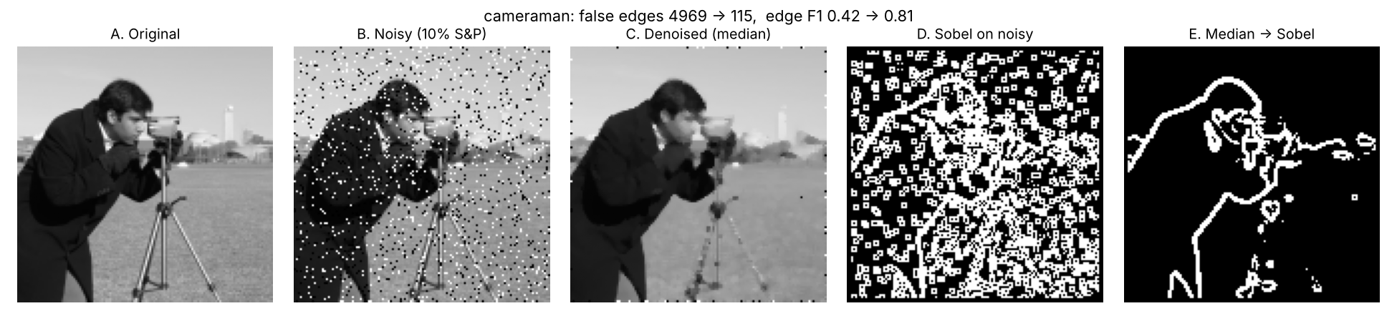
Figure 5: Cameraman at 10% noise. (A) original, (B) noisy, (C) median filtered, (D) Sobel on the noisy image, (E) median then Sobel.
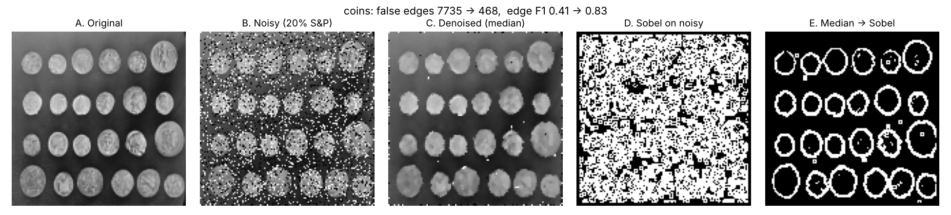
Figure 6: Coins at 20% noise, the hardest case tested.
Table 10: Image quality and edge detection results for all test cases
Image | Noise | PSNR noisy → filtered (dB) | SSIM noisy → filtered | False edge pixels: Sobel only → median + Sobel | Edge F1: Sobel only → median + Sobel
cameraman | 5% | 17.9 → 26.5 | 0.42 → 0.85 | 2,824 → 82 | 0.57 → 0.81
cameraman | 10% | 15.2 → 26.3 | 0.27 → 0.84 | 4,969 → 115 | 0.42 → 0.81
cameraman | 20% | 12.0 → 24.4 | 0.16 → 0.80 | 8,101 → 307 | 0.30 → 0.76
coins | 5% | 18.6 → 29.2 | 0.59 → 0.93 | 2,594 → 136 | 0.69 → 0.90
coins | 10% | 15.5 → 27.6 | 0.42 → 0.91 | 4,684 → 216 | 0.54 → 0.88
coins | 20% | 12.1 → 24.2 | 0.26 → 0.86 | 7,735 → 468 | 0.41 → 0.83
shapes | 5% | 18.1 → 34.0 | 0.37 → 0.99 | 2,821 → 29 | 0.47 → 0.98
shapes | 10% | 15.1 → 33.2 | 0.23 → 0.98 | 5,231 → 38 | 0.32 → 0.97
shapes | 20% | 12.0 → 26.3 | 0.14 → 0.93 | 8,566 → 226 | 0.22 → 0.89

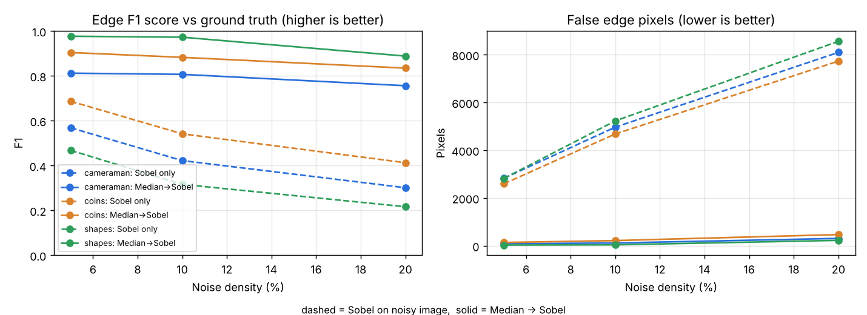
Figure 7: Edge F1 (left) and false edge pixels (right) against noise density. Dashed lines: Sobel only. Solid lines: median then Sobel.
Observations. Without filtering, false edges grow almost linearly with noise density, and F1 falls to 0.22–0.41 at 20% noise. With the median filter, F1 stays above 0.76 in every case. The benefit shrinks slightly at 20% noise because some 3×3 windows then contain five or more noise pixels, which a 3×3 median cannot reject.

13.2 Hardware verification and timing
Table 11: Hardware verification and timing results
Measure | Result
Median unit test (2,000 windows, including all-noise, ties, all-black, all-white) | 2,000 of 2,000 match the software model
Full image, one pixel per clock | 15,876 of 15,876 output pixels match, 0 errors
Full image, about 25% random idle clocks | 15,876 of 15,876 output pixels match, 0 errors
Throughput | 1 pixel per clock (16,384 input pixels processed in 16,389 clocks)
Pipeline latency | 4 register stages (window 1 + median 3); 5 clocks measured from last input to last output
First output | 263 clocks after the first input, because two rows plus two pixels must be buffered before the first full window

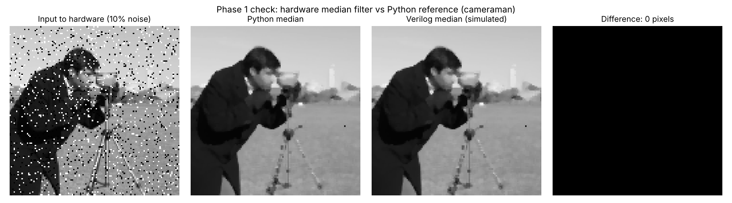
Figure 8: Hardware (RTL simulation) output compared with the Python model. The difference image is entirely black: 0 differing pixels.

14. EXPECTED RESULTS
The results below are confirmed by the experiments and simulations in Section 13.
- Cleaner edges: Sobel applied after the median filter gives clean object outlines, while Sobel on the noisy image is dominated by noise (Figures 5 and 6).
- Quantified improvement: 94% to 99% fewer false edge pixels and an edge F1 of 0.76 to 0.98, compared with 0.22 to 0.69 without filtering.
- Better image quality: PSNR rises from 12.0–18.6 dB to 24.2–34.0 dB, and SSIM from 0.14–0.59 to 0.80–0.99.
- Correct hardware: the Verilog median filter matches the software model exactly, with 0 errors on 15,876 pixels.
- Streaming performance: 1 pixel per clock with a fixed 4-stage pipeline latency, using only two line buffers instead of a frame buffer.
- Demonstration: an interactive interface that shows the algorithm and the hardware working step by step.

15. APPLICATIONS
- Industrial inspection: finding part outlines and defects on production lines where sensors pick up impulse noise.
- Medical imaging pre-processing: cleaning X-ray and ultrasound images before boundary detection.
- Automotive and drones: lane and obstacle edge detection where low, fixed latency matters.
- Surveillance cameras: in-camera pre-processing before compression or analysis.
- Document scanning and OCR: removing speckle noise before finding character edges.
- Satellite and remote sensing: cleaning images affected by transmission bit errors.
- Teaching: the interactive interface explains median filtering, Sobel and pipelined hardware visually.

16. ADVANTAGES
- Robust to impulse noise: removes salt-and-pepper noise without blurring edges like a mean filter.
- High throughput: one pixel per clock cycle once the pipeline is full.
- Low, fixed latency: 4 register stages, independent of image content.
- Small memory: two line buffers of 128 bytes instead of storing the whole frame.
- Simple arithmetic: only comparators in the median, and only adders and shifts in Sobel; no multipliers.
- Proven correct: bit-exact match with the software model on every tested pixel.
- Robust to input pauses: the valid handshake keeps results correct when pixels arrive irregularly.
- Parameterised: image width and height are Verilog parameters.
- Reproducible: fixed random seed, scripted experiments, all code in a public Git repository.

17. LIMITATIONS
- Results come from RTL simulation; the design has not been run on a physical FPGA board.
- A 3×3 median leaves small noise clusters at high density (20%), where false edges rise to 226–468 pixels.
- One fixed edge threshold (T = 200) is used for all images.
- Border pixels without a full 3×3 window are not processed.
- Images are read from files, not from a live camera.
- Experiments use 128×128 grayscale images only.

18. FUTURE SCOPE
- Implement the Sobel operator and threshold stage in Verilog after the median filter, forming a complete hardware edge detection pipeline.
- Synthesise and implement the design for the Artix-7 device to obtain resource usage, maximum clock frequency and a power estimate.
- Run the design on an FPGA board with a camera input and a VGA or HDMI display output.
- Add an adaptive median filter [7] to handle noise densities above 20%.
- Make the edge threshold a run-time input, or choose it automatically per image.
- Support larger images (for example 640×480) and colour input.
- Add non-maximum suppression for thinner edges, moving towards Canny-style detection [5].

19. TECHNICAL SPECIFICATION
Table 12: Technical specification of the implemented design
Parameter | Value
Pixel format | 8-bit unsigned grayscale (0–255)
Frame size | 128 × 128 = 16,384 pixels
Input interface | pix_in[7:0] + valid_in, one pixel per clock, raster order
Output interface | median_out[7:0] + median_valid
Median output size | 126 × 126 = 15,876 pixels
Line buffers | 2 × 128 × 8 bits
Window registers | 9 × 8 bits
Median pipeline | 3 stages, 31 comparators
Total latency | 4 register stages
Throughput | 1 pixel per clock
Reset | Synchronous, active high
Sobel gradient width (software model) | 11-bit signed Gx, Gy; 11-bit unsigned magnitude (0–2040)
Edge threshold | 200

20. CONCLUSION
This project showed that removing salt-and-pepper noise with a 3×3 median filter before Sobel edge detection greatly improves edge quality. Across three images and three noise densities, false edges fell by 94% to 99% and edge F1 rose to 0.76–0.98. The noise-removal stage was implemented as a streaming, pipelined Verilog design with line buffers and a 3-stage comparator pipeline. It processes one pixel per clock with a 4-stage latency and matches the bit-accurate software model on every one of 15,876 output pixels, including under irregular input timing. Together with the interactive interface, this establishes a verified foundation for completing the full hardware edge detection pipeline.

REFERENCES
- R. C. Gonzalez and R. E. Woods, Digital Image Processing, 4th ed. New York: Pearson, 2018.
- I. Sobel and G. Feldman, "A 3×3 isotropic gradient operator for image processing," presented at the Stanford Artificial Intelligence Project, 1968.
- L. G. Roberts, "Machine perception of three-dimensional solids," Ph.D. dissertation, Massachusetts Institute of Technology, 1963.
- J. M. S. Prewitt, "Object enhancement and extraction," in Picture Processing and Psychopictorics, B. S. Lipkin and A. Rosenfeld, Eds. New York: Academic Press, 1970, pp. 75–149.
- J. Canny, "A computational approach to edge detection," IEEE Trans. Pattern Anal. Mach. Intell., vol. PAMI-8, no. 6, pp. 679–698, 1986, doi: 10.1109/TPAMI.1986.4767851.
- T. Huang, G. Yang and G. Tang, "A fast two-dimensional median filtering algorithm," IEEE Trans. Acoust., Speech, Signal Process., vol. 27, no. 1, pp. 13–18, 1979, doi: 10.1109/TASSP.1979.1163188.
- H. Hwang and R. A. Haddad, "Adaptive median filters: new algorithms and results," IEEE Trans. Image Process., vol. 4, no. 4, pp. 499–502, 1995, doi: 10.1109/83.370679.
- D. G. Bailey, Design for Embedded Image Processing on FPGAs. Singapore: John Wiley & Sons (Asia), 2011, doi: 10.1002/9780470828519.
- Z. Vašíček and L. Sekanina, "Novel hardware implementation of adaptive median filters," in Proc. 11th IEEE Workshop on Design and Diagnostics of Electronic Circuits and Systems (DDECS), 2008, pp. 1–6, doi: 10.1109/DDECS.2008.4538766.
- Vanishree and K. V. Ramana Reddy, "Implementation of pipelined Sobel edge detection algorithm on FPGA for high speed applications," in Proc. Int. Conf. Emerging Trends in Communication, Control, Signal Processing and Computing Applications (C2SPCA), 2013, pp. 1–5, doi: 10.1109/C2SPCA.2013.6749364.
- Z. Wang, A. C. Bovik, H. R. Sheikh and E. P. Simoncelli, "Image quality assessment: from error visibility to structural similarity," IEEE Trans. Image Process., vol. 13, no. 4, pp. 600–612, 2004, doi: 10.1109/TIP.2003.819861.
- IEEE Standard for Verilog Hardware Description Language, IEEE Std 1364-2005, 2006.
- Xilinx (AMD), 7 Series FPGAs Data Sheet: Overview, DS180.
- S. van der Walt et al., "scikit-image: image processing in Python," PeerJ, vol. 2, e453, 2014, doi: 10.7717/peerj.453.
- S. Williams, Icarus Verilog, open-source Verilog simulator. [Online]. Available: steveicarus.github.io/iverilog
- K. E. Batcher, "Sorting networks and their applications," in Proc. AFIPS Spring Joint Computer Conference, vol. 32, 1968, pp. 307–314.

