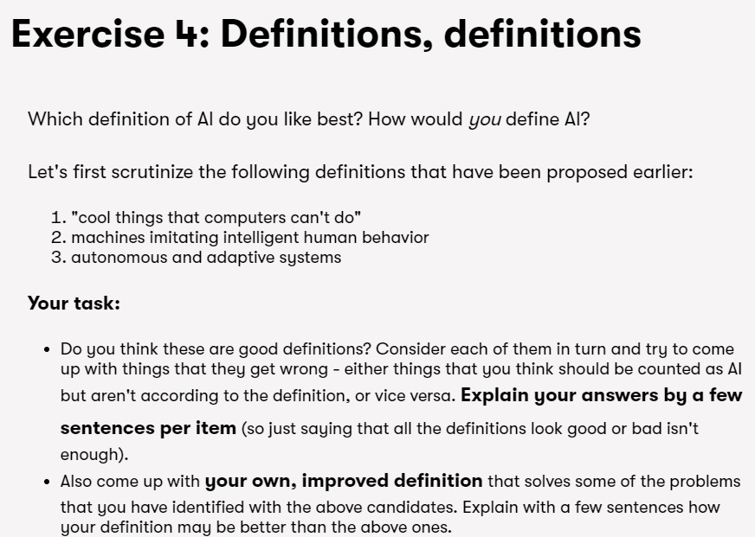

My attempt was:

1. "cool things that computers can't do": This definition is unprofessional, vague, and wrong for the most part. A definition should be a concise explanation of the subject. What computers can and can't do depends completely on the programmers at the moment.

2. Machines imitating intelligent human behavior: This definition brings up the same point as the Chinese Room Argument. Imitating human behavior can be quite deceptive and far from true intelligence.

3. Autonomous and adaptive systems: This is by far the best definition of AI out of the three provided. AI, as a whole, needs to be independent. In the past, programmers used to form a model for a system, and the system used to blindly follow that. Nowadays, the systems are evolving to the point where they are starting to create their own conclusions and findings from the data provided. A good example would be the AlphaGo Zero, a system that is currently the best player of Go, a game that cannot be won from brute force. But they are still quite restrictive in such a way that the systems are learning to create new models only in the specified field of interest, something that is governed by the data provided by the programmer.

Source: course.elementsofai.com

Finally, My definition of AI would be something along the lines of:

"A system that is able to gather data and create models for its current situation independently."