**MOCKITO EXERCISES**

## Exercise 1: Mocking and Stubbing

Scenario:

You need to test a service that depends on an external API. Use Mockito to mock the external API and stub its methods.

Steps: 1. Create a mock object for the external API. 2. Stub the methods to return predefined values. 3. Write a test case that uses the mock object.

Solution Code:

import static org.mockito.Mockito.*; import org.junit.jupiter.api.Test; import org.mockito.Mockito;

public class MyServiceTest {

@Test public void testExternalApi() {

ExternalApi mockApi = Mockito.mock(ExternalApi.class); when(mockApi.getData()).thenReturn("Mock Data"); MyService service = new MyService(mockApi);

String result = service.fetchData(); assertEquals("Mock Data", result); }

}

# SOLUTION:

// Java Test Code:

import static org.mockito.Mockito.*; import org.junit.jupiter.api.Test; import org.mockito.Mockito;

public class MyServiceTest { @Test

public void testExternalApi() {

ExternalApi mockApi = Mockito.mock(ExternalApi.class); when(mockApi.getData()).thenReturn("Mock Data"); MyService service = new MyService(mockApi);

String result = service.fetchData(); assertEquals("Mock Data", result);

}

}

// Dependencies for pom.xml:

<!-- JUnit 5 -->

<dependency>

<groupId>org.junit.jupiter</groupId>

<artifactId>junit-jupiter</artifactId>

<version>5.10.0</version>

<scope>test</scope>

</dependency>

<!-- Mockito -->

<dependency>

<groupId>org.mockito</groupId>

<artifactId>mockito-core</artifactId>

<version>5.12.0</version>

<scope>test</scope>

</dependency>

# OUTPUT:

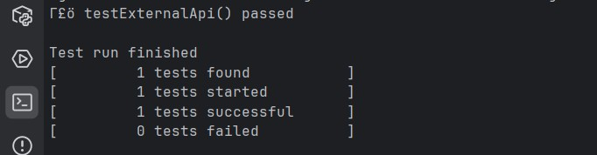

## Exercise 2: Verifying Interactions

Scenario:

You need to ensure that a method is called with specific arguments. Steps: 1. Create a mock object.

1. Call the method with specific arguments.
2. Verify the interaction. Solution Code:

import static org.mockito.Mockito.*; import org.junit.jupiter.api.Test; import org.mockito.Mockito;

public class MyServiceTest {

@Test public void testVerifyInteraction() {

ExternalApi mockApi = Mockito.mock(ExternalApi.class); MyService service = new MyService(mockApi); service.fetchData();

verify(mockApi).getData();

}

}

# SOLUTION:

// Java Test Code:

import static org.mockito.Mockito.*; import org.junit.jupiter.api.Test; import org.mockito.Mockito;

public class MyServiceTest { @Test

public void testVerifyInteraction() {

ExternalApi mockApi = Mockito.mock(ExternalApi.class); MyService service = new MyService(mockApi); service.fetchData();

verify(mockApi).getData();

}

}

// Dependencies for pom.xml:

<!-- JUnit 5 -->

<dependency>

<groupId>org.junit.jupiter</groupId>

<artifactId>junit-jupiter</artifactId>

<version>5.10.0</version>

<scope>test</scope>

</dependency>

<!-- Mockito -->

<dependency>

<groupId>org.mockito</groupId>

<artifactId>mockito-core</artifactId>

<version>5.12.0</version>

<scope>test</scope>

</dependency>

# OUTPUT:

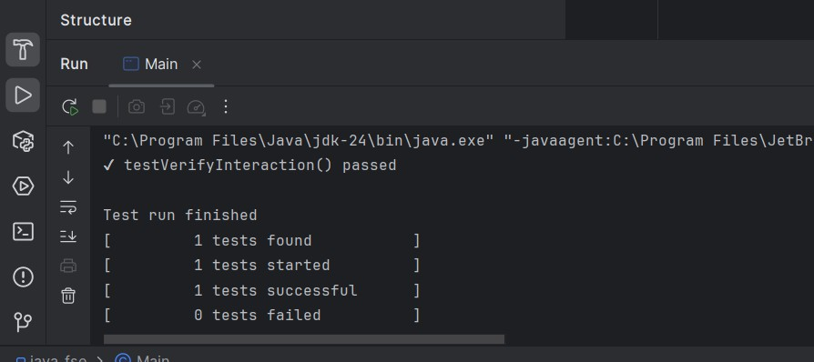

## Exercise 1: Logging Error Messages and Warning Levels Task:

Write a Java application that demonstrates logging error messages and warning levels using SLF4J.

Step-by-Step Solution:

1. Add SLF4J and Logback dependencies to your `pom.xml` file: org.slf4j slf4j-api 1.7.30 ch.qos.logback logback-classic 1.2.3
2. Create a Java class that uses SLF4J for logging:

import org.slf4j.Logger; import org.slf4j.LoggerFactory; public class LoggingExample {

private static final Logger logger = LoggerFactory.getLogger(LoggingExample.class); public static void main(String[] args) {

logger.error("This is an error message"); logger.warn("This is a warning message");

} }

# SOLUTION:

import org.slf4j.Logger;

import org.slf4j.LoggerFactory;

// Java Code:

public class LoggingExample {

private static final Logger logger = LoggerFactory.getLogger(LoggingExample.class);

public static void main(String[] args) { logger.error("This is an error message"); logger.warn("This is a warning message");

}

}

// Dependencies for pom.xml:

<!-- SLF4J API -->

<dependency>

<groupId>org.slf4j</groupId>

<artifactId>slf4j-api</artifactId>

<version>1.7.30</version>

</dependency>

<!-- Logback (SLF4J implementation) -->

<dependency>

<groupId>ch.qos.logback</groupId>

<artifactId>logback-classic</artifactId>

<version>1.2.3</version>

</dependency>

**OUTPUT:**

