SPRING DATA JPA HANDS ON

# Spring Data JPA - Quick Example Software Pre-requisites

* + MySQL Server 8.0
  + MySQL Workbench 8
  + Eclipse IDE for Enterprise Java Developers 2019-03 R
  + Maven 3.6.2

# Create a Eclipse Project using Spring Initializr

* + Go to <https://start.spring.io/>
  + Change Group as “com.cognizant”
  + Change Artifact Id as “orm-learn”
  + In Options > Description enter "Demo project for Spring Data JPA and Hibernate"
  + Click on menu and select "Spring Boot DevTools", "Spring Data JPA" and "MySQL Driver"
  + Click Generate and download the project as zip
  + Extract the zip in root folder to Eclipse Workspace
  + Import the project in Eclipse "File > Import > Maven > Existing Maven Projects > Click Browse and select extracted folder > Finish"
  + Create a new schema "ormlearn" in MySQL database. Execute the following commands to open MySQL client and create schema.

> mysql -u root -p

mysql> create schema ormlearn;

* + In orm-learn Eclipse project, open src/main/resources/application.properties and include the below database and log configuration.

# Spring Framework and application log logging.level.org.springframework=info logging.level.com.cognizant=debug

# Hibernate logs for displaying executed SQL, input and output logging.level.org.hibernate.SQL=trace logging.level.org.hibernate.type.descriptor.sql=trace

# Log pattern

logging.pattern.console=%d{dd-MM-yy} %d{HH:mm:ss.SSS} %-20.20thread %5p

%-25.25logger{25} %25M %4L %m%n

# Database configuration

spring.datasource.driver-class-name=com.mysql.cj.jdbc.Driver spring.datasource.url=jdbc:mysql://localhost:3306/ormlearn spring.datasource.username=root spring.datasource.password=root

# Hibernate configuration spring.jpa.hibernate.ddl-auto=validate

spring.jpa.properties.hibernate.dialect=org.hibernate.dialect.MySQL5Dialect

* + Build the project using ‘mvn clean package -Dhttp.proxyHost=proxy.cognizant.com

-Dhttp.proxyPort=6050 -Dhttps.proxyHost=proxy.cognizant.com

-Dhttps.proxyPort=6050 -Dhttp.proxyUser=123456’ command in command line

* + Include logs for verifying if main() method is called.

import org.slf4j.Logger;

import org.slf4j.LoggerFactory;

private static final Logger LOGGER = LoggerFactory.getLogger(OrmLearnApplication.class);

public static void main(String[] args) { SpringApplication.run(OrmLearnApplication.class, args); LOGGER.info("Inside main");

}

* + Execute the OrmLearnApplication and check in log if main method is called.

SME to walk through the following aspects related to the project created:

1. src/main/java - Folder with application code
2. src/main/resources - Folder for application configuration
3. src/test/java - Folder with code for testing the application
4. OrmLearnApplication.java - Walkthrough the main() method.
5. Purpose of @SpringBootApplication annotation
6. pom.xml
   1. Walkthrough all the configuration defined in XML file
   2. Open 'Dependency Hierarchy' and show the dependency tree.

# Country table creation

* Create a new table country with columns for code and name. For sample, let us insert one country with values 'IN' and 'India' in this table.

create table country(co_code varchar(2) primary key, co_name varchar(50));

* Insert couple of records into the table

insert into country values ('IN', 'India');

insert into country values ('US', 'United States of America');

# Persistence Class - com.cognizant.orm-learn.model.Country

* Open Eclipse with orm-learn project
* Create new package com.cognizant.orm-learn.model
* Create Country.java, then generate getters, setters and toString() methods.
* Include @Entity and @Table at class level
* Include @Column annotations in each getter method specifying the column name.

import javax.persistence.Column; import javax.persistence.Entity; import javax.persistence.Id; import javax.persistence.Table;

@Entity @Table(name="country") public class Country {

@Id @Column(name="code") private String code;

@Column(name="name") private String name;

// getters and setters

// toString()

}

*Notes:*

* @Entity is an indicator to Spring Data JPA that it is an entity class for the application
* @Table helps in defining the mapping database table
* @Id helps is defining the primary key
* @Column helps in defining the mapping table column

# Repository Class - com.cognizant.orm-learn.CountryRepository

* Create new package com.cognizant.orm-learn.repository
* Create new interface named CountryRepository that extends JpaRepository<Country, String>
* Define @Repository annotation at class level

import org.springframework.data.jpa.repository.JpaRepository; import org.springframework.stereotype.Repository;

import com.cognizant.ormlearn.model.Country;

@Repository

public interface CountryRepository extends JpaRepository<Country, String> {

}

# Service Class - com.cognizant.orm-learn.service.CountryService

* Create new package com.cognizant.orm-learn.service
* Create new class CountryService
* Include @Service annotation at class level
* Autowire CountryRepository in CountryService
* Include new method getAllCountries() method that returns a list of countries.
* Include @Transactional annotation for this method
* In getAllCountries() method invoke countryRepository.findAll() method and return the result

# Testing in OrmLearnApplication.java

* Include a static reference to CountryService in OrmLearnApplication class

private static CountryService countryService;

* Define a test method to get all countries from service.

private static void testGetAllCountries() { LOGGER.info("Start");

List<Country> countries = countryService.getAllCountries(); LOGGER.debug("countries={}", countries); LOGGER.info("End");

}

* Modify SpringApplication.run() invocation to set the application context and the CountryService reference from the application context.

ApplicationContext context = SpringApplication.run(OrmLearnApplication.class, args);

countryService = context.getBean(CountryService.class);

testGetAllCountries();

* Execute main method to check if data from ormlearn database is retrieved.

**SQL OUTPUT:**

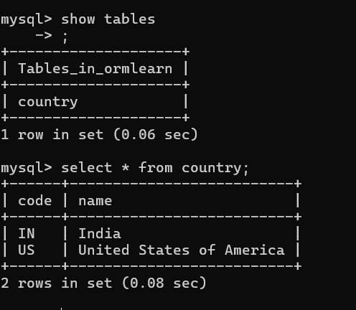

**CONSOLE OUTPUT:**

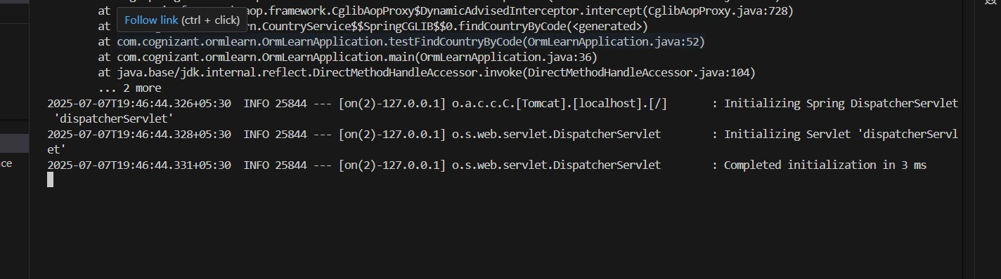

# Difference between JPA, Hibernate and Spring Data JPA

Java Persistence API (JPA)

* JSR 338 Specification for persisting, reading and managing data from Java objects
* Does not contain concrete implementation of the specification
* Hibernate is one of the implementation of JPA Hibernate
* ORM Tool that implements JPA Spring Data JPA
* Does not have JPA implementation, but reduces boiler plate code
* This is another level of abstraction over JPA implementation provider like Hibernate
* Manages transactions

**Refer code snippets below on how the code compares between Hibernate and Spring Data JPA**

**Hibernate**

/* Method to CREATE an employee in the database */ public Integer addEmployee(Employee employee){

Session session = factory.openSession(); Transaction tx = null;

Integer employeeID = null;

try {

tx = session.beginTransaction();

employeeID = (Integer) session.save(employee); tx.commit();

} catch (HibernateException e) { if (tx != null) tx.rollback(); e.printStackTrace();

} finally { session.close();

}

return employeeID;

}

**Spring Data JPA**

EmployeeRespository.java

public interface EmployeeRepository extends JpaRepository<Employee, Integer> {

}

EmployeeService.java

@Autowire

private EmployeeRepository employeeRepository;

@Transactional

public void addEmployee(Employee employee) { employeeRepository.save(employee);

}

# Reference Links:

<https://dzone.com/articles/what-is-the-difference-between-hibernate-and-sprin-1>

[https://www.javaworld.com/article/3379043/what-is-jpa-introduction-to-the-java-persistence-api.](https://www.javaworld.com/article/3379043/what-is-jpa-introduction-to-the-java-persistence-api.html) [html](https://www.javaworld.com/article/3379043/what-is-jpa-introduction-to-the-java-persistence-api.html)

# Hands on 5

**Implement services for managing Country**

An application requires for features to be implemented with regards to country. These features needs to be supported by implementing them as service using Spring Data JPA.

* Find a country based on country code
* Add new country
* Update country
* Delete country
* Find list of countries matching a partial country name

Before starting the implementation of the above features, there are few configuration and data population that needs to be incorporated. Please refer each topic below and implement the same.

# Explanation for Hibernate table creation configuration

* Moreover the ddl-auto defines how hibernate behaves if a specific table or column is not present in the database.
  + create - drops existing tables data and structure, then creates new tables
  + validate - check if the table and columns exist or not, throws an exception if a matching table or column is not found
  + update - if a table does not exists, it creates a new table; if a column does not exists, it creates a new column
  + create-drop - creates the table, once all operations are completed, the table is dropped

# Hibernate ddl auto (create, create-drop, update, validate)

spring.jpa.hibernate.ddl-auto=validate

Populate country table

* Delete all the records in Country table and then use the below script to create the actual list of all countries in our world.

insert into country (co_code, co_name) values ("AF", "Afghanistan"); insert into country (co_code, co_name) values ("AL", "Albania"); insert into country (co_code, co_name) values ("DZ", "Algeria");

insert into country (co_code, co_name) values ("AS", "American Samoa"); insert into country (co_code, co_name) values ("AD", "Andorra");

insert into country (co_code, co_name) values ("AO", "Angola"); insert into country (co_code, co_name) values ("AI", "Anguilla");

insert into country (co_code, co_name) values ("AQ", "Antarctica");

insert into country (co_code, co_name) values ("AG", "Antigua and Barbuda"); insert into country (co_code, co_name) values ("AR", "Argentina");

insert into country (co_code, co_name) values ("AM", "Armenia"); insert into country (co_code, co_name) values ("AW", "Aruba"); insert into country (co_code, co_name) values ("AU", "Australia"); insert into country (co_code, co_name) values ("AT", "Austria"); insert into country (co_code, co_name) values ("AZ", "Azerbaijan"); insert into country (co_code, co_name) values ("BS", "Bahamas"); insert into country (co_code, co_name) values ("BH", "Bahrain"); insert into country (co_code, co_name) values ("BD", "Bangladesh"); insert into country (co_code, co_name) values ("BB", "Barbados"); insert into country (co_code, co_name) values ("BY", "Belarus"); insert into country (co_code, co_name) values ("BE", "Belgium"); insert into country (co_code, co_name) values ("BZ", "Belize"); insert into country (co_code, co_name) values ("BJ", "Benin");

insert into country (co_code, co_name) values ("BM", "Bermuda"); insert into country (co_code, co_name) values ("BT", "Bhutan");

insert into country (co_code, co_name) values ("BO", "Bolivia, Plurinational State of"); insert into country (co_code, co_name) values ("BQ", "Bonaire, Sint Eustatius and Saba"); insert into country (co_code, co_name) values ("BA", "Bosnia and Herzegovina");

insert into country (co_code, co_name) values ("BW", "Botswana"); insert into country (co_code, co_name) values ("BV", "Bouvet Island"); insert into country (co_code, co_name) values ("BR", "Brazil");

insert into country (co_code, co_name) values ("IO", "British Indian Ocean Territory"); insert into country (co_code, co_name) values ("BN", "Brunei Darussalam");

insert into country (co_code, co_name) values ("BG", "Bulgaria"); insert into country (co_code, co_name) values ("BF", "Burkina Faso"); insert into country (co_code, co_name) values ("BI", "Burundi"); insert into country (co_code, co_name) values ("KH", "Cambodia"); insert into country (co_code, co_name) values ("CM", "Cameroon"); insert into country (co_code, co_name) values ("CA", "Canada"); insert into country (co_code, co_name) values ("CV", "Cape Verde");

insert into country (co_code, co_name) values ("KY", "Cayman Islands");

insert into country (co_code, co_name) values ("CF", "Central African Republic"); insert into country (co_code, co_name) values ("TD", "Chad");

insert into country (co_code, co_name) values ("CL", "Chile"); insert into country (co_code, co_name) values ("CN", "China");

insert into country (co_code, co_name) values ("CX", "Christmas Island");

insert into country (co_code, co_name) values ("CC", "Cocos (Keeling) Islands"); insert into country (co_code, co_name) values ("CO", "Colombia");

insert into country (co_code, co_name) values ("KM", "Comoros"); insert into country (co_code, co_name) values ("CG", "Congo");

insert into country (co_code, co_name) values ("CD", "Congo, the Democratic Republic of the");

insert into country (co_code, co_name) values ("CK", "Cook Islands"); insert into country (co_code, co_name) values ("CR", "Costa Rica"); insert into country (co_code, co_name) values ("HR", "Croatia");

insert into country (co_code, co_name) values ("CU", "Cuba"); insert into country (co_code, co_name) values ("CW", "Curaçao"); insert into country (co_code, co_name) values ("CY", "Cyprus");

insert into country (co_code, co_name) values ("CZ", "Czech Republic"); insert into country (co_code, co_name) values ("CI", "Côte d'Ivoire"); insert into country (co_code, co_name) values ("DK", "Denmark");

insert into country (co_code, co_name) values ("DJ", "Djibouti"); insert into country (co_code, co_name) values ("DM", "Dominica");

insert into country (co_code, co_name) values ("DO", "Dominican Republic"); insert into country (co_code, co_name) values ("EC", "Ecuador");

insert into country (co_code, co_name) values ("EG", "Egypt"); insert into country (co_code, co_name) values ("SV", "El Salvador");

insert into country (co_code, co_name) values ("GQ", "Equatorial Guinea"); insert into country (co_code, co_name) values ("ER", "Eritrea");

insert into country (co_code, co_name) values ("EE", "Estonia"); insert into country (co_code, co_name) values ("ET", "Ethiopia");

insert into country (co_code, co_name) values ("FK", "Falkland Islands (Malvinas)"); insert into country (co_code, co_name) values ("FO", "Faroe Islands");

insert into country (co_code, co_name) values ("FJ", "Fiji"); insert into country (co_code, co_name) values ("FI", "Finland"); insert into country (co_code, co_name) values ("FR", "France");

insert into country (co_code, co_name) values ("GF", "French Guiana"); insert into country (co_code, co_name) values ("PF", "French Polynesia");

insert into country (co_code, co_name) values ("TF", "French Southern Territories"); insert into country (co_code, co_name) values ("GA", "Gabon");

insert into country (co_code, co_name) values ("GM", "Gambia"); insert into country (co_code, co_name) values ("GE", "Georgia"); insert into country (co_code, co_name) values ("DE", "Germany"); insert into country (co_code, co_name) values ("GH", "Ghana"); insert into country (co_code, co_name) values ("GI", "Gibraltar"); insert into country (co_code, co_name) values ("GR", "Greece"); insert into country (co_code, co_name) values ("GL", "Greenland"); insert into country (co_code, co_name) values ("GD", "Grenada"); insert into country (co_code, co_name) values ("GP", "Guadeloupe"); insert into country (co_code, co_name) values ("GU", "Guam"); insert into country (co_code, co_name) values ("GT", "Guatemala"); insert into country (co_code, co_name) values ("GG", "Guernsey"); insert into country (co_code, co_name) values ("GN", "Guinea");

insert into country (co_code, co_name) values ("GW", "Guinea-Bissau"); insert into country (co_code, co_name) values ("GY", "Guyana");

insert into country (co_code, co_name) values ("HT", "Haiti");

insert into country (co_code, co_name) values ("HM", "Heard Island and McDonald Islands");

insert into country (co_code, co_name) values ("VA", "Holy See (Vatican City State)"); insert into country (co_code, co_name) values ("HN", "Honduras");

insert into country (co_code, co_name) values ("HK", "Hong Kong"); insert into country (co_code, co_name) values ("HU", "Hungary");

insert into country (co_code, co_name) values ("IS", "Iceland"); insert into country (co_code, co_name) values ("IN", "India"); insert into country (co_code, co_name) values ("ID", "Indonesia");

insert into country (co_code, co_name) values ("IR", "Iran, Islamic Republic of"); insert into country (co_code, co_name) values ("IQ", "Iraq");

insert into country (co_code, co_name) values ("IE", "Ireland"); insert into country (co_code, co_name) values ("IM", "Isle of Man"); insert into country (co_code, co_name) values ("IL", "Israel");

insert into country (co_code, co_name) values ("IT", "Italy"); insert into country (co_code, co_name) values ("JM", "Jamaica"); insert into country (co_code, co_name) values ("JP", "Japan"); insert into country (co_code, co_name) values ("JE", "Jersey"); insert into country (co_code, co_name) values ("JO", "Jordan");

insert into country (co_code, co_name) values ("KZ", "Kazakhstan"); insert into country (co_code, co_name) values ("KE", "Kenya"); insert into country (co_code, co_name) values ("KI", "Kiribati");

insert into country (co_code, co_name) values ("KP", "Democratic People's Republic of Korea");

insert into country (co_code, co_name) values ("KR", "Republic of Korea"); insert into country (co_code, co_name) values ("KW", "Kuwait");

insert into country (co_code, co_name) values ("KG", "Kyrgyzstan");

insert into country (co_code, co_name) values ("LA", "Lao People's Democratic Republic");

insert into country (co_code, co_name) values ("LV", "Latvia");

insert into country (co_code, co_name) values ("LB", "Lebanon"); insert into country (co_code, co_name) values ("LS", "Lesotho"); insert into country (co_code, co_name) values ("LR", "Liberia"); insert into country (co_code, co_name) values ("LY", "Libya");

insert into country (co_code, co_name) values ("LI", "Liechtenstein"); insert into country (co_code, co_name) values ("LT", "Lithuania"); insert into country (co_code, co_name) values ("LU", "Luxembourg"); insert into country (co_code, co_name) values ("MO", "Macao");

insert into country (co_code, co_name) values ("MK", "Macedonia, the Former Yugoslav Republic of");

insert into country (co_code, co_name) values ("MG", "Madagascar"); insert into country (co_code, co_name) values ("MW", "Malawi"); insert into country (co_code, co_name) values ("MY", "Malaysia"); insert into country (co_code, co_name) values ("MV", "Maldives"); insert into country (co_code, co_name) values ("ML", "Mali");

insert into country (co_code, co_name) values ("MT", "Malta");

insert into country (co_code, co_name) values ("MH", "Marshall Islands"); insert into country (co_code, co_name) values ("MQ", "Martinique"); insert into country (co_code, co_name) values ("MR", "Mauritania"); insert into country (co_code, co_name) values ("MU", "Mauritius");

insert into country (co_code, co_name) values ("YT", "Mayotte"); insert into country (co_code, co_name) values ("MX", "Mexico");

insert into country (co_code, co_name) values ("FM", "Micronesia, Federated States of"); insert into country (co_code, co_name) values ("MD", "Moldova, Republic of");

insert into country (co_code, co_name) values ("MC", "Monaco"); insert into country (co_code, co_name) values ("MN", "Mongolia"); insert into country (co_code, co_name) values ("ME", "Montenegro"); insert into country (co_code, co_name) values ("MS", "Montserrat"); insert into country (co_code, co_name) values ("MA", "Morocco"); insert into country (co_code, co_name) values ("MZ", "Mozambique"); insert into country (co_code, co_name) values ("MM", "Myanmar"); insert into country (co_code, co_name) values ("NA", "Namibia"); insert into country (co_code, co_name) values ("NR", "Nauru");

insert into country (co_code, co_name) values ("NP", "Nepal");

insert into country (co_code, co_name) values ("NL", "Netherlands"); insert into country (co_code, co_name) values ("NC", "New Caledonia"); insert into country (co_code, co_name) values ("NZ", "New Zealand"); insert into country (co_code, co_name) values ("NI", "Nicaragua"); insert into country (co_code, co_name) values ("NE", "Niger");

insert into country (co_code, co_name) values ("NG", "Nigeria"); insert into country (co_code, co_name) values ("NU", "Niue");

insert into country (co_code, co_name) values ("NF", "Norfolk Island");

insert into country (co_code, co_name) values ("MP", "Northern Mariana Islands"); insert into country (co_code, co_name) values ("NO", "Norway");

insert into country (co_code, co_name) values ("OM", "Oman"); insert into country (co_code, co_name) values ("PK", "Pakistan"); insert into country (co_code, co_name) values ("PW", "Palau");

insert into country (co_code, co_name) values ("PS", "Palestine, State of"); insert into country (co_code, co_name) values ("PA", "Panama");

insert into country (co_code, co_name) values ("PG", "Papua New Guinea"); insert into country (co_code, co_name) values ("PY", "Paraguay");

insert into country (co_code, co_name) values ("PE", "Peru");

insert into country (co_code, co_name) values ("PH", "Philippines"); insert into country (co_code, co_name) values ("PN", "Pitcairn"); insert into country (co_code, co_name) values ("PL", "Poland"); insert into country (co_code, co_name) values ("PT", "Portugal"); insert into country (co_code, co_name) values ("PR", "Puerto Rico"); insert into country (co_code, co_name) values ("QA", "Qatar"); insert into country (co_code, co_name) values ("RO", "Romania");

insert into country (co_code, co_name) values ("RU", "Russian Federation"); insert into country (co_code, co_name) values ("RW", "Rwanda");

insert into country (co_code, co_name) values ("RE", "Réunion");

insert into country (co_code, co_name) values ("BL", "Saint Barthélemy");

insert into country (co_code, co_name) values ("SH", "Saint Helena, Ascension and Tristan da Cunha");

insert into country (co_code, co_name) values ("KN", "Saint Kitts and Nevis"); insert into country (co_code, co_name) values ("LC", "Saint Lucia");

insert into country (co_code, co_name) values ("MF", "Saint Martin (French part)");

insert into country (co_code, co_name) values ("PM", "Saint Pierre and Miquelon");

insert into country (co_code, co_name) values ("VC", "Saint Vincent and the Grenadines");

insert into country (co_code, co_name) values ("WS", "Samoa"); insert into country (co_code, co_name) values ("SM", "San Marino");

insert into country (co_code, co_name) values ("ST", "Sao Tome and Principe"); insert into country (co_code, co_name) values ("SA", "Saudi Arabia");

insert into country (co_code, co_name) values ("SN", "Senegal"); insert into country (co_code, co_name) values ("RS", "Serbia"); insert into country (co_code, co_name) values ("SC", "Seychelles");

insert into country (co_code, co_name) values ("SL", "Sierra Leone"); insert into country (co_code, co_name) values ("SG", "Singapore");

insert into country (co_code, co_name) values ("SX", "Sint Maarten (Dutch part)"); insert into country (co_code, co_name) values ("SK", "Slovakia");

insert into country (co_code, co_name) values ("SI", "Slovenia");

insert into country (co_code, co_name) values ("SB", "Solomon Islands"); insert into country (co_code, co_name) values ("SO", "Somalia");

insert into country (co_code, co_name) values ("ZA", "South Africa");

insert into country (co_code, co_name) values ("GS", "South Georgia and the South Sandwich Islands");

insert into country (co_code, co_name) values ("SS", "South Sudan"); insert into country (co_code, co_name) values ("ES", "Spain");

insert into country (co_code, co_name) values ("LK", "Sri Lanka"); insert into country (co_code, co_name) values ("SD", "Sudan"); insert into country (co_code, co_name) values ("SR", "Suriname");

insert into country (co_code, co_name) values ("SJ", "Svalbard and Jan Mayen"); insert into country (co_code, co_name) values ("SZ", "Swaziland");

insert into country (co_code, co_name) values ("SE", "Sweden"); insert into country (co_code, co_name) values ("CH", "Switzerland");

insert into country (co_code, co_name) values ("SY", "Syrian Arab Republic"); insert into country (co_code, co_name) values ("TW", "Taiwan, Province of China"); insert into country (co_code, co_name) values ("TJ", "Tajikistan");

insert into country (co_code, co_name) values ("TZ", "Tanzania, United Republic of"); insert into country (co_code, co_name) values ("TH", "Thailand");

insert into country (co_code, co_name) values ("TL", "Timor-Leste"); insert into country (co_code, co_name) values ("TG", "Togo");

insert into country (co_code, co_name) values ("TK", "Tokelau"); insert into country (co_code, co_name) values ("TO", "Tonga");

insert into country (co_code, co_name) values ("TT", "Trinidad and Tobago"); insert into country (co_code, co_name) values ("TN", "Tunisia");

insert into country (co_code, co_name) values ("TR", "Turkey");

insert into country (co_code, co_name) values ("TM", "Turkmenistan");

insert into country (co_code, co_name) values ("TC", "Turks and Caicos Islands"); insert into country (co_code, co_name) values ("TV", "Tuvalu");

insert into country (co_code, co_name) values ("UG", "Uganda"); insert into country (co_code, co_name) values ("UA", "Ukraine");

insert into country (co_code, co_name) values ("AE", "United Arab Emirates"); insert into country (co_code, co_name) values ("GB", "United Kingdom"); insert into country (co_code, co_name) values ("US", "United States");

insert into country (co_code, co_name) values ("UM", "United States Minor Outlying Islands");

insert into country (co_code, co_name) values ("UY", "Uruguay"); insert into country (co_code, co_name) values ("UZ", "Uzbekistan"); insert into country (co_code, co_name) values ("VU", "Vanuatu");

insert into country (co_code, co_name) values ("VE", "Venezuela, Bolivarian Republic of");

insert into country (co_code, co_name) values ("VN", "Viet Nam");

insert into country (co_code, co_name) values ("VG", "Virgin Islands, British"); insert into country (co_code, co_name) values ("VI", "Virgin Islands, U.S."); insert into country (co_code, co_name) values ("WF", "Wallis and Futuna"); insert into country (co_code, co_name) values ("EH", "Western Sahara");

insert into country (co_code, co_name) values ("YE", "Yemen"); insert into country (co_code, co_name) values ("ZM", "Zambia"); insert into country (co_code, co_name) values ("ZW", "Zimbabwe");

insert into country (co_code, co_name) values ("AX", "Åland Islands");

Refer subsequent hands on exercises to implement the features related to country.

**SQL TABLE:**

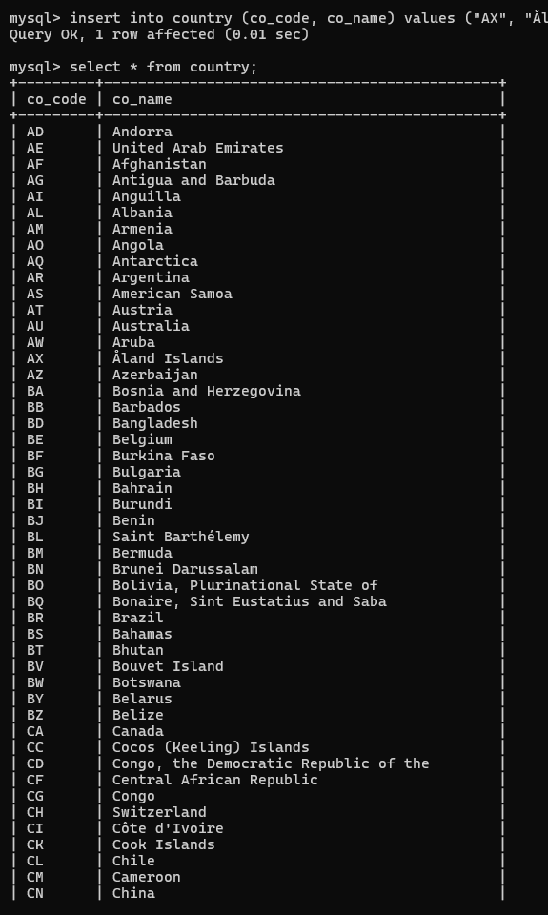

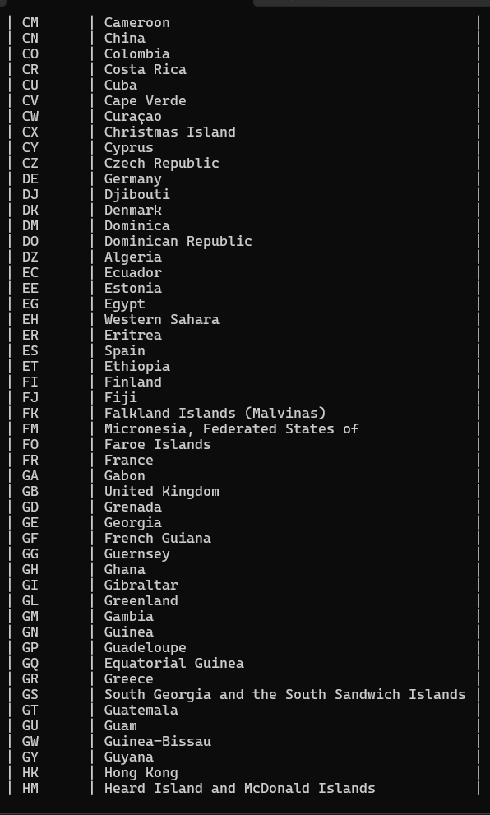

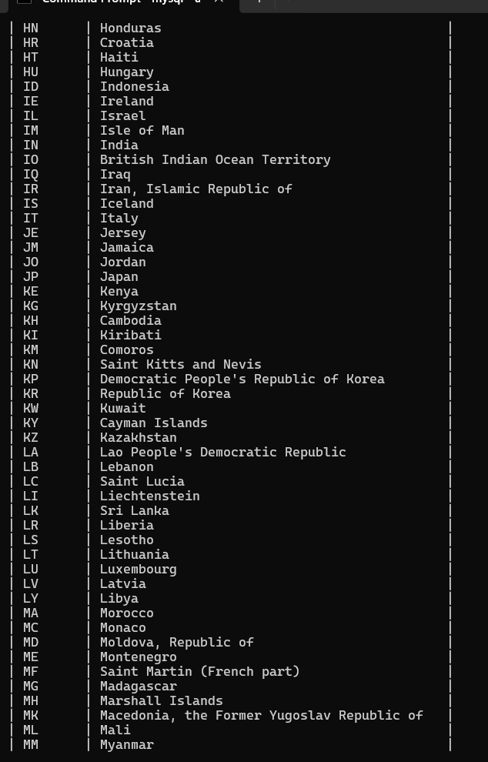

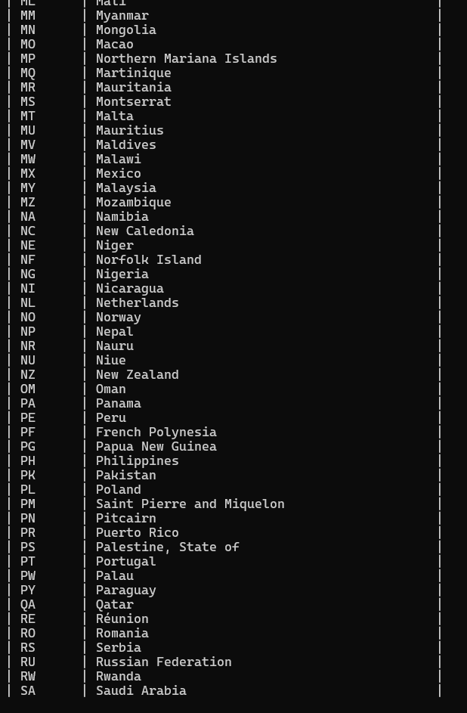

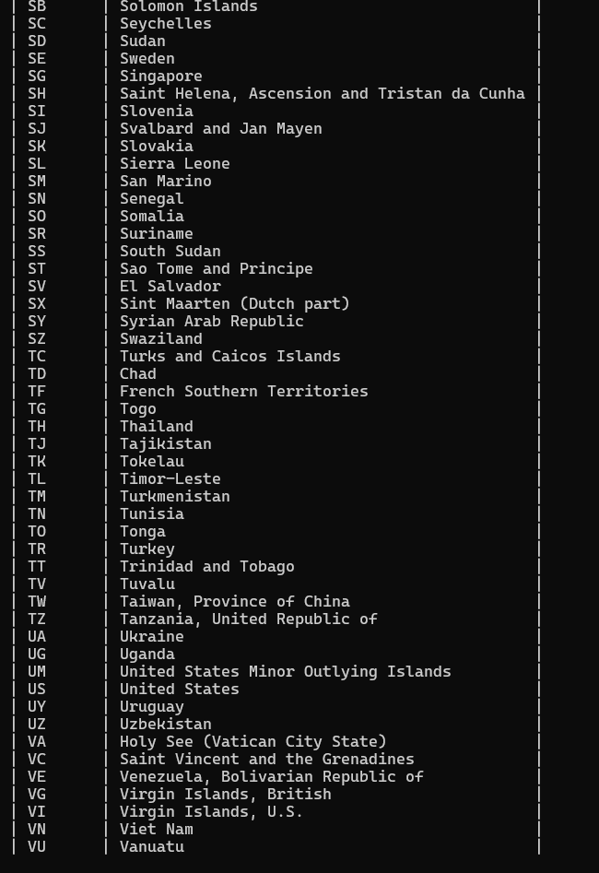

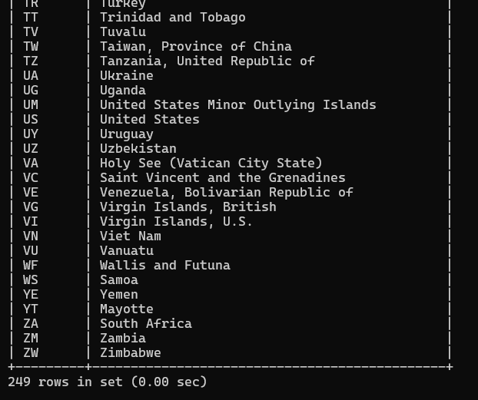

**CONSOLE OUTPUT:**

