AIMPLIFY Executive Report
Asset Governance & Adoption | 25 Aug 2026 – 25 Aug 2026

Assets Catalog
21  Total assets | 19  Published assets | 5  Awaiting review | 0  L1 waiting approval | 5  L2 waiting approval

Asset Families
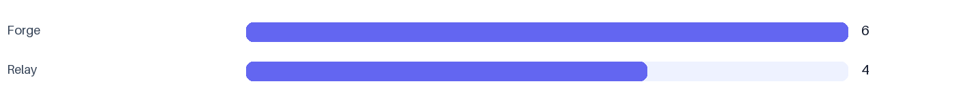
Family | Published assets | Share
Forge | 6 | 32%
Relay | 4 | 21%

Platform Adoption
18  Active users | 29  Asset views | 6  Demo views
2  Downloads | 5  Clone requests | 1  Demo requests

Top Events
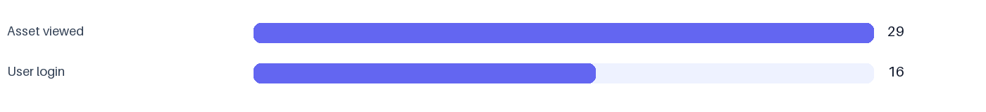
Event | Count
Asset viewed | 29
User login | 16

Most Trending Assets
Asset | Family | Views | Downloads | Clones | Demo requests | Score
Asset A | Forge | 10 | 2 | 1 | 1 | 14

Most Active Users
Name | Email | Events | Last active
Test User | test@example.com | 8 | 25 Aug 2026 12:18 UTC

Daily Submission and Publishing Trend
Date | Submitted | Approved | Published | Needs changes
2026-08-25 | 2 | 1 | 1 | 0

Current Governance Funnel
Status | Assets
Published | 19
Approved | 5

Performance by Department
Name | Submitted | Approved | Published | Average AI score
Forge | 5 | 4 | 3 | 82

Performance by Platform Family
Name | Submitted | Approved | Published | Average AI score
Forge | 5 | 4 | 3 | 82
Generated 25 Aug 2026 12:18 UTC

