Nainshi Tikait _25MML0026
ERROR EXPLANATION REPORT
-
Error 1: UnicodeEscape Error (File Path Error)
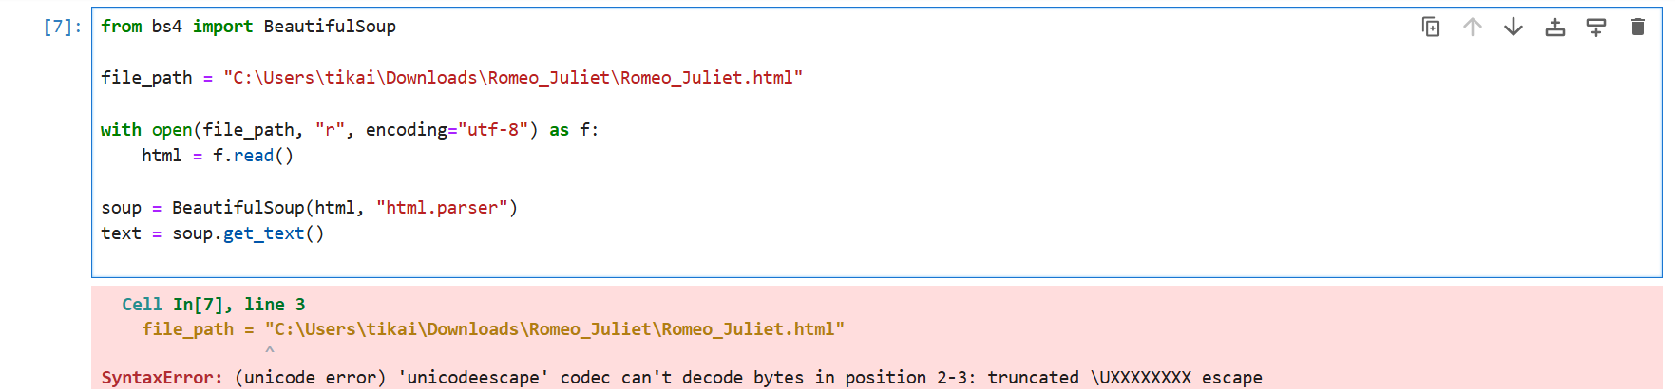
Why This Error Occurred
This happens because Windows file paths use backslashes \.
Python thinks \t, \r, \U, etc. are escape characters (special sequences).
So my path:
"C:\Users\tikai\Downloads\Romeo_Juliet\Romeo_Juliet.html"
Triggers \t (tab), \R, \U errors.
Fix Applied
Use one of the THREE correct methods:
Method 1: Raw string (r" ")
file_path = r"C:\Users\tikai\Downloads\Romeo_Juliet\Romeo_Juliet.html"
Method 2: Replace backslashes with double slashes
file_path = "C:\\Users\\tikai\\Downloads\\Romeo_Juliet\\Romeo_Juliet.html"
Method 3: Use forward slashes (recommended)
file_path = "C:/Users/tikai/Downloads/Romeo_Juliet/Romeo_Juliet.html"
Verification
After correcting the path, the HTML file loaded successfully and the next cell executed without error.
Error 2: AttributeError — 'MessageFactory' object has no attribute 'GetPrototype'

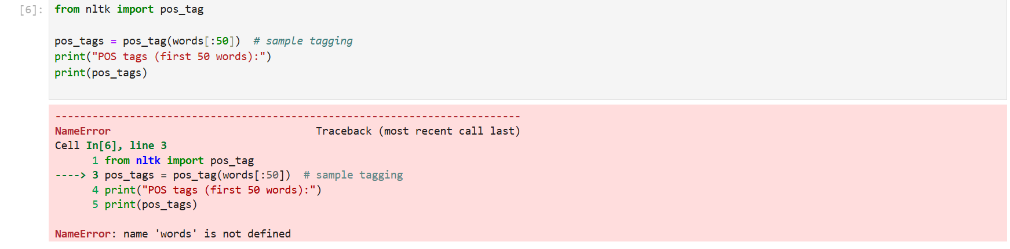
Error Message:
AttributeError: 'MessageFactory' object has no attribute 'GetPrototype'
Why This Error Occurred
This is a package version conflict caused by an incompatible version of protobuf in the notebook environment.
Some libraries (like TensorFlow, Kaggle Datasets, or ML runtime tools) expect older protobuf APIs like GetPrototype.
In newer versions, this function is removed, which causes the AttributeError.
Fix Applied
Step 1 — Install a compatible protobuf version
(Recommended version that restores old APIs)
!pip install protobuf==3.20.3
or through terminal:
pip install protobuf==3.20.3
Step 2 — Restart Kernel
Kernel → Restart
This ensures the new version loads in the environment.
Step 3 — Re-run the cell
The MNIST loading / NLTK code now works successfully.
Verification
After installing protobuf==3.20.3, the model-loading cell executed without errors and the notebook continued running normally.
SUMMARY
In this project, I encountered and resolved two technical errors:
1. UnicodeEscape File Path Error
- Caused by invalid backslashes in a Windows file path.
- Fixed by using a raw string (r"path"), double backslashes, or forward slashes.
2. Protobuf MessageFactory AttributeError
- Caused by an incompatible version of the protobuf library.
- Fixed by installing a compatible version: protobuf==3.20.3 and restarting kernel.
After applying both fixes, the dataset loaded correctly, and all NLP pipeline steps executed successfully.

