##### JUET SERVICE CENTER

##### A PROJECT REPORT

###### ***Submitted by :***

##### Nainy Jain -161B125

Niharika Singh -161B129

Tarang Banzal-161B249

**BACHELOR OF TECHNOLOGY**

**IN**

**COMPUTER SCIENCE & ENGINEERING**

**at**



JAYPEE UNIVERSITY OF ENGINEERING & TECHNOLOGY, GUNA-473226 MP

November – 2018

**DECLARATION**

We hereby declare that the project entitled “JUET SERVICE CENTER” submitted for the B. Tech. (CSE) degree is my original work and the project has not formed the basis for the award of any other degree, diploma, fellowship or any other similar titles.

**Signature of the Student**

**Place: Jaypee University of Engineering and Technology,Guna**

**Date: 30 Nov 2018**

**CERTIFICATE**

This is to certify that the work titled “JUET SERVICE CENTER” submitted by “NAINY JAIN,NIHARIKA SINGH,TARANG BANZAL” in partial fulfillment for the award of degree of B.Tech of Jaypee University of Engineering & Technology, Guna has been carried out under my supervision. As per best of my knowledge and belief there is no infringement of intellectual property right and copyright. Also, this work has not been submitted partially or wholly to any other University or Institute for the award of this or any other degree or diploma. In case of any violation concern student will solely be responsible.

Signature of Supervisor

Dr.Ajay Kumar

Assistant Professor

Date-30 Nov 2018

**Table of Contents**

|  |  |  |
| --- | --- | --- |
|  |  |  |
|  |
|  |
|  |
|  |  |
| 1. | **ACKNOWLEDGEMENT 5** |  |
| 2 | **LIST OF FIGURES 6** |  |
|  |  |
|  |  |
|  |  |  |
| **3.** | **INTRODUCTION 7** |  |
|  |  |  |
|  |  |  |
| **4.** | **SYSTEM DESIGN 17** |  |
|  |  |
|  |  |
| **5.** | **IMPLEMENTATION 27** |  |
|  |  |  |
|  |  |  |
| **6.** | **CONCLUSIONS 39** |
| **7.** | **BIBLIOGRAPHY 41** |
|  |  |
|  |  |  |

**ACKNOWLEDGEMENT**

We are using this opportunity to express our gratitude to everyone who supported us throughout the project. We are thankful for their aspiring guidance and advice during the project work. We are sincerely grateful to them for sharing their truthful and illuminating views on a number of issues related to the project.

We would also like to thank our project guide Dr.Ajay Kumar for giving us the required and conductive conditions for our project, whose contribution in stimulating suggestions and encouragement,  helped us to coordinate our project ,who  help us to assemble the parts and gave suggestion about the task .

 We want to appreciate the guidance given by other supervisor as well as the panels especially in our project presentation that has improved our presentation skills thanks to their comment and advices.

Nainy Jain(161B125)

Niharika Singh(161b129)

Tarang Banzal(161b249)

 Date-30 Nov 2018

**LIST OF FIGURES**

|  |  |  |
| --- | --- | --- |
| **Fig no**. | **Description** | **Page no** |
| 1 | Login page | 17 |
| 2 | Home page student | 18 |
| 3 | Register,old,mark complaint | 19 |
| 4 | Feedback,settings | 20 |
| 5 | Admin home page | 21 |
| 6 | Admin home screen | 22 |
| 7 | Worker home page | 23 |
| 8 | Entity relationship diagram | 24 |
| 9 | Student ER | 24 |
| 10 | Admin and worker ER | 25 |
| 11 | Complaint ER | 26 |
| 12 | Feedback ER | 26 |

**CHAPTER-1**

**INTRODUCTION**

* 1. **Problem Definition**

This project is based on student record service.By this, we can store the data of students, worker, admin, and complaints.This project will provide services to ensure that students can easily register the complaints and the admin will assign a particular worker for the specific complaint.

* 1. **Existing System**

In the architecture there existed a system Juet Webkiosk which maintains the record of student’s attendance, personal information, student’s marks, Student’s fees, about university. This means that every Student can access the webkiosk from hostels and utilize the service. This is the efficient system for the students for academics details. The existing system is the motivation for a new system with features for hostel related issues.

* 1. **Proposed System**

The proposed system should have the following features. The related issues of the hostels like the complaints related to students room of different matters like problem of furniture, electricity and LAN etc. Students are provided with the feedback feature with star rating, which can be managed by admin.Different database are being managed for different users (Students, admin, workers).

In this system we are going to develop a facility to a user that he will not face any difficulty at the time of searching data like students information, different complaints.In general,the proposed system addresses the following problems:

* Time wastage on queues.
* Errors in the allocation process.
* Loss of data due to lack or inappropriate set of paper based backup.
* Unnecessary efforts and resources are directed to some tasks while there is more appropriate and cheap alternative to provide service self.
  1. **Scope**

The purpose of our project is to create a web application called JUET SERVICE CENTER. The application will be access via a internet on a PC at any place. This project will serve the student, register complaint by providing the solution with assigned worker, Students in the long run can take the advantage of this website to solve their issues related to hostel. They can easily find ways and it will reduce the manual work and that to paper work being avoided.Admin don’t have to maintain the complaint registers and hence they can directly assign the worker the complaint. Worker will be able to learn new technology and can explore their work by receiving feedback from student. University will be benefitted from this website in the long run for the hostel related problems. The work of the worker can be improved more as the feedback is provided by the student and admin can view them with rating provided. Provide additional flexibility and convenience to the users (Students,admin,worker). Provides better reliability and security of the information.

* 1. **Definitions**

|  |  |
| --- | --- |
| Button | A user interface element that allows a User to click and inform the system to take an action. |
| Member | A person that is part of the system ie student,admin,worker which has requested the system. |
| Session | The time which a User is actively using the website. |
| TextBox | A user interface element that allows a User to input text to the system. |

* 1. **Need**

The website is required for the purpose of hostel complaints being solved. And the Student will easily register complaints to admin by providing personal information with the complaint and the type of complaint with description.Admin’s paper work need to be reduced so that they can easily assign worker.Such websites help a lot in the advancement of user in providing them knowledge of such web Application.

**1.6 Project Overview**

Juet Service Center will provide the facility within hostels to lodge a complaint. It provides cost savings to students, admin, workers, and service will be provided to students for their problem. Juet service center will provide 24X7 services to every student.Juet service center is designed to be used simple and efficient.

The goal is to –

* All actions should be prompt for better redressal of complaint.
* To make the redressal process fair, impartial, consistent.

The services provided to students will be impartial in reference to complaint solved. Students are provided with the feature to submit the feedback for the complaint solved. The admin can see the feedback of th-e specific student with the rating system being provided. Students have to log in with student er.no and password to get to the student home page for filling personal information and then fill the register complaint form which will be stored in the database.

Students can also have the option to see their old complaints which were being solved or not solved. Logout feature is also available on student home page under settings and if student want to change password ,change password option is available.Admin is also provided with id and password to log in to admin home page ,their the admin can assign worker according to work type and worker. The

admin can search complaint according to student, work type and complaint.

The admin can see the feedback of particular student by their id.

Worker also have id and password to log in to worker home page, there he can fill his personal information, and check for the complaints which being assigned to him by admin. Admin too have setting option to change password and logout.

* 1. **Hardware Specifications**
* Processor(2.3 GHz)
* LED display
* Intel core
* Monitor
* Mouse

**1.8 Software Specifications**

**Operating System**

* Windows

**Web Browser**

* Google Chrome
* Internet Explorer
* Microsoft Edge

These Web Browsers are used in our project as a software application for accessing information on the World Wide Web. Each web page, image is identified by a URL, enabling browsers to retrieve and display them on the user’s device. A web browser is to fetch information resources and display them. The Browser provides us with the following features. Back and forward buttons to go back to the previous page visited or forward to the next one. A refresh or reload button to reload the current page. A home button to return to the user's [home page](https://en.wikipedia.org/wiki/Home_page).An address bar to input the URL of a page and display it.

**Back End**

* Eclipse

JAVA

JSP(JAVA SERVER PAGES)

SERVLET

We create a simple web application with the combination of Servlet**, JSP, and JDBC.** JSP is only considered as to display data, which means that you should not handle the application logic on the JSP, such as update, insert, delete, .., and not navigate on the JSP page. In this application we use the MYSQL database to create tables and store data. We have download JDBC library to driving the connection with the Database.

* MySQL
* Apache Tomcat

**Front End**

* HTML

**HTML**provides the basic structure to our website, which is enhanced and modified by other technologies like CSS and JavaScript. It's the starting point for our website learning how to create content for the web. HTML is at the core of every web page, regardless the complexity of our site or number of technologies involved. Every web page is made up of a bunch of the tags denoting each type of content on the page. Each type of content on the page is "wrapped" in, i.e. surrounded by, HTML tags. Using HTML, we can add headings, format paragraphs, control line breaks, make lists, emphasize text, insert images, create links, build tables, control some styling, and much more.

* CSS

This programming language dictates how the HTML elements of our website should actually appear on the frontend of the web page. CSS is what gives your entire website its style. Those slick colors, interesting fonts, and background images which add style to the website. This language affects the entire mood and tone of a web page, making it an incredibly powerful tool -- and an important skill for web developers to learn. It's also what allows websites to adapt to different screen sizes and device types.

* JAVASCRIPT

JavaScript is supported by all modern web browsers and is used on our website on the webpage for more powerful and complex functionality which add features to page. JavaScript is used to create combo boxes for storing information.

* NOTEPAD

We type the web pages using Notepad, a program that comes with windows. Once we have typed up a web page, you need to view it.  We will use web browser (Internet Explorer, Google chrome).Notepad is used to write HTML code with style sheet for our web pages. It is easily available software and is easy to use.

* 1. **User Interface**

This website provides User friendly experience, allowing the user to interact with the website in intuitive way. It makes easy for users to communicate with the website. The interface will provide easy access to help as well as clearly indicate the current state of the user’s complaints.

**LOGGING**

Within the system, logging will be used to provide a trail of actions performed, for security and privacy. The user’s password MUST never be exposed to compromise.

**CHANGE PASSWORD**

The System consists of setting option of which change password, which provide the user with the facility of securing the data for personal use.

**FEEDBACK**

The feedback option helps the students in giving their views over the work being done by the worker. This makes the system more efficient.

**DATA ENTRY**

The website allows the user to enter his/her data .This allows the user to enter his/her personal information for complaint registering.

* 1. **Design Constraints**

The user login id and password details will be stored in the database and the user personal information is stored in the database and will be committed to database only.The database may store passwords and there will be change password option and logout feature too.

* 1. **User Characteristics**

The user of this website is simply anyone that has access to the internet and a web

browser.It is assumed that the user is familiar enough with a computer to operate the browser,and is able to browse over websites.

* 1. **Assumptions and Dependencies**

**Client:**

We have assumed that all the students are able to access the website from hostels

in proper working condition and that the user is capable of operating these system's basic functions including but not limited to being able to power on the system, login and open either Internet Explorer or Mozilla Firefox, and navigate the browser to the address of this JUET SERVICE CENTER website.

**Provider:**

We have assumed that the JUET SERVICE CENTER website will be running on a properly working web server and database system with an Internet connection that allows this system to perform all communications with clients.

**Assumptions:**

**-** There is no need to record anything on paper manually. The work of registering complaints can be easily done through rooms.

- The user’s password and id is stored in specific database. Different database are created to store information.

**2. Specific Requirements**

1. Restrictions

1.1. User side

1.1.1. Software

1.1.1.1. Google Chrome, Internet Explorer, Microsoft Edge.

1.1.2. Hardware

1.1.2.1 Laptops and desktop computers

1.2 System side

1.2.1. Software

1.2.1.1. Web based application

1.2.1.2. Database information storage system

2 Database

2.1. Student has these attributes

2.1.1. Unique Er_no

2.1.2. Name

2.1.3. Dob

2.1.4. Block

2.1.5. room no

2.1.6. contact

2.1.7. father’s name

2.1.8. password

2.2. Admin has these attributes

2.2.1. Id

2.2.2. Name

2.2.3. Contact

2.2.4. Post

2.2.5. Password

2.3. Workers has these attributes

2.3.1 Id

2.3.2. Name

2.3.3. Type

2.3.4. Contact

2.3.5. Password

2.4 Complaint has these attributes

2.4.1. id

2.4.2. er_no

2.4.3. name

2.4.4. r_date

2.4.5.problem

2.4.6.ptype

2.4.7.status

2.5 Feedback has these Attributes

2.5.1. fid

2.5.2. er_no

2.5.3. feedback

2.5.4. comment

3. **Non- Functional Requirements**

* 1. SECURITY
  2. PORTABILITY
  3. MAINTAINABLE
  4. RELIABILITY
  5. AVAILABILITY
  6. DATA INTEGRITY

**CHAPTER-2**

**SYSTEM DESIGN**

**2.1 Flowcharts**

**From Login page to home screen page.**

**START** START

**Student**

**Admin**

**VALID OR NOT**

**HOME SCREEN**

YES

NO

(Username and password)

**Worker**

**Fig 1.**

**STEPS:**

* This is the home page of our website. The member type has three fields students,Admin.worker.
* The user has a id and password by which it login and go to respective pages.
* If the user id and password are valid the user is redirected, else if invalid the user has to attempt again with valid id and password.

**Home screen page for student**

PERSONAL **INFO**

**FEEDBACK**

**REGISTER**

**COMPLAINT**

**SETTINGS(Logout, Change password)**

**COMPLAINT**

**MARK**

**OLD**

**COMPLAINT**

**Fig 2.**

**STEPS:**

* If the user logged in is a student ,he will be redirected to student home page.
* This page shows different buttons like Personal info, old complaint, register complaint, complaint mark, settings(logout,change password),Feedback.
* Personal info for entering personal information, old complaint which will show student’s old complaint database, register complaint which will ask student to enter specific complaint, complaint mark which will display student’s complaint status solved or not ,settings option provided for logout and change password, feedback to provide feedback by student for complaint work.

* **Register Complaint**

Complaint

Database

(Update)

Describe Complaint

Fill Your Details

Submit

* **Old Complaint**

Complaint

Database

(Fetch data)

Details of old compliant

* **Mark Complaint**

Complaint

Database

Complaint

Database

(Fetch data)

Details of complaints

(Mark)

(Update)

**Fig 3.**

**STEPS:**

* Register complaint- allows the student to register complaint by firstly describing the complaint by filling details of complaint type with complaint and then click on submit, and then the details will be stored in complaint database.
* Old complaint- picks all the old complaint from the complaint database with all details of complaint.
* Mark complaint-gives students an option to mark the status of complaint by fetching old complaints from database and after marking it will get updated in the database.
* **Feedback:**

Fill your feedback

Feedback

Database

(Update)

* **Settings:**

(update Password)

Enter old password

Student

Database

Enter new password

Confirm new password

Valid

Yes

No

**Fig 4.**

**STEPS:**

* Feedback- Students will fill the feedback of the work done by worker in resolving there complaint.
* Settings – on clicking, Settings button will open with a drop down showing two options for change password and logout.

If student want to change the password, then he can click on change password option in which the student has to first enter the old password ,if valid then new password and confirm password which will be updated in the database.

**Admin Home Screen**

Assign Worker

Select work type, complaint

Select worker

Submit

Complaint database

**Fig 5.**

**STEPS:**

* If the user logged in is an admin,he will be redirected to admin home page.
* This page provides the admin with the feature that he can assign worker for a registered complaint. By clicking on assign worker, the admin will provide the details that to which worker the registered complaint will be assigned.By selecting work type of the worker and selecting worker and then submit the information.
* The information will be stored in the complaint database .

**Admin home screen**

Start (admin)



Search by Student

Search by

Work type

Search by complaint

(Complaint Search tabs)

Enter student details(Er,Name)

Select work type

Select date, recent or old complaints

Student database

Complaint. Database

Result Page

(Searching)

(Searching)

(Searching)

**Fig 6.**

**STEPS:**

* Admin also had the option to search for complaints by different option being provided in the drop down list.Admin can search complaint by student type, work type, complaint.
* Search by student from student database by entering student id in field being provided.
* Search by work type from complaint database will display the complaints.
* Search by complaint by selecting date of recent or old complaints from the complaint database.
* After searching the specified information the results will be displayed over the page.

**Worker Home Screen**

Personal info

New Complaints

database

Database

Details of workers

Complaint

Database

Details of complaints

**Fig 7.**

**STEPS:**

* If the user logged in is a worker, he will be redirected to worker home page.
* This page allows the worker to enter their personal information like their name, id, work type and contact by clicking on personal info tab present on the page.
* For worker to know about recent complaints, he can click on complaint tab to view complaint details.
* Then by clicking on submit button, the information will be stored in the specified database.
* Worker is also provided with logout and change password option in the settings tab.

**Database Modelling and Design**

A sound database design will be the key to the success of this system. By ensuring that, at this stage, all the relevant information is incorporated into the system, the rest of the system design will fall easily around the database. Database design is generally thought to involve the modelling of different Entities, Relationships and Attributes. The conceptual design stage is used to build an understanding of each of the entities, relationships and attributes that have been identified. This is then translated to form a logical design by creating valid relations. The physical design must then be created and will be dependant on the Database Management System in use.

**Conceptual Database Design**

The Entity-Relationship (ER) diagram allows the database designer to get a clear picture of how different entities relate to one-another in our system. The E-R diagram in illustrates the entire conceptual database design. This is summarized below by displaying just the entities and their relationships.

In the first stage of ER diagram, the relationship between different entites

student,worker,admin,complaint with different relationship assign,register,check,solve..

worker

aassign

student

register

admin

complaint

solve

chcheck

**Fig 8.**

In the this stage of ER diagram, the relationship between different attributes of student with student entity

sstudent

**Fig 8.**

In the this stage of ER diagram, the relationship between different attributes of admin with admin entity.

admin

**Fig 9.**

In the this stage of ER diagram, the relationship between different attributes of worker with worker entity.

worker

**Fig 10.**

In the this stage of ER diagram, the relationship between different attributes of complaint with complaint entity.

complaint

**Fig 11.**

In the this stage of ER diagram, the relationship between different attributes of feedback with feedback entity.

feedback

**Fig 12.**

**CHAPTER-3**

**IMPLEMENTATION**

**3.1 Initial Implementation:**

* Planning is an essential aspect of any successful project.However,it can be difficult to turn goals and strategy into tangible action,and,therefore,projects of all sizes and across all industries have a high tendency to fail.Implementation planning can reduce this chance of failure by helping turn strategy into action.
* In this chapter, you’ll come to know the implementation strategy, it’s role and importance in project planning and executing different activities.
* We develop a strategic plan,which will define various parts of project.To execute the objectives outlined in our plan,we will first describe the initial phase from which you can have knowledge of data and how to use it.
* Various data and information is represented in the form of data and tables.
* Design and structure of the tables and database are the general operational goals which are required in building specific strategies to meet them. Specific tasks, processes and decisions will flow within the database.
* We started by investigating different data fields and its type required for each entity,for completing required information.
* Then we design tables ie.how much rows and columns needed to fill the entries.
* We create different data fields with specific data types to store the value in the database.
* Then we generate the database according to the needs through MYSQL.
* We created different database of students, Admin.worker, feedback, complaint.

**3.1.1 Student Table->Database**

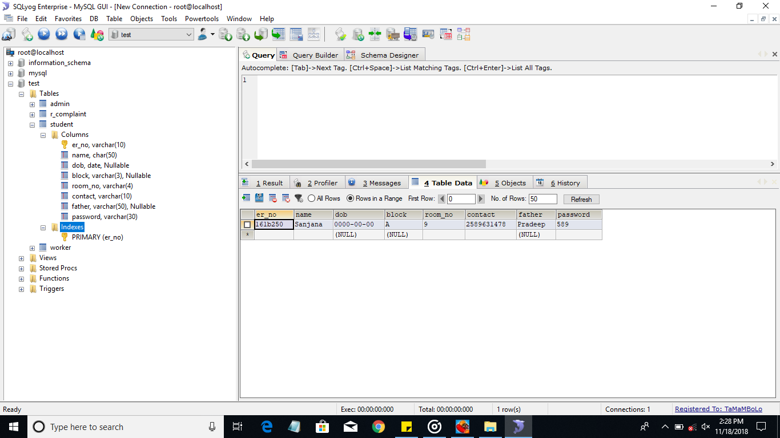

**Column’s name include:**

* Er_no,varchar(20)
* Name,char(30)
* Dob,date,nullable
* Block,varchar(3),nullable
* Room_no,varchar(4)
* Contact,varchar(4)
* Father,varchar(30),nullable
* Password,varchar(30)

|  |  |  |  |  |  |  |  |
| --- | --- | --- | --- | --- | --- | --- | --- |
| Er_no | Name | Dob | Block | Room_no | Contact | father | Password |

**3.1.2 Worker Table->Database**

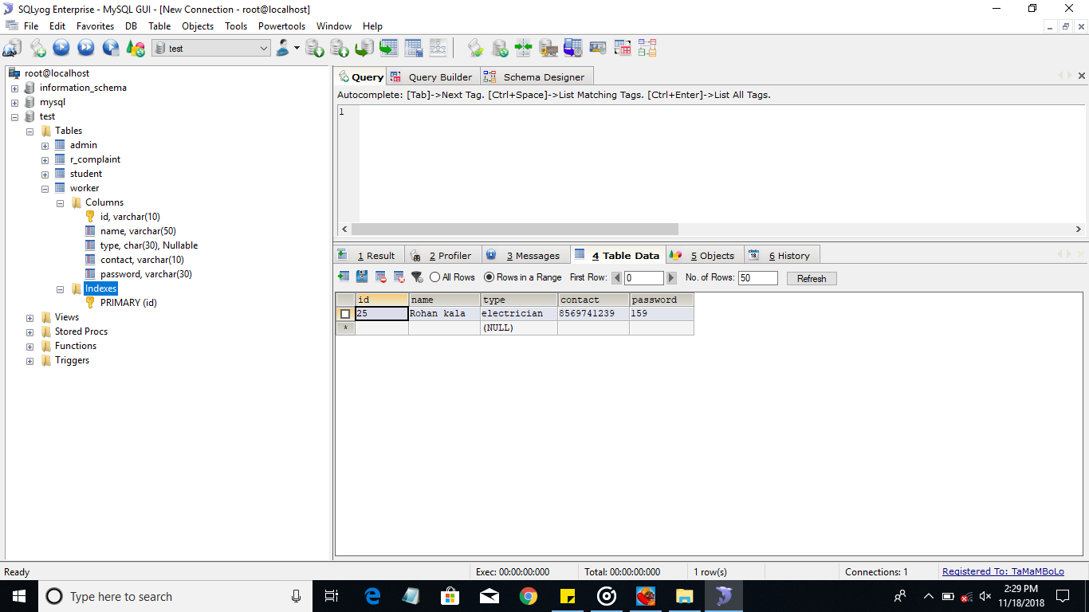

**Column’s name include:**

* Id,varchar(20)
* Name,varchar(50)
* Type,char(30),nullable
* Contact,varchar(10)
* Password,varchar(30)

|  |  |  |  |  |
| --- | --- | --- | --- | --- |
| **Id** | **Name** | **Type** | **contact** | **password** |

**3.1.3 Admin Table->Database**

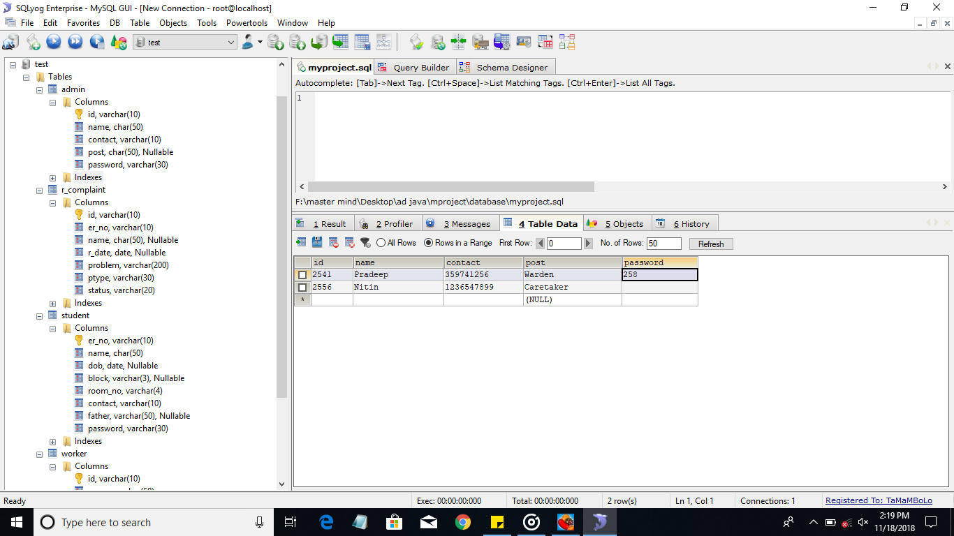

**Column’s name are:**

* Id,varchar(30)
* Name,char(50)
* Contact,varchar(10)
* Post,char(50),nullable
* Password,varchar(30)

|  |  |  |  |  |
| --- | --- | --- | --- | --- |
| **id** | **Name** | **contact** | **post** | **password** |

**3.1.4 Feedback Table->Database**

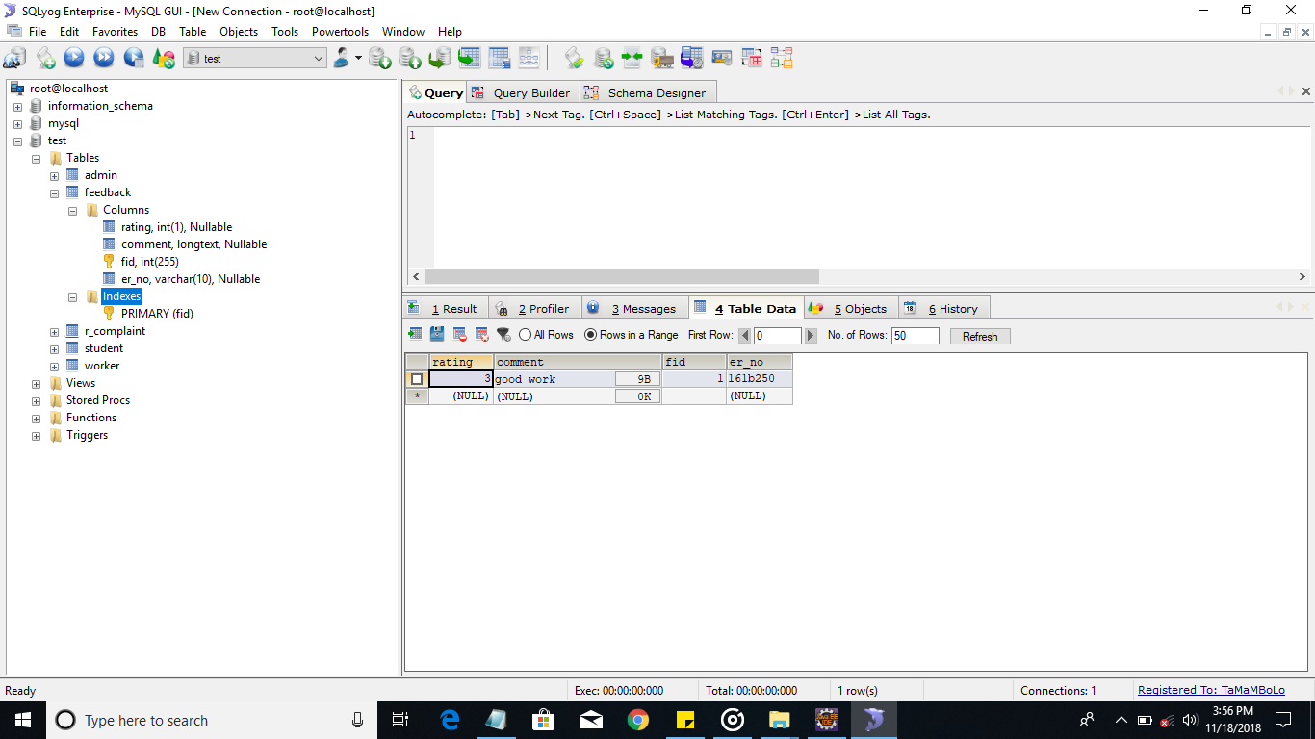

**Column’s name are:**

* Rating,int(1),nullable
* Comment,longInt,nullable
* Fid,int(255)
* Er_no,varchar(10),nullable

|  |  |  |  |
| --- | --- | --- | --- |
| **Rating** | **Comment** | **fid** | **Er_no** |

**3.1.5 Complaint Table->Database**



**Column’s name are:**

* Id,varchar(20)
* Er_no,varchar(10)
* Name,char(30),nullable
* r_date,date,nullable
* Problem,varchar(200)
* ptype,varchar(30)
* Status,varchar(20)

|  |  |  |  |  |  |  |
| --- | --- | --- | --- | --- | --- | --- |
| **id** | **Er_no** | **Name** | **r_date** | **problem** | **ptype** | **status** |

**4.1 Full Implementation**

* The goal of full Implementation is to assure practices are used with high fidelity, and are achieving expected outcomes at all initial sites. With a focus on both fidelity and structure, all pages are functioning together to support the system.
* The outcomes were measured and showed intended results.
* Data and other information used are relevant to the current state for each observation.
* Data are reviewed to make process support the requirements.
* Is a web-based application developed using Java programming language.
* With a platform of a typical “ juet service center”, this system provides online technical services to its customers on a 24×7 basis.
* It also maintains database of their student, admin, worker,complaint,feedback details of the student’s, and many more.
* Manage the records of every student.
* Manage the records of every worker.
* Manage the complaint registered by every student.
* Provide a simple and easy Graphical User Interface (GUI).
* The System gives the desired results which are displayed below in the form of screenshots and are functioning appropriately well.
* The screenshots gives an idea about the system implementation in structured way.

**Home page of Juet Service Center:** 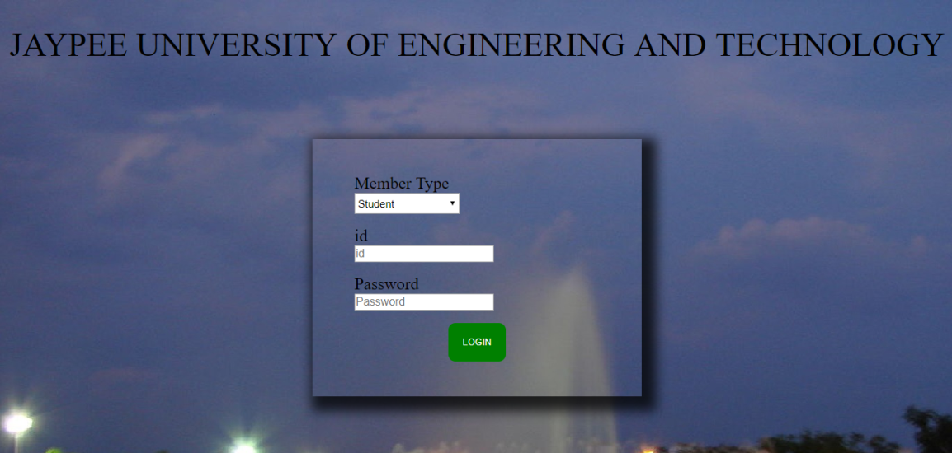

**Student Home Page:**



**Student’s Personal Info page**

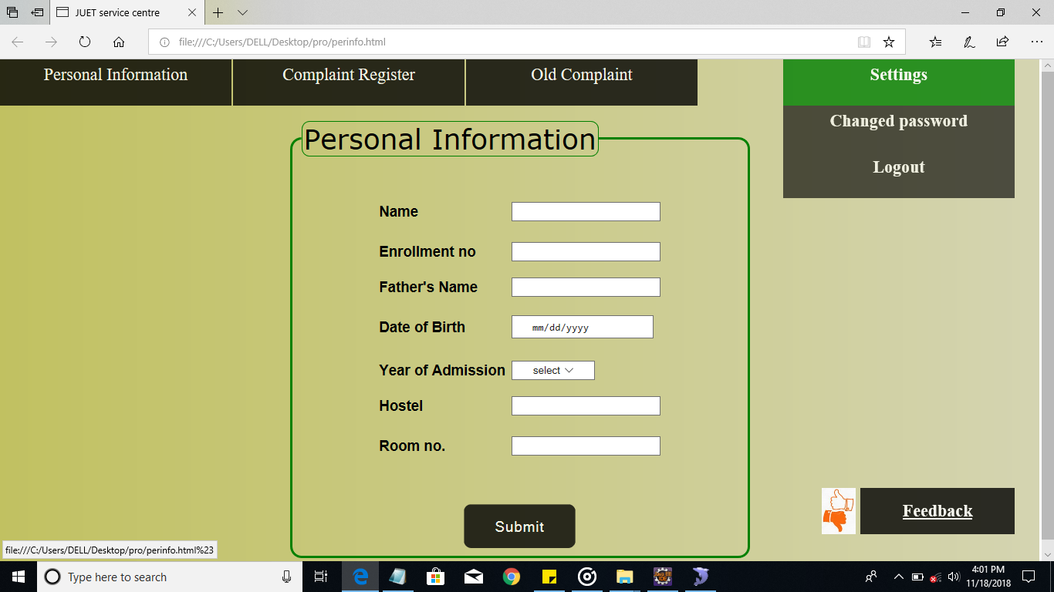

**Register Complaint page for student:**

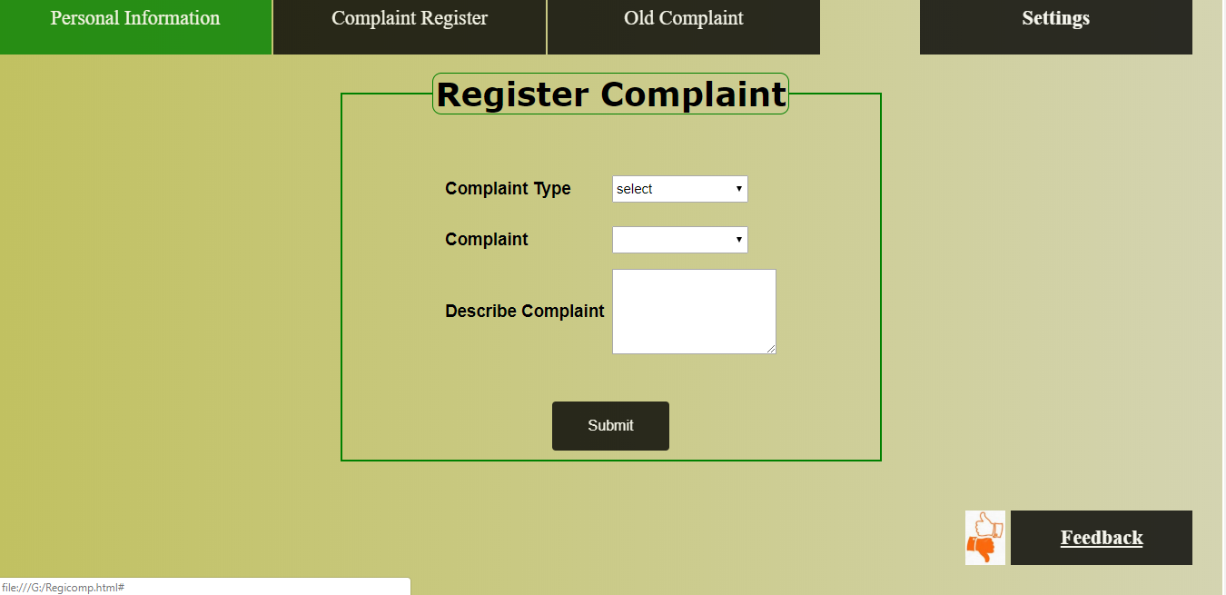

**Student Feedback Page:**

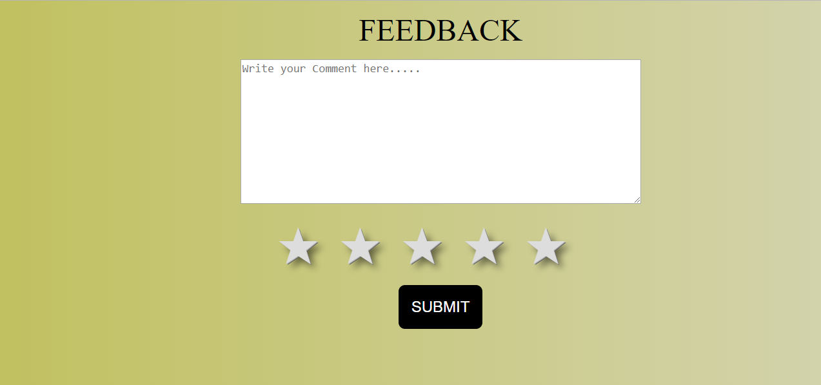

**Admin Page :**



**Assign worker page**

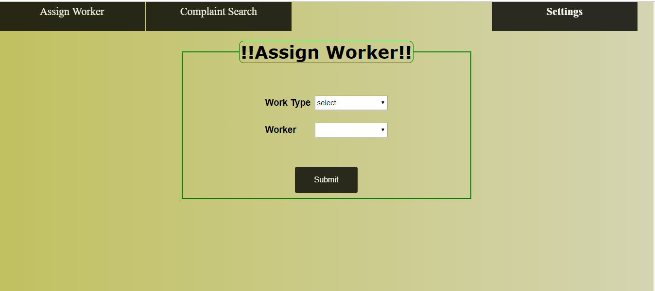

**Change Password page:**

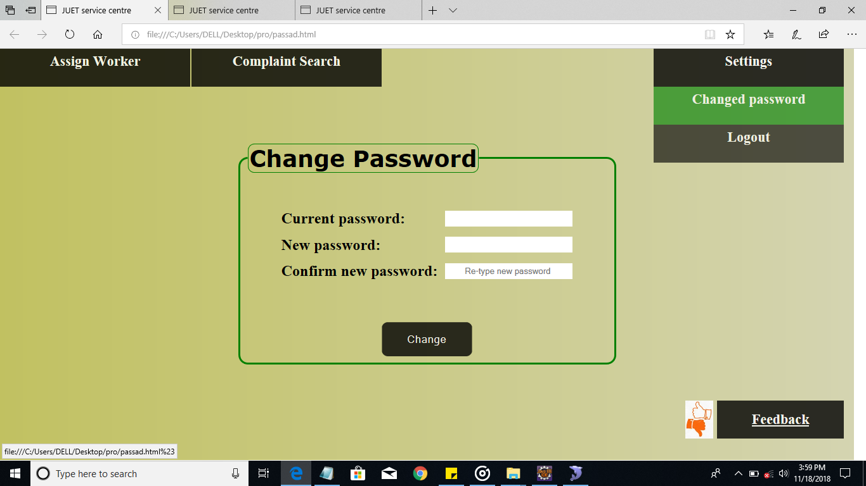

**Worker’s Personal Info Page:**

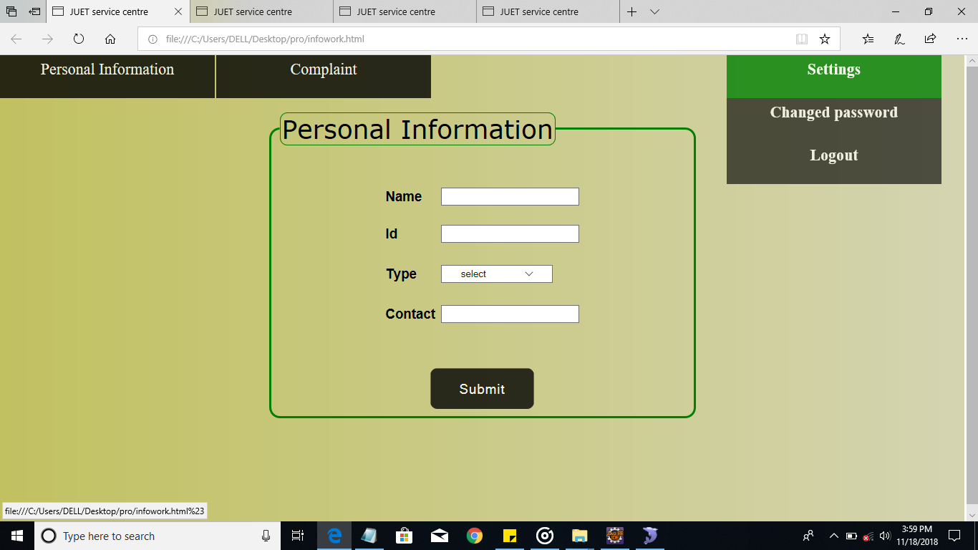

**Change Password Page:**

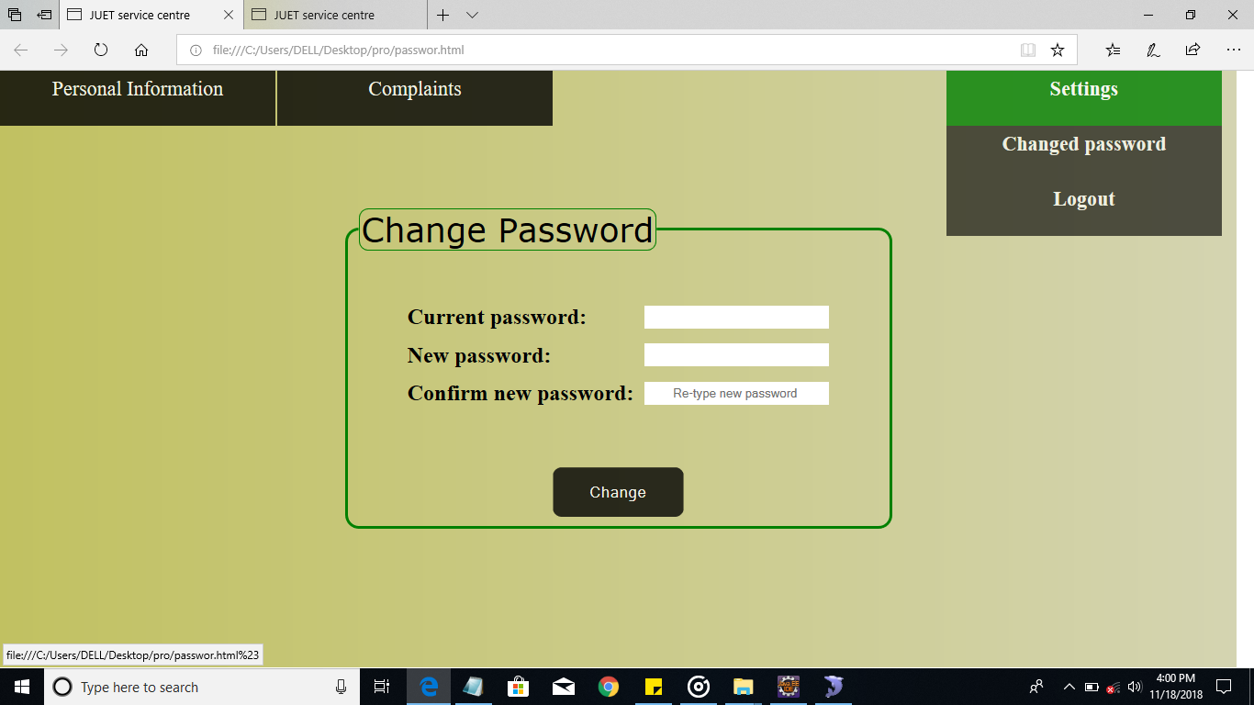

**CHAPTER-4**

**CONCLUSION**

The system shows the flow, structure and working of JUET SERVICE CENTER. Our project JUET SERVICE CENTER automates the operation of a service center by solving the problems of student. We will make sure that all the students are satisfied with the complaints resolved.The project can provide solution by helping students save time, cost in manually registering for complaints.

It involves staff members, workers as well as students all under one common roof to solve a Complaint. Concerns about minimizing the pressure of paper work for staff. This is an easy way to communicate over a issue,by suggesting ways to resolve it.It is easy to handle at all levels of management.

The system is used to manage various activites related to hostel like room related complaint issue.The students residing in hostels face problems related to room’s,they can easily register complaint for the problem.

**Cross platform compatibility:**

Most web based applications are far more compatible across platforms than traditional installed software.Typically the minimum requirement would be a web browser .These web browsers are available for a multitude of operating systems.

**Most Manageable:**

Web based systems need only be installed on the server placing minimal requirements on the end user workstation.This makes maintaining and updating the system much simpler as usually it can all be done on the server.

**Reduced costs:**

Web based applications can lower costs due to reduced support and maintenance ,lower requirements on the end user system and simplified architecture.

Login and user validation with session management may be a big challenge. The data required is collected by the developer to enable tailoring of relevant objectives and find the main changes that can implemented.This is the most crucial part since the development of a new system should only be founded on reasons that the relevant users will perform better under the new system.

The propsed system will increase efficiency,effectiveness,productivity and most importantly it will reduce the overheads in terms of number of personnel required to effectively carry out the task.

The system will take care of the events like register complaint,assigning to worker,feedback of students.The system will assist to register and maintain the complaint and student’s information and generate various results.The users of this project are students,workers and admin.

The purpose of implementing this project is to understand the data modeling concepts that is used in a real time scenario and to implement a fully functional database system which interacts with a front end interface.

The project can also be expanded in terms of scope of coverage.It may not necessarily be confined in the college environment.Hostel related services are also offered outside the learning environment in which there are similar operations to the once as in schools.

The system simply removes the hostel from the paper register work by a click on a button.It also gives the system uses the flexibility of solving a large number of complaints.Futhermore,the system is sufficiently scalable and more functions and capabilities can still be accommodated in the system if suggested by users or the university management.

The developer proposes that the system be integrated in any other automated system that handles students data .For example, the system uses some of the students registration details and if there exists any automated students registration system or if it can be developed in future.

**BIBLIOGRAPHY**

* [**http://www.google.co.in/**](http://www.google.co.in/)
* [**http://stackoverflow.com/**](http://stackoverflow.com/)
* [**http://www.coderanch.com/**](http://www.coderanch.com/)
* [**https://www.wikipedia.org**](https://www.wikipedia.org)