**Lab Exercise 3**

**1.1 Exercise:**

For this exercise you are required to perform the same temporal analysis that you did in this

lab, but on a different dataset. To import the dataset run the following statements in your

Neo4J browser editor (they are the same statements as the ones in the “Environment” section

but with different URLs):

LOAD CSV WITH HEADERS FROM

"https://gist.githubusercontent.com/apogiatzis/f7793b9707f3b15f5e811acb4f9d82bb/raw/d5e769a47955fd79ca3b00efd82d48041f883a31/persons.csv" AS csvLine

MERGE (e:Email {address: csvLine.email})

MERGE (t:Phone {number: csvLine.phone})

CREATE (p:Person {obj_id: csvLine.obj_id, first_name:

csvLine.first_name, last_name: csvLine.last_name, date_of_birth:

date(csvLine.date_of_birth), occupation: csvLine.occupation,

nationality: csvLine.nationality, phone: csvLine.phone, ni_number:

csvLine.ni_number})

CREATE (p)-[:HAS_EMAIL]->(e)

CREATE (p)-[:HAS_PHONE]->(t)

LOAD CSV WITH HEADERS FROM

"https://gist.githubusercontent.com/apogiatzis/ce3572b2671730a95ff2d96e3318764d/raw/e4d29e632f1510594f499608983c475da0143e68/accounts.csv" AS csvLine

MATCH (p:Person {obj_id: csvLine.owners})

MERGE (b:Bank {name: csvLine.bank})

CREATE (a:Account {obj_id: csvLine.obj_id, balance:

toFloat(csvLine.balance), currency: csvLine.currency, owner:

csvLine.owners, opened_at: datetime(replace(csvLine.opened_at, ' ',

'T'))})

CREATE (p)-[:OWNS]->(a)

CREATE (a)-[:PROVIDED_BY]->(b)

LOAD CSV WITH HEADERS FROM

"https://gist.githubusercontent.com/apogiatzis/e8188df98dbc8810d49f274af7e607ac/raw/c014fc9cdd1d4f024b910af4966a5e2ab5a104f9/transactions.csv"

AS csvLine

MATCH (sender:Account {obj_id: csvLine.sender})

MATCH (recipient:Account {obj_id: csvLine.recipient})

CREATE (t:Transaction:Transfer {obj_id: csvLine.obj_id, amount:

toFloat(csvLine.amount), currency: csvLine.currency, type:

csvLine.type, timestamp: datetime(replace(csvLine.timestamp, ' ',

'T'))})

CREATE (sender)-[:PERFORMED]->(t)

CREATE (t)-[:TO]->(recipient)

LOAD CSV WITH HEADERS FROM

"https://gist.githubusercontent.com/apogiatzis/04addd6990394aec5695d70e020d7ee3/raw/b63b71c0bcd5275e6c31ee7bc9a1944975be8fe2/deposits.csv" AS csvLine

MATCH (sender:Person {obj_id: csvLine.sender})

MATCH (recipient:Account {obj_id: csvLine.recipient})

CREATE (t:Transaction:Deposit {obj_id: csvLine.obj_id, amount:

toFloat(csvLine.amount), currency: csvLine.currency, type:

csvLine.type, timestamp: datetime(replace(csvLine.timestamp, ' ',

'T'))})

CREATE (sender)-[:PERFORMED]->(t)

CREATE (t)-[:TO]->(recipient)

MATCH (p:Person)-[:PERFORMED]-(d:Deposit)-[:TO]->(a:Account) RETURN p,a,d

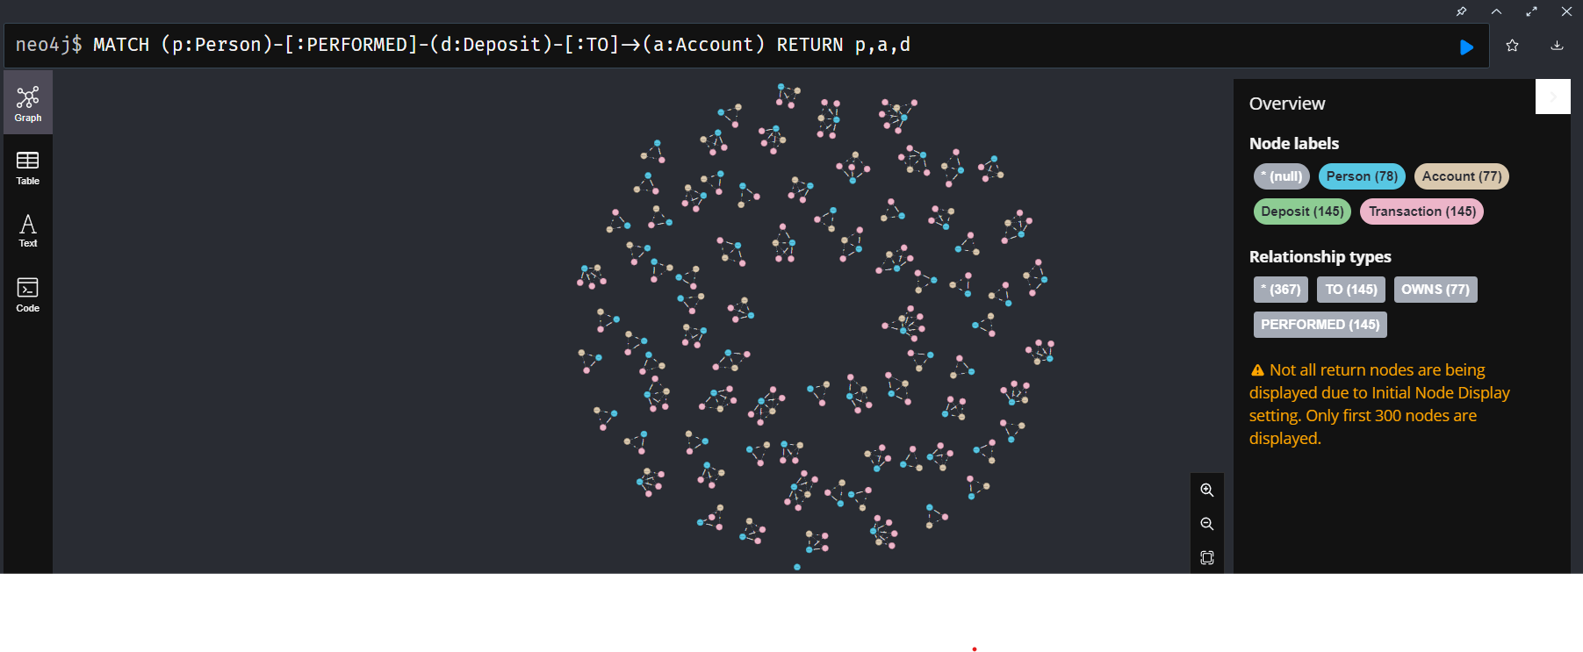

MATCH (p:Person)-[:PERFORMED]-(d:Deposit)-[:TO]->(a:Account) RETURN

d.amount, count(DISTINCT d.amount) AS freq ORDER BY freq DESC

MATCH (p:Person)-[:PERFORMED]-(d:Deposit)-[:TO]->(a:Account)

WITH min(d.timestamp) AS min_date, max(d.timestamp) AS max_date

RETURN min_date, min_date.epochMillis AS min_date_epoch, max_date,

max_date.epochMillis AS max_date_epoch

UNWIND range(880092632000, 1644640280000, 86400000) AS t

MATCH (p:Person)-[:PERFORMED]-(d:Deposit)-[:TO]->(a:Account)

WHERE d.timestamp.epochMillis >= t AND d.timestamp.epochMillis < t +

86400000

RETURN datetime({epochMillis:t}), COUNT(*) as deposit_count ORDER BY

deposit_count desc

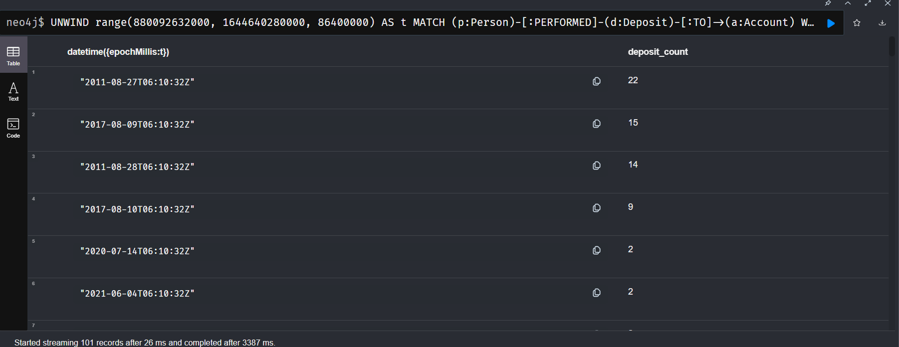

MATCH (p:Person)-[:PERFORMED]-(d:Deposit)-[:TO]->(a:Account)

WITH *,datetime("2011-08-27T06:10:32Z") as window_start

WHERE d.timestamp.epochMillis >= window_start.epochMillis AND

d.timestamp.epochMillis < window_start.epochMillis + 86400000

RETURN p,d,a

MATCH (p1:Person)-[:HAS_EMAIL|:HAS_PHONE]->(info)<-

[:HAS_EMAIL|:HAS_PHONE]-(p2:Person)

WHERE p1.obj_id<>p2.obj_id

WITH p1, p2, count(*) as cnt

MERGE (p1) - [:SHARED_IDENTIFIERS {count: cnt}] - (p2);

MATCH (p:Person)-[:PERFORMED]-(d:Deposit)-[:TO]->(a:Account)

MATCH (p)-[:SHARED_IDENTIFIERS]-(o:Person)

WITH *,datetime("2011-08-27T06:10:32Z") as window_start

WHERE d.timestamp.epochMillis >= window_start.epochMillis AND

d.timestamp.epochMillis < window_start.epochMillis + 86400000

RETURN p,d,a,o

MATCH (p:Person)-[:PERFORMED]-(d:Deposit)-[:TO]->(a:Account)

MATCH (p)-[:SHARED_IDENTIFIERS]-(o:Person)

WITH *,datetime("2011-08-27T06:10:32") as window_start

WHERE d.timestamp.epochMillis >= window_start.epochMillis AND

d.timestamp.epochMillis < window_start.epochMillis + 86400000

RETURN d.obj_id

