**Lab Exercise 3**

**1.1 Exercise:**

For this exercise you are required to perform the similar analysis that you did in this lab, but

on a different dataset. To import the dataset run the following statement in your Neo4J

browser editor:

CALL

apoc.cypher.runFile("https://gist.githubusercontent.com/apogiatzis/7e53f828f0566980b935b314d575226d/raw/682a030f9c24a46e67e6481ea66c484bca54c5a4/lab3_ex_import.cypher")

CALL db.schema.visualization()

MATCH (n)

RETURN head(labels(n)) as type, count(*) as count

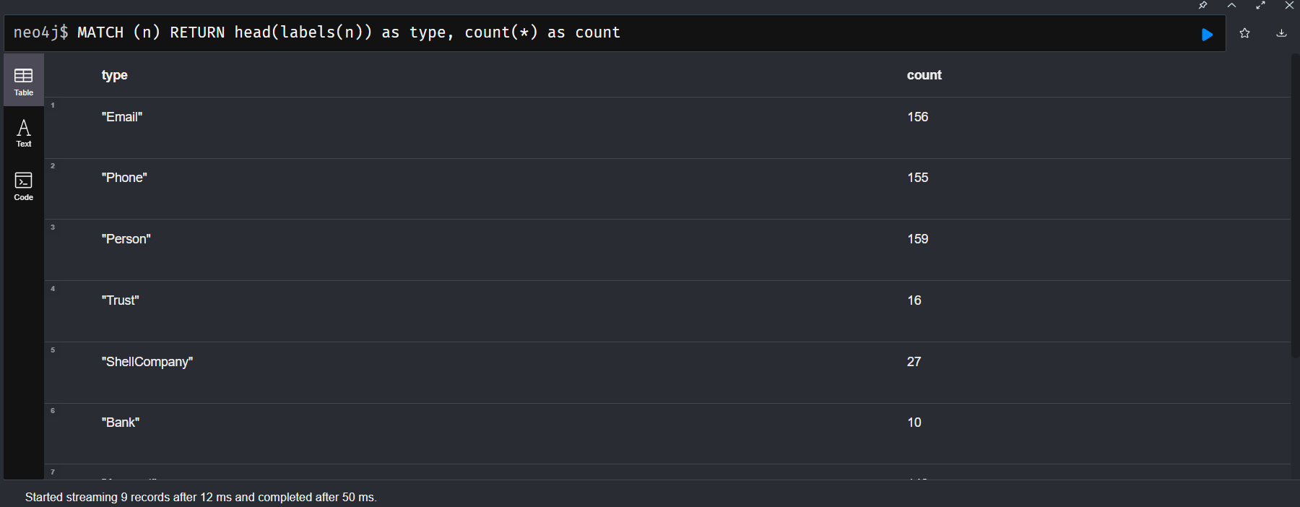

MATCH (p:Account)

WITH apoc.node.degree(p,"<") AS inDegree, apoc.node.degree(p,">") AS outDegree

RETURN inDegree, outDegree

ORDER BY inDegree DESC;

MATCH (p:Account)

RETURN apoc.node.degree(p,"<TO") AS inDegree

ORDER BY inDegree DESC;

MATCH (p:Account)

RETURN apoc.node.degree(p,"<TO") AS inDegree, p.obj_id

ORDER BY inDegree DESC;

MATCH (p:Account)<-[:TO]-(t:Transfer)

WHERE p.obj_id = "38f2a17e-88a9-45ee-acab-8dbfd125241e"

WITH min(t.timestamp) as minDate, max(t.timestamp) as maxDate

WITH *, (maxDate.epochMillis-minDate.epochMillis)/1000/60/60 as

hoursTimeDelta

RETURN minDate, maxDate, hoursTimeDelta

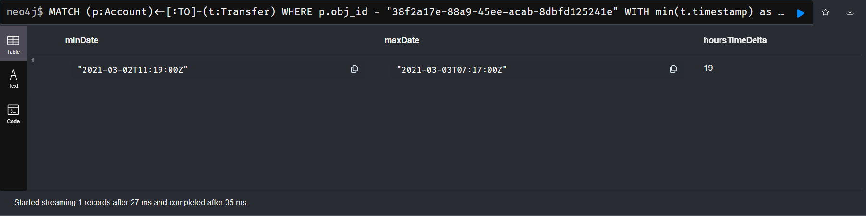

MATCH (p:Account)

RETURN apoc.node.degree(p,"<TO") AS inDegree, p

ORDER BY inDegree DESC

LIMIT 1;

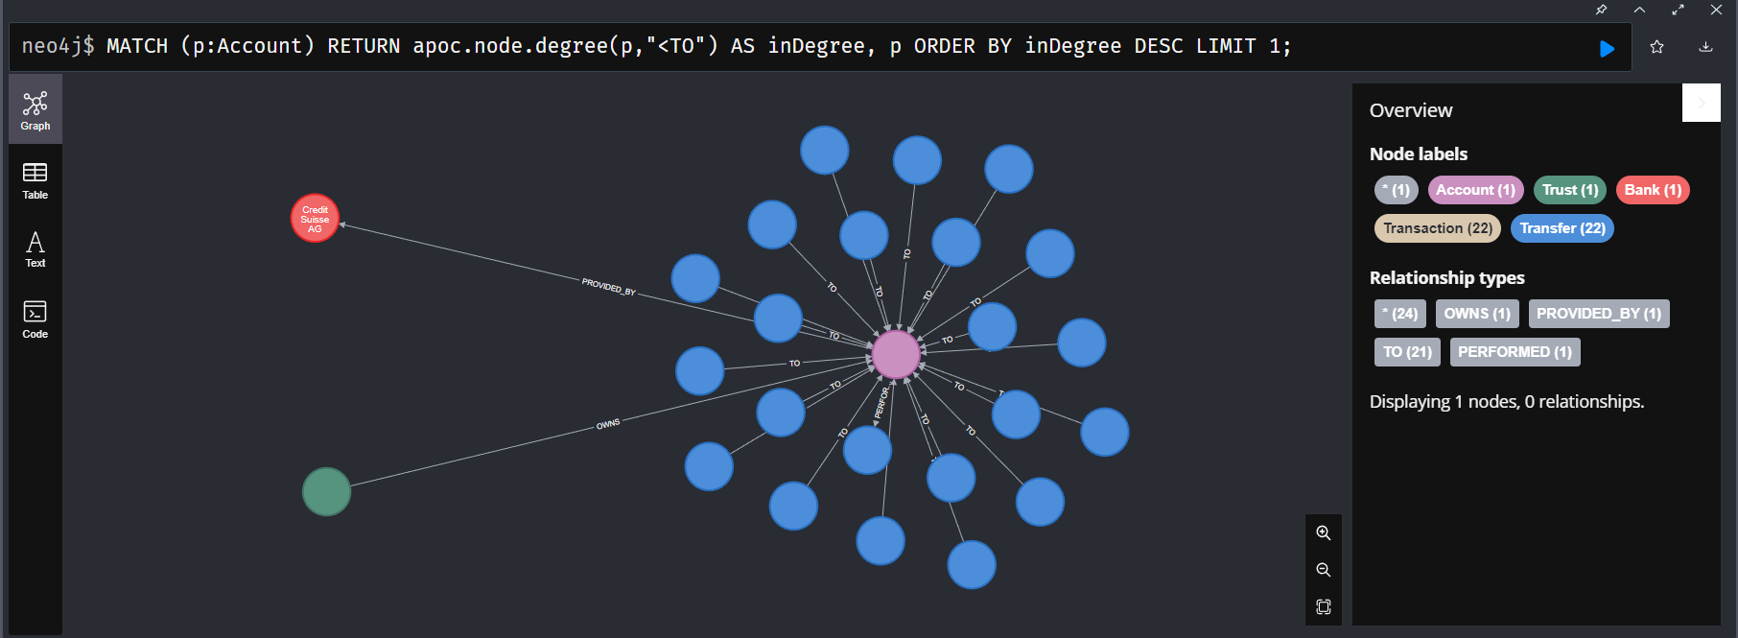

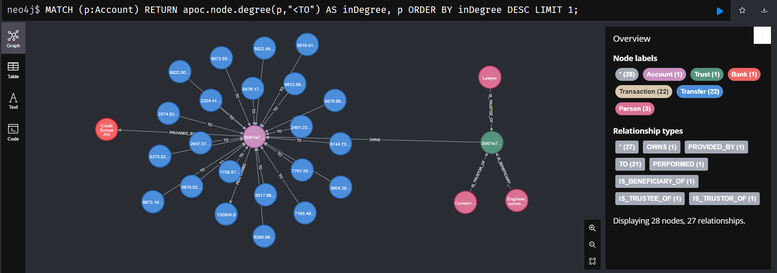

MATCH p=(s:ShellCompany {obj_id:"9e5ae7d7-2482-40be-9e05-4cd55c782060"})-[:OWNS]-(a:Account)-[*]->(a)

RETURN nodes(p)

MATCH p=(a:Account)-[:TO|PERFORMED*..6]->(a)

RETURN p

ORDER BY length(p) DESC

LIMIT 1

WITH [" ebb647bf-45f2-4246-868d-4ed9d2a30449", "4cf2176b-d5ee-4409-a30c-3c9ca1639f61", "9e5ae7d7-2482-40be-9e05-4cd55c782060"] as shellCompaniesIds

MATCH p=(s1:ShellCompany)-[*..1]-()-[*..1]-(s2:ShellCompany)

WHERE s1.obj_id IN shellCompaniesIds AND s2.obj_id IN shellCompaniesIds AND

s1.obj_id <> s2.obj_id

RETURN p

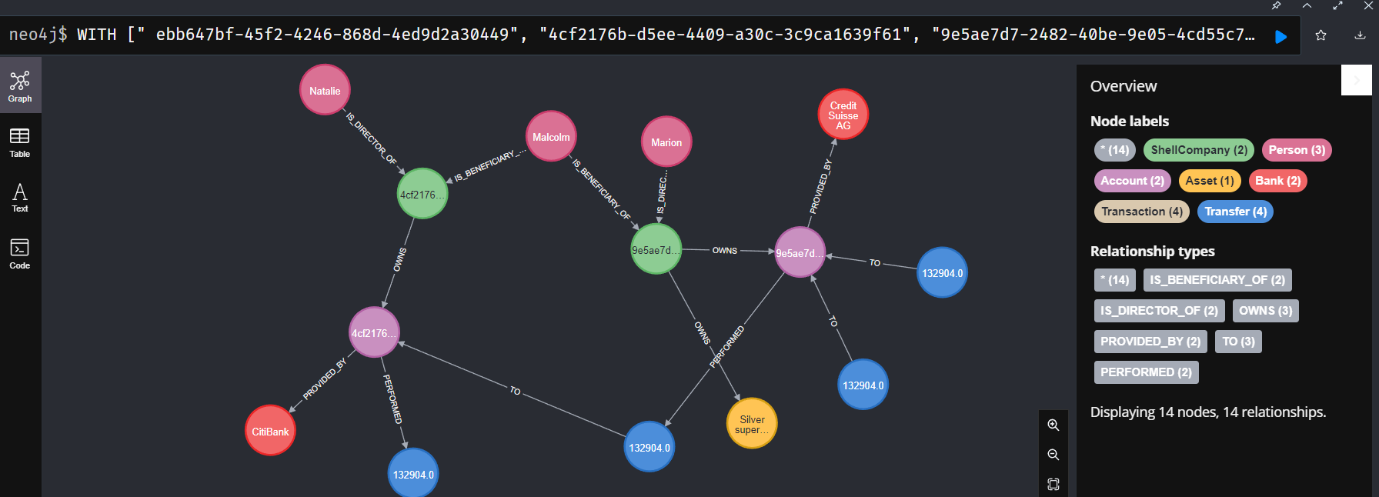

MATCH path=(p:Person)-[*]->()-[:OWNS]->(a:Asset)

WHERE p.obj_id = "580fc4ad-8b88-4f4b-9ef1-19ea974eafa3" AND toFloat(a.value_in_gbp) > 10000

RETURN path

