#Node Creations :-

create (A:AML_Service{name:"AML Service"})

create (k:Bank1{name:"Bank1"})

create (k:Bank2{name:"Bank2"})

create (k:Bank3{name:"Bank3"})

create (k:Bank4{name:"Bank4"})

create (j:PSP1{name:"PSP1"})

create (j:PSP2{name:"PSP2"})

create (j:PSP3{name:"PSP3"})

create (j:PSP4{name:"PSP4"})

create (m:ID_service1{name:"ID Service 1"})

create (m:ID_service2{name:"ID Service 2"})

create (m:ID_service3{name:"ID Service 3"})

match (n) return *

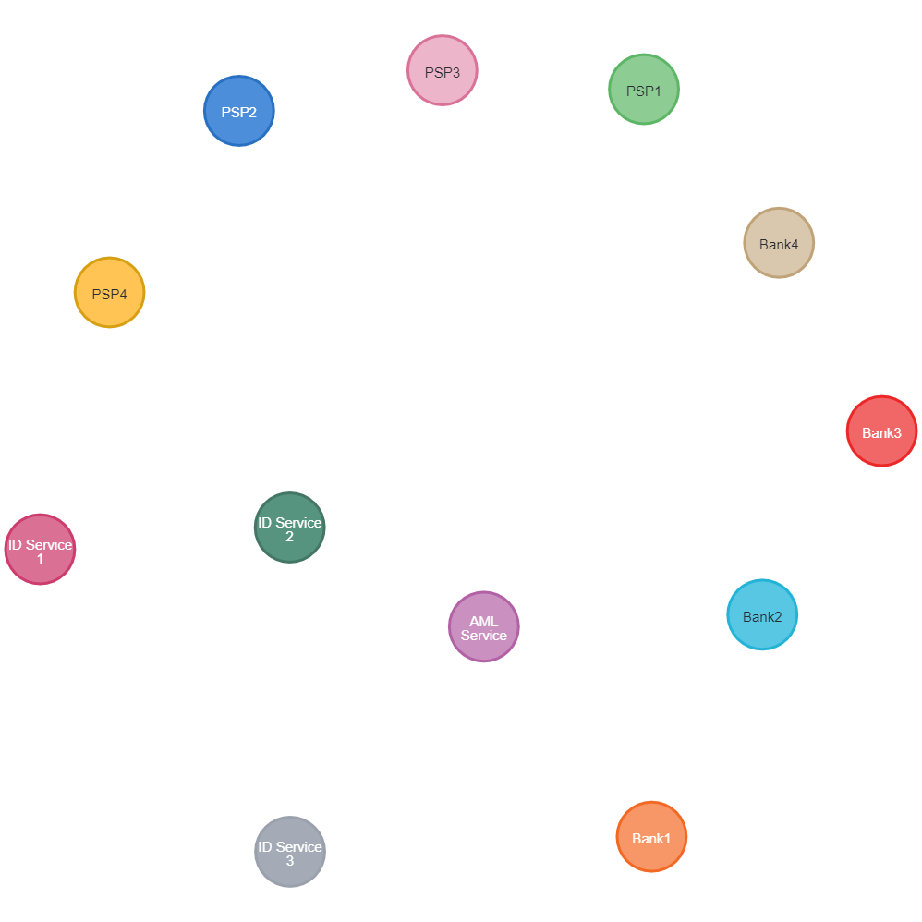

#Relationship Creation :-

match (A:AML_Service),(k:Bank1) where A.name="AML Service" AND k.name="Bank1" create(A)-[b:A2B]->(k) return b

match (A:AML_Service),(k:Bank1) where A.name="AML Service" AND k.name="Bank1" create(A)<-[b:A2B]-(k) return b

match (A:AML_Service),(k:Bank2) where A.name="AML Service" AND k.name="Bank2" create(A)-[b:A2B2]->(k) return b

match (A:AML_Service),(k:Bank3) where A.name="AML Service" AND k.name="Bank3" create(A)-[b:A2B3]->(k) return b

match (A:AML_Service),(k:Bank3) where A.name="AML Service" AND k.name="Bank3" create(A)<-[b:A2B3]-(k) return b

match (A:AML_Service),(k:Bank4) where A.name="AML Service" AND k.name="Bank3" create(A)-[b:A2B4]->(k) return b

match (A:AML_Service),(k:Bank4) where A.name="AML Service" AND k.name="Bank4" create(A)<-[b:A2B4]-(k) return b

match (A:AML_Service),(j:PSP1) where A.name="AML Service" AND j.name="PSP1" create(A)-[p:A2P]->(j) return p

match (A:AML_Service),(j:PSP2) where A.name="AML Service" AND j.name="PSP2" create(A)<-[p:A2P]-(j) return p

match (A:AML_Service),(j:PSP3) where A.name="AML Service" AND j.name="PSP3" create(A)<-[p:A2P]-(j) return p

match (A:AML_Service),(j:PSP3) where A.name="AML Service" AND j.name="PSP3" create(A)-[p:A2P]->(j) return p

match (A:AML_Service),(j:PSP4) where A.name="AML Service" AND j.name="PSP4" create(A)-[p:A2P]->(j) return p

match (A:AML_Service),(j:PSP4) where A.name="AML Service" AND j.name="PSP4" create(A)<-[p:A2P]-(j) return p

