TSMC Viya3.5 Installation Note

*皆以root帳號執行

# 系統規格檢查

#確認所有機器OS版本為RedHat 7.6

**sudo cat /etc/os-release**

**#確認所有機器Core數(最少8個processor)**

**sudo grep processor /proc/cpuinfo**

**#確認所有機器Memory(最少80G)**

**sudo free -m**

**#關閉所有機器SELinux**

**sudo setenforce 0**

**#確認所有機器hostname設定，每一台機器都要包含所有機器的hostname**

**more /etc/hosts**

**x.x.x.x [full-hostname] [short-hostname]**

**e.g.**

**10.104.85.26 twncli-test.twn.sashq-d.openstack.sas.com twncli-test**

**#確認controller的java版本1.8.x**

**java -version**

# **放置安裝所需檔案**

**#建置放安裝檔案的資料夾**

**sudo mkdir -p /sas/install_file**

**#把http://35.189.181.26/viya_repos/install_file內的檔案放置 /sas/install_file，並解壓縮檔案**

**unzip OpenLDAP-master.zip (如果沒有unzip的話 要sudo yum -y unzip來安裝)**

**tar -xvf sas_viya_playbook.tar**

**#把 http://35.189.181.26/viya_repos/viya_repos_split 內的檔案放置 /sas，把分割檔合併起來**

**sudo cat viya_repos.tar.part* > viya_repos.tar**

**#untar viya_repos.tar**

**tar -xvf /sas/viya_repos.tar**

**#確認httpd服務開啟**

**sudo systemctl start httpd**

**#建立Symbolic link [如果有cluster的shared folder就不用這步驟]**

**cd /var/www/html/**

**ln -s /sas/viya_repos viya_repos**

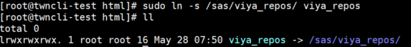

# **SSH驗證連線設定**

**#在controllert 產生 ssh public key，在把各個key複製到controller自己和各台worker上**

**cd ~/.ssh**

**ssh-keygen -t rsa -N "" -f ~/.ssh/id_rsa**

**ssh-copy-id root@[controller hostname]**

**ssh-copy-id root@[worker1 hostname]**

**ssh-copy-id root@[worker2 hostname]**

**ssh-copy-id root@[worker3 hostname]**

**ssh-copy-id root@[worker4 hostname]**

**ssh-copy-id root@[worker5 hostname]**

**ssh-copy-id root@[worker6 hostname]**

**ssh-copy-id root@[worker7 hostname]**

**ssh-copy-id root@[worker8 hostname]**

**ssh-copy-id root@[worker9 hostname]**

**ssh-copy-id root@[worker10 hostname]**

**ssh-copy-id root@[worker11 hostname]**

**ssh-copy-id root@[worker12 hostname]**

**ssh-copy-id root@[worker13 hostname]**

**ssh-copy-id root@[worker14 hostname]**

**ssh-copy-id root@[worker15 hostname]**

# **前置安裝**

**#前置package安裝 (目前測試環境僅sshpass和ansible不在default redhat repository內，如果現場發現有缺少，再聯繫我，我補放rpm上去讓你裝)**

**sudo yum install -y zip unzip vim**

**sudo yum install -y httpd**

**sudo yum install -y java**

**sudo yum install -y python**

**sudo yum install -y python-setuptools**

**sudo yum install -y python-devel**

**sudo yum install -y openssl-devel**

**sudo yum install -y gcc**

**sudo yum install -y wget**

**sudo yum install -y automake**

**sudo yum install -y libffi-devel**

**sudo yum install -y python-six**

**sudo yum install -y python-paramiko**

**#移置/sas/install_file**

**cd /sas/install_file**

**sudo rpm -ivh sshpass-1.06-2.el7.x86_64.rpm**

**sudo rpm -ivh ansible-2.7.2-1.el7.ans.noarch.rpm**

**#測試ansible**

**ansible –version**

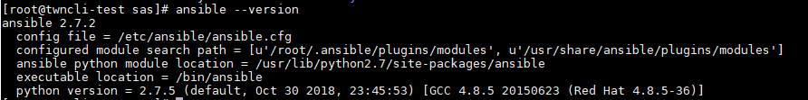

**ansible localhost -m ping**

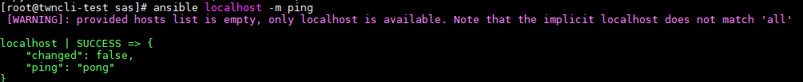

# **使用Viya-ark做安裝前檢查**

**#設定inventory.ini**

**vi /sas/install_file/sas_viya_playbook/inventory.ini**

**#最上方設定連線資訊**

**deployTarget ansible_host=[controller_hostname] ansible_user=root ansible_ssh_private_key_file=~/.ssh/id_rsa**

**worker1 ansible_host=[worker1_hostname] ansible_user=root ansible_ssh_private_key_file=~/.ssh/id_rsa**

**worker2 ansible_host=[worker2_hostname] ansible_user=root ansible_ssh_private_key_file=~/.ssh/id_rsa**

**…**

**#找到[sas_casserver_worker] 把所有worker列上去**

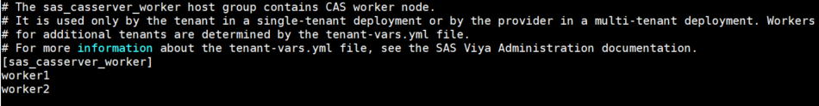

**#跑playbook做安裝前系統設定檢查**

**cd /sas/install_file/sas_viya_playbook**

**ansible-playbook -i /sas/install_file/sas_viya_playbook/inventory.ini /sas/install_file/sas_viya_playbook/viya-ark-master/playbooks/pre-install-playbook viya_pre_install_playbook.yml**

**#確認每個機器都有成功**

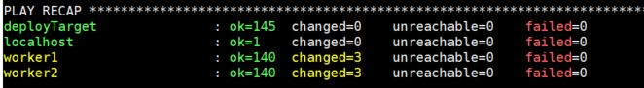

# **安裝OpenLDAP**

**cd /sas/install_file/OpenLDAP-master**

**#設定inventory.ini**

**vi /sas/install_file/OpenLDAP-master/inventory.ini**

**#輸入全部機台的 “代稱 hostname”**

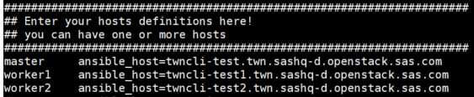

**#[openldapserver]設定controller的代稱 也就是master**

**#[openldapclients] 設定全部機台的代稱**

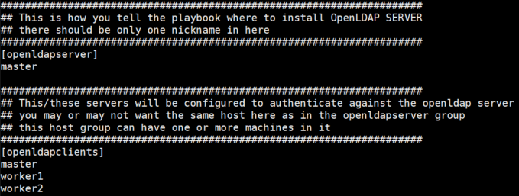

**#開始安裝OpenLDAP**

**ansible-playbook -i inventory.ini gel.openldapsetup.yml**

**#確認所有機器都成功**

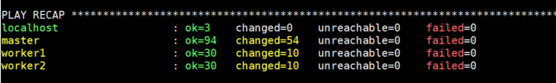

**p.s 如果需重新安裝OpenLDAP的話可以透過指令ansible-playbook -i inventory.ini gel.openldapremove.yml**

# **安裝SAS Viya 3.5**

**#確認inventory.ini的機器資訊和[sas_casserver_worker]設定正確**

**vi /sas/install_file/sas_viya_playbook/inventory.ini**

**#設定cas_disk_cache**

**mkdir /cache/**

**#controller有幾個core數設定幾個資料夾**

**for((i=1;i<=9;i=i+1));do mkdir -p /cache/sascache0$i;done**

**chmod -R 777 /cache**

**#設定cas_disk_cache**

**vi /sas/install_file/sas_viya_playbook/vars.yml**

**CAS_DISK_CACHE: /cache/sascache01:/cache/sascache02:/cache/sascache03:/cache/sascache04:/cache/sascache05:/cache/sascache06:/cache/sascache07:/cache/sascache08:/cache/sascache09:/cache/sascache10:/cache/sascache11:/cache/sascache12**



**#設定Repository_Warehouse (如果有cluster shared folder就設定shared folder位置)**

**REPOSITORY_WAREHOUSE: "http://[controller hostname]/viya_repos/"**



**#放入OpenLDAP產生的sitedefault.yml檔案**

**cp /sas/install_file/OpenLDAP-master/sitedefault.yml /sas/install_file/sas_viya_playbook/roles/consul/files/**

**ll /sas/install_file/sas_viya_playbook/roles/consul/files/**

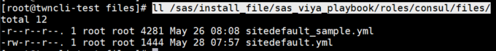

**#Run測試playbook檢查**

**cd /sas/install_file/sas_viya_playbook**

**ansible-playbook system-assessment.yml**

**#確認檢查各機器都正確**

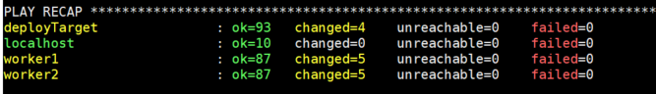

**#開始安裝Viya 3.5**

**ansible-playbook site.yml**

**#確認檢查各機器都正確**



**p.s 如果出錯需重新安裝viya的話可以透過指令ansible-playbook deploy-cleanup.yml**

**可以用 sudo rpm -e $(rpm -qg SAS) –nopreun確認移除乾淨**

# **驗證SAS Viya 3.5**

**#修改sasboot密碼**

**grep sasboot /var/log/sas/viya/saslogon/default/sas-saslogon_2020-05-28_01-35-50.log**



**#至瀏覽器輸入** <http://[controller-hostname]/SASLogon/reset_password?code=p7ekPeG65N>

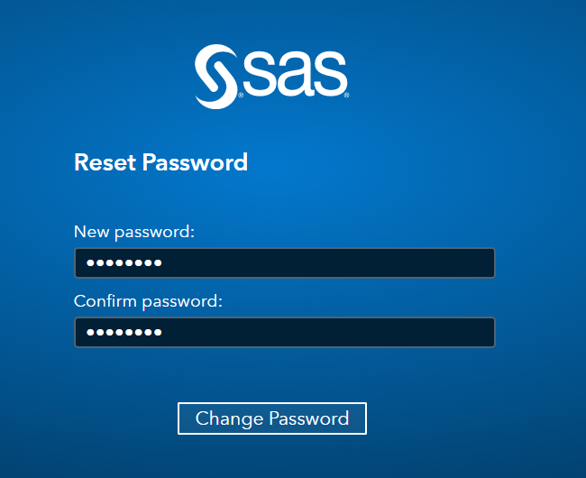

**#以sasboot登入 並以admin權限登入**

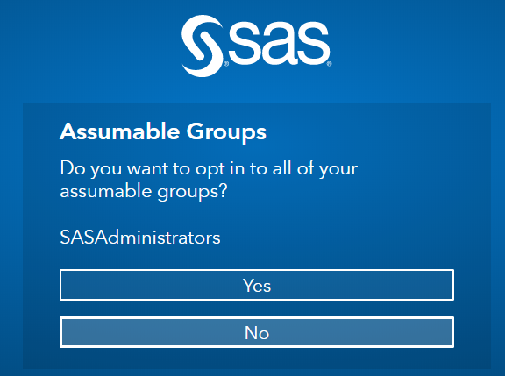

**#建立備份路徑**

**mkdir /opt/sas/backup**

**chown sas:sas /opt/sas/backup**

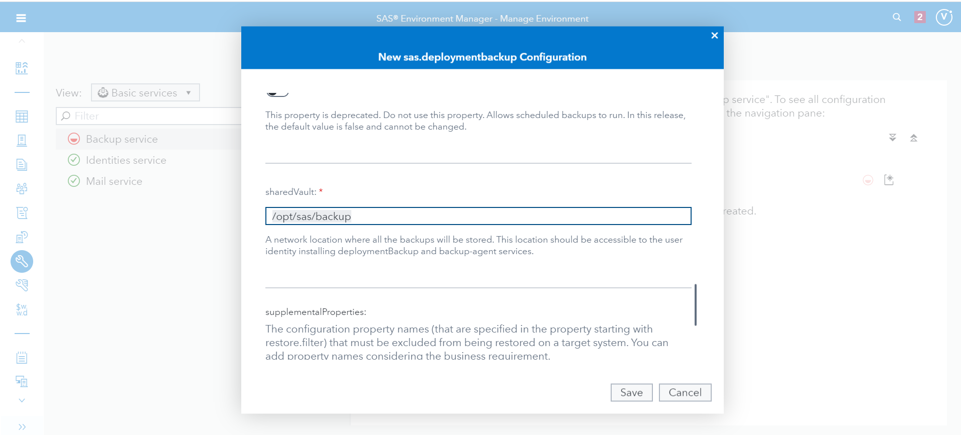

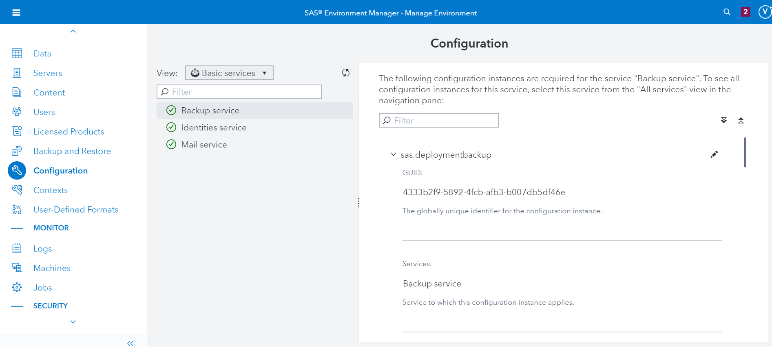

**#切換至**<http://[controller_hostname]/SASEnvironmentManager/> 查看服務狀態是否皆為正常 [綠色]

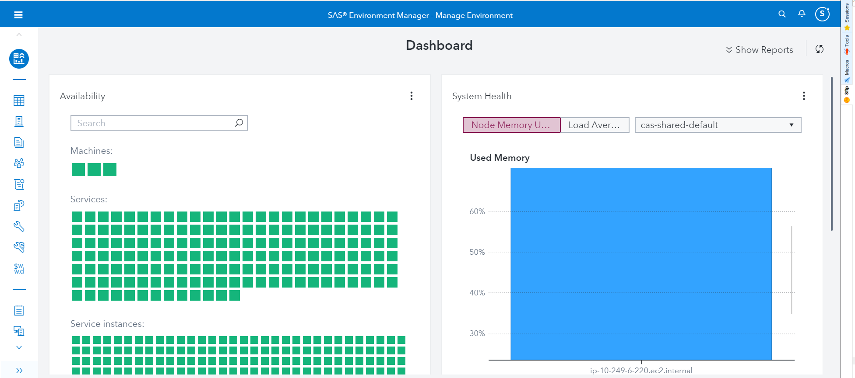

**#登出後，切換viyademo01/demopw登入，如果可以登入表示OpenLDAP設定成功**