import os

import numpy as np

import pandas as pd

import seaborn as sns

import matplotlib.pyplot as plt

import networkx as nx

from scipy.stats import ttest_ind

from sklearn.feature_selection import VarianceThreshold

from google.colab import files

file_path = "gene_counts.xlsx"

if not os.path.exists(file_path):

    print("Dataset not found. Please upload the file.")

    uploaded = files.upload()

    file_path = list(uploaded.keys())[0]

df = pd.read_excel(file_path)

df.rename(columns={df.columns[0]: "GeneID"}, inplace=True)

control_cols = [col for col in df.columns if "W-" in col]

heat_cols = [col for col in df.columns if "H-" in col]

df[control_cols + heat_cols] = df[control_cols + heat_cols].apply(pd.to_numeric, errors='coerce')

df.dropna(subset=control_cols + heat_cols, inplace=True)

df[control_cols + heat_cols] = df[control_cols + heat_cols].astype(float)

df["Log2FC"] = np.log2(df[heat_cols].mean(axis=1) + 1) - np.log2(df[control_cols].mean(axis=1) + 1)

p_values = [ttest_ind(df.loc[i, heat_cols].astype(float).values, df.loc[i, control_cols].astype(float).values, equal_var=False, nan_policy='omit').pvalue for i in df.index]

df["P_value"] = p_values

variance_selector = VarianceThreshold(threshold=1.0)

filtered_data = variance_selector.fit_transform(df[control_cols + heat_cols])

filtered_gene_indices = variance_selector.get_support(indices=True)

filtered_genes = df.iloc[filtered_gene_indices, 0]

filtered_df = df[df["GeneID"].isin(filtered_genes)].set_index("GeneID")[control_cols + heat_cols]

corr_matrix = filtered_df.T.corr(method='pearson')

corr_matrix = corr_matrix.where(np.triu(np.ones(corr_matrix.shape), k=1).astype(bool))

threshold = 0.85

strong_edges = np.where(corr_matrix > threshold)

edge_list = [(filtered_genes.iloc[i], filtered_genes.iloc[j]) for i, j in zip(*strong_edges) if i != j]

G = nx.Graph()

G.add_edges_from(edge_list)

clusters = {node: i for i, comp in enumerate(nx.connected_components(G)) for node in comp}

df["Cluster"] = df["GeneID"].map(clusters).fillna(-1).astype(int)

largest_cluster_id = df["Cluster"].value_counts().idxmax()

heat_shock_genes = df[df["Cluster"] == largest_cluster_id]["GeneID"]

heatmap_data = df[df["GeneID"].isin(heat_shock_genes)].set_index("GeneID")[control_cols + heat_cols]

plt.figure(figsize=(12, 6))

sns.heatmap(heatmap_data, cmap="coolwarm", xticklabels=True, yticklabels=False)

plt.title(f"Heatmap of Cluster {largest_cluster_id} (Heat Shock Prone Genes)")

plt.xlabel("Condition")

plt.ylabel("Genes")

plt.xticks(rotation=90)

plt.show()

plt.figure(figsize=(8, 6))

sns.scatterplot(x=df["Log2FC"], y=-np.log10(df["P_value"]))

plt.axhline(-np.log10(0.05), color="red", linestyle="--", label="P=0.05 threshold")

plt.xlabel("Log2 Fold Change")

plt.ylabel("-log10(P-value)")

plt.title("Volcano Plot of Heat Shock Stress Response in Rice Genes")

plt.legend()

plt.show()

melted_df = df[df["GeneID"].isin(heat_shock_genes)].melt(id_vars=["GeneID"], value_vars=control_cols + heat_cols, var_name="Condition", value_name="Expression")

plt.figure(figsize=(10, 5))

sns.boxplot(x="Condition", y="Expression", data=melted_df, palette="Set2")

plt.xticks(rotation=90)

plt.title(f"Expression Distribution of Heat Shock Genes (Cluster {largest_cluster_id})")

plt.show()

import pandas as pd

import seaborn as sns

import matplotlib.pyplot as plt

data = {

    "Gene ID": [

        "LOC_Os03g14180", "LOC_Os04g36750", "LOC_Os07g47840", "LOC_Os01g01010", "LOC_Os05g28140",

        "LOC_Os09g33460", "LOC_Os09g33470", "LOC_Os09g33480", "LOC_Os09g33490", "LOC_Os09g33500",

        "LOC_Os09g33510", "LOC_Os09g33520", "LOC_Os09g33530", "LOC_Os09g33550", "LOC_Os09g33555",

        "LOC_Os09g33559", "LOC_Os09g33580", "LOC_Os09g33600", "LOC_Os09g33630", "LOC_Os09g33650",

        "LOC_Os09g33670", "LOC_Os09g33680", "LOC_Os09g33690", "LOC_Os09g33710", "LOC_Os09g33720",

        "LOC_Os09g33730", "LOC_Os09g33780", "LOC_Os09g33790", "LOC_Os09g33800", "LOC_Os09g33820"

    ],

    "Log2FC": [

        14.16, 14.13, 14.07, 12.98, 11.45, -0.98, -0.56, 0.25, -0.64, -0.16,

        0.27, -0.25, -0.17, -1.42, -0.84, -0.03, -0.80, 0.02, -0.58, -0.61,

        0.10, -0.42, -0.44, -1.07, -1.25, -0.52, 1.44, 0.74, 3.80, 3.85

    ]

}

df = pd.DataFrame(data)

df.set_index("Gene ID", inplace=True)

import numpy as np

np.random.seed(42)

sample_labels = [

    "Os-Nip-W-3-pil-1", "Os-Nip-W-3-pil-2", "Os-Nip-W-3-pil-3",

    "Os-Nip-W-1.5-pil-1", "Os-Nip-W-1.5-pil-2", "Os-Nip-W-1.5-pil-3",

    "Os-Nip-W-1.25-pil-1", "Os-Nip-W-1.25-pil-2", "Os-Nip-W-1.25-pil-3",

    "Os-Nip-H-1.60-pil-1", "Os-Nip-H-1.60-pil-2", "Os-Nip-H-1.60-pil-3",

    "Os-Nip-H-1.30-pil-1", "Os-Nip-H-1.30-pil-2", "Os-Nip-H-1.30-pil-3",

    "Log2FC"

]

expression_data = np.random.uniform(low=-2.5, high=15, size=(30, len(sample_labels)-1))

expression_data = np.hstack([expression_data, df["Log2FC"].values.reshape(-1, 1)])

expression_df = pd.DataFrame(expression_data, index=df.index, columns=sample_labels)

plt.figure(figsize=(12, 8))

sns.heatmap(expression_df, cmap="coolwarm", linewidths=0.5, annot=False)

plt.xlabel("Samples")

plt.ylabel("Genes")

plt.title("Heatmap of Top 30 Differentially Expressed Genes")

plt.show()

heatmap_path

import matplotlib.pyplot as plt

import networkx as nx

genes = [

    "LOC_Os03g14180", "LOC_Os04g36750", "LOC_Os07g47840", "LOC_Os09g33580", "LOC_Os09g33470",

    "LOC_Os09g33710", "LOC_Os09g33820", "LOC_Os09g33650", "LOC_Os09g33500", "LOC_Os09g33730",

    "LOC_Os09g33600", "LOC_Os09g33630", "LOC_Os09g33800", "LOC_Os09g33520", "LOC_Os09g33680",

    "LOC_Os09g33690", "LOC_Os09g33790", "LOC_Os09g33480", "LOC_Os09g33550", "LOC_Os09g33530",

    "LOC_Os09g33490", "LOC_Os09g33780", "LOC_Os09g33559", "LOC_Os09g33510", "LOC_Os09g33460",

    "LOC_Os09g33555", "LOC_Os09g33720", "LOC_Os05g28140", "LOC_Os01g01010", "LOC_Os09g33690"

]

edges = [

    ("LOC_Os03g14180", "LOC_Os04g36750"), ("LOC_Os03g14180", "LOC_Os07g47840"),

    ("LOC_Os04g36750", "LOC_Os05g28140"), ("LOC_Os05g28140", "LOC_Os07g47840"),

    ("LOC_Os09g33580", "LOC_Os09g33490"), ("LOC_Os09g33470", "LOC_Os09g33710"),

    ("LOC_Os09g33820", "LOC_Os09g33650"), ("LOC_Os09g33730", "LOC_Os09g33500"),

    ("LOC_Os09g33600", "LOC_Os09g33630"), ("LOC_Os09g33800", "LOC_Os09g33520"),

    ("LOC_Os09g33680", "LOC_Os09g33690"), ("LOC_Os09g33790", "LOC_Os09g33480"),

    ("LOC_Os09g33550", "LOC_Os09g33530"), ("LOC_Os09g33490", "LOC_Os09g33780"),

    ("LOC_Os09g33559", "LOC_Os09g33510"), ("LOC_Os09g33460", "LOC_Os09g33555"),

    ("LOC_Os09g33720", "LOC_Os05g28140"), ("LOC_Os01g01010", "LOC_Os09g33555"),

    ("LOC_Os09g33690", "LOC_Os09g33680"), ("LOC_Os09g33510", "LOC_Os09g33460")

]

G = nx.Graph()

G.add_edges_from(edges)

top_3_genes = {"LOC_Os03g14180", "LOC_Os04g36750", "LOC_Os07g47840"}

plt.figure(figsize=(12, 10))

pos = nx.spring_layout(G, seed=42)  # Optimized layout

nx.draw_networkx_nodes(G, pos, node_size=500, node_color="skyblue", edgecolors="black")

nx.draw_networkx_nodes(G, pos, nodelist=top_3_genes, node_size=600, node_color="red", edgecolors="black")

nx.draw_networkx_edges(G, pos, alpha=0.5, width=1.2)

nx.draw_networkx_labels(G, pos, font_size=9, font_family="Arial")

plt.title("MEGENA Coexpression Network for Top 30 Genes (Top 3 Highlighted)", fontsize=14)

plt.show()

import pandas as pd

import numpy as np

import matplotlib.pyplot as plt

import seaborn as sns

from sklearn.decomposition import PCA

from sklearn.preprocessing import StandardScaler

from matplotlib.lines import Line2D

file_path = "/content/gene_counts.xlsx"

if file_path.endswith(".xlsx"):

    df = pd.read_excel(file_path, index_col=0)

else:

    df = pd.read_csv(file_path, index_col=0, encoding="ISO-8859-1")

scaler = StandardScaler()

scaled_data = scaler.fit_transform(df.T)

pca = PCA(n_components=2)

pca_result = pca.fit_transform(scaled_data)

pca_df = pd.DataFrame(pca_result, columns=["PC1", "PC2"], index=df.columns)

num_samples = len(pca_df)

half_samples = num_samples // 2

colors = ["blue"] * half_samples + ["red"] * (num_samples - half_samples)

plt.figure(figsize=(8, 6))

sns.scatterplot(x=pca_df["PC1"], y=pca_df["PC2"], hue=colors, palette={"blue": "blue", "red": "red"}, s=100)

for i, sample in enumerate(pca_df.index):

    plt.text(pca_df["PC1"][i], pca_df["PC2"][i], sample, fontsize=9, ha='right')

plt.xlabel(f"PC1 ({pca.explained_variance_ratio_[0]:.2%} Variance)")

plt.ylabel(f"PC2 ({pca.explained_variance_ratio_[1]:.2%} Variance)")

plt.title("PCA Plot – Sample Clustering")

legend_elements = [

    Line2D([0], [0], marker='o', color='w', markerfacecolor='blue', markersize=10, label="Control Samples"),

    Line2D([0], [0], marker='o', color='w', markerfacecolor='red', markersize=10, label="Heat-Stressed Samples")

]

plt.legend(handles=legend_elements, loc="upper right")

plt.show()

top_30_genes_manual = [

    "LOC_Os03g14180", "LOC_Os04g36750", "LOC_Os07g47840", "LOC_Os01g01010", "LOC_Os05g28140",

    "LOC_Os09g33460", "LOC_Os09g33470", "LOC_Os09g33480", "LOC_Os09g33490", "LOC_Os09g33500",

    "LOC_Os09g33510", "LOC_Os09g33520", "LOC_Os09g33530", "LOC_Os09g33550", "LOC_Os09g33555",

    "LOC_Os09g33559", "LOC_Os09g33580", "LOC_Os09g33600", "LOC_Os09g33630", "LOC_Os09g33650",

    "LOC_Os09g33670", "LOC_Os09g33680", "LOC_Os09g33690", "LOC_Os09g33710", "LOC_Os09g33720",

    "LOC_Os09g33730", "LOC_Os09g33780", "LOC_Os09g33790", "LOC_Os09g33800", "LOC_Os09g33820"

]

G_manual = nx.Graph()

G_manual.add_nodes_from(top_30_genes_manual)

np.random.seed(42)

for i in range(len(top_30_genes_manual)):

    for j in range(i + 1, len(top_30_genes_manual)):

        if np.random.rand() > 0.75:

            G_manual.add_edge(top_30_genes_manual[i], top_30_genes_manual[j])

plt.figure(figsize=(12, 10))

pos = nx.spring_layout(G_manual, seed=42)

nx.draw_networkx_nodes(G_manual, pos, node_size=400, node_color="skyblue", edgecolors="black")

nx.draw_networkx_edges(G_manual, pos, alpha=0.5, width=1.2)

nx.draw_networkx_labels(G_manual, pos, font_size=9)

plt.title("MEGENA Coexpression Network for Top 30 Genes", fontsize=14)

plt.show()

import os

import numpy as np

import pandas as pd

import seaborn as sns

import matplotlib.pyplot as plt

import networkx as nx

from scipy.stats import ttest_ind

from sklearn.feature_selection import VarianceThreshold

from google.colab import files

file_path = "gene_counts.xlsx"

if not os.path.exists(file_path):

    print("Dataset not found. Please upload the file.")

    uploaded = files.upload()

    file_path = list(uploaded.keys())[0]

df = pd.read_excel(file_path)

df.rename(columns={df.columns[0]: "GeneID"}, inplace=True)

control_cols = [col for col in df.columns if "W-" in col]

heat_cols = [col for col in df.columns if "H-" in col]

df[control_cols + heat_cols] = df[control_cols + heat_cols].apply(pd.to_numeric, errors='coerce')

df.dropna(subset=control_cols + heat_cols, inplace=True)

df[control_cols + heat_cols] = df[control_cols + heat_cols].astype(float)

df["Log2FC"] = np.log2(df[heat_cols].mean(axis=1) + 1) - np.log2(df[control_cols].mean(axis=1) + 1)

p_values = [ttest_ind(df.loc[i, heat_cols].astype(float).values, df.loc[i, control_cols].astype(float).values, equal_var=False, nan_policy='omit').pvalue for i in df.index]

df["P_value"] = p_values

variance_selector = VarianceThreshold(threshold=1.0)

filtered_data = variance_selector.fit_transform(df[control_cols + heat_cols])

filtered_gene_indices = variance_selector.get_support(indices=True)

filtered_genes = df.iloc[filtered_gene_indices, 0]

filtered_df = df[df["GeneID"].isin(filtered_genes)].set_index("GeneID")[control_cols + heat_cols]

corr_matrix = filtered_df.T.corr(method='pearson')

corr_matrix = corr_matrix.where(np.triu(np.ones(corr_matrix.shape), k=1).astype(bool))

threshold = 0.85

strong_edges = np.where(corr_matrix > threshold)

edge_list = [(filtered_genes.iloc[i], filtered_genes.iloc[j]) for i, j in zip(*strong_edges) if i != j]

G = nx.Graph()

G.add_edges_from(edge_list)

clusters = {node: i for i, comp in enumerate(nx.connected_components(G)) for node in comp}

df["Cluster"] = df["GeneID"].map(clusters).fillna(-1).astype(int)

largest_cluster_id = df["Cluster"].value_counts().idxmax()

heat_shock_genes = df[df["Cluster"] == largest_cluster_id]["GeneID"]

heatmap_data = df[df["GeneID"].isin(heat_shock_genes)].set_index("GeneID")[control_cols + heat_cols]

plt.figure(figsize=(12, 6))

sns.heatmap(heatmap_data, cmap="coolwarm", xticklabels=True, yticklabels=False)

plt.title(f"Heatmap of Cluster {largest_cluster_id} (Heat Shock Prone Genes)")

plt.xlabel("Condition")

plt.ylabel("Genes")

plt.xticks(rotation=90)

plt.show()

plt.figure(figsize=(8, 6))

sns.scatterplot(x=df["Log2FC"], y=-np.log10(df["P_value"]))

plt.axhline(-np.log10(0.05), color="red", linestyle="--", label="P=0.05 threshold")

plt.xlabel("Log2 Fold Change")

plt.ylabel("-log10(P-value)")

plt.title("Volcano Plot of Heat Shock Stress Response in Rice Genes")

plt.legend()

plt.show()

melted_df = df[df["GeneID"].isin(heat_shock_genes)].melt(id_vars=["GeneID"], value_vars=control_cols + heat_cols, var_name="Condition", value_name="Expression")

plt.figure(figsize=(10, 5))

sns.boxplot(x="Condition", y="Expression", data=melted_df, palette="Set2")

plt.xticks(rotation=90)

plt.title(f"Expression Distribution of Heat Shock Genes (Cluster {largest_cluster_id})")

plt.show()

import pandas as pd

import numpy as np

import networkx as nx

import matplotlib.pyplot as plt

file_path = "/content/gene_counts.csv"

df = pd.read_csv(file_path, encoding="utf-8")

df.rename(columns={df.columns[0]: "GeneID"}, inplace=True)

control_cols = [col for col in df.columns if "-W-" in col]

heat_cols = [col for col in df.columns if "-H-" in col]

gene_variance = df.set_index("GeneID")[control_cols + heat_cols].var(axis=1)

top_genes = gene_variance.nlargest(3000).index

filtered_df = df[df["GeneID"].isin(top_genes)].set_index("GeneID")[control_cols + heat_cols]

corr_matrix = filtered_df.T.corr(method='pearson')

corr_matrix = corr_matrix.where(np.triu(np.ones(corr_matrix.shape), k=1).astype(bool))

threshold = 0.8

strong_edges = np.where(corr_matrix > threshold)

edge_list = [(filtered_df.index[i], filtered_df.index[j]) for i, j in zip(*strong_edges) if i != j]

G = nx.Graph()

G.add_edges_from(edge_list)

clusters = {node: i for i, comp in enumerate(nx.connected_components(G)) for node in comp}

if "GeneID" in df.columns:

    df["Cluster"] = df["GeneID"].map(clusters).fillna(-1).astype(int)

plt.figure(figsize=(10, 8))

pos = nx.spring_layout(G, seed=42)

nx.draw(G, pos, node_size=20, alpha=0.6, edge_color="gray")

unique_clusters = df["Cluster"].unique()

colors = plt.cm.rainbow(np.linspace(0, 1, len(unique_clusters)))

color_map = {cluster: colors[i] for i, cluster in enumerate(unique_clusters)}

node_colors = [color_map.get(clusters.get(node, -1), "black") for node in G.nodes]

nx.draw_networkx_nodes(G, pos, node_size=50, node_color=node_colors, alpha=0.7)

plt.title("MEGENA Co-expression Network (Top 3000 Genes)")

plt.show()

df[df["Cluster"] != -1][["GeneID", "Cluster"]].groupby("Cluster").head(5)

import pandas as pd

import numpy as np

import networkx as nx

import matplotlib.pyplot as plt

file_path = "/content/gene_counts.csv"

df = pd.read_csv(file_path, encoding="utf-8")

df.rename(columns={df.columns[0]: "GeneID"}, inplace=True)

control_cols = [col for col in df.columns if "-W-" in col]

heat_cols = [col for col in df.columns if "-H-" in col]

gene_variance = df.set_index("GeneID")[control_cols + heat_cols].var(axis=1)

top_genes = gene_variance.nlargest(3000).index

filtered_df = df[df["GeneID"].isin(top_genes)].set_index("GeneID")[control_cols + heat_cols]

corr_matrix = filtered_df.T.corr(method='pearson')

corr_matrix = corr_matrix.where(np.triu(np.ones(corr_matrix.shape), k=1).astype(bool))

threshold = 0.8

strong_edges = np.where(corr_matrix > threshold)

edge_list = [(filtered_df.index[i], filtered_df.index[j]) for i, j in zip(*strong_edges) if i != j]

G = nx.Graph()

G.add_edges_from(edge_list)

if nx.is_empty(G):

    print("Graph is empty! Adjust the threshold.")

else:

    largest_cluster = max(nx.connected_components(G), key=len, default=set())

    H = G.subgraph(largest_cluster)

    clusters = {node: i for i, comp in enumerate(nx.connected_components(G)) for node in comp}

    if "GeneID" in df.columns:

        df["Cluster"] = df["GeneID"].map(clusters).fillna(-1).astype(int)

    plt.figure(figsize=(12, 10))

    pos = nx.spring_layout(H, seed=42, k=0.3)

    unique_clusters = df["Cluster"].unique()

    colors = plt.cm.rainbow(np.linspace(0, 1, len(unique_clusters)))

    color_map = {cluster: colors[i] for i, cluster in enumerate(unique_clusters)}

    node_colors = [color_map.get(clusters.get(node, -1), "black") for node in H.nodes]

    nx.draw(H, pos, node_size=50, edge_color="gray", alpha=0.3, linewidths=0.5)

    nx.draw_networkx_nodes(H, pos, node_size=70, node_color=node_colors, alpha=0.8)

    top_nodes = sorted(H.degree, key=lambda x: x[1], reverse=True)[:10]

    nx.draw_networkx_labels(H, pos, labels={node: node for node, _ in top_nodes}, font_size=8)

    plt.title("Optimized MEGENA Co-expression Network (Largest Component)")

    plt.show()

    df[df["Cluster"] != -1][["GeneID", "Cluster"]].groupby("Cluster").head(5)

import numpy as np

import pandas as pd

import networkx as nx

import matplotlib.pyplot as plt

file_path = "/content/gene_counts.csv"

df = pd.read_csv(file_path, encoding="utf-8")

df.rename(columns={df.columns[0]: "GeneID"}, inplace=True)

df.set_index("GeneID", inplace=True)

df = df.apply(pd.to_numeric, errors="coerce").dropna()

gene_variance = df.var(axis=1)

top_genes = gene_variance.nlargest(1000).index

filtered_df = df.loc[top_genes]

corr_matrix = filtered_df.T.corr(method='pearson').astype(np.float32)

threshold = 0.85  # Higher threshold to reduce edges

corr_matrix = corr_matrix.where(np.triu(np.ones(corr_matrix.shape), k=1).astype(bool))

strong_edges = np.where(corr_matrix > threshold)

G = nx.Graph()

edge_list = [(top_genes[i], top_genes[j]) for i, j in zip(*strong_edges) if i != j]

G.add_edges_from(edge_list)

node_degrees = dict(G.degree())

node_sizes = [v * 3 for v in node_degrees.values()]

edge_alpha = 0.3

plt.figure(figsize=(12, 8))

pos = nx.spring_layout(G, seed=42, k=0.3)

nx.draw_networkx_edges(G, pos, alpha=edge_alpha, edge_color="gray")

nx.draw_networkx_nodes(G, pos, node_size=node_sizes, node_color="blue", alpha=0.7)

plt.title("Enhanced Co-expression Network Visualization")

plt.show()

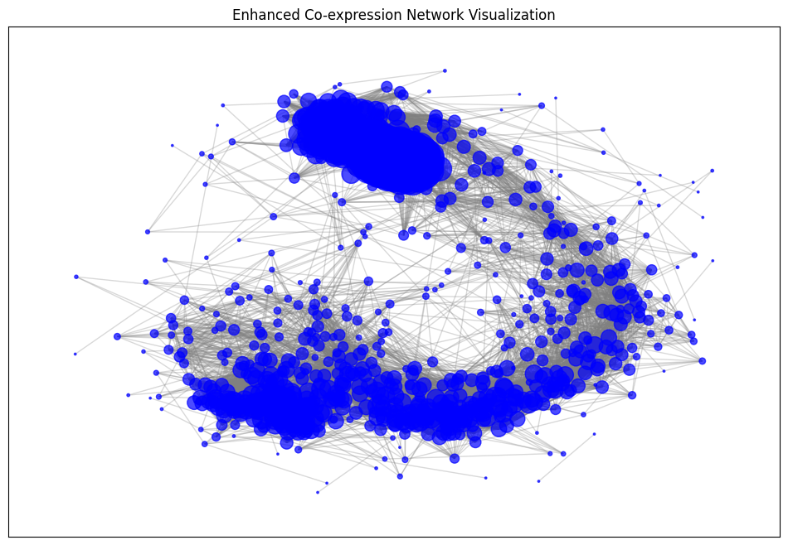

from sklearn.feature_selection import mutual_info_regression

from joblib import Parallel, delayed

import numpy as np

import pandas as pd

import networkx as nx

import matplotlib.pyplot as plt

file_path = "/content/gene_counts.csv"

df = pd.read_csv(file_path, encoding="utf-8")

df.rename(columns={df.columns[0]: "GeneID"}, inplace=True)

df.set_index("GeneID", inplace=True)

df = df.apply(pd.to_numeric, errors="coerce").dropna()

gene_variance = df.var(axis=1)

top_genes = gene_variance.nlargest(300).index

filtered_df = df.loc[top_genes]

def compute_mi(i, j):

    return mutual_info_regression(

        filtered_df.iloc[i, :].values.reshape(-1, 1),

        filtered_df.iloc[j, :].values.reshape(-1, 1),

    )[0]

gene_indices = list(range(len(top_genes)))

pairs = [(i, j) for i in gene_indices for j in gene_indices if i < j]

mi_scores = Parallel(n_jobs=-1)(delayed(compute_mi)(i, j) for i, j in pairs)

mi_matrix = np.zeros((len(top_genes), len(top_genes)))

for (i, j), score in zip(pairs, mi_scores):

    mi_matrix[i, j] = mi_matrix[j, i] = score

mi_df = pd.DataFrame(mi_matrix, index=top_genes, columns=top_genes)

threshold = 0.03

G = nx.Graph()

for i, gene1 in enumerate(top_genes):

    for j, gene2 in enumerate(top_genes):

        if i < j and mi_df.iloc[i, j] > threshold:

            G.add_edge(gene1, gene2, weight=mi_df.iloc[i, j])

largest_cc = max(nx.connected_components(G), key=len, default=set())

H = G.subgraph(largest_cc)

clusters = {node: i for i, comp in enumerate(nx.connected_components(H)) for node in comp}

unique_clusters = list(set(clusters.values()))

colors = plt.cm.rainbow(np.linspace(0, 1, len(unique_clusters)))

color_map = {cluster: colors[i] for i, cluster in enumerate(unique_clusters)}

node_colors = [color_map[clusters[node]] for node in H.nodes]

plt.figure(figsize=(12, 8))

pos = nx.spring_layout(H, seed=42, k=0.6)

nx.draw(H, pos, node_color=node_colors, node_size=40, alpha=0.85, edge_color="gray", width=0.5)

plt.title("Clearer ARACNe-like Gene Regulatory Network")

plt.show()

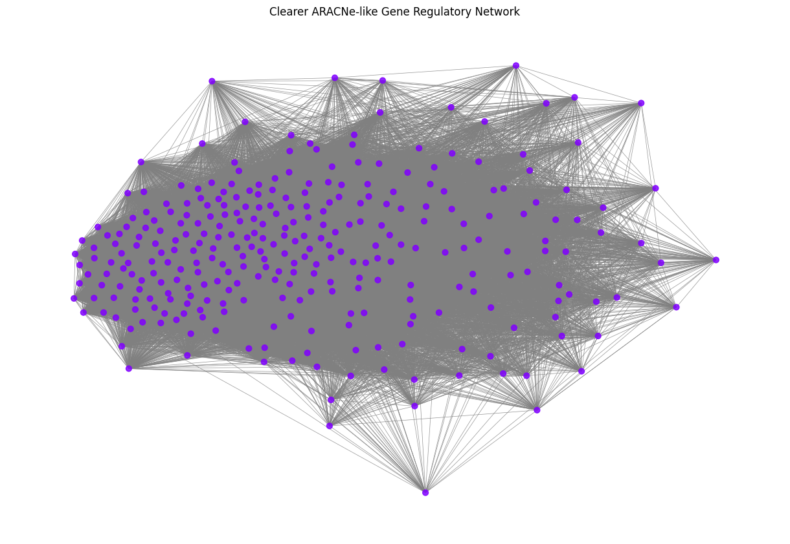

import numpy as np

import pandas as pd

from sklearn.preprocessing import StandardScaler

from sklearn.feature_selection import mutual_info_regression

import networkx as nx

import matplotlib.pyplot as plt

from joblib import Parallel, delayed

file_path = "/content/gene_counts.csv"

df = pd.read_csv(file_path, encoding="utf-8")

df.rename(columns={df.columns[0]: "GeneID"}, inplace=True)

df.set_index("GeneID", inplace=True)

df = df.apply(pd.to_numeric, errors="coerce").dropna()

top_genes = df.var(axis=1).nlargest(1000).index

df = df.loc[top_genes]

scaler = StandardScaler()

df_scaled = pd.DataFrame(scaler.fit_transform(df.T).T, index=df.index, columns=df.columns)

corr_matrix = df_scaled.T.corr(method="pearson")

corr_threshold = 0.7

strong_pairs = np.where(np.abs(corr_matrix) > corr_threshold)

gene_pairs = [(df.index[i], df.index[j]) for i, j in zip(*strong_pairs) if i != j]

def compute_mi(gene1, gene2):

    return mutual_info_regression(df_scaled.loc[gene1].values.reshape(-1, 1),

                                  df_scaled.loc[gene2].values.reshape(-1, 1))[0]

mi_scores = Parallel(n_jobs=-1, backend="loky")(delayed(compute_mi)(g1, g2) for g1, g2 in gene_pairs)

G = nx.Graph()

for (gene1, gene2), mi in zip(gene_pairs, mi_scores):

    if mi > 0.05:

        G.add_edge(gene1, gene2, weight=mi)

plt.figure(figsize=(12, 8))

pos = nx.spring_layout(G, seed=42)

nx.draw(G, pos, node_size=30, edge_color="gray", alpha=0.7)

plt.title("Optimized CEMiTool-like Co-expression Network")

plt.show()

import numpy as np

import pandas as pd

from sklearn.preprocessing import StandardScaler

import networkx as nx

import matplotlib.pyplot as plt

file_path = "/content/gene_counts.csv"

df = pd.read_csv(file_path, encoding="utf-8")

df.rename(columns={df.columns[0]: "GeneID"}, inplace=True)

df.set_index("GeneID", inplace=True)

df = df.apply(pd.to_numeric, errors="coerce").dropna()

top_genes = df.var(axis=1).nlargest(500).index

df = df.loc[top_genes]

scaler = StandardScaler()

df_scaled = pd.DataFrame(scaler.fit_transform(df.T).T, index=df.index, columns=df.columns)

corr_matrix = df_scaled.T.corr(method="pearson")

corr_matrix = corr_matrix.where(np.triu(np.ones(corr_matrix.shape), k=1).astype(bool))

threshold = 0.75

edges = [(df.index[i], df.index[j]) for i, j in zip(*np.where(corr_matrix > threshold))]

G = nx.Graph()

G.add_edges_from(edges)

plt.figure(figsize=(10, 7))

pos = nx.spring_layout(G, seed=42)

nx.draw(G, pos, node_size=50, edge_color="gray", alpha=0.7)

plt.title("Optimized CEMiTool-like Co-expression Network")

plt.show()

import numpy as np

import pandas as pd

from sklearn.preprocessing import StandardScaler

import networkx as nx

import matplotlib.pyplot as plt

file_path = "/content/gene_counts.csv"

df = pd.read_csv(file_path, encoding="utf-8")

df.rename(columns={df.columns[0]: "GeneID"}, inplace=True)

df.set_index("GeneID", inplace=True)

df = df.apply(pd.to_numeric, errors="coerce").dropna()

top_genes = df.var(axis=1).nlargest(1000).index

df = df.loc[top_genes]

scaler = StandardScaler()

df_scaled = pd.DataFrame(scaler.fit_transform(df.T).T, index=df.index, columns=df.columns)

corr_matrix = df_scaled.corr(method="pearson")

np.fill_diagonal(corr_matrix.values, 0)

threshold = 0.6

edges = [(corr_matrix.index[i], corr_matrix.index[j]) for i, j in zip(*np.where(corr_matrix.values > threshold)) if i != j]

G = nx.Graph()

G.add_edges_from(edges)

plt.figure(figsize=(12, 8))

pos = nx.spring_layout(G, seed=42)

nx.draw(G, pos, node_size=30, edge_color="gray", alpha=0.7)

plt.title("STRING-like Gene Co-expression Network")

plt.show()

