Problem Statement :- Credit Card Fraud Detection

Name:- NAITIK KUKREJA

University Roll No. :- 202401100400120

Class Roll No. :-47

Branch:- CSEAIML

Section:-B

**Credit Card Fraud Detection**

**Problem Statement**

Credit card fraud is a major issue in the banking and financial sector. Fraudsters use stolen card information to perform unauthorized transactions, leading to financial losses and customer dissatisfaction. The objective of this project is to build a machine learning model that can detect fraudulent credit card transactions based on transaction data.

**Dataset Description**

The dataset used in this project is sourced from Kaggle and contains credit card transactions made by European cardholders in September 2013. It includes a total of 284,807 transactions, out of which only 492 are fraudulent. This makes the dataset highly imbalanced, with fraud cases representing only 0.17% of the data.

The features in the dataset are mostly anonymized using Principal Component Analysis (PCA), labeled as V1 to V28. Two additional features are:

* Amount: The transaction amount.
* Time: The time elapsed between this transaction and the first transaction in the dataset.
* Class: The target variable, where 0 indicates a legitimate transaction and 1 indicates a fraudulent transaction.

**Challenge: Imbalanced Data**

Due to the highly imbalanced nature of the dataset, standard classification metrics like accuracy are not sufficient to evaluate model performance. For example, a model that always predicts "not fraud" will still achieve over 99% accuracy. Therefore, metrics like **precision** and **recall** are more informative:

* **Precision**: The proportion of predicted fraudulent transactions that are actually fraud.
* **Recall**: The proportion of actual fraud cases that were correctly identified by the model.

**Methodology**

1. **Data Preprocessing**
   * Unnecessary columns such as Time were dropped.
   * The dataset was split into training and testing sets using stratified sampling to maintain class balance.
2. **Model Training**
   * A Random Forest classifier was used with class balancing to handle the imbalanced data.
3. **Evaluation**
   * A confusion matrix was generated to visualize the model’s performance.
   * The model was evaluated using accuracy, precision, and recall metrics.

### Conclusion

The credit card fraud detection problem highlights the difficulty of working with imbalanced datasets. While machine learning models such as Random Forest can detect a significant number of fraud cases, careful tuning and evaluation using appropriate metrics are necessary to avoid false positives and minimize missed frauds. This model can assist banks and financial institutions in flagging potentially fraudulent transactions more effectively.

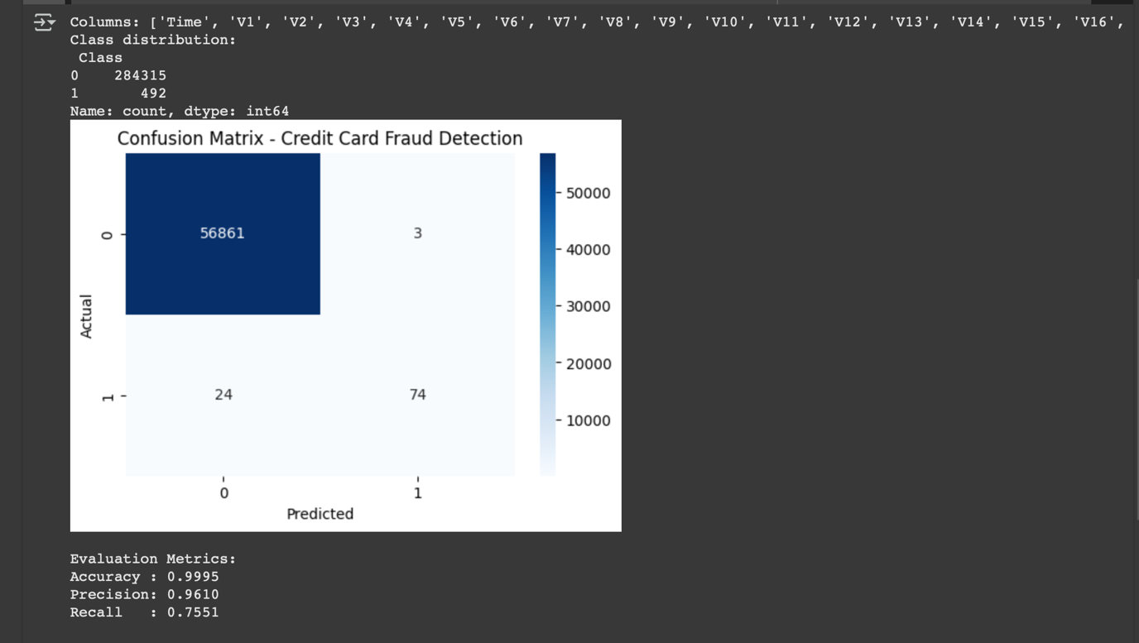

CODE:-

# Import necessary libraries

import pandas as pd

import seaborn as sns

import matplotlib.pyplot as plt

# Import scikit-learn modules for modeling and evaluation

from sklearn.model_selection import train_test_split

from sklearn.ensemble import RandomForestClassifier

from sklearn.metrics import confusion_matrix, accuracy_score, precision_score, recall_score

# 1. Load the dataset with appropriate encoding

# The dataset may contain special characters, so we use 'ISO-8859-1' to avoid decoding errors

df = pd.read_csv('/content/7. Predict Credit Card Fraud.csv', encoding='ISO-8859-1') # treating as credit_fraud.csv

# 2. Preview column names and check class distribution to understand data imbalance

print("Columns:", df.columns.tolist())

print("Class distribution:\n", df['Class'].value_counts()) # Shows how many fraud (1) and non-fraud (0) samples

# 3. Define feature matrix X and target variable y

# Drop the 'Class' column from features (since it's the label), and optionally drop 'Time' if present

X = df.drop(['Class', 'Time'], axis=1, errors='ignore') # 'errors=ignore' prevents crash if 'Time' not in dataset

y = df['Class'] # Target label: 0 = Not Fraud, 1 = Fraud

# 4. Split the dataset into training and testing sets (80% train, 20% test)

# Stratify ensures class balance in both sets

X_train, X_test, y_train, y_test = train_test_split(

X, y, test_size=0.2, stratify=y, random_state=42

)

# 5. Train a Random Forest Classifier

# We use class_weight='balanced' to handle class imbalance

model = RandomForestClassifier(n_estimators=100, class_weight='balanced', random_state=42)

model.fit(X_train, y_train) # Fit model on training data

# 6. Make predictions on the test set

y_pred = model.predict(X_test)

# 7. Compute the confusion matrix to evaluate predictions

cm = confusion_matrix(y_test, y_pred)

# Visualize the confusion matrix as a heatmap

plt.figure(figsize=(6, 4))

sns.heatmap(cm, annot=True, fmt='d', cmap='Blues')

plt.xlabel('Predicted') # X-axis label

plt.ylabel('Actual') # Y-axis label

plt.title('Confusion Matrix - Credit Card Fraud Detection')

plt.show()

# 8. Compute and display evaluation metrics

accuracy = accuracy_score(y_test, y_pred) # Overall correctness

precision = precision_score(y_test, y_pred) # Correctly predicted frauds out of total predicted frauds

recall = recall_score(y_test, y_pred) # Correctly predicted frauds out of actual frauds

# Display the metrics

print("\nEvaluation Metrics:")

print(f"Accuracy : {accuracy:.4f}")

print(f"Precision: {precision:.4f}")

print(f"Recall : {recall:.4f}")